# **ENHANCING CAPSTONE ARCHIVING AND OPTIMIZING DATA INTELLIGENCE WITH PROJECT CAPSTONOVA**

A Capstone Project Presented to the Faculty of

College of Computer, Information and Communications Technology

Cebu Technological University-Main Campus

In Partial Fulfillment

of Requirements for the degree

Bachelor of Science in Information Systems

By

Arado, Niño John

Canales, Kingston Harddy

Genson, Leah Faye

Jubahib, Shekinah Mae

Angelbert P. Maghanoy, Ph.D.

Adviser

October 2025

# **APPROVAL SHEET**

The Capstone Project entitled **Enhancing Capstone Archiving and Optimizing Data Intelligence with Project Capstonova** prepared and submitted by Niño John L. Arado, Kingston Harddy Canales, Leah Faye A. Genson, and Shekinah Mae O. Jubahib has been examined and is recommended for approval and acceptance.

Recommended:

**ANGELBERT P. MAGHANOY, Ph.D.**

Adviser

Approved by the Committee on PROPOSAL HEARING with a verdict of **APPROVED WITH MINOR REVISIONS** on **October 21, 2025.**

**NOREEN B. FUENTES, Ph.D, DIT**

Chairman

**JANETH S. UGANG, Ph.D. EMELIE C. VILLACERAN, Ph.D**

Member Member

ACCEPTED and APPROVED in partial fulfillment of the requirements in Bachelor of Science in Information System

**GERRY RITZ R. DENSING, Ph.D.**

Associate Dean, CCICT

**JOSE MARIA S. GARCIA II, Ph.D.**

Dean, CCICT

# **ACKNOWLEDGEMENT**

With sincere gratitude, we acknowledge the individuals and institutions whose unwavering support and guidance made this capstone project possible. This journey has been filled with challenges, but through the kindness and encouragement of many, we have preserved.

First and foremost, we thank God for His wisdom and strength. His presence gave us courage during difficult times.

We deeply appreciate our families for their love and sacrifices. Their unwavering support kept us motivated throughout this journey.

Our heartfelt gratitude goes to our adviser, Angelbert P. Maghanoy, for his patience and invaluable guidance. His belief in our abilities inspired us to do our best.

We also extend our thanks to the faculty of Cebu Technological University-Main Campus for their mentorship and encouragement. Their knowledge has been instrumental in shaping our academic growth.

Lastly, we acknowledge our fellow team members. This project was not just about work, it was about shared dreams, sleepless nights, and overcoming obstacles together. The lessons we learned and the bonds we formed will remain with us beyond this project.

The Researchers

# **DEDICATION**

We wholeheartedly dedicate this Capstone Project, "Enhancing Capstone Archiving and Optimizing Data Intelligence with Project Capstonova," to our dearest parents. Your unconditional love, tireless sacrifices, and unwavering support have been the foundation of our strength and determination throughout this academic journey. This accomplishment is as much yours as it is ours.

To our wonderful team, thank you for your dedication and hard work. You all contributed to the table ideas, energy, and enthusiasm that made this project a collaboration. It wasn't merely the completion of an assignment; it was a valuable experience of learning and growth.

We also express our deepest gratitude to our adviser, Sir Angelbert P. Maghanoy. Your patience, guidance, and support have molded this project into what it is today. We thank you for having faith in us and for accompanying us every step of the way.

Finally, we thank God for the grace, wisdom, and strength that guided us through the trials. To friends, mentors, and all those who have encouraged and supported us throughout, this is all for you.

# **TABLE OF CONTENTS**

ENHANCING CAPSTONE ARCHIVING AND OPTIMIZING DATA INTELLIGENCE WITH PROJECT CAPSTONOVA i

APPROVAL SHEET ii

ACKNOWLEDGEMENT iii

DEDICATION iv

TABLE OF CONTENTS v

LIST OF TABLES vii

CHAPTER 1 1

INTRODUCTION 1

Rationale of the Study 1

Objectives of the Study 3

Scope and Limitations of the Study 5

Significance of the Study 9

Flow of the Study 11

Definition of Terms 12

CHAPTER 2 REVIEW OF RELATED LITERATURE AND STUDIES 13

Related Literature 13

Related Studies 26

Comparative Matrix 31

CHAPTER 3 RESEARCH METHODOLOGY 33

Software Engineering Methodologies 33

Planning Phase 34

Business Model Canvas 36

Program Workflow 37

Work Breakdown Structure 42

Gantt Chart 44

Functional Decomposition 45

Analysis Design Phase 46

Use-Case Diagram 47

Storyboard 52

Database Design 107

Entity Relationship Diagram 107

Data Dictionary 108

Network Design 117

Network Model 117

Network Topology 119

Development Phase 120

Technology Stack Diagram 120

Software Specification 121

Hardware Specification 121

Program Specification 123

List of Modules 123

Testing Phase 127

Unit Testing 128

Integration Testing 133

Alpha Testing 134

Acceptance Testing 136

Implementation/Deployment Phase 137

User-Guide 137

Installation Guide 163

Roadmap 174

CONCLUSION 175

RECOMMENDATIONS 176

REFERENCES 177

CURRICULUM VITAE 186

APPENDICES 190

# **LIST OF TABLES**

Table 1. Comparative Matrix 31

Table 2. User 108

Table 3. User Details 109

Table 4. Capstone Project 109

Table 5. Capstone Manuscript 110

Table 6. Capstone Source Code 110

Table 7. Project Researchers 111

Table 8. Programming Languages 111

Table 9. Project Languages 112

Table 10. Keywords 112

Table 11. Project Keywords 112

Table 12. Document Request 113

Table 13. Viewer Access 113

Table 14. Notification 114

Table 15. Whitelist 114

Table 16. Suggestion 114

Table 17. System Settings 115

Table 18. Approval History 115

Table 19.. Action Type 116

Table 20. User Log 116

Table 21. Software Specification 121

Table 22. List of Modules 123

Table 23. Unit Testing 128

Table 24. Integration Testing 133

Table 25. Alpha Testing 135

Table 26. Alpha Testing Clients 136

Table 27. Alpha Testing Test Cases 137

Table 28. User Guide Super Admin 138

Table 29. User Guide Admin 146

Table 30. User Guide Adviser 151

Table 31. User Guide Proponent 155

Table 32. User Guide Viewer 159

Table 33. Installation Guide - Core Software 163

Table 34. Installation Guide - System Components 171

Table 35. Installation Guide - Summary of all Components 173

**LIST OF FIGURES**

Figure 1. Flow of the Study 11

Figure 2. Capstone and Thesis Archiving System 27

Figure 3. Capstone Projects and Master's Theses 28

Figure 4. Capstone Repository at Yale-NUS College 28

Figure 5. Master’s Projects and Capstones Repository at the University of San Francisco (USF) 29

Figure 6. Graduate Theses, Dissertations, and Other Capstone Projects Collection 30

Figure 7. Agile Development Methodology 33

Figure 8. Business Model Canvas 36

Figure 9. Program Workflow - (Super Admin) 37

Figure 10. Program Workflow - (Admin) 38

Figure 11. Program Workflow - (Adviser) 39

Figure 12. Program Workflow - (Proponent) 40

Figure 13. Program Workflow - (Viewer) 41

Figure 14. WBS Tree 42

Figure 15. Work Breakdown Structure 43

Figure 16. Capstone 2 Gant Chart 44

Figure 17. Functional Decomposition 45

Figure 18. Functional Decomposition Legend 46

Figure 19. Use-Case Diagram (Super Admin) 47

Figure 20. Use-Case Diagram (Admin) 48

Figure 21. Use-Case Diagram (Adviser) 49

Figure 22. Use-Case Diagram (Proponent) 50

Figure 23. Use-Case Diagram (Viewer) 51

Figure 24. Proponent - Sign up Page UI 52

Figure 25. Proponent - Login Page UI 53

Figure 26. Proponent - Personal Account UI 53

Figure 27. Proponent - Upload Capstone Project UI 54

Figure 28. Proponent - Upload Manuscript UI 54

Figure 29. Proponent - Upload Source Code UI 55

Figure 30. Proponent - Upload User Manual UI 55

Figure 31. Proponent - Upload Usage Guide UI 56

Figure 32. Proponent - Project Submission Complete UI 56

Figure 33. Proponent - Notification UI 57

Figure 34. Adviser - Login Page UI 57

Figure 35. Adviser - Dashboard UI 58

Figure 36. Adviser - Advisee UI 58

Figure 37. Adviser - Projects UI 59

Figure 38. Adviser - View Abstract UI 59

Figure 39. Adviser – View Full Document UI 60

Figure 40. Adviser – Adviser’s Suggestions UI 60

Figure 41. Adviser – My Suggestions UI 61

Figure 42. Adviser – Add Suggestion UI 61

Figure 43. Adviser – DA Adviser’s Overview UI 62

Figure 44. Adviser – DA Project Type UI 62

Figure 45. Adviser – DA Environment Trend UI 63

Figure 46. Adviser – DA Project Tools Trend UI 63

Figure 47. Adviser – Notification UI 64

Figure 48. Adviser – Account Settings UI 64

Figure 49. Adviser – Update Profile UI 65

Figure 50. Admin – Login UI 65

Figure 51. Admin – Dashboard UI 66

Figure 52. Admin- Whitelist Form UI 66

Figure 53. Admin- Whitelist UI 67

Figure 54. Admin- List of Viewers UI 67

Figure 55. Admin- Viewer’s Profile UI 68

Figure 56. Admin- List of Proponents UI 68

Figure 57. Admin - Proponent’s Profile UI 69

Figure 58. Admin - List of Advisers UI 69

Figure 59. Admin - Adviser’s Suggestions UI 70

Figure 60. Admin- Add Adviser UI 70

Figure 61. Admin - Adviser’s Profile 71

Figure 62. Admin - Restricted Accounts 71

Figure 63. Admin – Submission UI 72

Figure 64. Admin - Capstone Project Files UI 72

Figure 65. Admin - Suggestions UI 73

Figure 66. Admin - DA Advisory Load UI 73

Figure 67. Admin - DA Project Type UI 74

Figure 68. Admin - DA Environment Trend UI 74

Figure 69. Admin - DA Project Tools Trend UI 75

Figure 70. Admin - DA ML Service UI 75

Figure 71. Admin - Project Reports UI 76

Figure 72. Admin - User Account Report UI 76

Figure 73. Admin - Notification UI 77

Figure 74.Admin - Account Settings UI 77

Figure 75. Admin - Update Profile UI 78

Figure 76. Super Admin- Login Page UI 78

Figure 77. Super Admin- Dashboard UI 79

Figure 78. Super Admin- Whitelist Form UI 79

Figure 79. Super Admin- Whitelist UI 80

Figure 80. Super Admin- List of Viewers UI 80

Figure 81. Super Admin- Viewer’s Profile UI 81

Figure 82.Super Admin- List of Proponents UI 81

Figure 83. Super Admin- Add Proponent UI 82

Figure 84. Super Admin - Proponent’s Profile UI 82

Figure 85. Super Admin - List of Advisers UI 83

Figure 86. Super Admin - Adviser’s Suggestions UI 83

Figure 87. Super Admin- Add Adviser UI 84

Figure 88. Super Admin - Adviser’s Profile 84

Figure 89. Super Admin - List of Admins 85

Figure 90. Super Admin - Add Admin UI 85

Figure 91. Super Admin - Admin’s Profile 86

Figure 92. Super Admin - Restricted Accounts 86

Figure 93. Super Admin - Submissions UI 87

Figure 94. Super Admin - Capstone Project Files UI 87

Figure 95. Super Admin - DA Advisory Load UI 88

Figure 96. Super Admin - DA Project Type UI 88

Figure 97. Super Admin - DA Environment Trend UI 89

Figure 98. Admin - DA Project Tools Trend UI 89

Figure 99. Super Admin - DA ML Service UI 90

Figure 100. Super Admin - Pending Access Requests UI 90

Figure 101. Super Admin - Approval History UI 91

Figure 102. Super Admin - Project Reports UI 91

Figure 103. Super Admin - User Account Report UI 92

Figure 104. Super Admin - Notification UI 92

Figure 105. Super Admin - SysConfig Admin UI 93

Figure 106. Super Admin - SysConfig Adviser UI 93

Figure 107. Super Admin - SysConfig Proponent UI 94

Figure 108. Super Admin - SysConfig Viewers UI 94

Figure 109. Super Admin - Account Settings UI 95

Figure 110. Super Admin - Update Profile UI 95

Figure 111. Viewers- Welcome Page One UI 96

Figure 112. Viewers- Welcome Page Two UI 97

Figure 113. Viewer- Advanced Search UI 98

Figure 114. Viewer- Search Project UI 98

Figure 115. Viewer- View Abstract UI 99

Figure 116. Viewer - Sign Up Page UI 99

Figure 117. Viewer - Login Page UI 100

Figure 118. Viewer- Menu UI 100

Figure 119. Viewer - Library UI 101

Figure 120. Viewer - View Suggestions UI 102

Figure 121. Viewer - View Trends UI 103

Figure 122. Viewer - About Us One UI 104

Figure 123. Viewer - About Us Two UI 105

Figure 124. Viewers- Account Page UI 106

Figure 125. Viewer - Notification UI 106

Figure 126. Entity Relationship Diagram 107

Figure 127. Dual-Firewall Client-Server Network Model 118

Figure 128. Star Network Topology 119

Figure 129. Technology Stack Diagram 120

Figure 130. Roadmap 174

# **CHAPTER** **1**

# **INTRODUCTION**

### **Rationale of the Study**

In today’s digital world, many universities are now using modern technology to manage academic work and keep research safe. At Cebu Technological University – College of Computer, Information, and Communications Technology (CTU-CCICT), capstone projects are still stored in the traditional way by printing, bookbinding, and keeping them in physical storage rooms. While this preserves a physical copy of the work, it also hinders access to it, increases chances of being destroyed over time, and slows searching and retrieval. Because of this, many important research works do not get used to their full capacity, and innovation and collaboration opportunities are limited.

These issues manifest themselves in various forms. For instance, both teachers and students have difficulties checking capstone titles because there is no central location to observe previous projects. This tends to lead to duplicated research topics, slowness in approving proposals, and lost opportunities for carrying forward on previous work. Looking for past projects by hand takes a lot of time and effort, especially when teachers need to check if a project is original or when students are looking for ideas or examples. Also, printed documents can be easily damaged or lost, which creates problems for saving important information and passing it on in the future.

To help solve these long-standing problems, this study reviews related research and current systems to guide the creation of a suitable solution. Lalisan and Sobejana (2019) explain how digital archiving can make information easier to access and manage. Bradley, Lei, and Blackall (2007) show the importance of compressing data to save storage space. Nolan and Costanza (2006) have identified physical record challenges. Tindoc et al. (2023) highlight the importance of how data mining and smart classification can help in research systems. These works reaffirm the need for a system that not only digitizes records but also keeps them and updates them to aid in academic achievement.

To fulfill this need, we propose Project CapstoNova as a reliable, secure, and centralized Capstone Archiving Information System for CTU-CCICT. CapstoNova will replace the current paper and warehouse storage with a modern-day digital system that will allow easy submission, storage, and retrieval of capstone projects. Through this system, project leaders can upload approved capstone papers immediately after the last defense without using USB drives. CapstoNova also sorts projects automatically by platform (web, mobile, or hybrid), programming language, and topic of study for quick retrieval. Students can search capstone projects to check if an idea has already been implemented and to gather ideas as references. Advisers can monitor their advisees and their implemented projects, and suggest capstone ideas to help more students, especially incoming ones, decide on which projects to pursue.

Additionally, the system includes an access control feature to protect intellectual property. While anyone can search and read project abstracts, full documents and source codes will only be accessible to authorized users.

CapstoNova development is grounded on the Agile method that emphasizes iterative development, collaboration, and adaptability in delivering features on time and continuous improvement with stakeholder feedback. It begins from establishing existing institutional workflows and ends up in developing an intuitive web-based system. CapstoNova employs technologies like PHP (Laravel) for back-end programming, MySQL for data management, and front-end technologies like HTML, CSS, Bootstrap, and Tailwind. Major modules comprise project submission, review, classification, advanced search, and access control, with in-built data mining facilities like clustering, trend prediction, and outlier detection to support research analysis. The system follows a dual-firewall client-server structure with a star topology for high security, scalability, and fault-tolerant performance. The platform is hosted by a central server that supports a range of client devices, with backup protocols and UPS systems for data integrity. By digitizing and making capstone archiving a smart, data-driven solution, CapstoNova promotes academic innovation, security, and ongoing institutional development.

### **Objectives of the Study**

This project seeks to create Project CapstoNova, a web-based system that seeks to develop a capstone project archiving, storage, secure access management, and smart data analysis at the College of Computer, Information, and Communications Technology (CCICT) at Cebu Technological University-Main Campus.

To achieve this goal, the specific objective is to design a centralized database where users can securely keep their encrypted and compressed capstone projects while implementing search functionalities to allow users to verify the originality of proposed capstone titles.

Specific objectives:

1. To design and develop a centralized archiving system for securely managing capstone manuscripts and source codes using the local storage repository.

2. To implement role-based user access for proponents, advisers, admins, super admins, and viewers, each with specific permissions and responsibilities.

3. To provide a project title search feature to check whether an idea or title has already been implemented, along with suggestion features (AI suggestions or adviser suggestions) that help prevent duplicate titles and allow advisers to share project ideas.

4. To automate the capstone submission, approval, and classification processes, including uploading of documents, approval workflow, and tagging by category.

5. To organize user accounts, projects, suggestions, archives, and other features for easier retrieval and browsing.

6. To integrate analytics and reporting tools to display project trends and statistics useful for research and planning.

7. To develop a secure access request system where the viewer must first create an account before requesting permission to view the full ACM-formatted manuscript.

8. To provide real-time notifications for users about project submissions, account updates, access requests, and system events.  
9. To generate system reports such as total submissions, archive status, active users, and adviser involvement for administrative use.

10. To ensure backup and protection of archived files through local storage procedures, user authentication, and file integrity checking.  
11. To prepare complete documentation including technical manuals, user guides, and the final capstone paper to support training, usage, and maintenance.

### **Scope and Limitations of the Study**

The objective of this research is to create a web-based capstone project archiving system for Cebu Technological University – College of Computer, Information, and Communications Technology (CTU-CCICT) that improves capstone project management, storage, and retrieval. The system will automate the submission, approval, and classification of projects with the incorporation of data compression and analytics for effective handling of research.

The research will only involve the design and implementation of the web-based system at CTU-CCICT and specifically for capstone project archiving.

Specifically, the study aims to develop a web-based for:

1. To implement a web application that allows Super Admin to:

* Manage their accounts, view, and update their information.
* View or upload whitelist information, including IDs, emails, names, departments, courses, and advisers.
* Manage all user accounts (Viewer, Proponent, Adviser, Admin) by searching, adding, updating, or restricting accounts, as well as restoring restricted accounts.
* Manage project submissions by searching, viewing (manuscript, source code, user guide, and system manual), and archiving or restoring them.
* View data analytics showing advisory load, project types (Web, Mobile, Hybrid, IoT), environment trends (Education, Healthcare, Automation, AI, etc.), project tool trends (Python, PHP, Java, etc.), and ML (Machine Learning) service usage.
* Approve or reject manuscript access requests from Viewer users and track approval history to manage project visibility.
* View project reports showing the number of submissions per course and user account reports showing the number of Viewers, Proponents, Admins, and Advisers.
* Receive notifications about access requests, new submissions, security alerts, and whitelist uploads.
* Manage system configurations for each user type (Admin, Adviser, Proponent, and Viewer).

1. To implement a web application that allows Admin to:

* Manage their accounts, view, and update their information.
* View or upload whitelist information, including IDs, emails, names, departments, courses, and advisers.
* Manage all user accounts (Viewer, Proponent, Adviser) by searching, adding, updating, or restricting accounts, as well as restoring restricted accounts.
* Manage project submissions by searching, viewing (manuscript, source code, user guide, and system manual), and archiving or restoring them.
* View active and archived capstone project suggestions submitted by advisers.
* View data analytics showing advisory load, project types (Web, Mobile, Hybrid, IoT), environment trends (Education, Healthcare, Automation, AI, etc.), project tool trends (Python, PHP, Java, etc.), and ML (Machine Learning) service usage.
* View project reports showing the number of submissions per course and user account reports showing the number of Viewers, Proponents, Admins, and Advisers.
* Receive notifications about new submissions, security alerts, and whitelist uploads.

1. To implement a web application that allows Adviser to:

* Manage their accounts, and view and update their information.
* View their advisees or the proponents under them, along with information such as name, department, and program.
* View the abstracts and full manuscripts of projects under their advisory.
* Suggest or archive capstone project ideas, and also view capstone project ideas submitted by other advisers.
* View data analytics showing the adviser’s overview, project types (Web, Mobile, Hybrid, IoT), environment trends (Education, Healthcare, Automation, AI, etc.), and project tool trends (Python, PHP, Java, etc.).
* Receive notifications when a new whitelist is uploaded under them and when new proponents register.

1. To implement a web application that allows Proponents to:

* Manage their accounts by signing up, view and update their information.
* Log in and upload their capstone manuscript, create an abstract, attach keywords for project categorization, submit their source code, upload the user manual, and upload the usage guide.
* View their capstone project and receive notifications, such as confirmation that their project was successfully submitted.

1. To implement a web application that allows Viewers to:

* Manage their accounts by signing up, and view and update their information.
* Search capstone projects, with an option for advanced search for more specific results.
* Request access to full manuscripts, which will be approved by the Super Admin or Admin. Once approved, the requested capstone project will be added to their library.
* View AI or Adviser capstone project suggestions as a guide for future projects. Each suggestion is labeled to indicate whether other Viewers have already expressed interest.
* View trends across all capstone projects, including project types, most-used programming languages, and environment trends.
* Receive notifications when access requests for full manuscripts are approved and for other security alerts.

Limitations of the Study:

* The system is designed exclusively for CTU-CCICT and doesn't accept projects from outside institutions​.
* Plagiarism detection is not implemented beyond title verification and basic similarity checks.
* Advisers can suggest project ideas, but the system does not support the full advisory workflow, like the direct tracking of student progress on those suggestions.
* Viewers have limited free access to project details and must request to view the full documents​. The request can be authorized only by the Admin or Super Admin.
* The complexity of the system with multiple roles and functions can require lengthy training for the users. In the absence of being complemented with proper documentation or support, the users can find it difficult to utilize the system

### **Significance of the Study**

The proposed web-based capstone project archiving system will act as a fast and user-friendly platform for managing, storing, and retrieving capstone projects. It will simplify the approval process, enhance access, and provide secure storage of research documents. This study is specifically beneficial to the following:

**CTU-CCICT Students and Faculty** Students and faculty members from CTU-CCICT can make use of this system by effortlessly browsing uploaded capstone projects according to subjects they are interested in. This way, they can view available capstone projects in order not to replicate ideas or to make use of them as a reference. They can also view basic information about each project to understand what it is about. If they need full access to the document (ACM format), they can simply send a request. The system also includes project topic suggestions from advisers, which can help users get new ideas or use them as references for their own work.

**CTU-CCICT**

The system will act as a computer repository of capstone projects of Cebu Technological University – College of Computer, Information, and Communications Technology (CTU-CCICT). It will improve the accessibility of research, project documentation and be a reference tool for both students and professors.

**Researchers**

This system can also serve as a useful starting point for future researchers interested in enhancing digital research repositories. They can explore new features such as plagiarism detection, AI-generated topic ideas, or simplifying the system for use on mobile platforms. In this way, the project supports better academic tools and encourages further innovation in accessing and managing research.

### **Flow of the Study**

**Objectives of the Study**

**Review of Related Literature and Related Studies**

**Existing Capstone Projects (for benchmarking)**

**System Requirements (based on client needs)**

**Client and Adviser Feedback**

**INPUT**

**PROCESS**

**Client and Adviser Validatiom**

**Application of Agile Methodology**

**Web-Based System Design and Development**

**Database Management and Integration**

**Iterative Testing and Implementation of System Features**

**PROJECT CAPSTONOVA**

**OUTPUT**

Figure 1. Flow of the Study

Figure 1 presents the workflow of creating Project CapstoNova, a capstone project information system. At first, data of relevant studies, objectives, system requirements, and client advisers' feedbacks are collected (Input). Second, the system is created with Agile methodology, web-based creation, database administration, and on-going validation from clients and advisers (Process). Lastly, the final Project CapstoNova system is generated as output (Output).

### **Definition of Terms**

**Archive.** A digital space dedicated to the secure storage and compression of manuscripts within the system.

**Manuscripts.** Complete capstone project files submitted by students, preserved securely.

**Repository.** A repository within the system is a safe, centralized digital storage area where capstone projects are stored and organized for easy retrieval.

**Whitelist.** A list containing the names of verified students who are officially registered in the system.

**CAPSTONOVA.** A capstone archiving system inspired by the fusion of "Capstone" and "Innovation." The name “CapstoNova” blends “Capstone,” symbolizing students' culminating academic work, and “Nova,” representing a new and transformative approach. Just as a nova brings brilliant light to the cosmos, CapstoNova offers a smart and innovative solution to traditional research archiving through intelligent digital storage.

# **CHAPTER 2 REVIEW OF RELATED LITERATURE AND STUDIES**

This chapter presents different related literature and research works that were gathered to strengthen and support the argument for the proposed study. The collected works are from journals, books, and other internet references. These sources are instrumental in determining the characteristics of the study and providing further insight into the Capstone Archiving Information System.

### **Related Literature**

This section provides a systematic literature review to the development of Project CapstoNova, based on digital repository systems, web-based management systems, automation and security, data analysis, and archiving practices of institutions. Every section integrates primary findings and illustrates how such research helps determine the necessity for CapstoNova.

**Digital Repository Systems**

A digital repository system is used to store, organize, and manage digital files like documents and projects online, making it easier and safer for users to access and share information in one central place. At Cebu Technological University – College of Computer, Information, and Communications Technology (CTU-CCICT), the CapstoNova system was created to serve as an online storage space for approved capstone projects. It is built using PHP (Laravel) on the back end, MySQL for database administration, and HTML, CSS, Bootstrap, and Tailwind for structure and design. The system is Agile-based and hence incrementally built with ongoing user feedback to improve the features. CapstoNova is also secure with client-server setup and double firewall and uses encryption and access control to grant access only to registered users for full documents (ACM format). It is automatically categorized by type of platform, programming language, and subject matter, and with features like file compression, data backup, and trend analysis to assist in research and project planning. All these technologies and tools altogether offer students, faculty, and staff a quicker, safer, and smarter way of managing and using capstone projects.

Various studies have noted the advantages of digital repository systems, which are discussed in the subsequent studies.

Sarawan et al.'s (2025) research focuses on applying lean principles to create an electronic student project archive system. Storage problems of papers, including wastage, inaccessibility, and unnecessary cost, were an element the researchers sought to eliminate (Sarawan et al., 2025). The study justifies CapstoNova since it introduces the advantages of digitalization in making projects more accessible and management more efficient.

Perante et al. (2024) also suggested a digital archiving management system for capstone and thesis projects specifically designed for Eastern Visayas State University. Their research aimed to resolve the inefficiencies of traditional paper-based systems, including storage inefficiency and document accessibility issues. This is aligned with Project CapstoNova's mission of developing a secure, efficient, and user-friendly digital repository system to enhance project management. As indicated by Ronquillo (2023), digital repositories significantly improve access and research output management, complementing Perante et al. (2024) work by supporting the importance of digital repositories in an academic setting.

Hoelscher (2024) explores digital primary source literacy and centers on preparing students for successful online archival research. The study identifies the difficulty of preparing students with skills to successfully navigate and utilize digital archives. This study is applicable to CapstoNova in highlighting the need for easy-to-use digital interfaces and simple search functions, facilitating effective academic research.

Erima and Garaba (2024) surveyed how universities in Kenya obtained digital archives despite the disruptions brought about by technologies. Their study seeks to address the threats and vulnerabilities of information stored digitally in universities. This aligns with CapstoNova's concern for secure access control and encryption to safeguard archived academic projects against unauthorized access and threats.

Nagrama et al. (2024) introduce a web-based document management system aimed at simplifying document handling and enhancing accessibility in educational environments. Their research highlights the drawbacks of disorganization and restricted access in manual systems. CapstoNova addresses these problems with intelligent classification, automated processing, and centralized storage, making project documentation and retrieval more efficient.

Tindoc et al. (2023) observe that developing a web-based system for research project archiving integrates storage, which simplifies data access and retrieval. This supports the argument of Montalban and Antiquera (2023), who posit that efficient digital archiving enhances the ease of thesis document access for students and lecturers. Such observations also support CapstoNova's mission of improving project storage, access, and management efficiency.

The study by Jansen and Akers (2016) discusses the role of digital repositories in preserving and providing long-term access to scholarly content, emphasizing the value of centralized storage for academic institutions. Digital repositories play an important role in preserving and safeguarding research outputs, particularly for universities with the aim of retaining institutional knowledge. This is exactly the idea that is reflected in CapstoNova, where it provides a secure repository for student capstone projects to enable long-term storage, easy retrieval, and reuse in research.

As per the open-source Islandora platform, digital repository systems are designed to be integrated with multiple tools for handling and conserving digital resources in an effective manner. Islandora offers versatile architecture and is compatible with metadata standards for simplifying cataloging and searching of content. CapstoNova also includes intelligent categorization and metadata tagging functionalities for enhanced retrieval, thus being compatible with the best practices observed in Islandora-type platforms.

Additionally, the American Journal of Multidisciplinary Research and Development (2022) expounds those institutional repositories reduce the risk of loss of data and enable efficient access to student work. This resonates with the main function of CapstoNova, which is to preserve and store accepted projects in a system that prevents physical deterioration and dispersal of information.

For the assurance that a digital archive is trustworthy, the CCSDS (2020) lists essential features such as fixity, integrity, and preservation policy compliance. These are the rules for the technical architecture of CapstoNova, such as encryption, backup, and request-based access for integrity and security.

Lastly, OCLC (2002) outlines the responsibilities of a trusted digital repository, such as sustainability, transparency, and long-term stewardship. CapstoNova adopts these responsibilities through methods like automated backup, versioning, and future scalability to support research preservation.

**Web-Based Management Platform**

Web-based management platforms let users access information from anywhere, which makes it easier to keep track of things, work as a team, and manage documents. These are skills that have been shown to be useful for managing schoolwork, and CapstoNova's web-based platform will be the central place to store capstone documents, keep track of uploaded projects, and let students, teachers, and admin’s view files from anywhere at any time. These capabilities have been recognized by several studies, highlighting their effectiveness in managing academic projects, as discussed in the studies below.

The research of Gan and Ouh (2020) documents their experience employing technology to facilitate capstone course projects using a web-based platform. The researchers identified problems such as wasteful tracking of projects and collaboration, which were universal with conventional project management approaches. This research supports CapstoNova's mission of employing a web-based platform for enhanced collaboration, simplified submission processes, and effective tracking of capstone projects directly. Likewise, as Malik et al. (2018) posit, using web-based management systems greatly improves guidance, collaboration, and communication between students and advisors, further supporting Gan and Ouh's (2020) evidence on the efficacy of digital platforms for academic project management.

Additionally, Syukhri and Gusmayeni (2021) offered a web-based archive management information system design to enhance the management of academic records and archives. Their study tackled the issue of document retrieval and organization in conventional systems. CapstoNova has the same objective by applying web-based management tools to make document organization easy, enhance retrieval, and facilitate user experience.

Moreover, the study by Dohinog (2022) talks about the efficacy of a centralized web-based document repository in enhancing document access and management in institutions. The primary problem it sought to address was fragmented or dispersed document storage systems, which restricted efficient access. CapstoNova corroborates with this study by offering a centralized web-based system to address the same issues of fragmentation and accessibility when managing capstone project documents.

The study by Sultan and Pasha (2024) presented a web-based archival system that allows institutions to manage research outputs digitally. Their system addressed inefficiencies in traditional paper-based filing by introducing online project submissions, search features, and user access levels. This supports CapstoNova’s approach of using a centralized, browser-accessible platform to manage capstone records efficiently and securely.

Wikipedia (n.d.) stated that Enterprise Content Management (ECM) is a framework that combines tools to handle the documents and content of a company. This makes storage, approval workflows, and controlled access more efficient. CapstoNova uses role-based dashboards for admins, advisers, and students to make sure that each user handles content in a way that fits their role.

The article by Al-Khanjari et al. (2022) assesses the operation of repository systems as critical components of Digital Content Management Systems (DCMS). It addresses the integration of metadata and system architecture, which are also incorporated in CapstoNova's design, particularly in the areas of digital storage and project categorization.

In addition, Barlow (2023) points out the way web-based repository systems for academia enable institutions to monitor research project uploads and make reporting more efficient. CapstoNova meets this requirement with tools such as real-time upload monitoring, adviser approval, and viewing of abstracts—all controlled through a web interface.

Lastly, MDPI (2021) researched the performance of content management systems (CMS) of libraries, archives, and museums. It highlighted speed, compliance, and accessibility to content attributes taken into consideration in the development of CapstoNova to provide a speedy and stable user experience on any device.

**Automation and Security**

Computer automation and security employ technology to automate operations and safeguard data from unauthorized access. This method saves time, reduces physical labor, and protects privacy. These topics have been extensively investigated and are essential to digital system management. CapstoNova automates project submissions, classification, and backups and protects academic material with encryption and access control. Such have been researched widely and understood as essential to securing and streamlining digital systems as the studies provided below depict.

Buchanan et al. (2022) study explores integrating computational thinking in archival systems to facilitate the automation of archival processes to make them efficient and secure. Their study reveals problems such as human processing errors, time-consuming workflows, and data security risks. This is closely aligned with CapstoNova, as it is concerned with utilizing automated processes to make document management efficient and data security improved. This is corroborated by the study by Erima and Garaba (2024), which illustrates the way automation of digital archiving efficiently protects academic archives from technological interference and illegal access, substantiating the importance of secure automated systems emphasized by Buchanan et al. (2022).

In addition, Corcoran et al. (2007) explained incorporating automated security policy in web-based document management systems to secure sensitive data and ensure appropriate data provenance. The study explained securing against vulnerabilities and inefficiencies in manually managing web-based archives. The same approach applies in CapstoNova where automated and secure access control is involved to efficiently handle sensitive capstone papers in order to counter risks of data leaks and unauthorized access.

Patel et al. (2022) introduced ARCHANGEL, a blockchain-based decentralized platform for securing public archives. Their work demonstrates how automation and distributed ledger technology preserve document authenticity and avoid manipulation. CapstoNova mirrors this by incorporating automated backups and permission-based access, keeping student research safe from tampering and accidental loss.

MES Ltd. (2023) outlined how automated file archiving solutions enhance data protection through reduced human error and more control over users accessing files. This supports the value of CapstoNova's automated file processing and login-controlled access to prevent unauthorized student submissions.

In an article published in an International Journal of Engineering Trends and Technology (IJETT), Singh and Kumari (2022) had discussed managing electronic records in cloud settings. Automation of backup and versioning, and keeping security procedures in place against unauthorized access was what they emphasized—a practice adopted in the architecture of CapstoNova.

Furthermore, Omondi et al. (2024) recommended AR/VR for safer digital access to Kenya's national archives. While CapstoNova doesn’t use AR/VR, the study supports secure, extended access—aligned with CapstoNova’s safety features. These findings affirm that automation and strong security protocols are vital for reliable academic archiving systems like CapstoNova.

**Data Analytics**

CapstoNova will use data analysis to monitor system usage, establish hot research areas, and aid in capstone project management among both students and lecturers. Data analysis plays an important role in the management of digital repositories, as described in the following research.

In their research article of Colavizza et al. (2021), authors discuss the use of artificial intelligence and data analytics techniques for the sake of managing digital libraries and deriving meaningful insights from humongous data sets. In their research work, they are able to solve challenging issues such as identifying meaningful patterns out of huge sets of historical data effectively and classifying humongous sets of data. This lends direct support for the application of data analytics on the part of CapstoNova to identify trends, sensibly categorize projects, and maximize the discoverability of research. Through illustrating that the use of data analytics when archiving research works significantly enhances learning and decision-making among prospective instructors and learners, Labou et al. (2019) gave more proof to show the proof Colavizza et al. (2021) showed to the effect that analytics is a key technology in knowledge management.

Panoply (2024) compiled a list of 34 contemporary data management tools applied in analytics, with emphasis on systems that possess features such as smart archiving, searchability, and visualization. Such systems are also crucial in the identification of trends and patterns in academic data sets. CapstoNova uses similar analytics strategies to help identify project themes, topic frequency tracking, and support adviser decision-making.

Jatheon (2023) elaborated on how archiving of data, alongside analytics, helps institutions to better manage stored data, stay compliant, and make informed decisions based on data. CapstoNova accomplishes the same by automatically sorting submissions and generating title trend reports that allow students to plan research.

Springer (2023) had a case on how data analytics and knowledge management improve decision-making in financial settings. The same is applicable in CapstoNova, where submission data guides upcoming studies and identifies areas for further research using trend analysis.

Researchers from Ithaka S+R (2022) undertook research to find the duration and effectiveness of digital preservation systems, more so those which utilize analytics for tracking information concerning access, use, and lifespan statistics. In tracking the way in which documents for a project are used and accessed through the platform, CapstoNova utilizes intelligent logs and reports, to which support exists.

**Institutional Archiving Practices**

Institutions employ standardized archiving techniques to keep, preserve, and manage valuable academic records and projects. These approaches promote academic resource consistency, maintenance, accessibility, and longevity. Institutional archiving practices are important, according to several research. To preserve and retrieve academic outputs, CapstoNova uses institutional archiving through orderly storage of authorized capstone projects, consistent file name, version control, and long-term access. Several studies have recognized the importance of effective archiving strategies within institutions, as shown in the following literature.

The research by Ahmed et al. (2014) examines institutional archiving practices for theses and dissertations in Asian universities, outlining ways for preserving academic work efficiently. Their work identifies issues concerning non-uniform archiving practices, restricted access, and inefficient preservation mechanisms. CapstoNova also endeavors to standardize and enhance archiving practices to achieve improved accessibility, preservation, and efficiency in management, which aligns with this point. In support of this, Barandiaran et al. (2014) highlight the significance of institutional repositories as an efficient standardized practice to successfully promote, preserve, and organize student research outputs, supplementing Ahmed et al.'s (2014) evidence regarding the advantages of standardized institutional archiving practices.

HERITRACE (2024) developed a semantic data management system for galleries, libraries, archives, and museums (GLAM) to facilitate curatorial processes. It focuses on structured, accessible institutional archiving even for lay users. CapstoNova aids this same objective by providing user-friendly archiving functionalities for students, advisers, and admins in academic institutions.

Wikipedia (n.d.) defines the Samvera framework as an open-source repository system that institutions utilize for scalable and flexible management of digital content. Its application in universities justifies the importance of institutional frameworks in managing academic archives, such as CapstoNova does for capstone projects.

The Open Archival Information System (OAIS) reference model covers institutional preservation concepts such ingest, storage, data management, and access. CapstoNova's workflow includes project submission, secure storage, adviser assessment, and retrieval.

Lastly, the National Library of Medicine (2023) published a study that showed how digital communication tools improve institutional literacy and accessibility. Although health-focused, its results extend to education as well—showing that institutions are advantaged by digital systems that handle and deliver significant content, just like how CapstoNova provides project archives.

**Agile Methodology**

Agile Methodology is a step-by-step procedure of handling projects by dividing the works into small portions. CapstoNova used this approach to ensure that the client's needs or requirements are met, and being able to complete on time. The literature below is evidence of the effectiveness of Agile Methodology in creating projects.

Kumar and Bhatia (2012) also carried out a study on the effect of agile methodology on the software development process, highlighting how agile practices result in quicker delivery, enhanced communication, and higher adaptability during development. Their study identifies those agile methodologies are effective in solving usual software problems like tardy feedback, inflexibility, and ineffective project monitoring. This is in support of the growth of CapstoNova, as the project embraces agile principles to facilitate ongoing improvement, frequent user feedback, and effective collaboration between developers and stakeholders.

Likewise, Chan and Thong (2009) offered a critical review and conceptual framework on the adoption of agile methodologies, with key factors that affect how agile is implemented in organizations. Their research deals with the enablers and barriers of adopting agile, e.g., organizational culture, team readiness, and perceived benefits. This is applicable to CapstoNova because the system is developed for an academic institution where user participation, iterative development, and flexibility to changes in requirements are critical to success. Using agile principles, CapstoNova can achieve better alignment with user needs and enhance system usability and performance through incremental releases.

In conclusion, the reviewed literature supports using digital repositories and web-based systems to improve academic project storage, access, and management. Studies highlight the benefits of digital platforms in replacing paper-based systems, enhancing collaboration, and ensuring long-term preservation, such as features central to CapstoNova. Research also emphasizes the importance of automation and security in reducing manual work and protecting data, which CapstoNova applies through encrypted storage and automated backups. Data analytics is shown to help track usage trends and guide decision-making, aligning with CapstoNova’s goal of supporting both students and faculty. Agile methodology is proven effective in delivering user-focused systems, which guided the flexible and responsive development of CapstoNova. Overall, the literature confirms that CapstoNova’s features and design meet academic needs for efficient, secure, and accessible capstone project management.

### **Related Studies**

Related Studies refer to previous research, theses, dissertations, and scholarly investigations that are relevant to the current study. These studies provide empirical evidence, support the research framework, and help identify gaps that the current study aims to address.

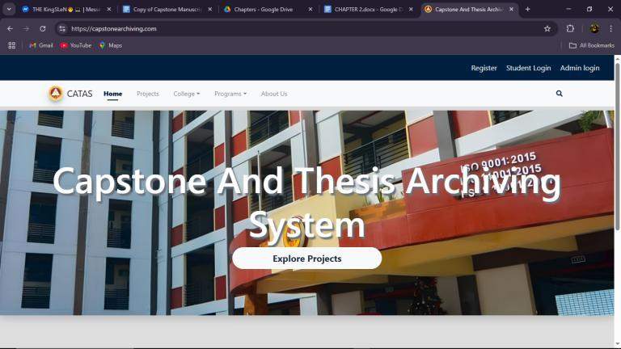

Figure 2. Capstone and Thesis Archiving System

The **Capstone and Thesis Archiving System (CATAS)** is a web-based platform by Tarlac State University designed to preserve and organize capstone and thesis projects digitally. It allows students, faculty, and researchers to easily search, access, and retrieve academic works from various programs. The system supports browsing by college, program, and year, and enhances visibility and collaboration within the academic community.214

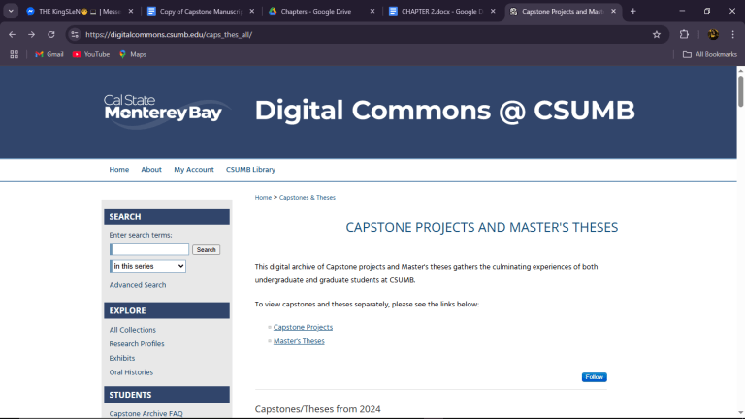

Figure 3. Capstone Projects and Master's Theses

The **Capstone Projects and Master's Theses Archive** at California State University, Monterey Bay (CSUMB) is a digital repository that preserves and showcases student academic works. It offers open access to undergraduate and graduate research, allowing users to browse by department or search by topic. The platform supports various media formats and promotes discovery, research, and visibility of student achievements.

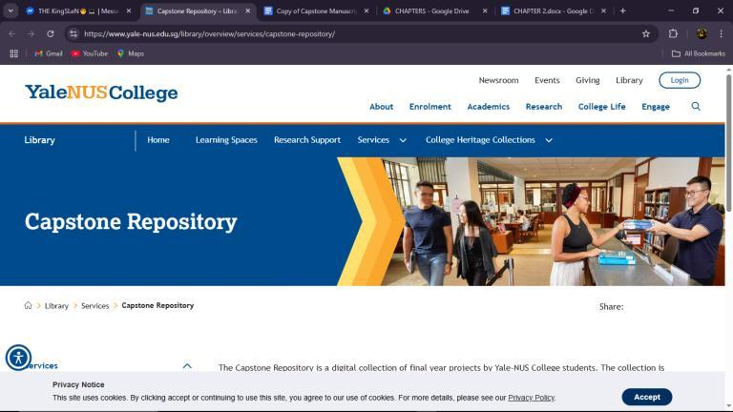

Figure 4. Capstone Repository at Yale-NUS College

The **Capstone Repository at Yale-NUS College** is a digital archive of final-year student projects, showcasing research, creative, and experiential work. It is mainly accessible to the Yale-NUS community, with graduates able to place short-term embargoes on their work. The repository supports academic reference and preserves student achievements.



Figure 5. Master’s Projects and Capstones Repository at the University of San Francisco (USF)

The **Master's Projects and Capstones** repository at the University of San Francisco (USF) is an open-access digital archive of graduate student work from various programs. It allows users to browse by year, program, or topic, promoting knowledge sharing and preserving student research for academic and professional use.

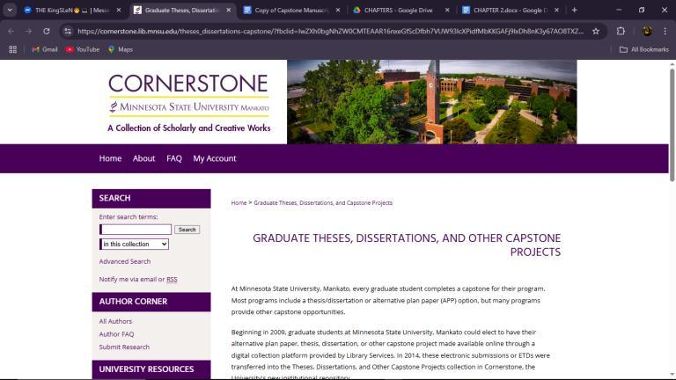

Figure 6. Graduate Theses, Dissertations, and Other Capstone Projects Collection

The **Graduate Theses, Dissertations, and Other Capstone Projects** collection at Minnesota State University, Mankato, is a digital repository that archives the scholarly work of its graduate students. Established in 2009, the collection includes various capstone projects, such as theses, dissertations, and alternative plan papers (APP). In 2014, these electronic submissions were integrated into Cornerstone, the university's institutional repository. The collection continues to grow as students opt to include their work, promoting knowledge sharing and preserving academic achievements.

### **Comparative Matrix**

A Comparative Matrix is designed to model and evaluate the different features of the study and existing related studies and compare and calculate the percentage according to the number of features covered by the competitors.

**Table 1. Comparative Matrix**

|  |  |  |  |  |  |  |
| --- | --- | --- | --- | --- | --- | --- |
| **Features** | **Capstone Archiving (TSU)** | **Digital Commons (CSUMB)** | **Yale-NUS Capstone** | **USF Repository** | **MSU Cornerstone** | **Project CapstoNova** |
| **Centralized Digital Repository** | **✔** | **✔** | **✔** | **✔** | **✔** | **✔** |
| **Title Verification** |  |  |  |  |  | **✔** |
| **Project Classification (Web, Mobile, Hybrid)** |  |  |  |  |  | **✔** |
| **Programming Language Detection** |  |  |  |  |  | **✔** |
| **Data Analytics & Visual Dashboards** |  |  |  |  |  | **✔** |
| **Trend Forecasting & Data Mining Techniques** |  |  |  |  |  | **✔** |
| **Secure Access Control & Folder Encryption** |  |  | **✔** | **✔** | **✔** | **✔** |
| **Request-Based Viewing (Abstract Default Access)** |  |  | **✔** |  |  | **✔** |
| **Student & Faculty User Roles** | **✔** |  |  | **✔** | **✔** | **✔** |
| **Public Access with Restrictions** | **✔** | **✔** | **✔** | **✔** | **✔** | **✔** |
| **Automatic Backup and File Compression** |  |  |  |  |  | **✔** |
| **Source Code Security & Classification** |  |  |  |  |  | **✔** |

# **CHAPTER 3** **RESEARCH METHODOLOGY**

### **Software Engineering Methodologies**

The Software Engineering Methodology plans, organizes, and manages project information system development. It focuses on iterative development, collaboration, and flexibility during the project. Agile methodologies involve the process of consistently updating a software system such as adding better analytics, or ensuring the system stays secure and relevant over time, feedback loops for stakeholders, and requirement polishing from planning to review. This iterative process enables teams to respond to shifting requirements and priorities during the development life cycle, delivering useful features early and often.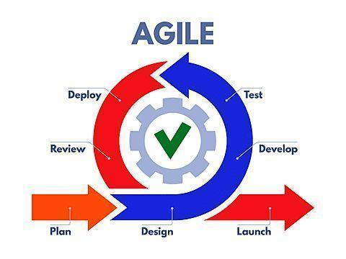

**Figure SEQ Figure \* ARABIC 7.Agile Development Methodology**

Figure 7. Agile Development Methodology

Agile Methodology was selected by the proponents for research development. The methodology minimizes the system to be developed in time as it follows an iterative process, is flexible, and involves collaboration with the customer. Agile enhances responsiveness, flexibility, and communication during the development process to address project needs in a timely manner. Continuous input and revision enable researchers to develop a tailor-made, high-quality solution for achieving research objectives and serving the needs of stakeholders. Kumar and Bhatia (2012) opine that Agile methodology maximizes the software development process by encouraging continuous collaboration, immediate delivery, and flexibility, an ideal methodology for dynamic and research environments.

### **Planning Phase**

During the Planning stage, the team defined the project's goals, scope, timeline, and resources. Activities included creating program workflow diagrams for each system user role (Super Admin, Admin, Adviser, Proponent, Viewer), developing a Work Breakdown Structure (WBS), generating a Gantt Chart for scheduling, completing a Business Model Canvas to map strategic elements, and designing a Functional Decomposition Diagram to break down project functions. In the Analysis phase, the team focused on gathering and documenting requirements. They produced Use Case Diagrams for each system actor, collected feedback from clients and advisers, and defined specific user roles. Additionally, they created storyboards to visually represent user journeys, such as the registration and manuscript submission process.

The Design stage involved planning both technical and user interface aspects of the system. The team created a database design, including an Entity Relationship Diagram (ERD) and a Data Dictionary. They also produced user interface mockups and storyboards for all roles, and developed a network design that featured a dual firewall and star topology. A Technology Stack Diagram was also prepared, specifying the use of PHP (Laravel), MySQL, HTML, CSS, Typescript, and Tailwind. During the Implementation phase, the team built the system based on the design documents. They developed various user modules for functionalities such as submission, search, suggestions, and notifications. The system was developed iteratively using Agile methodology to ensure flexibility and stakeholder involvement throughout the coding process.

The Testing phase ensured that the system met its defined requirements. Iterative testing was conducted with feedback loops from advisers and clients. The team performed walkthroughs using storyboards and user interfaces to identify functional issues and validated each module based on user roles. In the Deployment stage, the Capstonova system was made available to end-users. The web-based platform was deployed on a central server, and user registration with role-based access control was implemented. Capstone manuscripts and source code were uploaded for real-time system testing.

Finally, the Maintenance phase focused on post-deployment updates and fixes. Automated backups, file checks, and user access controls were managed by Admins and Super Admin. Regular updates reflected changes in roles, submissions, and archives, ensuring a smooth and structured Capstonova development process.

#### **Business Model Canvas**

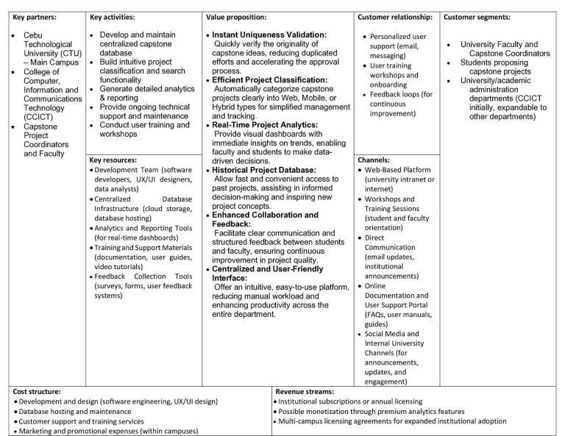

Figure 8. Business Model Canvas

A business model canvas defines how a project or organization generates, delivers, and captures value using nine key building blocks. The canvas usually determines critical partners, resources, and activities, specifies the distinctive value propositions provided, and determines customer segments, relationships, and channels. Furthermore, the canvas indicates a project's cost structure and viable revenue streams, with a brief strategic overview of its overall business model.

#### **Program Workflow**

A program workflow is the predetermined sequence of process, steps, and tasks involved in implementing and developing a program or a project. It prescribes the sequence of activities, resources required, task interdependence, and closing date. An effective workflow achieves maximum efficiency and effectiveness in conducting a project through clearly defining duties and roles. It has to be capable of coping with change and refurbishment and capable of delivering crystal clear instructions to the team. Successful work flow also encompasses measures for checking and assessment in terms of reports of progress and measurements so that the project is always kept on target toward objectives and targets.

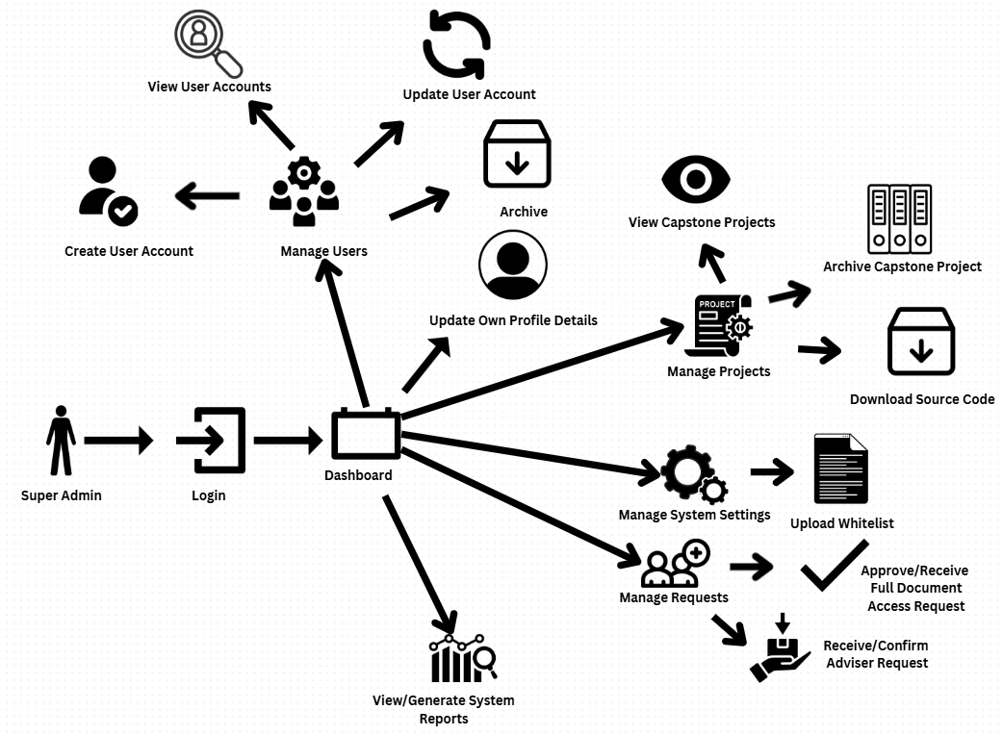

Figure 9. Program Workflow - (Super Admin)

Figure 9 highlights the role of the Super Admin in handling users, capstone projects, system settings, and access requests. The Super Admin adds, modifies, and removes the user accounts, handles capstone projects, adjusts system settings, gives access, and handles suggestions. They also generate reports and monitor the dashboard to ensure a smooth system flow and project monitoring.

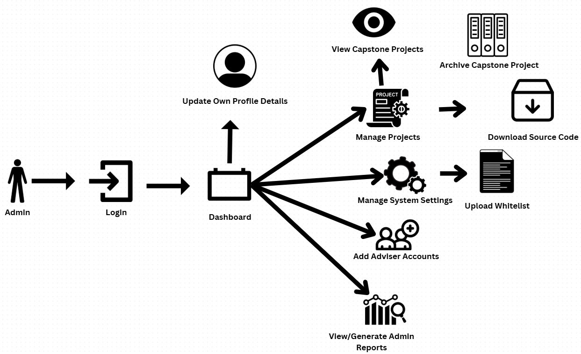

Figure 10. Program Workflow - (Admin)

Figure 10 illustrates the admin’s position and features provided in a capstone project management system. When logged in, the admin can edit their profile, manage projects (view, edit, delete, archive), manage system settings, handle user requests (upload whitelist, allow document access), and generate reports from the dashboard. All functionality is graphically represented, projecting the admin to be at the center of maintaining and managing the platform's operations.

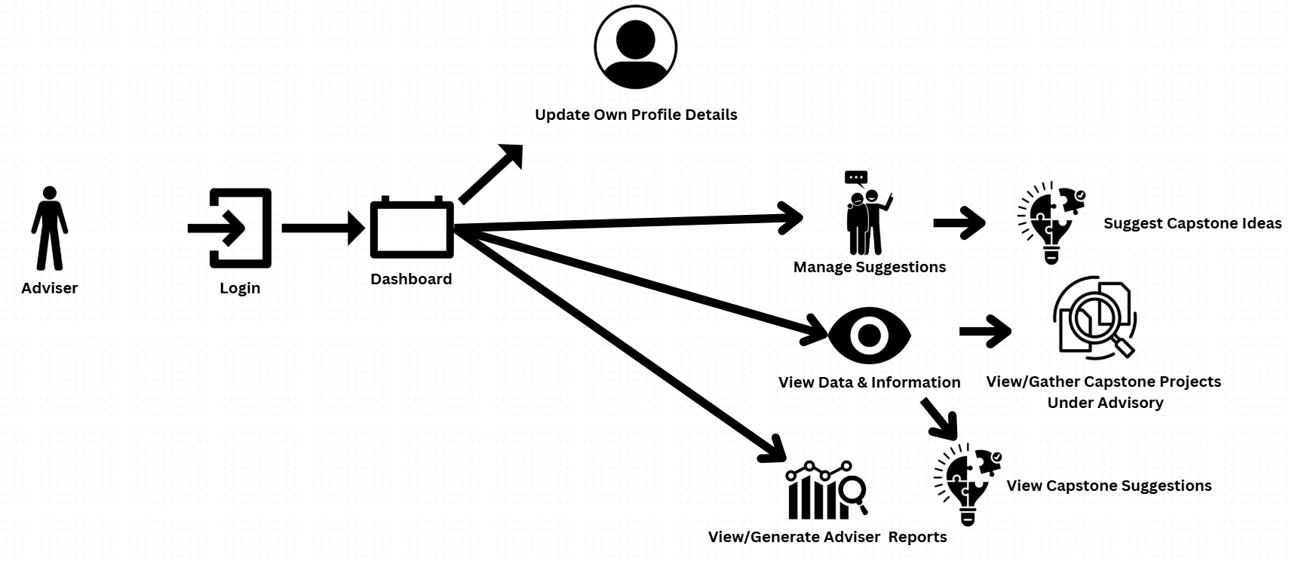

Figure 11. Program Workflow - (Adviser)

Figure 11 presents the various functions of an Adviser within a capstone project management system. The Adviser may update their profile and access multiple functions upon login. Advisers are responsible for handling advised projects, for instance, approving submitted project files of student proponents. Advisers give suggestions, offer ideas, and analyze pertinent information and data for their advisory purposes. This is done by examining projects they handle and reading through proposals submitted. They can also create adviser dashboard reports to track and monitor. The graphical description defines the role of Adviser as mentoring, guiding, and monitoring student capstone projects.

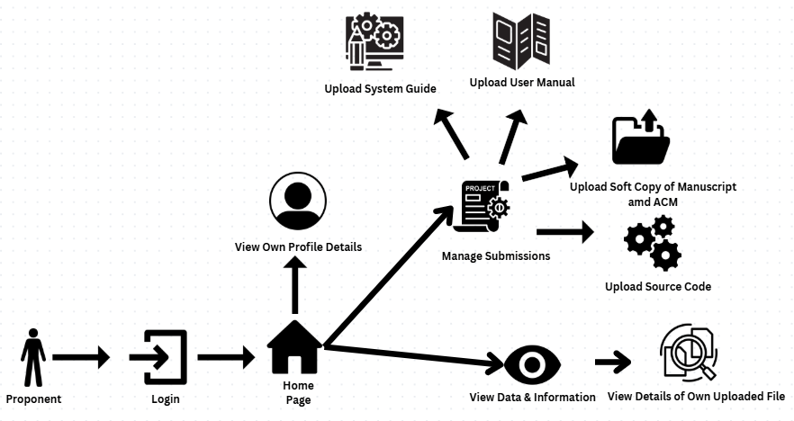

Figure 12. Program Workflow - (Proponent)

Figure 12 shows the capabilities provided to a Proponent (Project Leader) in a capstone project management system. Once logged in, proponents are able to edit their own profile, handle submissions by uploading the soft copy of their manuscript, and view data and information, e.g., the information of their uploaded files. They can also produce dashboard reports to track their submission status and progress. The figure indicates the proponent's part in uploading capstone documents and monitoring their respective contributions within the system.

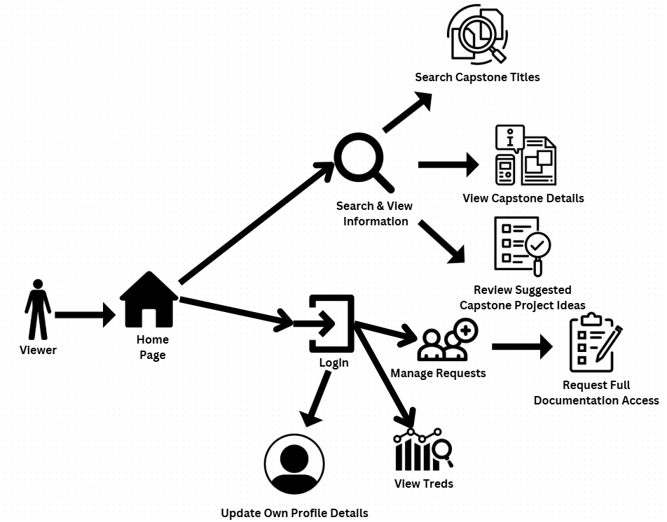

Figure 13. Program Workflow - (Viewer)

Figure 13 shows available functionalities for a Viewer user of a capstone project management system. After log-in, the viewer can refresh their profile, search and examine data like titles of capstone, project info, and proposed ideas. The viewer can further handle requests by submitting a request for access to full documentation. In addition, the viewer is able to view and generate dashboard reports for insight or overview of data. The layout indicates that the viewer has limited but effective access primarily for purposes of research, review, and requesting documents within the system.

#### **Work Breakdown Structure**

**Figure SEQ Figure \* ARABIC 14. WBS Tree**

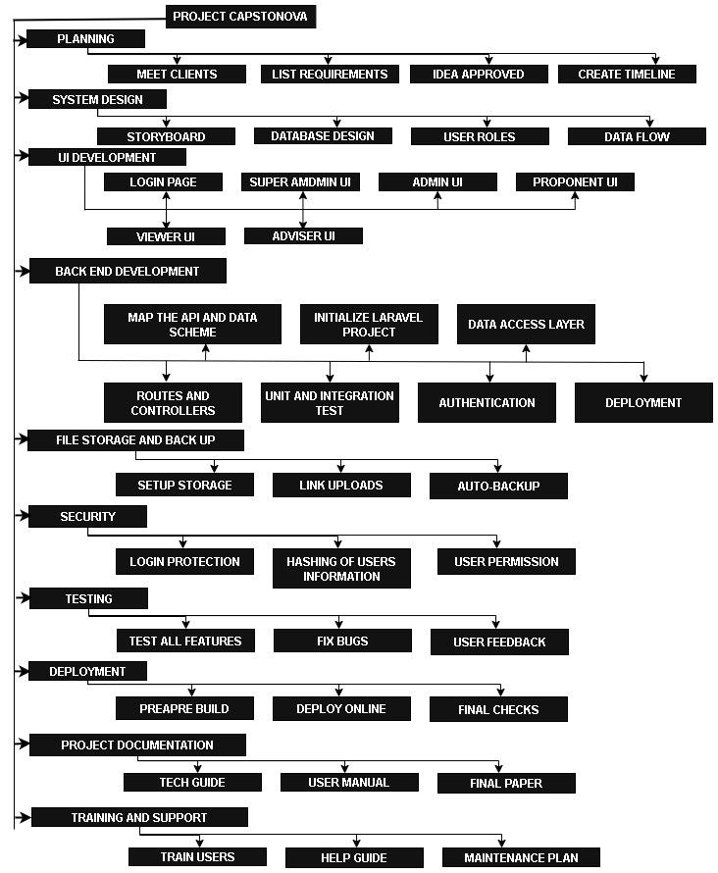

Figure 14. WBS Tree

WBS Tree is a hierarchical representation of the development of the project. It breaks down into smaller and clearer activities that serve as a guide throughout the development of the system.

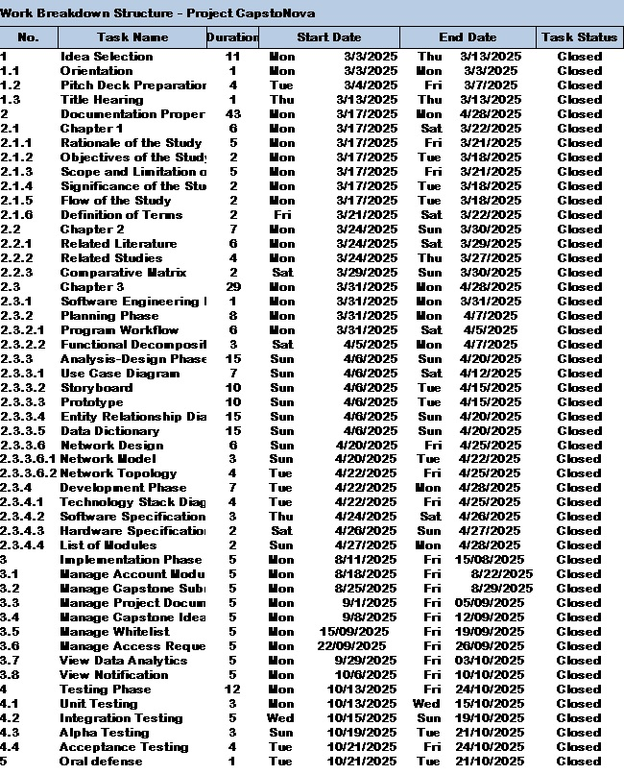

Figure 15. Work Breakdown Structure

Work Breakdown Structure provides the estimated duration for the Project Capstonova, laying out the task, dependency, duration, dates, assigned personnel, and the period the status.

#### **Gantt Chart**

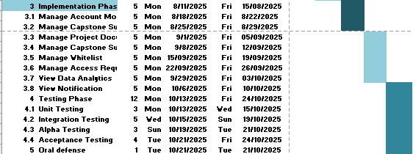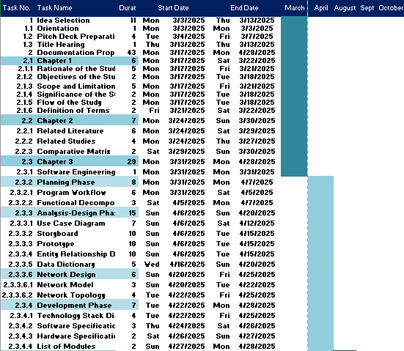

Figure 16. Capstone 2 Gant Chart

The Capstone 2 Gantt Chart serves as the project timeline for Project CapstoNova, outlining key tasks, task leads, and duration spanning from early March to late October 2025. It is divided into major phases such as Documentation Preparation, Analysis and Design, Development, Implementation, and Testing. Each task is arranged chronologically with specific start and end dates, clearly visualized using color-coded bars to indicate their progress over time.

#### **Functional Decomposition**

Functional decomposition is a method of top-down breakdown of a function or process into manageable, smaller components. Hierarchical representation makes it easy to define business functions and operations in a systematic way. Functional Decomposition Figures are shown below:

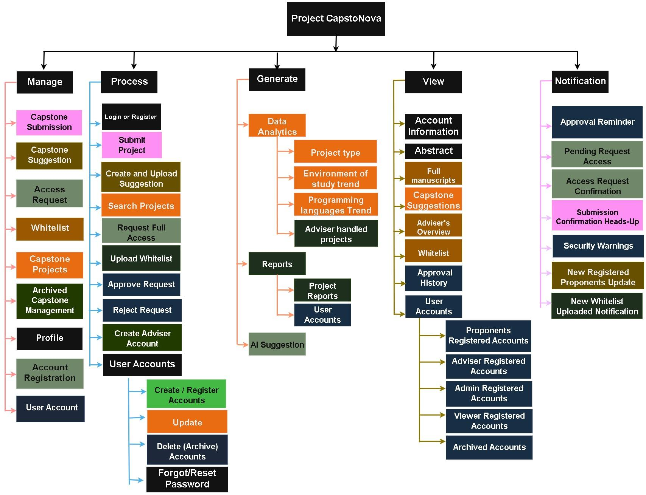

Figure 17. Functional Decomposition

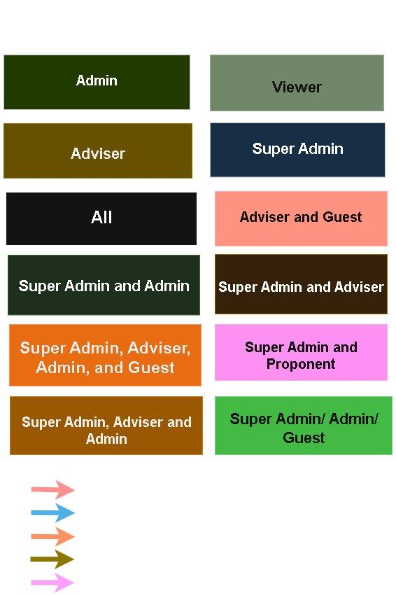

Figure 18. Functional Decomposition Legend

### 

### **Analysis Design Phase**

In the project design and analysis stage, proponents critically assess system needs, objectives, and user requirements. They examine existing processes to identify essential information for new concepts. Group brainstorming and critical analysis enable them to develop a well-structured plan that identifies data structuring, user interface, and network infrastructure to enable technology integration and user requirements. This stage provides the platform for idea development to enable the development of a secure, effective, and user-friendly digital archive system.

#### **Use-Case Diagram**

Use case diagram is a graphical illustration of the manner in which the user interacts with the system and depicts the relationship between the user and the system functionality that is implicated.

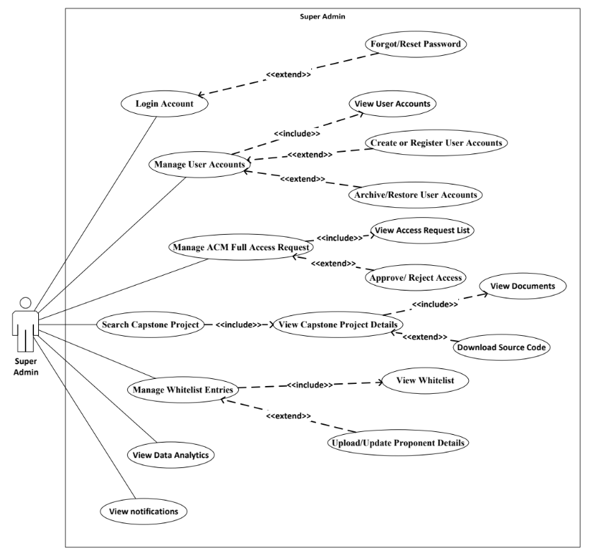

Figure 19. Use-Case Diagram (Super Admin)

Figure 19 outlines the Super Admin’s core responsibilities. After logging in, they can manage user accounts, handle system requests, generate reports, manage capstone archives, and upload a whitelist of valid Proponents’ ID numbers to control registration. These functions ensure smooth system operations and secure access management

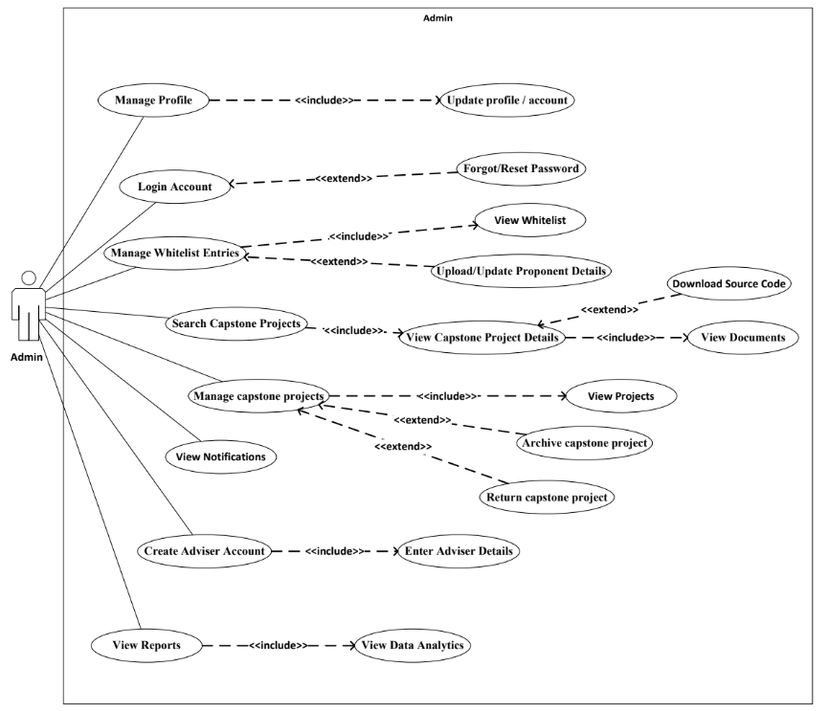

Figure 20. Use-Case Diagram (Admin)

Figure 20 shows what the admin can do in CapstoNova. Admins can log in, reset passwords, and manage their profiles. They handle personnel by creating adviser accounts and uploading necessary details. They also manage access through the whitelist. Admins oversee projects, view full content, and archive or restore them. They can also track system activity, review suggestions, and check reports to monitor system use.

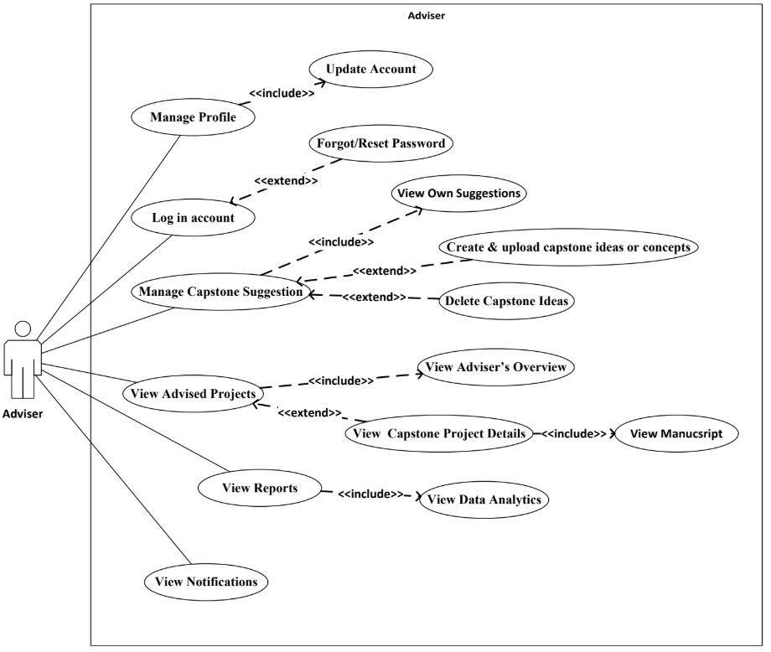

Figure 21. Use-Case Diagram (Adviser)

Figure 21 shows what an Adviser can do in CapstoNova. They can log in, reset passwords, update profiles, suggest and manage project ideas, review project content, supervise assigned projects, and monitor resources, whitelist, and trends to better support students.

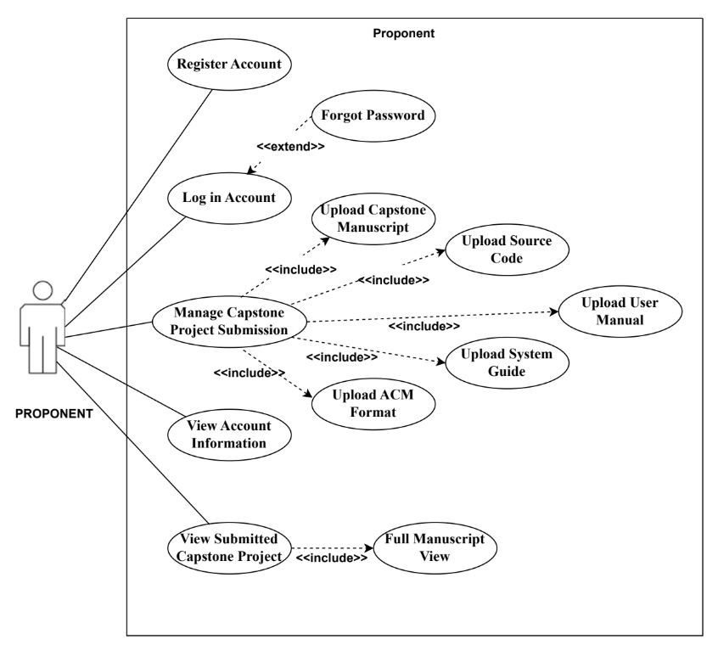

Figure 22. Use-Case Diagram (Proponent)

Figure 22 shows what a Proponent can do in CapstoNova. They register, log in, manage their password, submit their capstone by entering details and uploading files, then review and track their submission and project status.

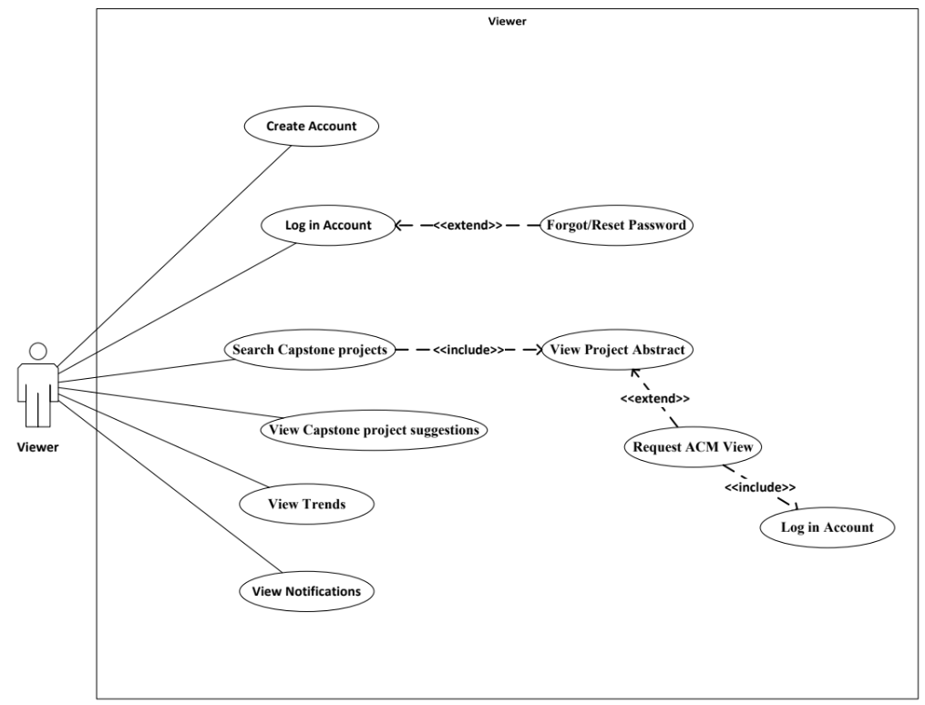

Figure 23. Use-Case Diagram (Viewer)

Figure 23 shows what a Viewer can do in CapstoNova. Viewers can search projects, view abstracts, and explore project suggestions in the public section. They can request full access if desired. Viewers can also register, log in, reset passwords, monitor access requests, and check their account status. This role allows users to explore the site with limited privileges, encouraging them to join for more features.

#### **Storyboard**

Storyboard is a graphic technique applied to represent a chain of steps or sequence of occurrences occurring in a system. Storyboards are best typically employed throughout development and planning and utilized as blueprint blueprints in prototypes, effective in designing organization and successfully communicating concepts to customers.

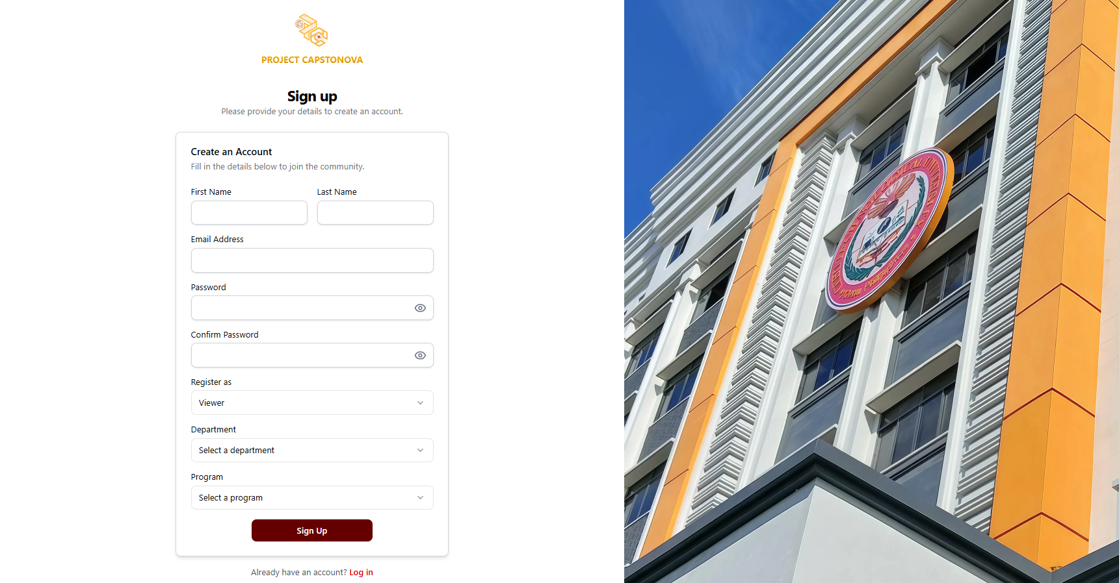

Figure 24. Proponent - Sign up Page UI

This is the sign-up page that proponents must fill out if they don’t have an account yet. A user can only sign up if their name is listed in the whitelist.

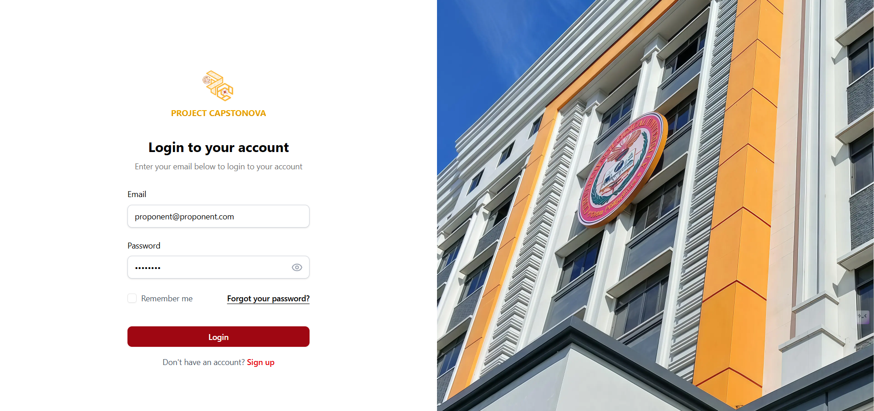

Figure 25. Proponent - Login Page UI

This is the login page that appears once the proponent has finished signing up successfully.

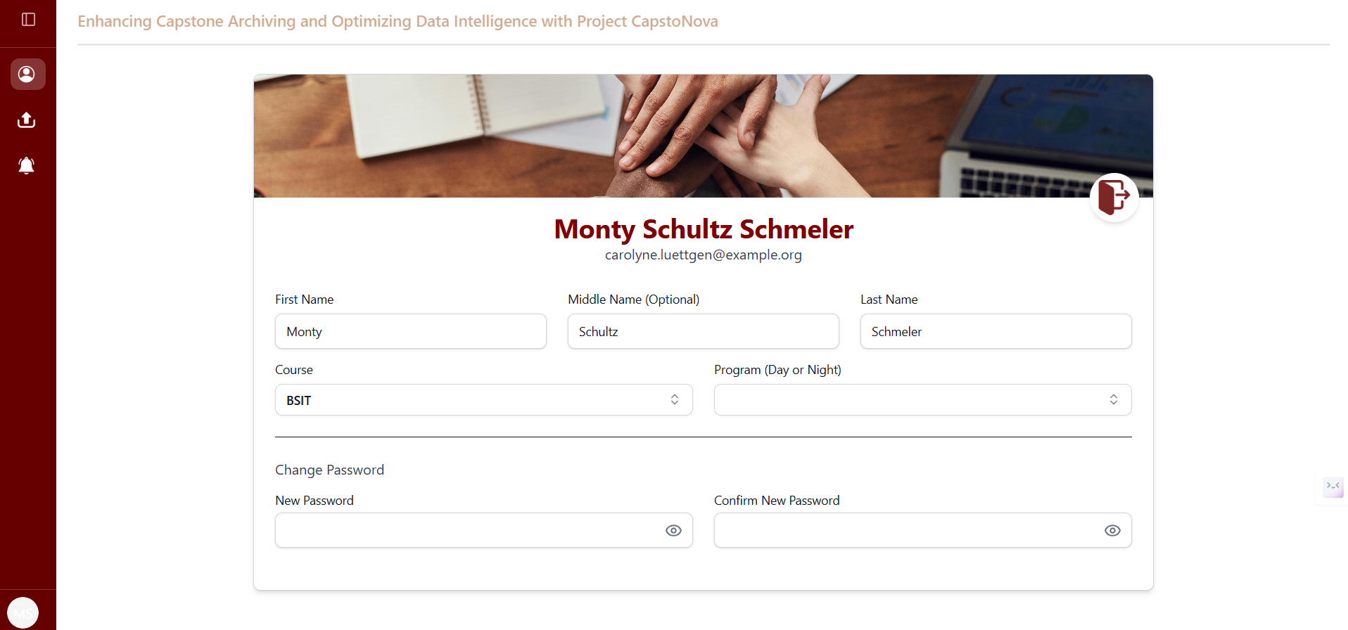

Figure 26. Proponent - Personal Account UI

This is the landing page that displays the personal account of a proponent after logging into the system.

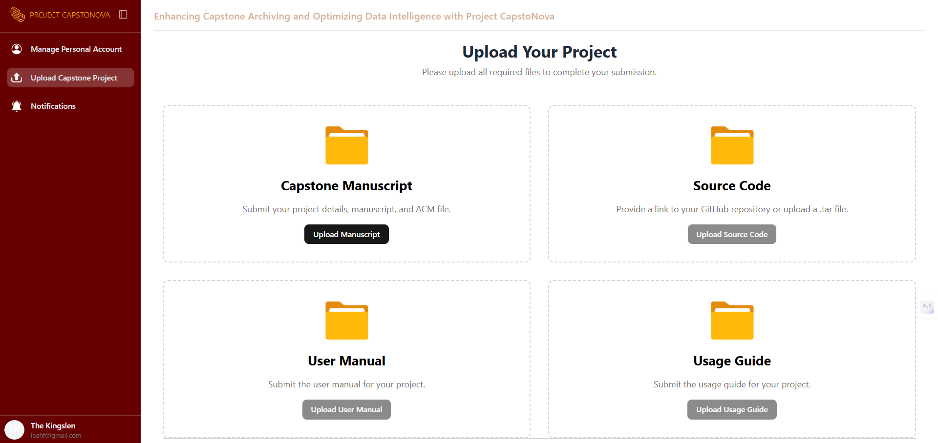

Figure 27. Proponent - Upload Capstone Project UI

This page displays where the proponent can upload their capstone project files and details.

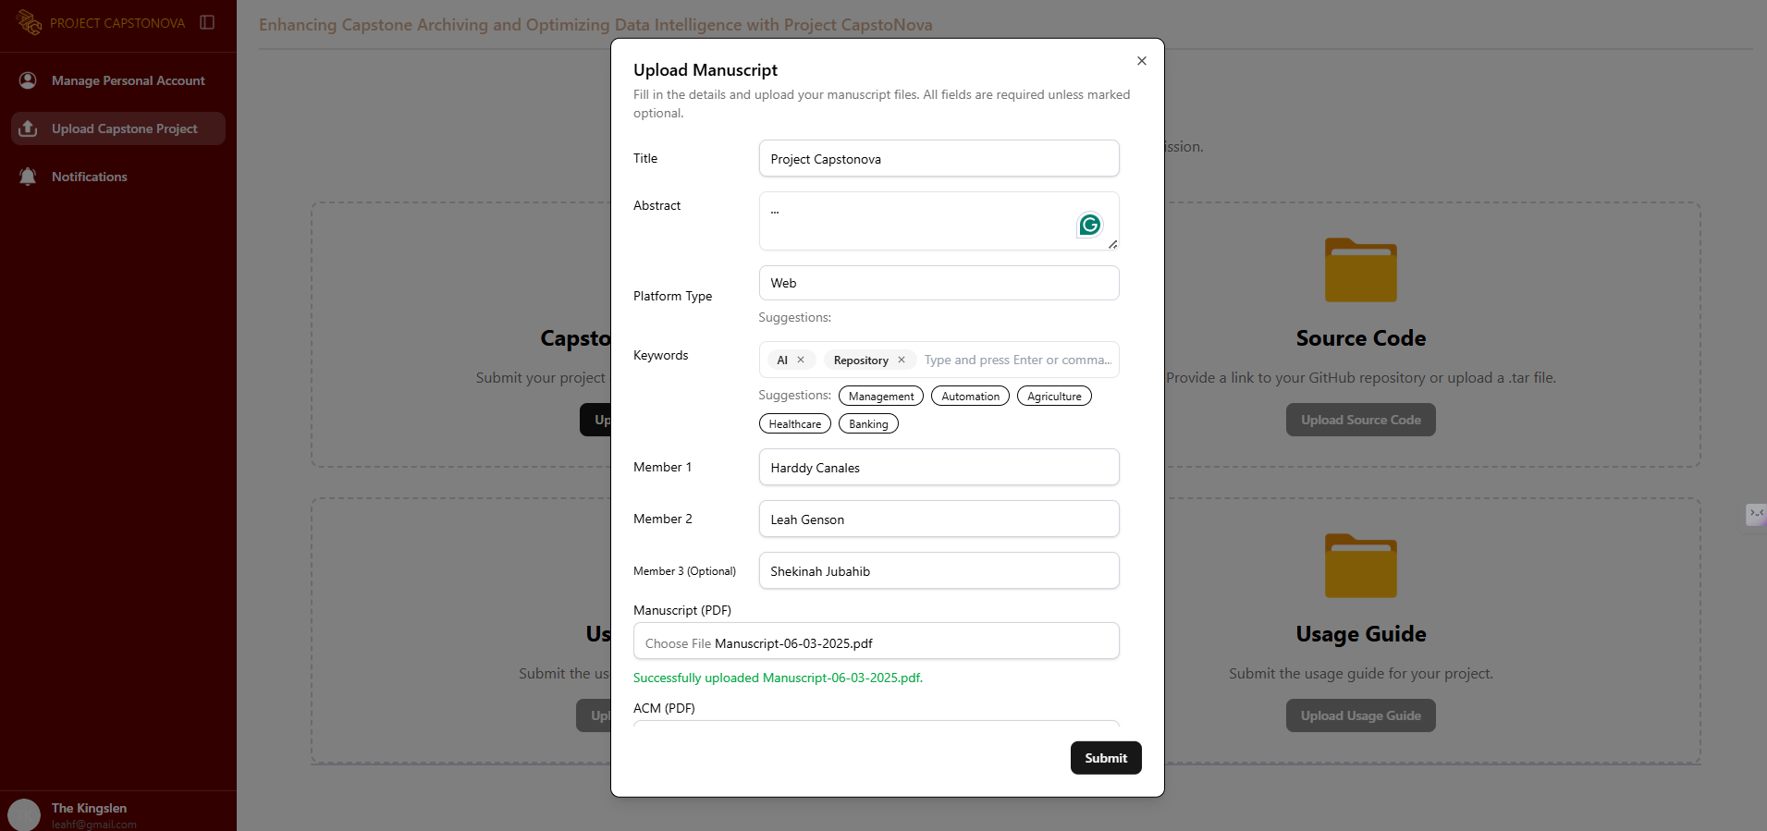

Figure 28. Proponent - Upload Manuscript UI

This page allows the proponent to upload their capstone manuscript, including the title, abstract, keywords, members, manuscript, and other files.

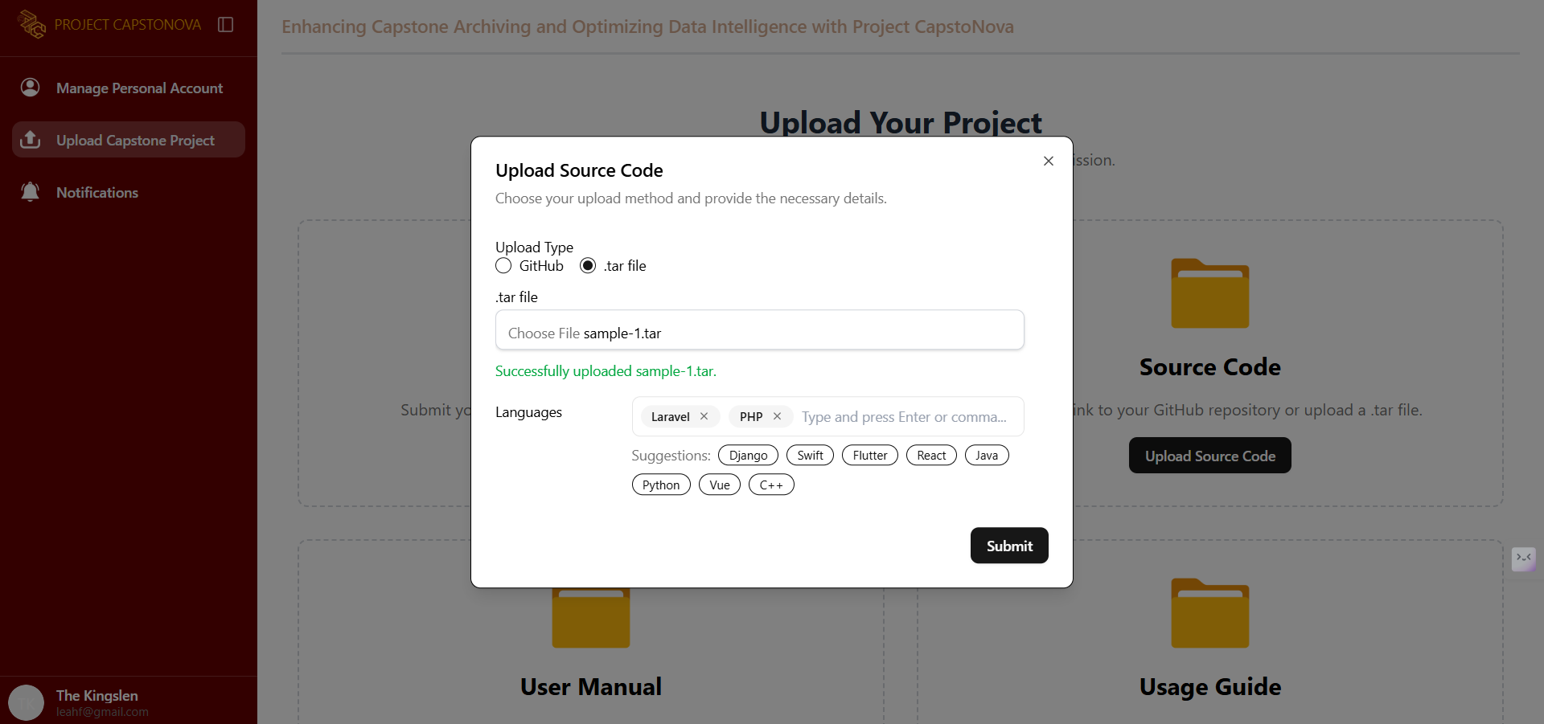

Figure 29. Proponent - Upload Source Code UI

The proponent can also upload the source code file.

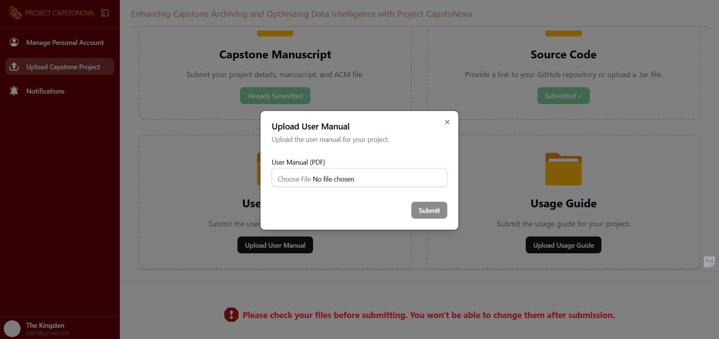

Figure 30. Proponent - Upload User Manual UI

The proponent can also upload the user manual.

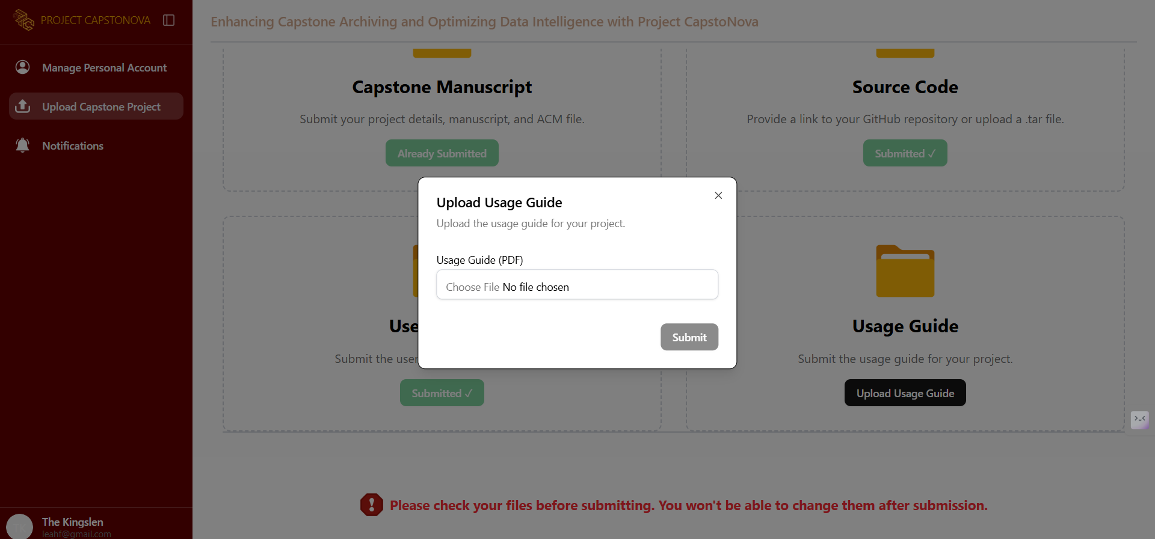

Figure 31. Proponent - Upload Usage Guide UI

The proponent can also upload the usage guide.

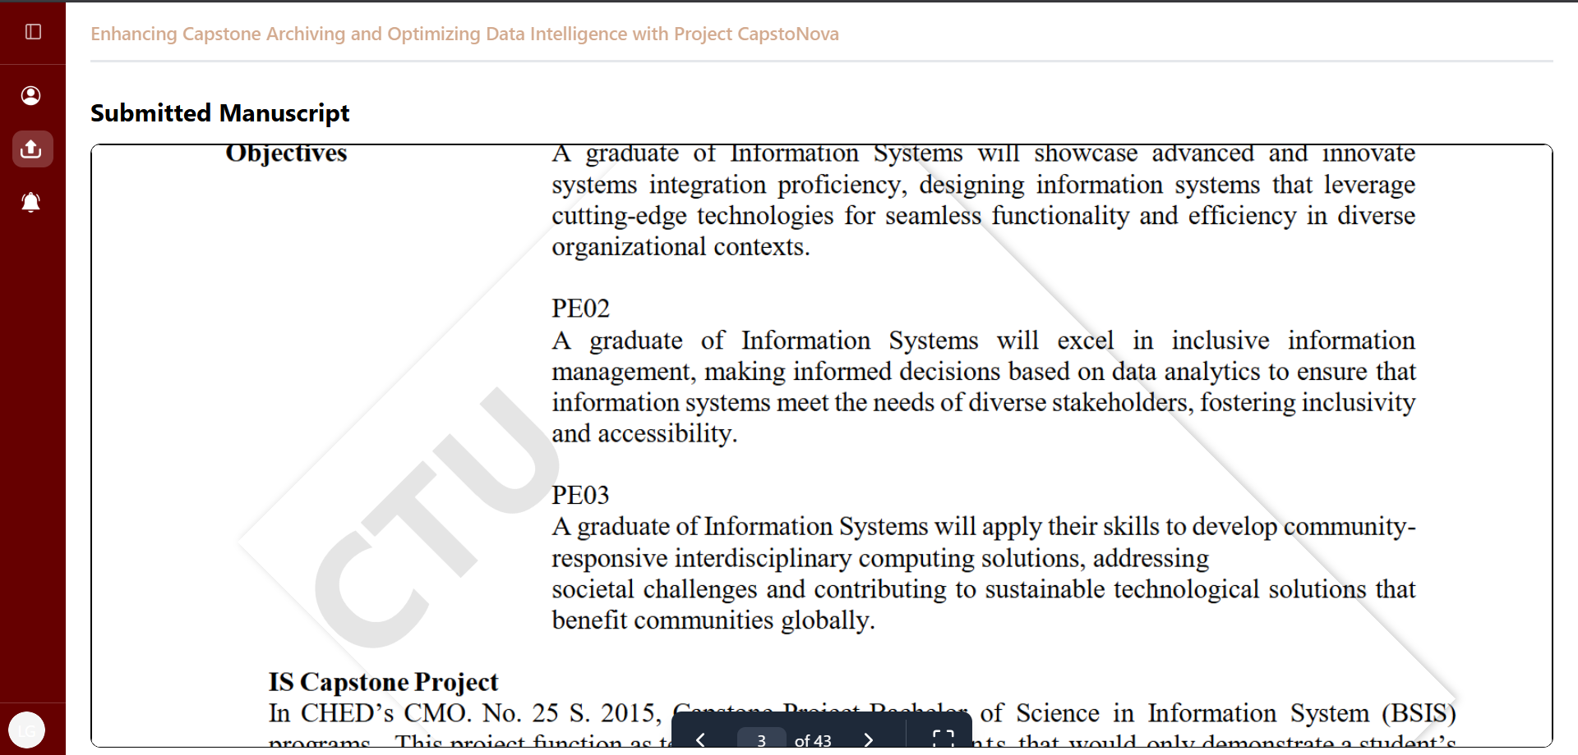

Figure 32. Proponent - Project Submission Complete UI

The figure shows a successful project submission, allowing the proponent to view the uploaded document.

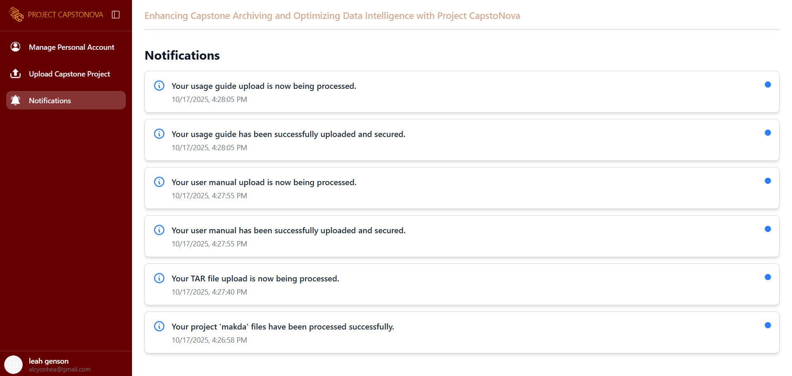

Figure 33. Proponent - Notification UI

This page shows the Proponent’s Notification Page, where all notifications are displayed.

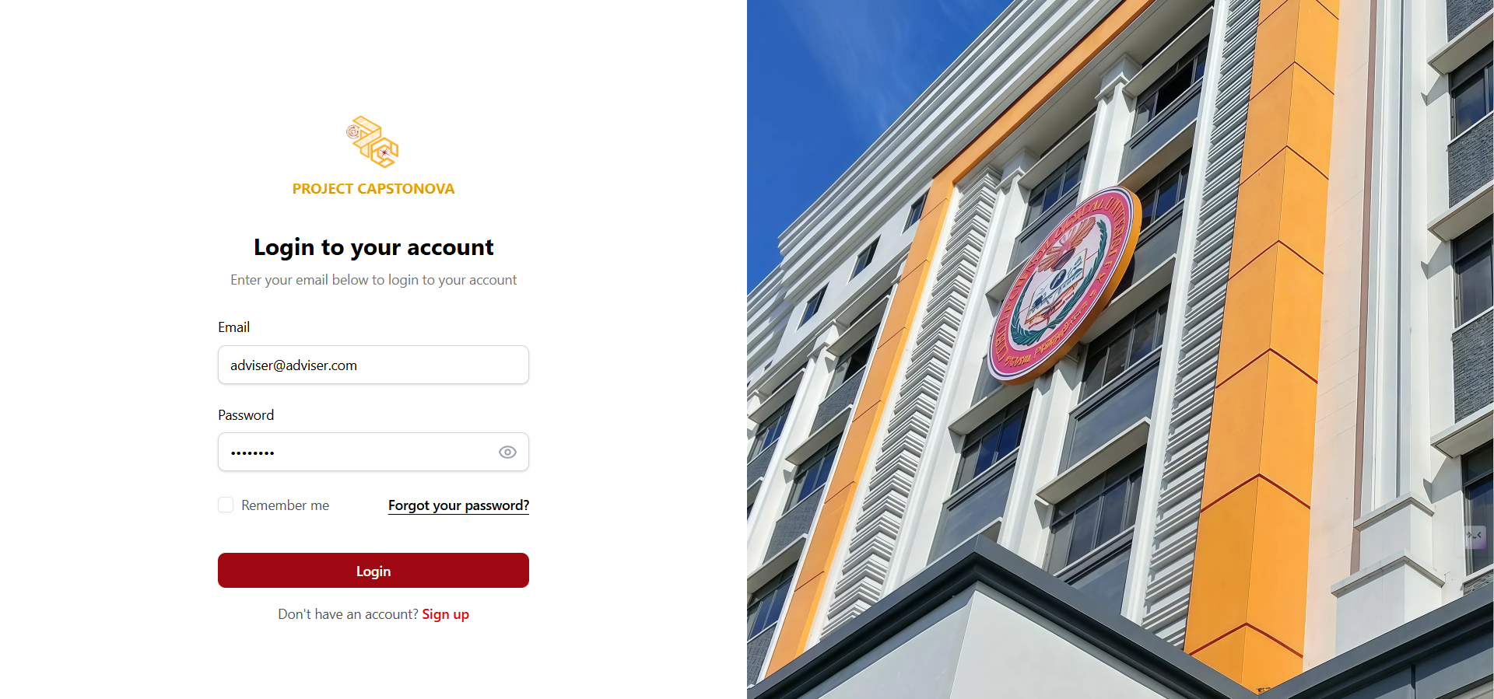

Figure 34. Adviser - Login Page UI

This page is the Adviser’s Login Page, where advisers can enter their email and password to access the system.

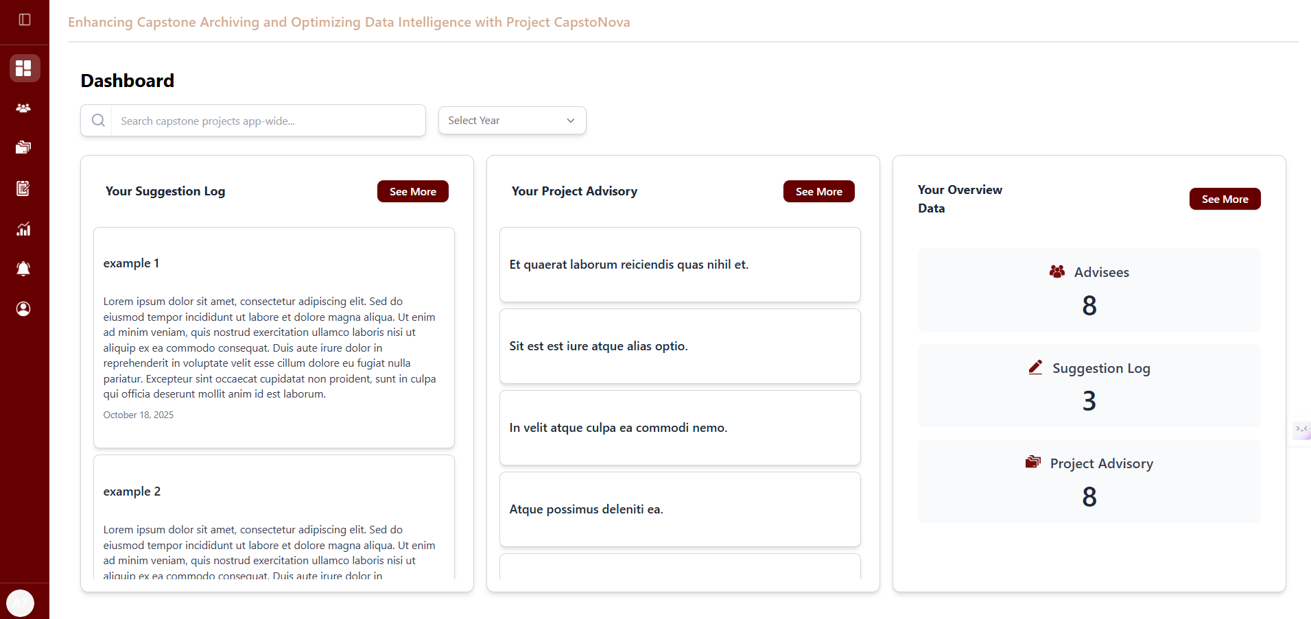

Figure 35. Adviser - Dashboard UI

This page is the Adviser’s Dashboard, which includes a search bar to browse capstone projects.

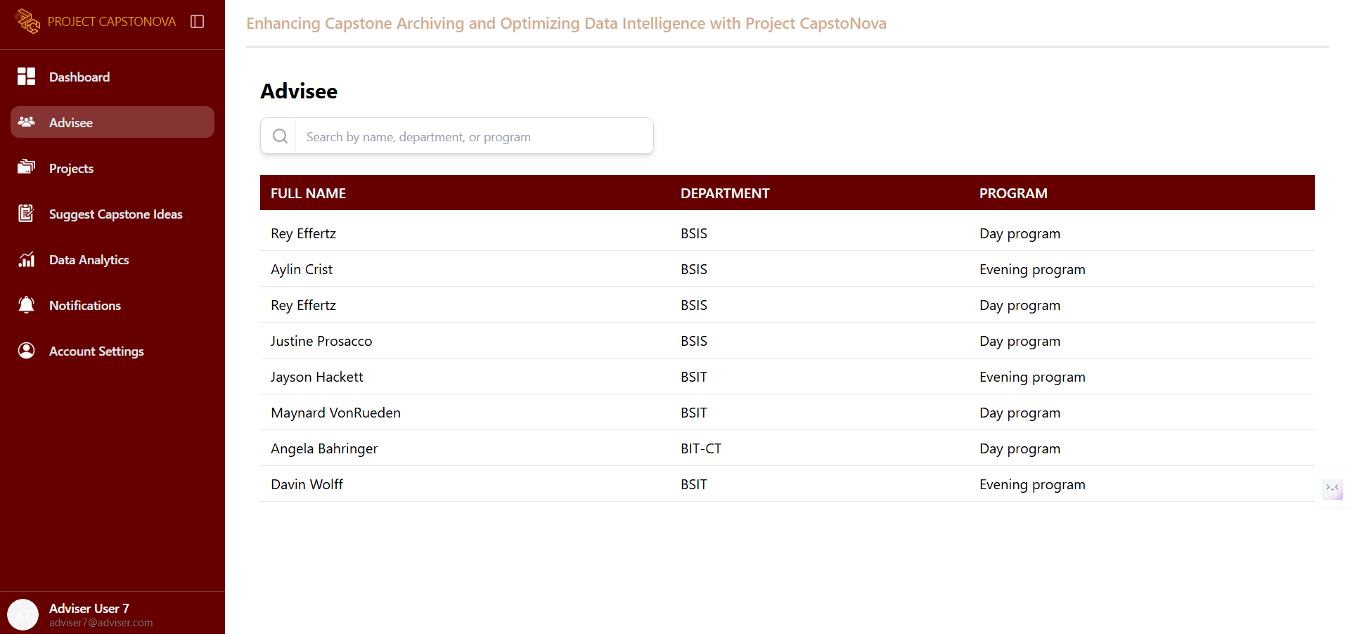

Figure 36. Adviser - Advisee UI

The adviser can view the names of project leaders under their advisory. They can also see each project leader’s details.

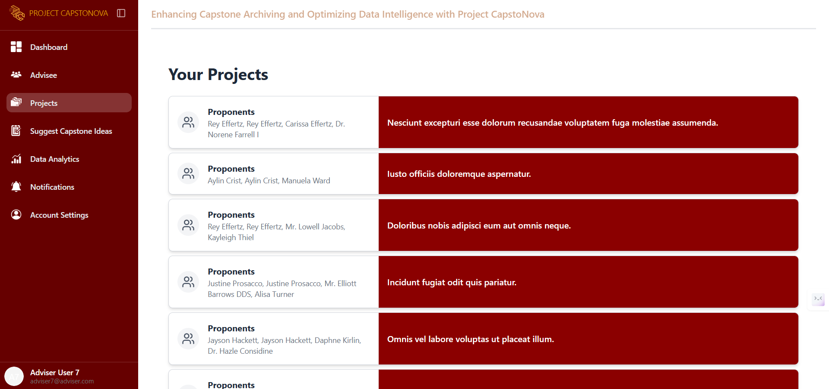

Figure 37. Adviser - Projects UI

The adviser can view the projects submitted by the project leaders under adviser’s advisory.

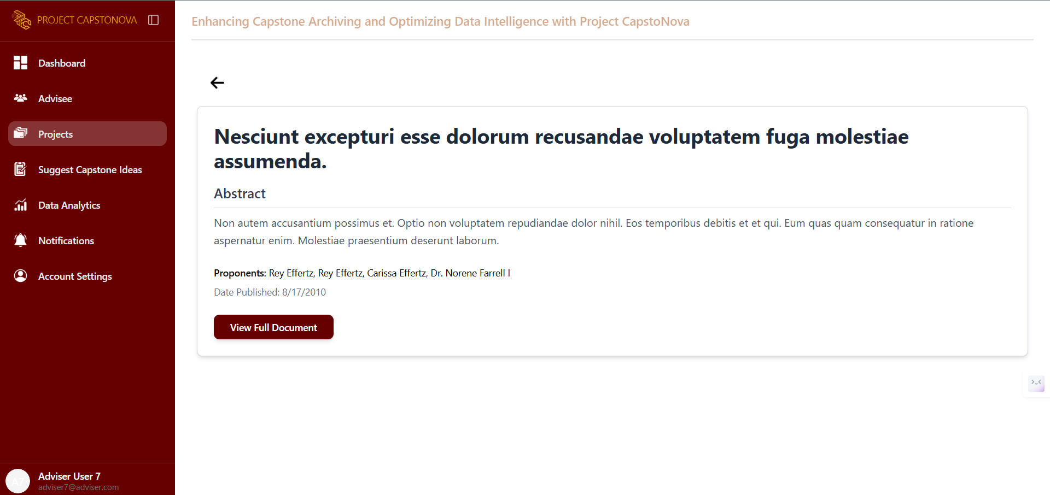

Figure 38. Adviser - View Abstract UI

This page displays the project abstract of proponents under the adviser’s advisory.

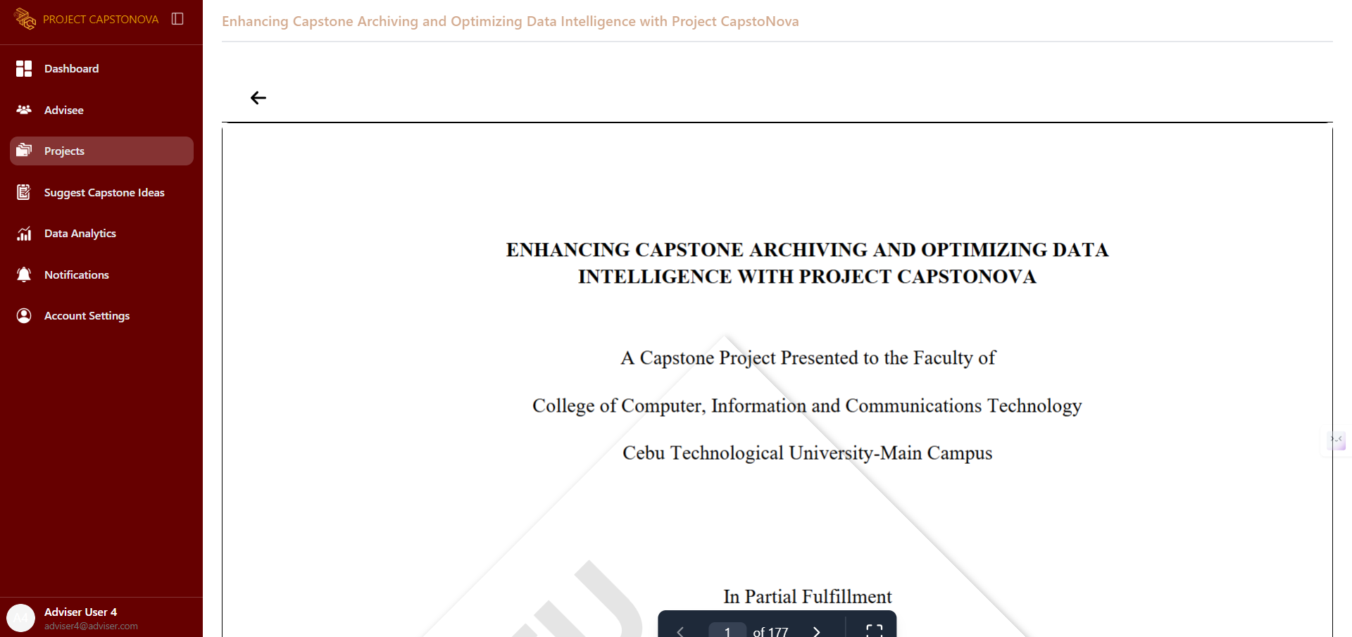

Figure 39. Adviser – View Full Document UI

The adviser can view the full manuscript of the projects under their advisory.

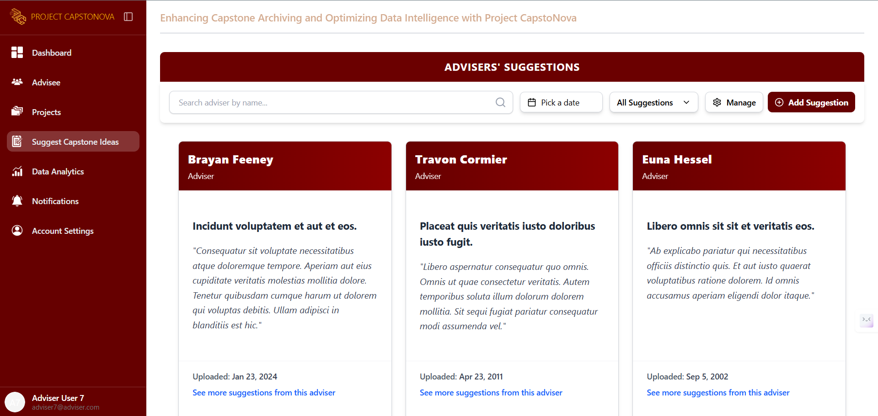

Figure 40. Adviser – Adviser’s Suggestions UI

The adviser can view all capstone suggestion ideas from other advisers. This page displays each suggestion along with the adviser's name and the date it was uploaded.

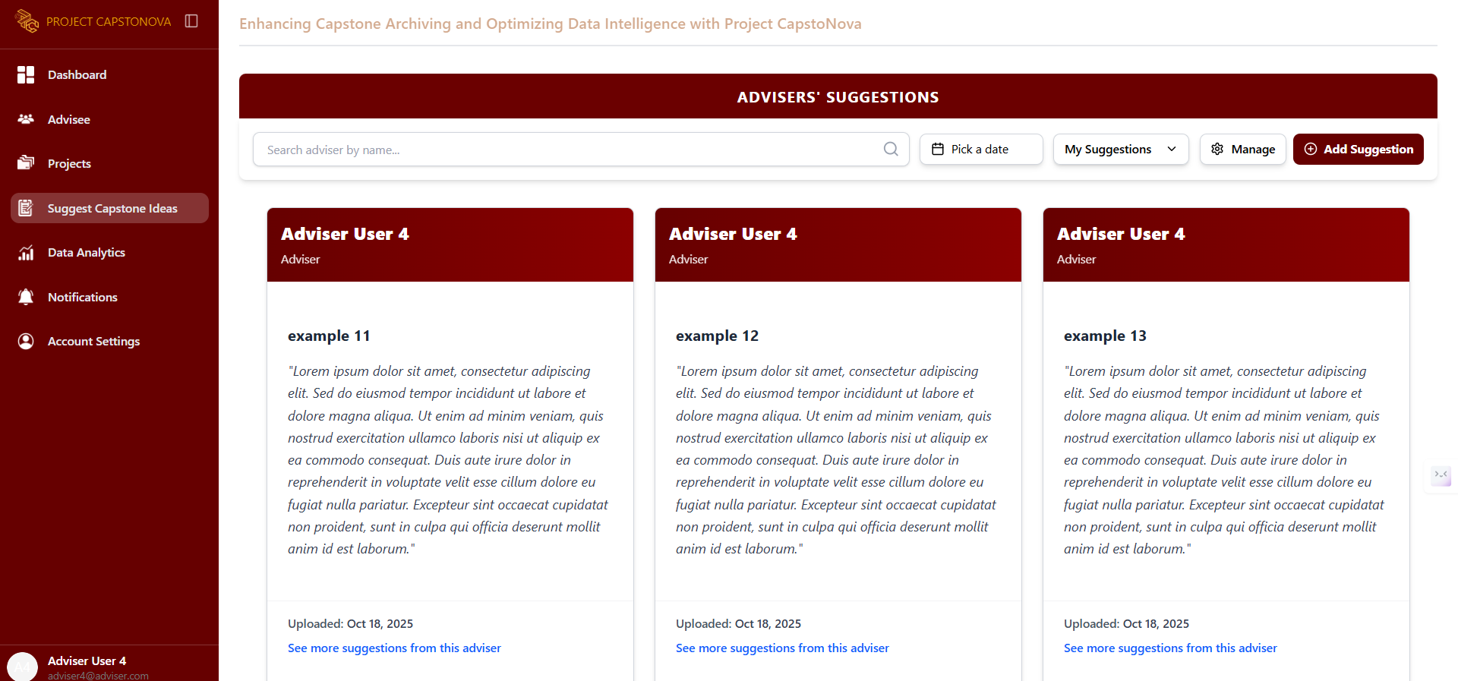

Figure 41. Adviser – My Suggestions UI

This page displays all of the adviser's suggestions, including the date each was uploaded and a button to move any suggestion to the trash.

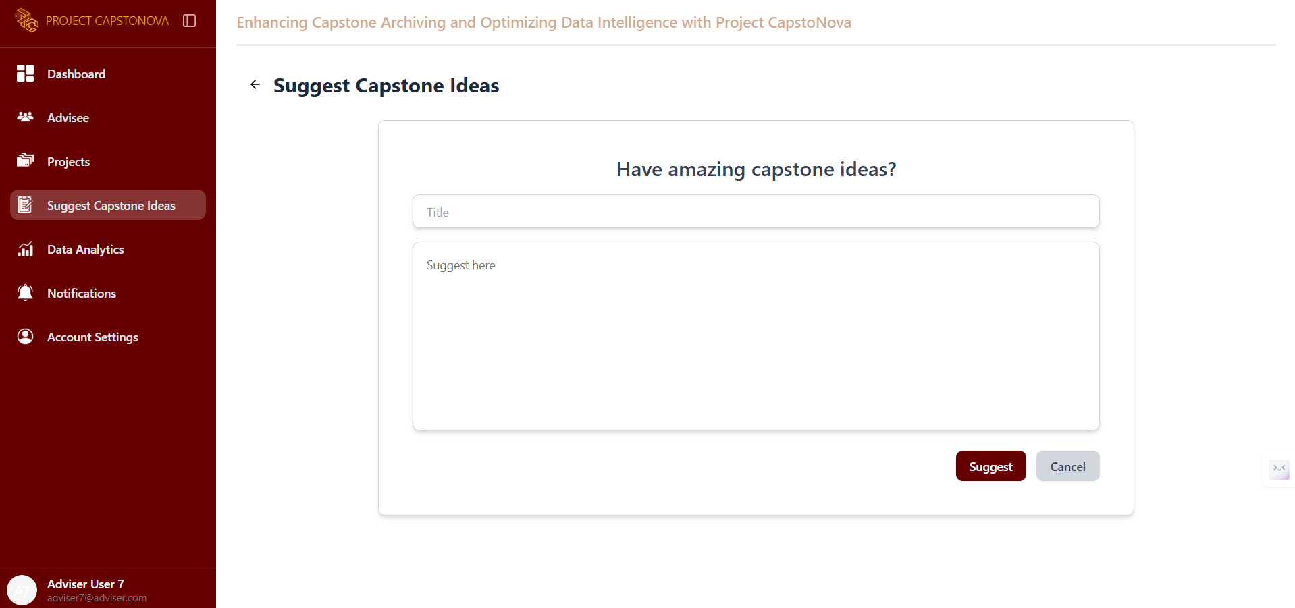

Figure 42. Adviser – Add Suggestion UI

This page allows advisers to suggest capstone ideas to help students generate concepts for their own projects.

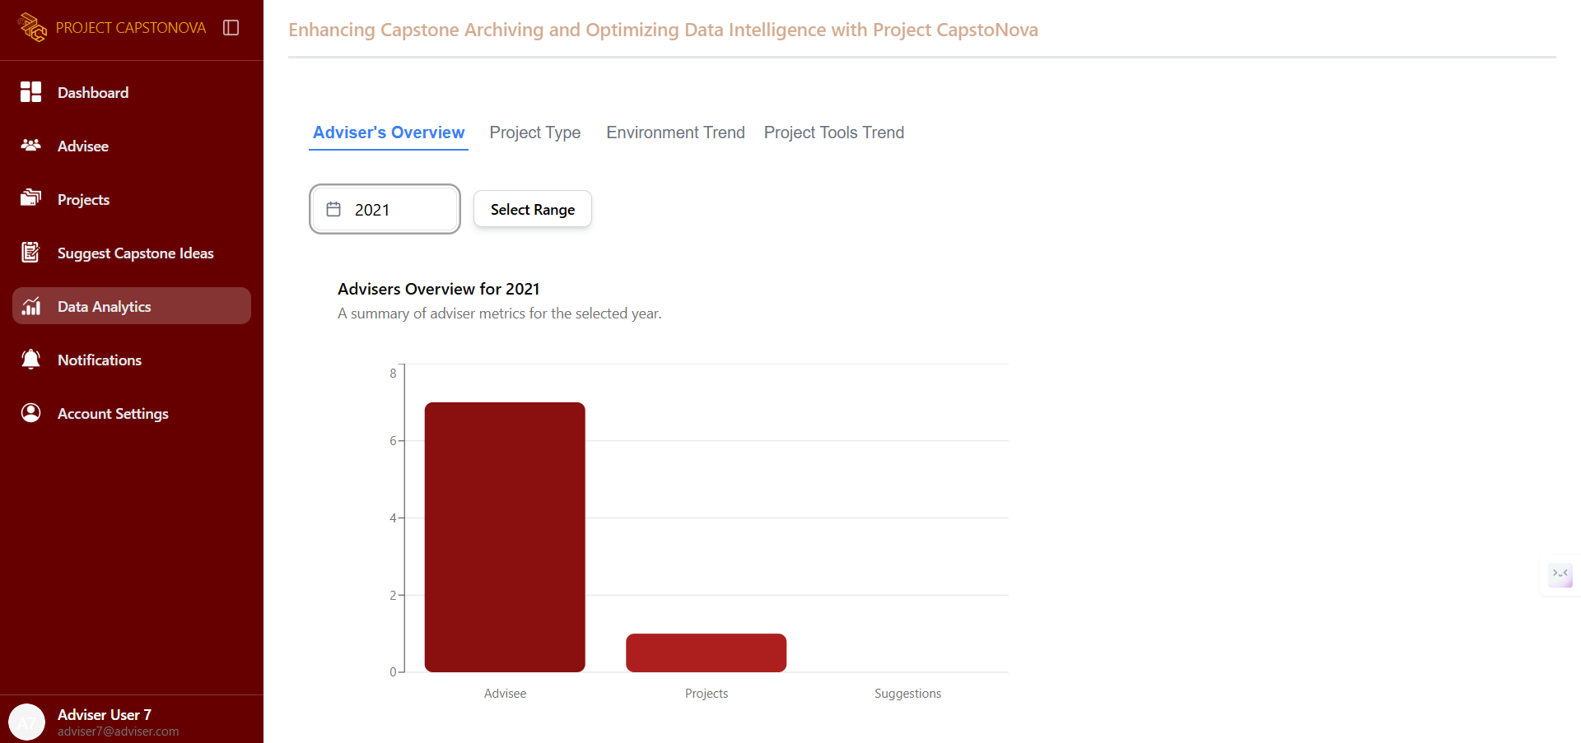

Figure 43. Adviser – DA Adviser’s Overview UI

This page displays data analytics for the adviser's overview, showing a summary of adviser metrics for the selected year.

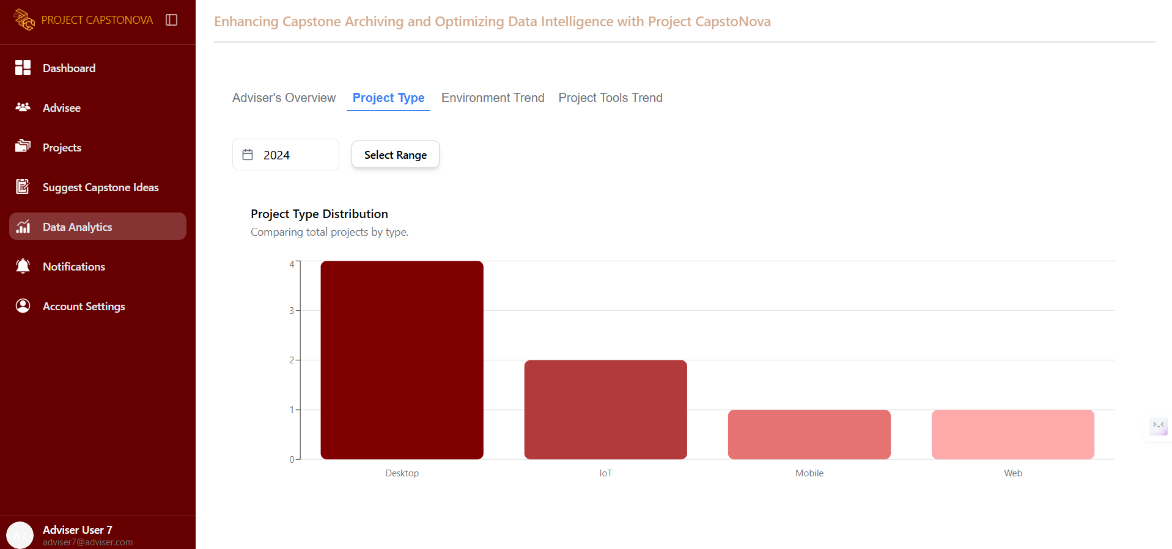

Figure 44. Adviser – DA Project Type UI

This page displays data analytics for Project Type Trends, showing how many projects use each type such as desktop, web application, and mobile application.

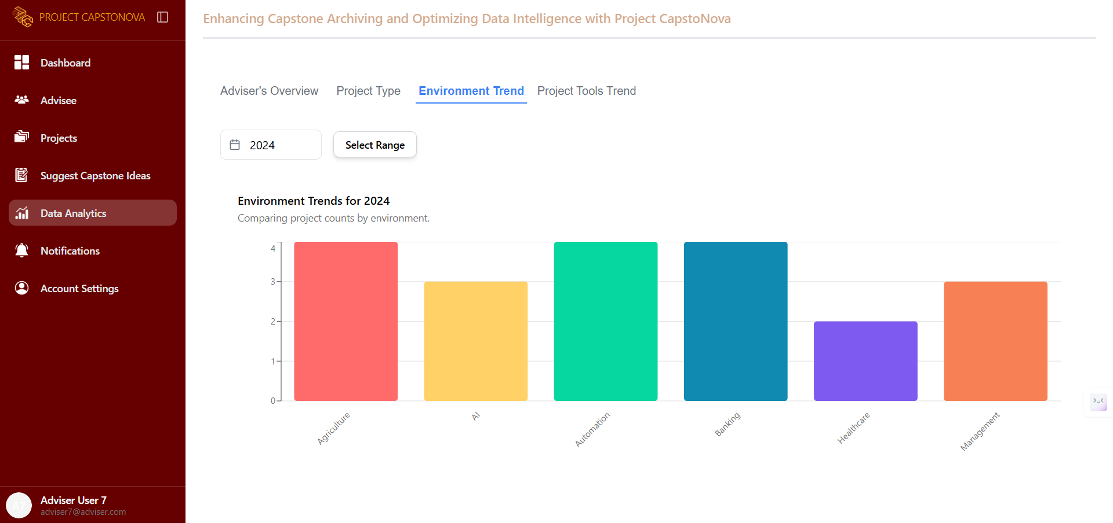

Figure 45. Adviser – DA Environment Trend UI

This page displays data analytics for Environment Trends, including insights into project topic trends. It also provides a filter to display results by year.

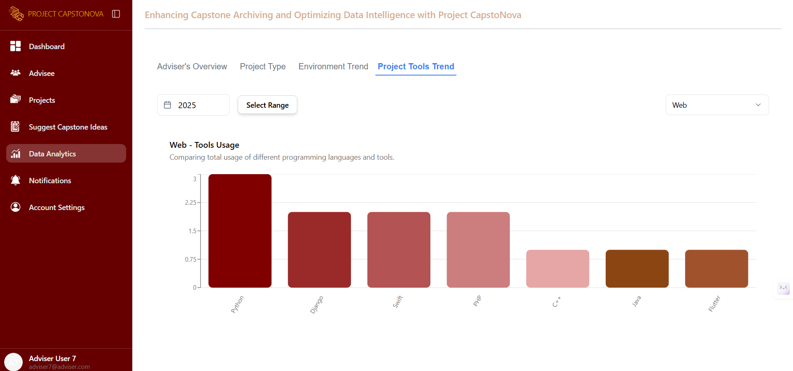

Figure 46. Adviser – DA Project Tools Trend UI

This page gives advisers a quick and easy way to see which development tools are most commonly used in student capstone projects.

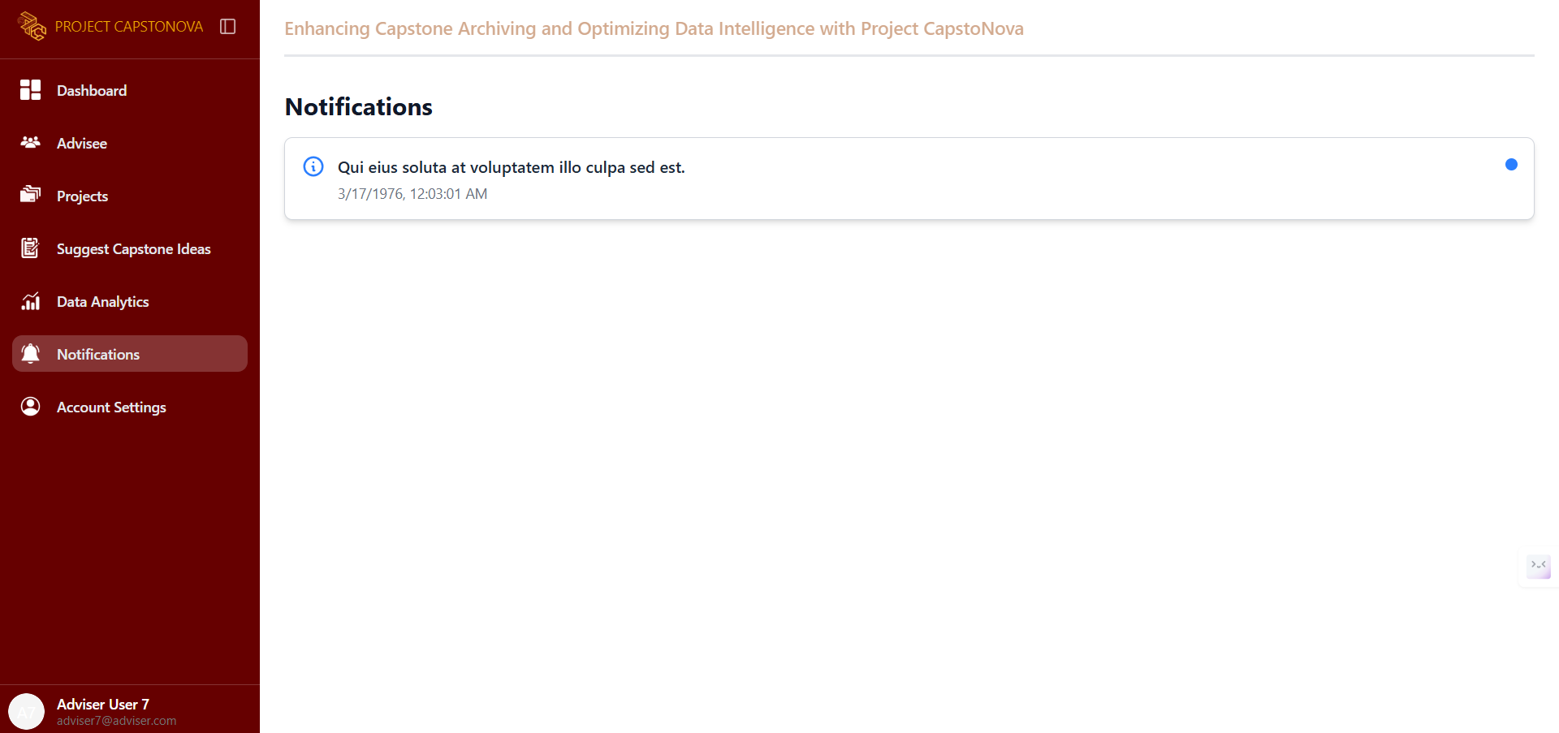

Figure 47. Adviser – Notification UI

This page displays all the adviser’s notifications.

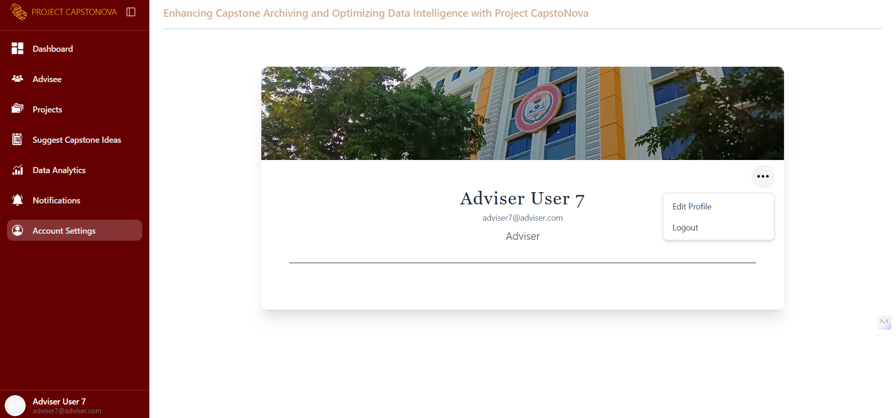

Figure 48. Adviser – Account Settings UI

This page displays the adviser’s account profile settings.

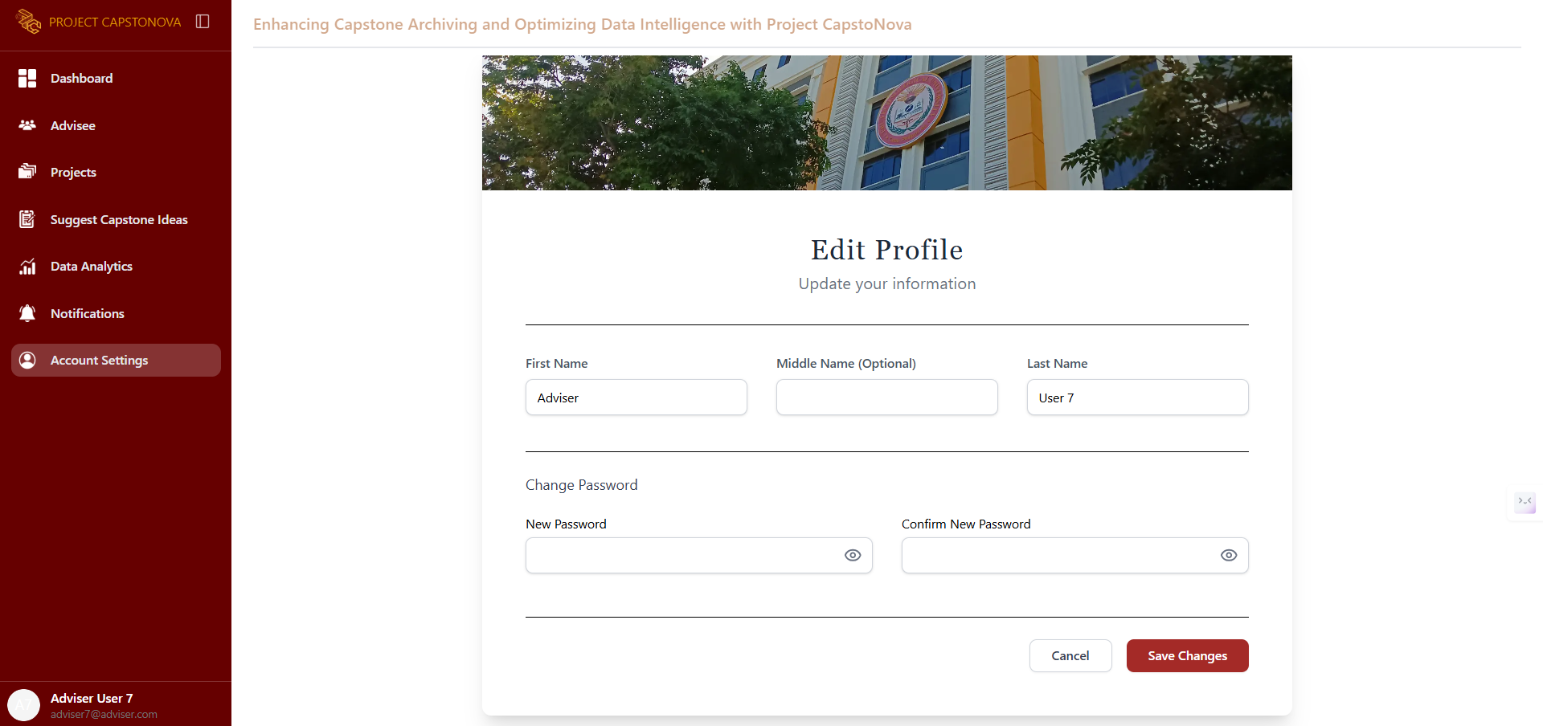

Figure 49. Adviser – Update Profile UI

This page allows the adviser to update their profile information.

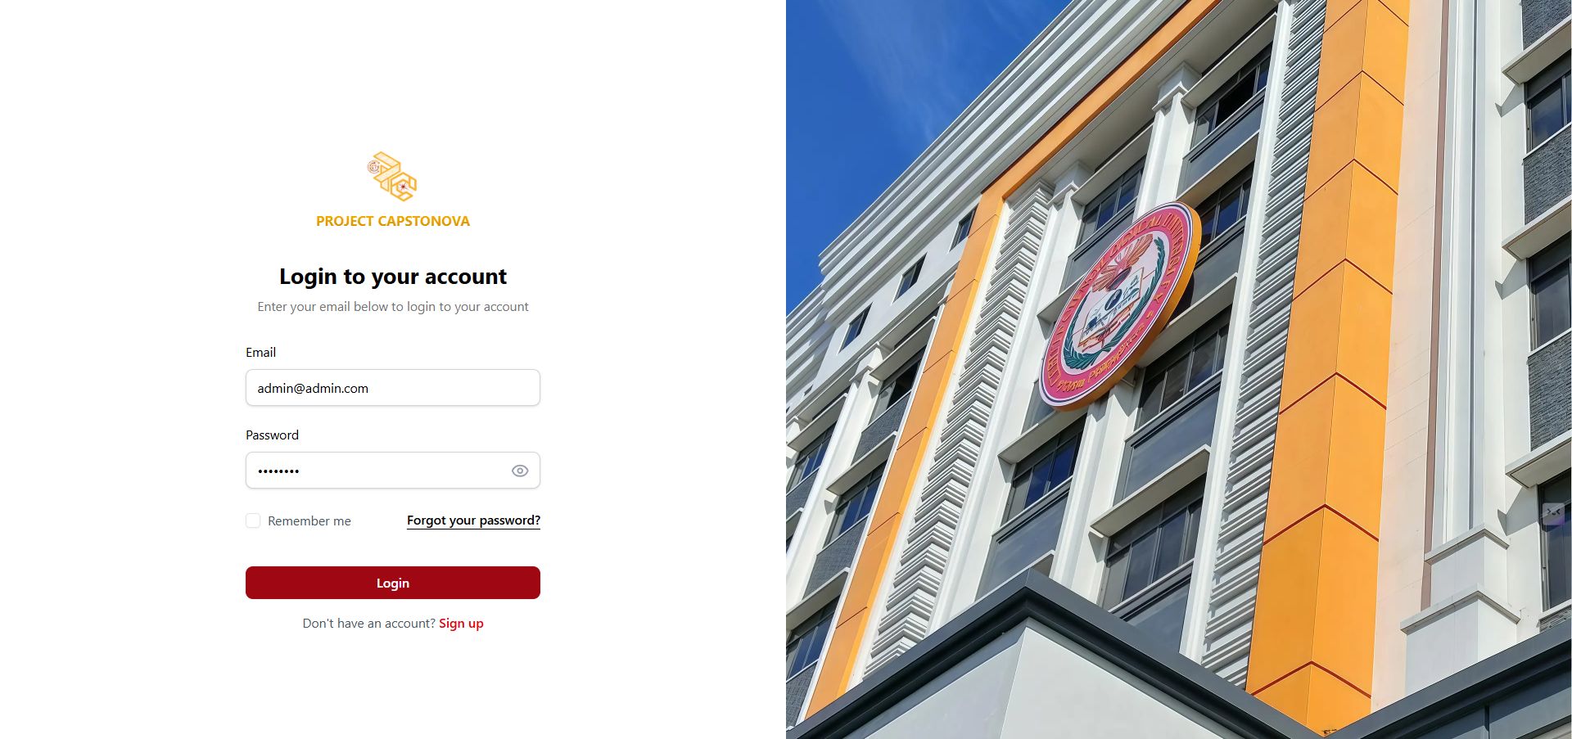

Figure 50. Admin – Login UI

Admin can enter their email and password to log in.

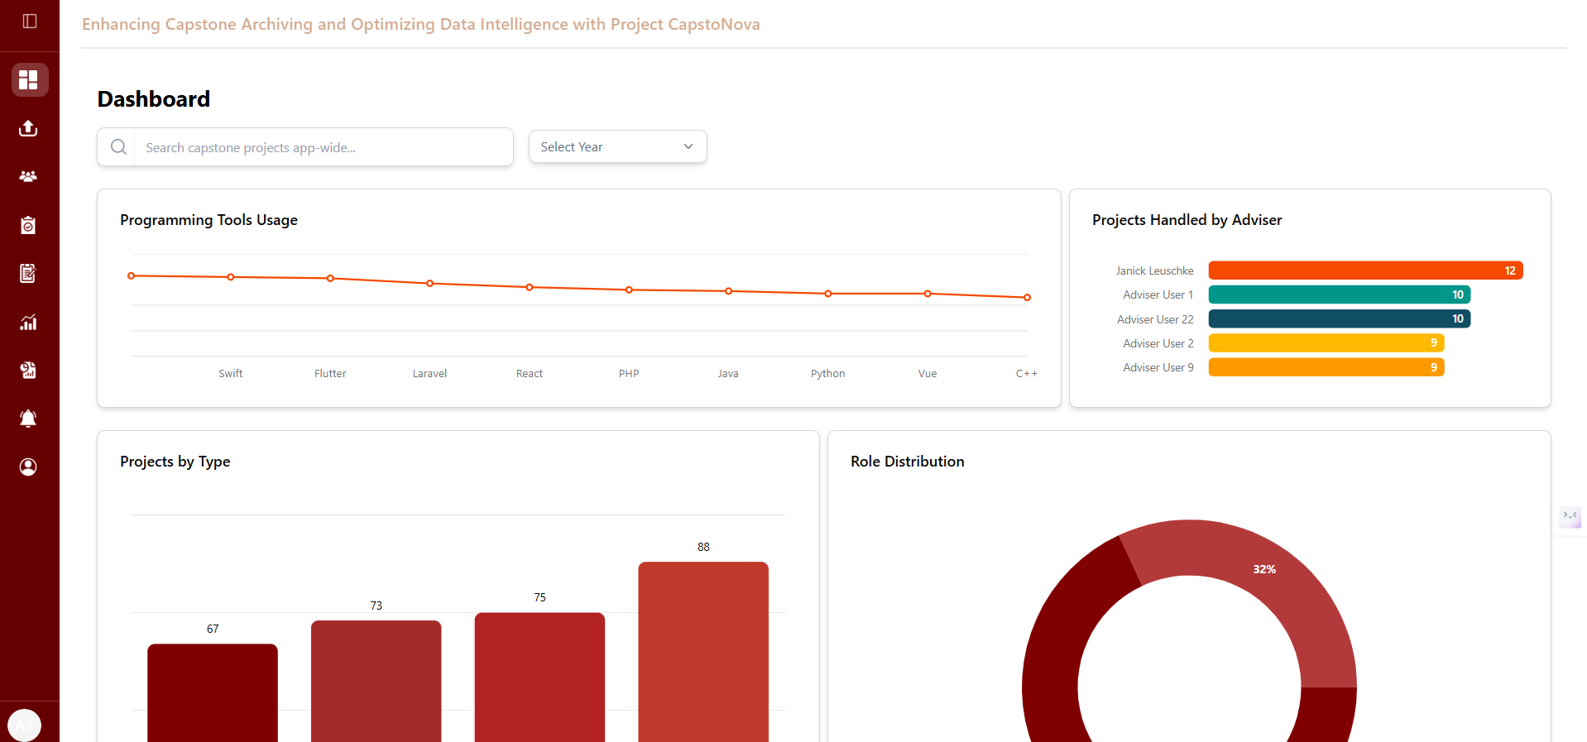

Figure 51. Admin – Dashboard UI

The Admin Dashboard allows to manage or view advisers, suggestions, view the latest submissions, and analyze project data.

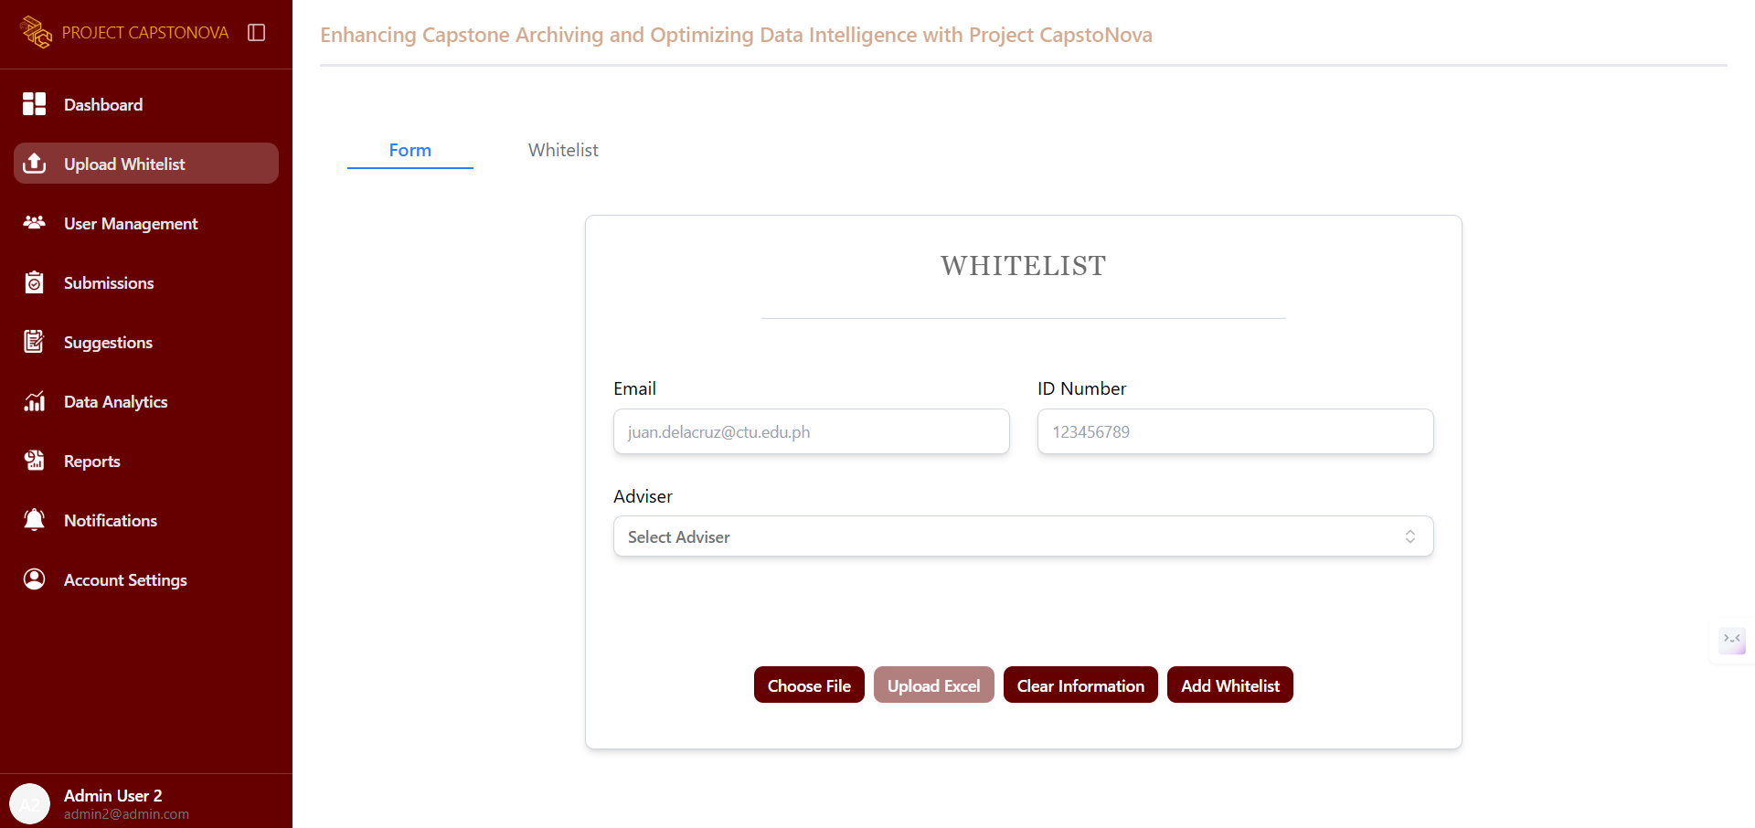

Figure 52. Admin- Whitelist Form UI

This page is dedicated to the whitelist form, where the admin can add entries to the whitelist by providing the proponent’s email, ID number, and adviser.

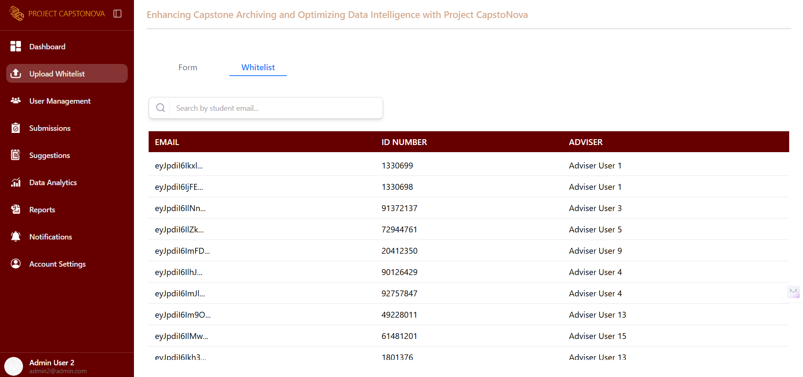

Figure 53. Admin- Whitelist UI

This page appears after the admin clicks the whitelist tab, displaying the list of added whitelist entries.

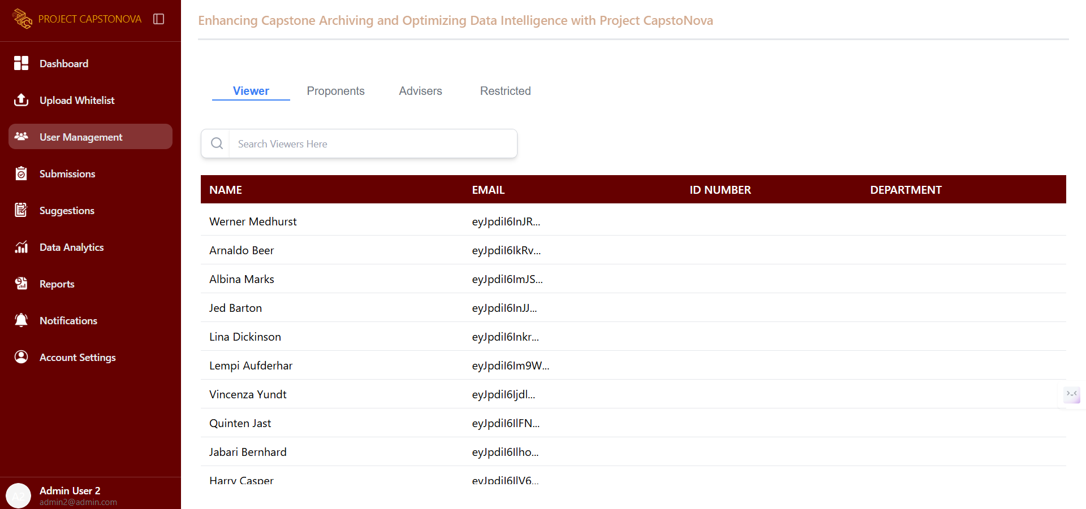

Figure 54. Admin- List of Viewers UI

This tab in the User Management page displays a list of all viewers who have requested full document access, including their name, email, ID number, and department.

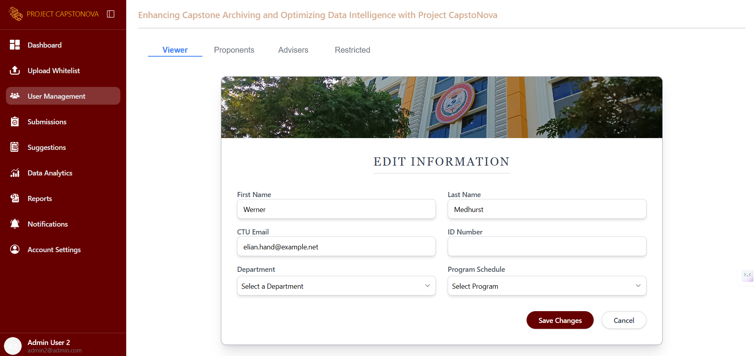

Figure 55. Admin- Viewer’s Profile UI

This page is displayed after selecting a specific viewer from the list. It provides options for editing and restricting the account. When the Edit button is clicked, this page allows the admin to edit the account’s profile.

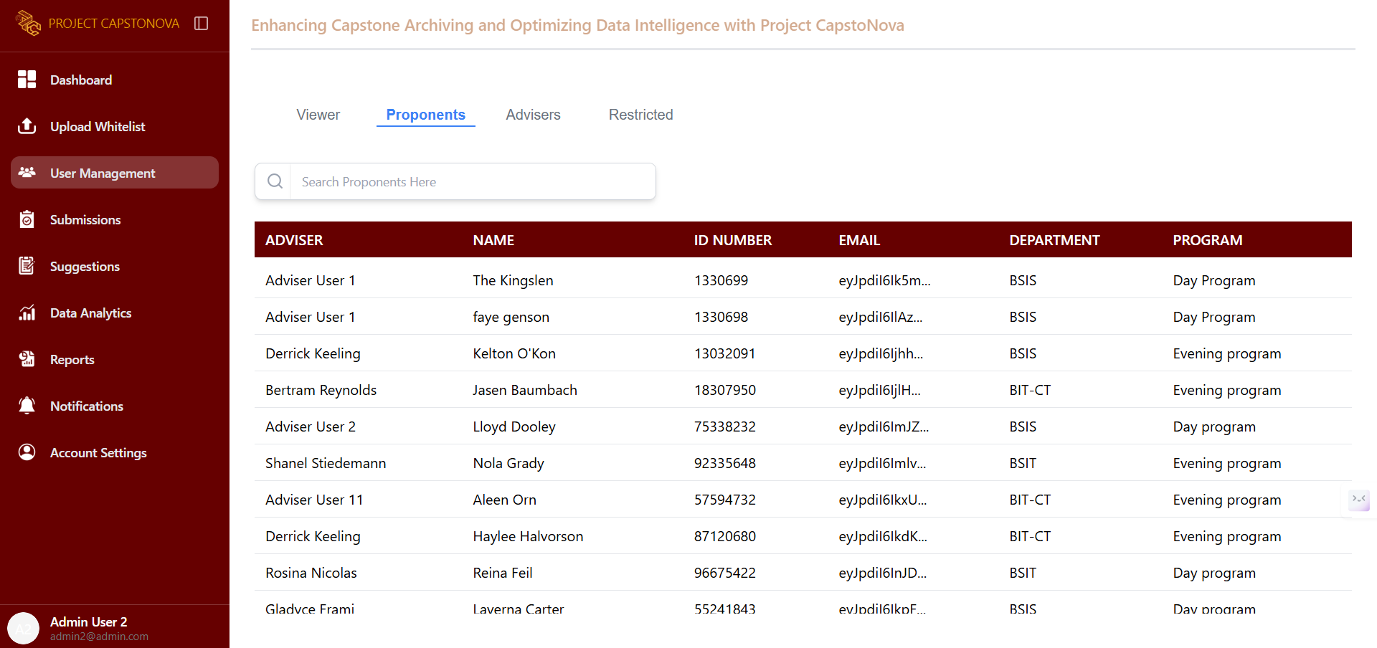

Figure 56. Admin- List of Proponents UI

This tab in the User Management page displays a list of all proponents, showing their name, email, ID number, department, and adviser.

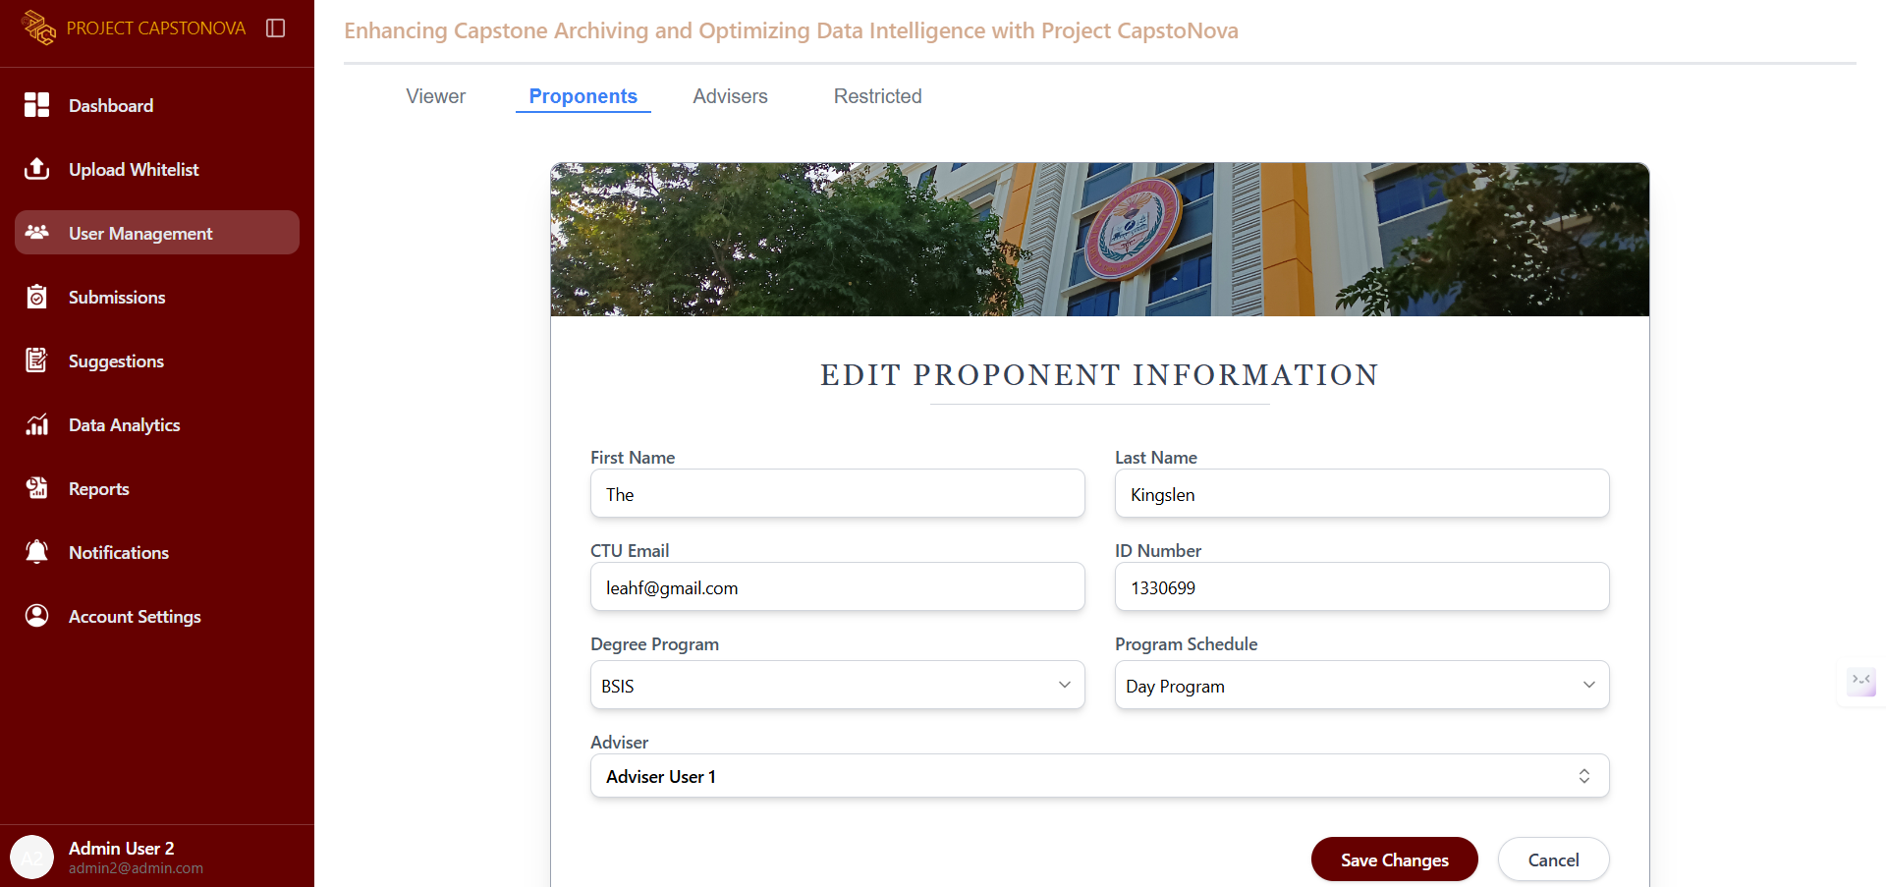

Figure 57. Admin - Proponent’s Profile UI

This page is displayed after selecting a specific proponent from the list. It provides options to edit or restrict the account. When the Edit button is clicked, this page allows the admin to modify the account’s profile.

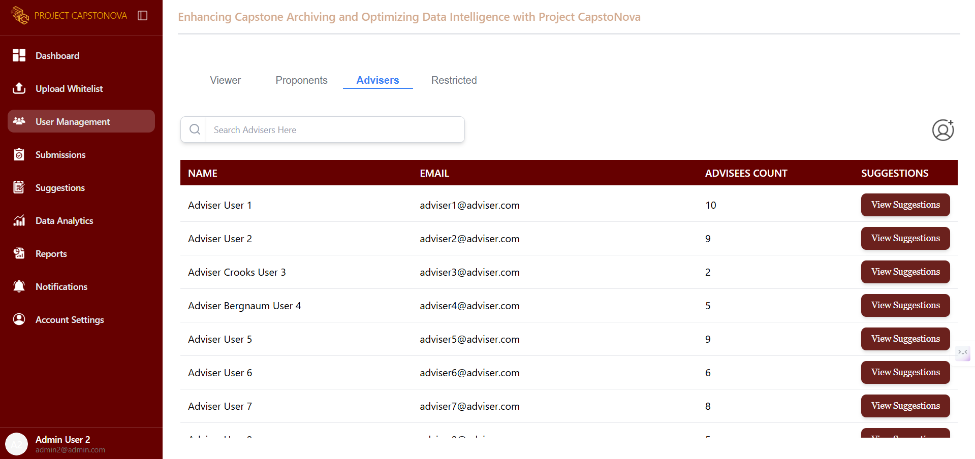

Figure 58. Admin - List of Advisers UI

This page displays a list of all advisers, showing their name, email, number of advisees, and a button to view their Capstone Idea suggestions.

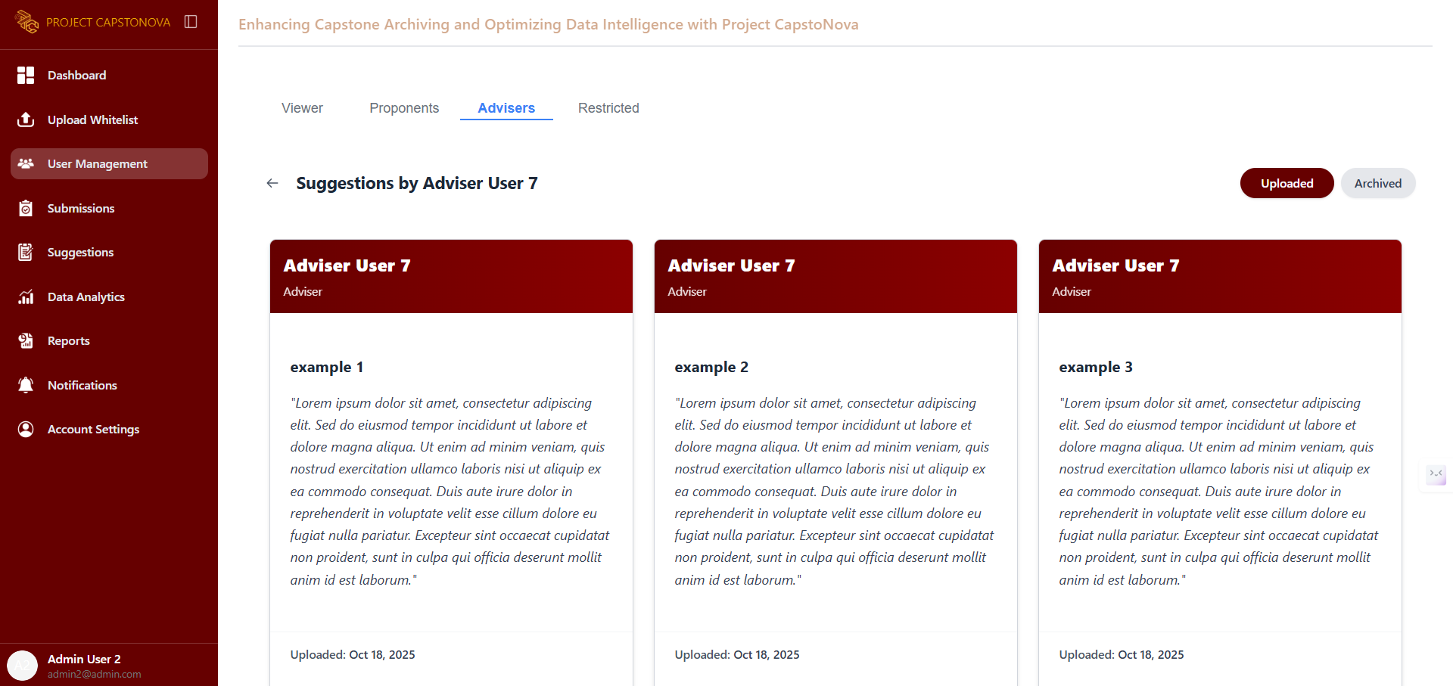

Figure 59. Admin - Adviser’s Suggestions UI

This page appears after the admin clicks the button to view an adviser’s suggestions. They can view only the uploaded and archived suggestions.

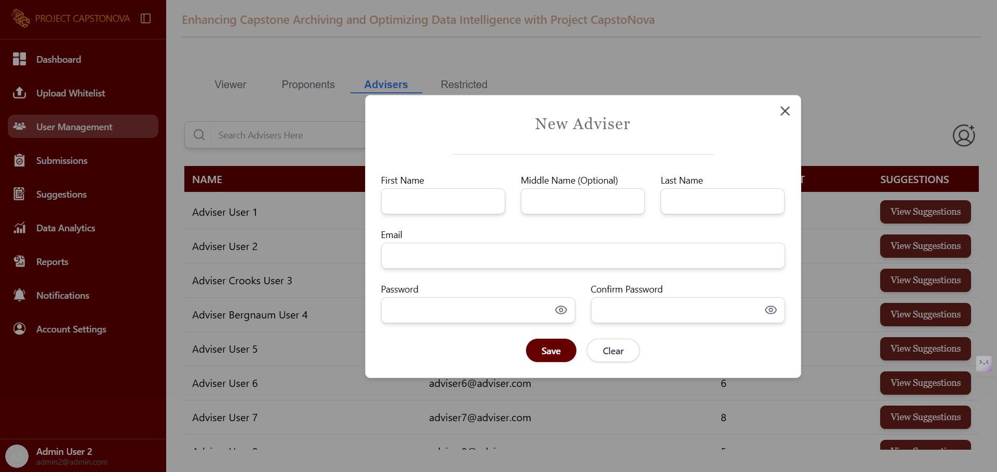

Figure 60. Admin- Add Adviser UI

This pops up when the Add button is clicked, displaying a form to add a new adviser.

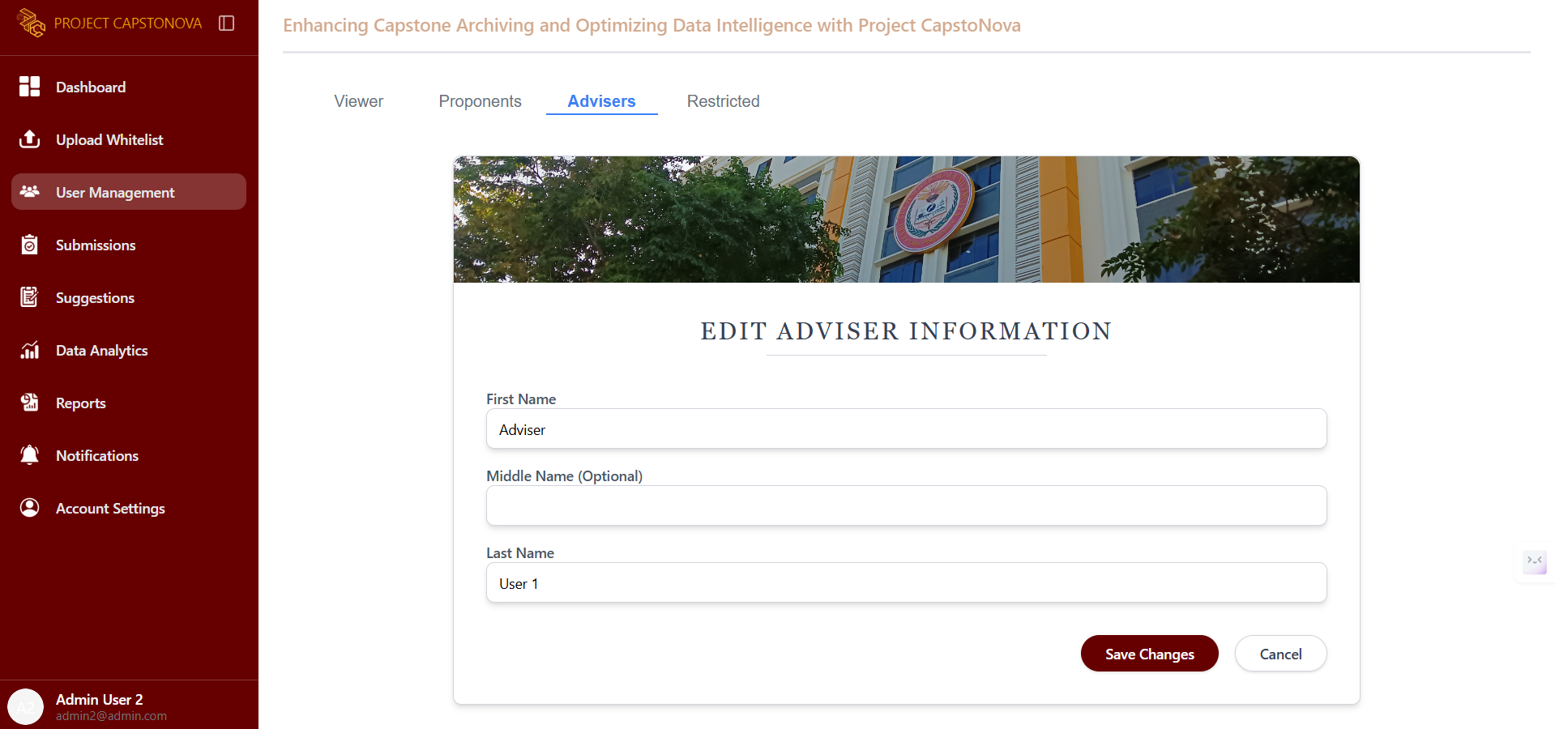

Figure 61. Admin - Adviser’s Profile

This page is displayed after selecting a specific adviser from the list. It provides options to edit or restrict the account. When the Edit button is clicked, this page allows the admin to modify the account’s profile.

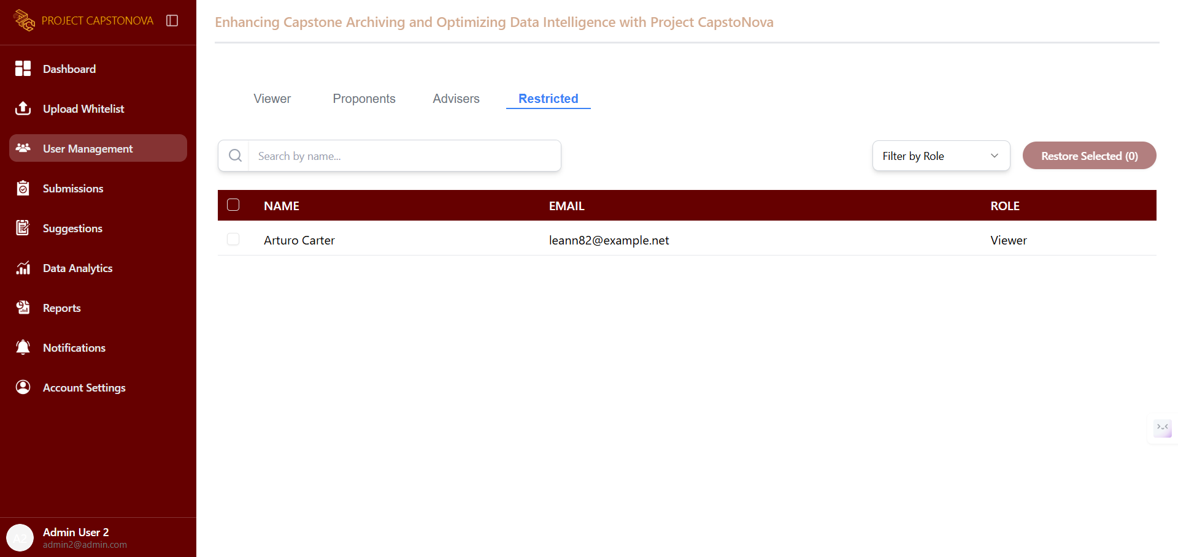

Figure 62. Admin - Restricted Accounts

This page displays a list of all restricted accounts, which can be restored by selecting and filtering them by role.

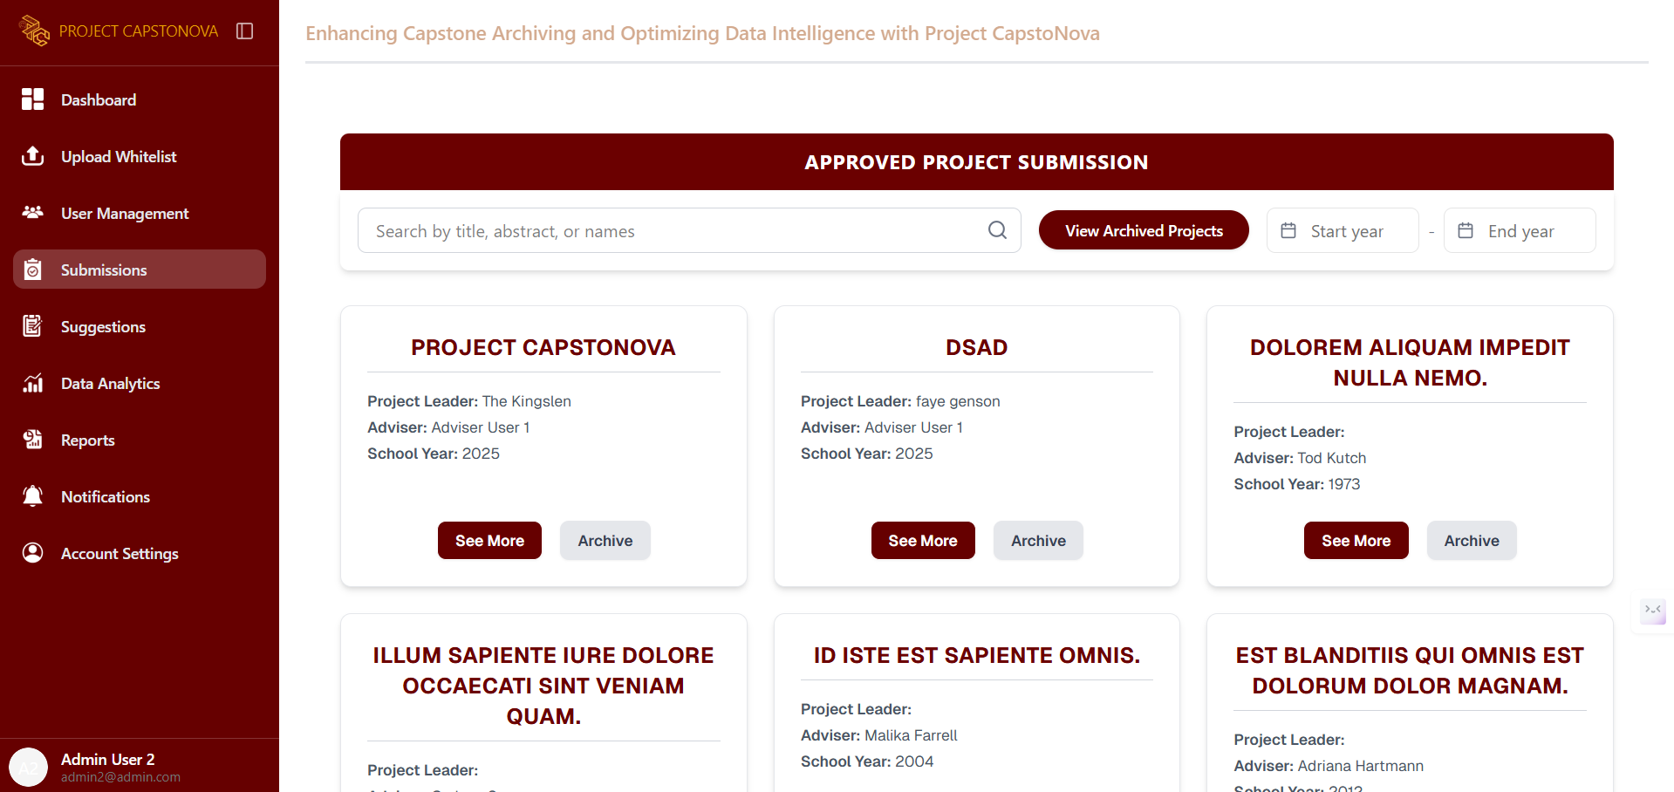

Figure 63. Admin – Submission UI

The admin can view a list of approved projects, with options to archive a project or see more details.

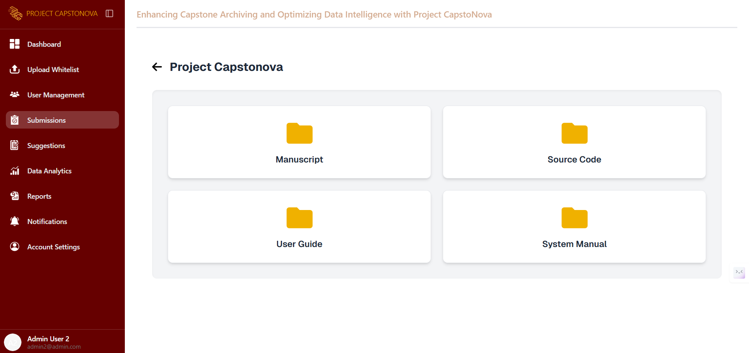

Figure 64. Admin - Capstone Project Files UI

This page appears after the Super Admin selects a project and clicks the See More button to view the manuscript, download the source code, and access the user guide and system manual.

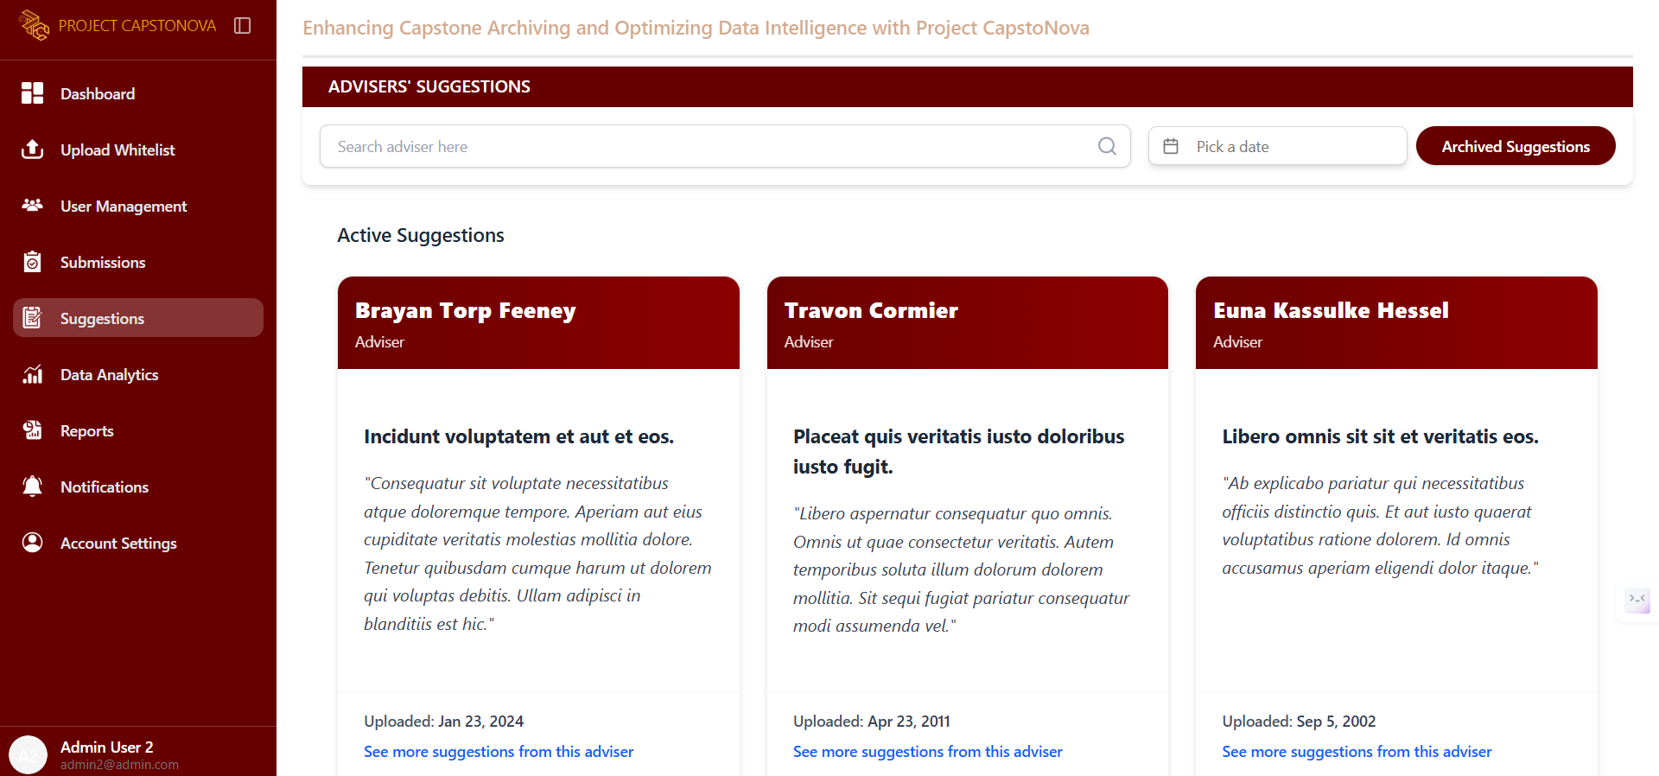

Figure 65. Admin - Suggestions UI

The admin can view all capstone suggestion ideas from all advisers. This page displays each suggestion along with the adviser's name and the date it was uploaded.

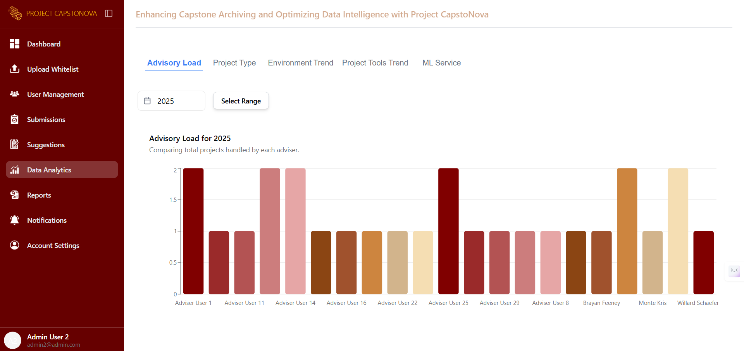

Figure 66. Admin - DA Advisory Load UI

This tab in the Data Analytics page displays the Advisory Load, showing and comparing the total number of projects handled by each adviser.

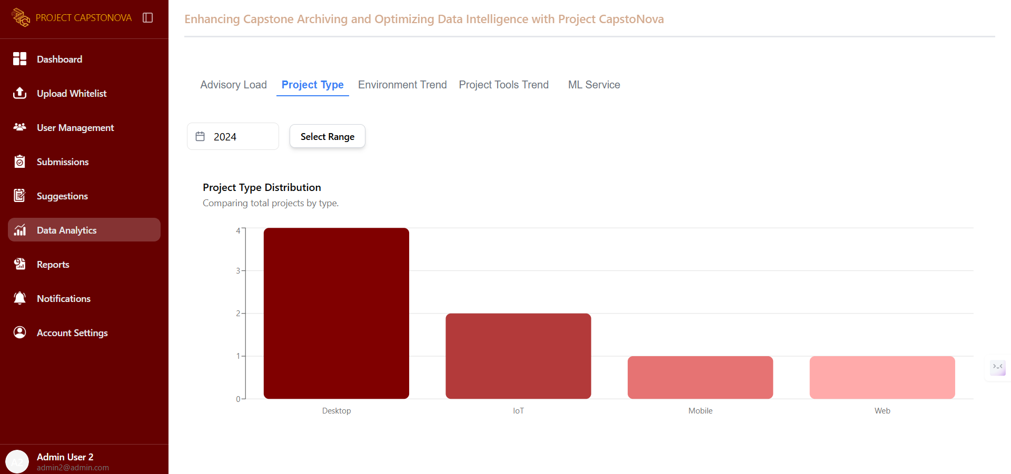

Figure 67. Admin - DA Project Type UI

This tab in the Data Analytics page displays the Project Type, showing and comparing the total projects by type.

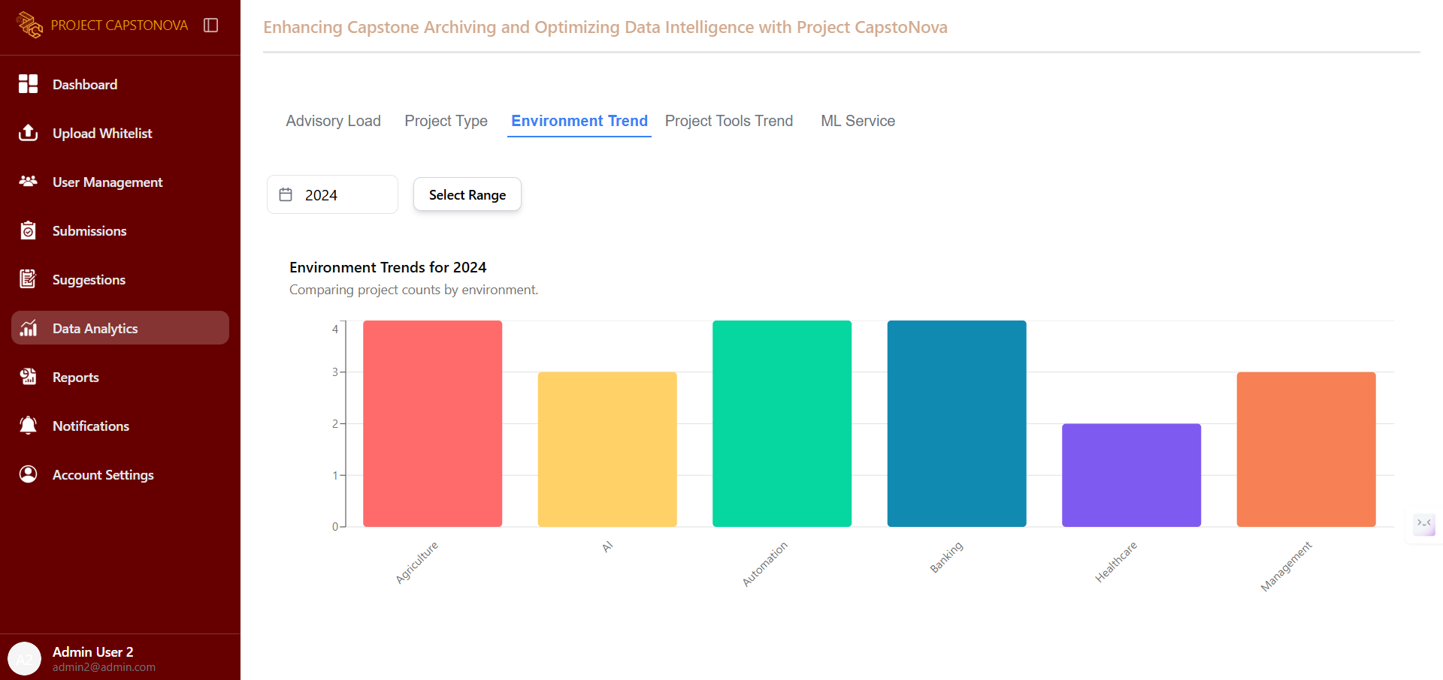

Figure 68. Admin - DA Environment Trend UI

This tab in the Data Analytics page displays the Environment Trend, showing and comparing project counts by environment.

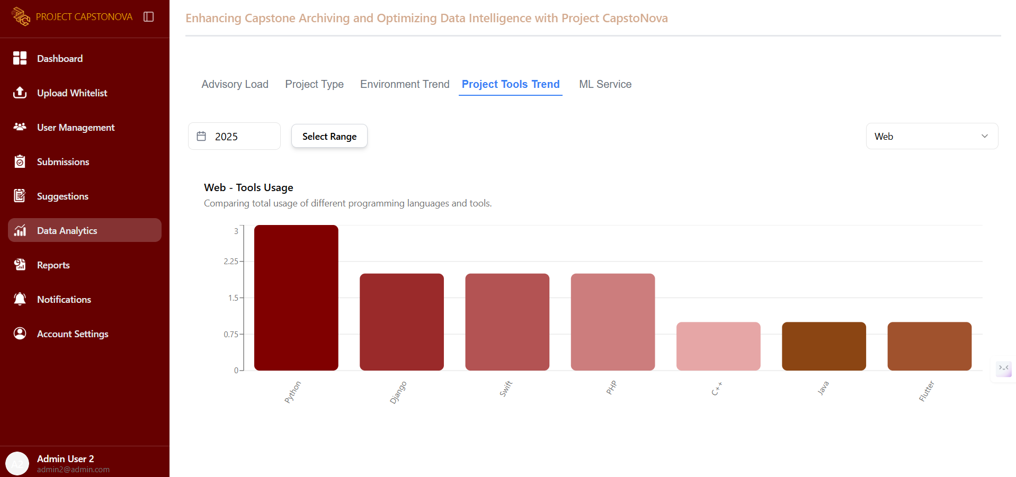

Figure 69. Admin - DA Project Tools Trend UI

This tab in the Data Analytics page displays the Project Tools Trend, showing and comparing the total usage of different programming languages and tools.

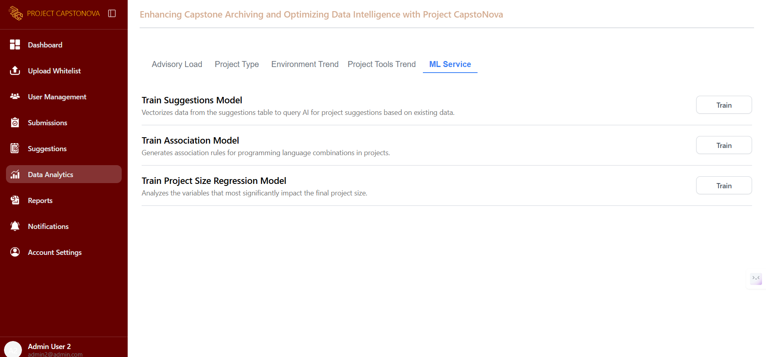

Figure 70. Admin - DA ML Service UI

This section provides the admin with tools to train machine learning models that support data-driven decision-making. It includes models for generating project suggestions, identifying programming language patterns, and analyzing factors that influence project size. Each model can be trained with existing project data to enhance system intelligence and provide more accurate insights.

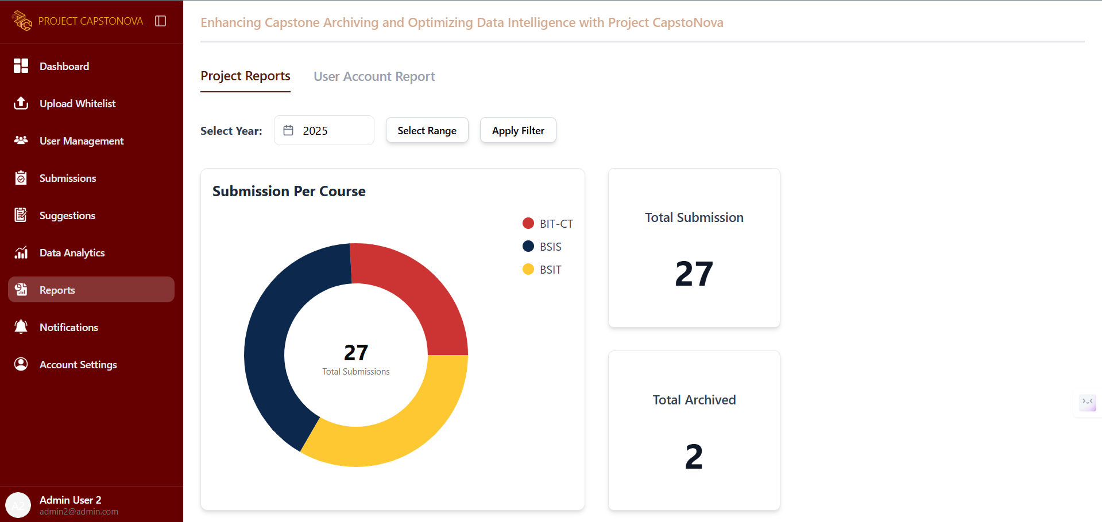

Figure 71. Admin - Project Reports UI

This tab in the Reports page, the Project Reports tab, shows the total number of submissions per course.

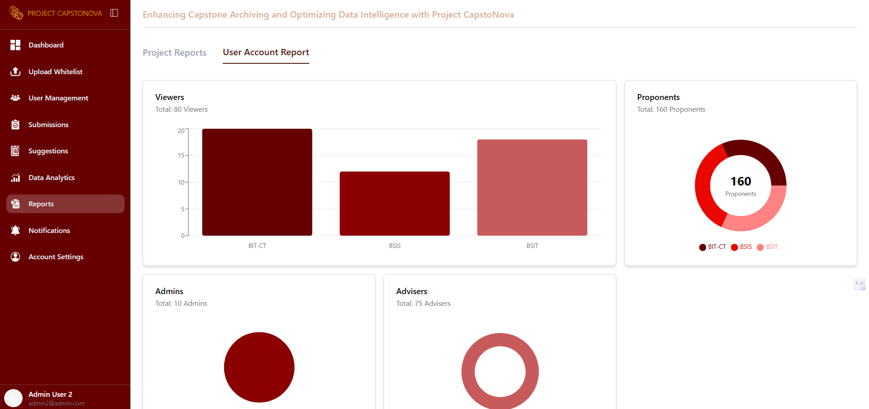

Figure 72. Admin - User Account Report UI

This tab in the Reports page, the User Account Report tab, displays a summary of all users and shows the total number of accounts.

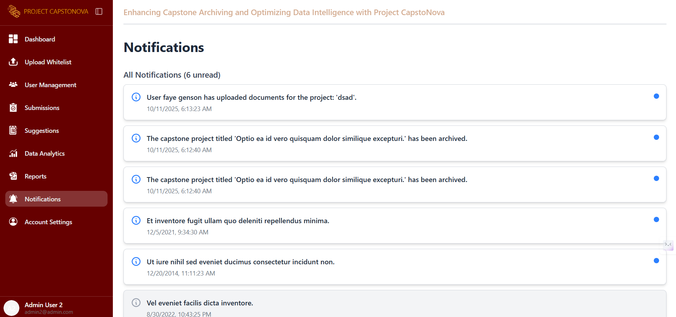

Figure 73. Admin - Notification UI

This page displays all system notifications.

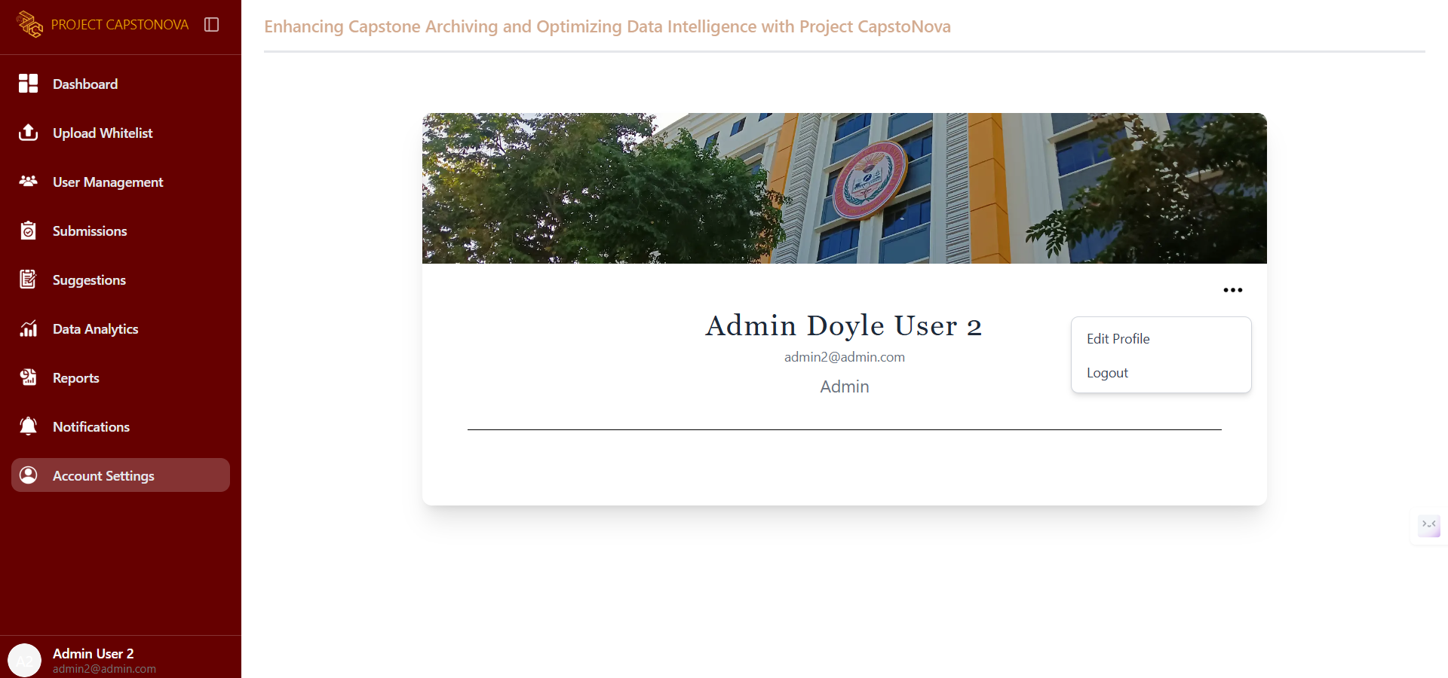

Figure 74.Admin - Account Settings UI

This page displays the admin’s account settings, including their full name, email, and user role. It also provides options to edit the profile or log out.

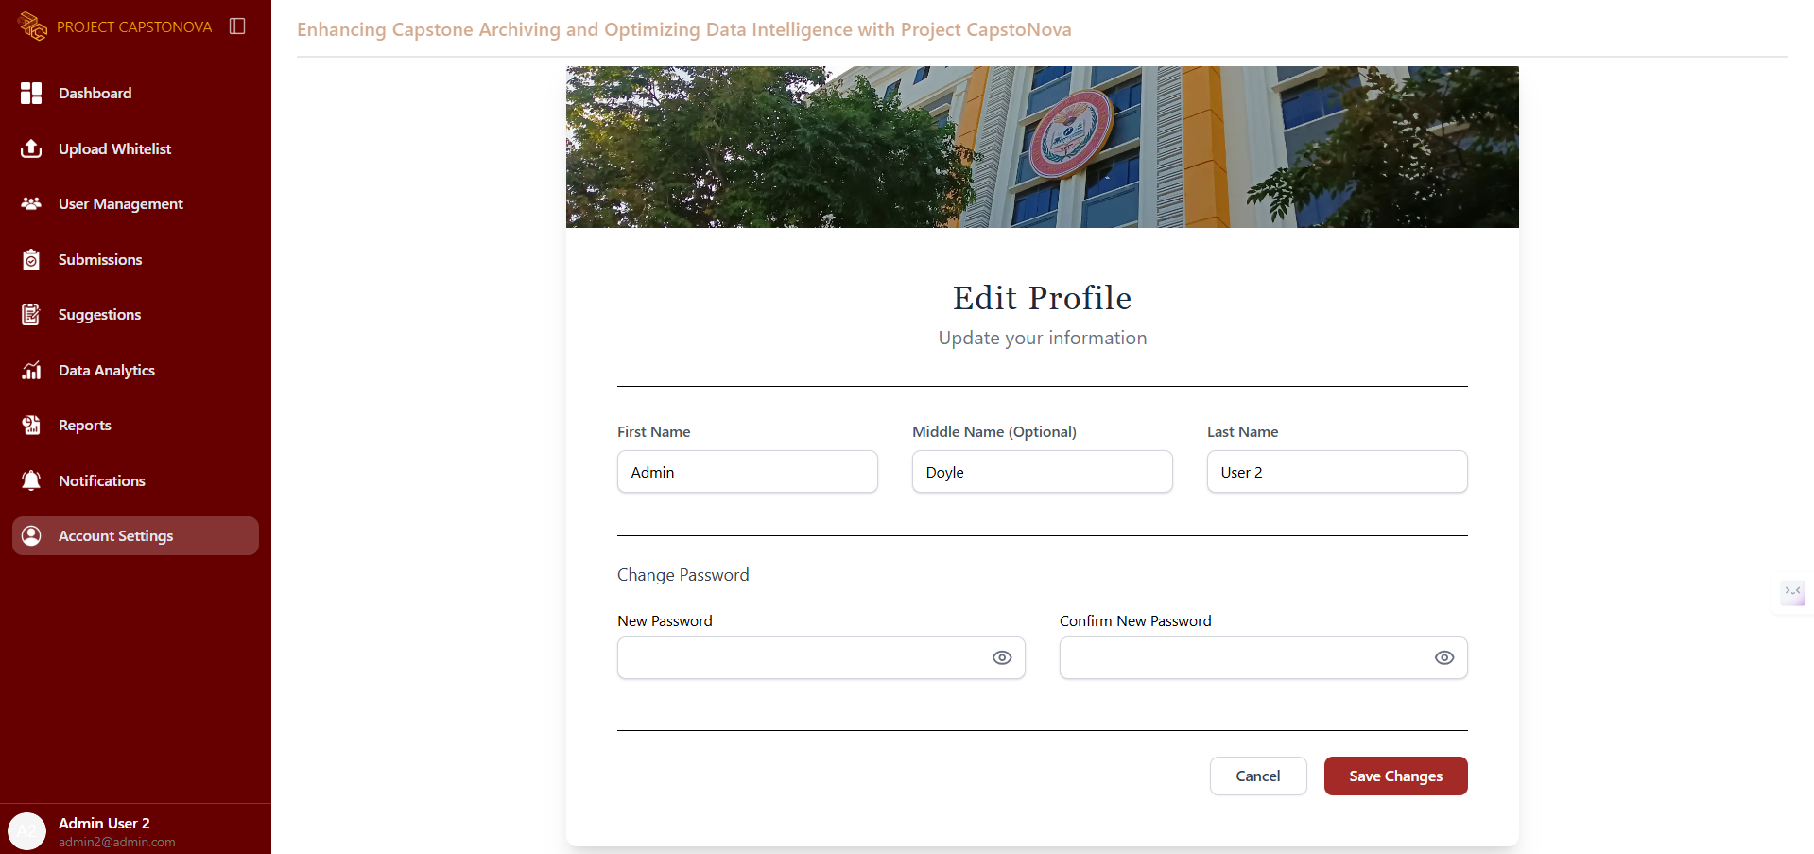

Figure 75. Admin - Update Profile UI

This page allows the admin to update their profile.

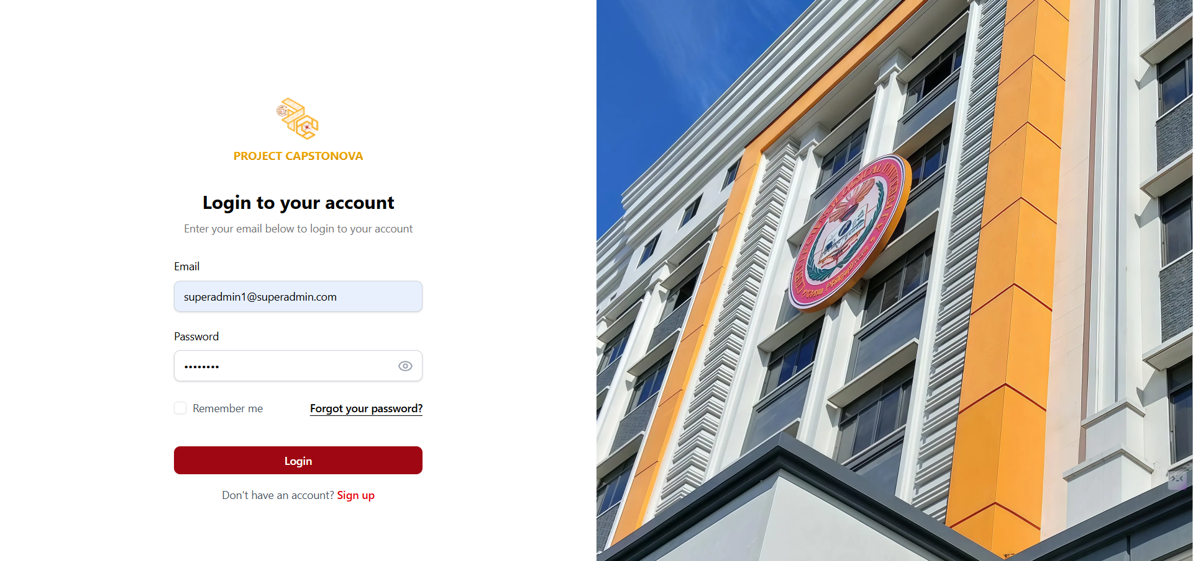

Figure 76. Super Admin- Login Page UI

This page is the Super Admin’s login screen, where they can enter their email and password to access the system.

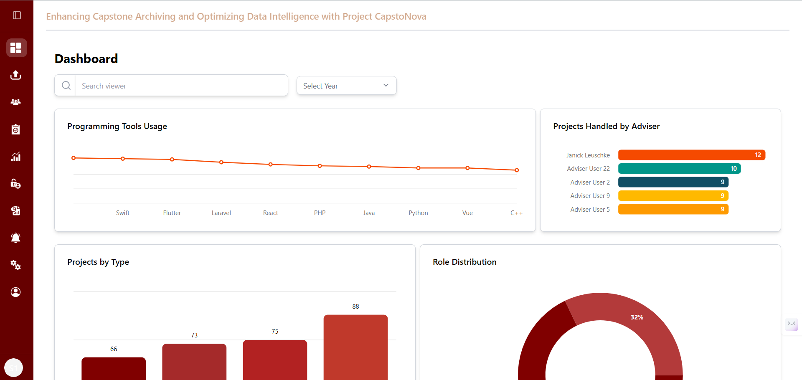

Figure 77. Super Admin- Dashboard UI

This is the Super Admin Dashboard, which displays a summary of data analytics on programming tool usage, projects handled by advisers, projects by type, role distribution, and the latest submissions.

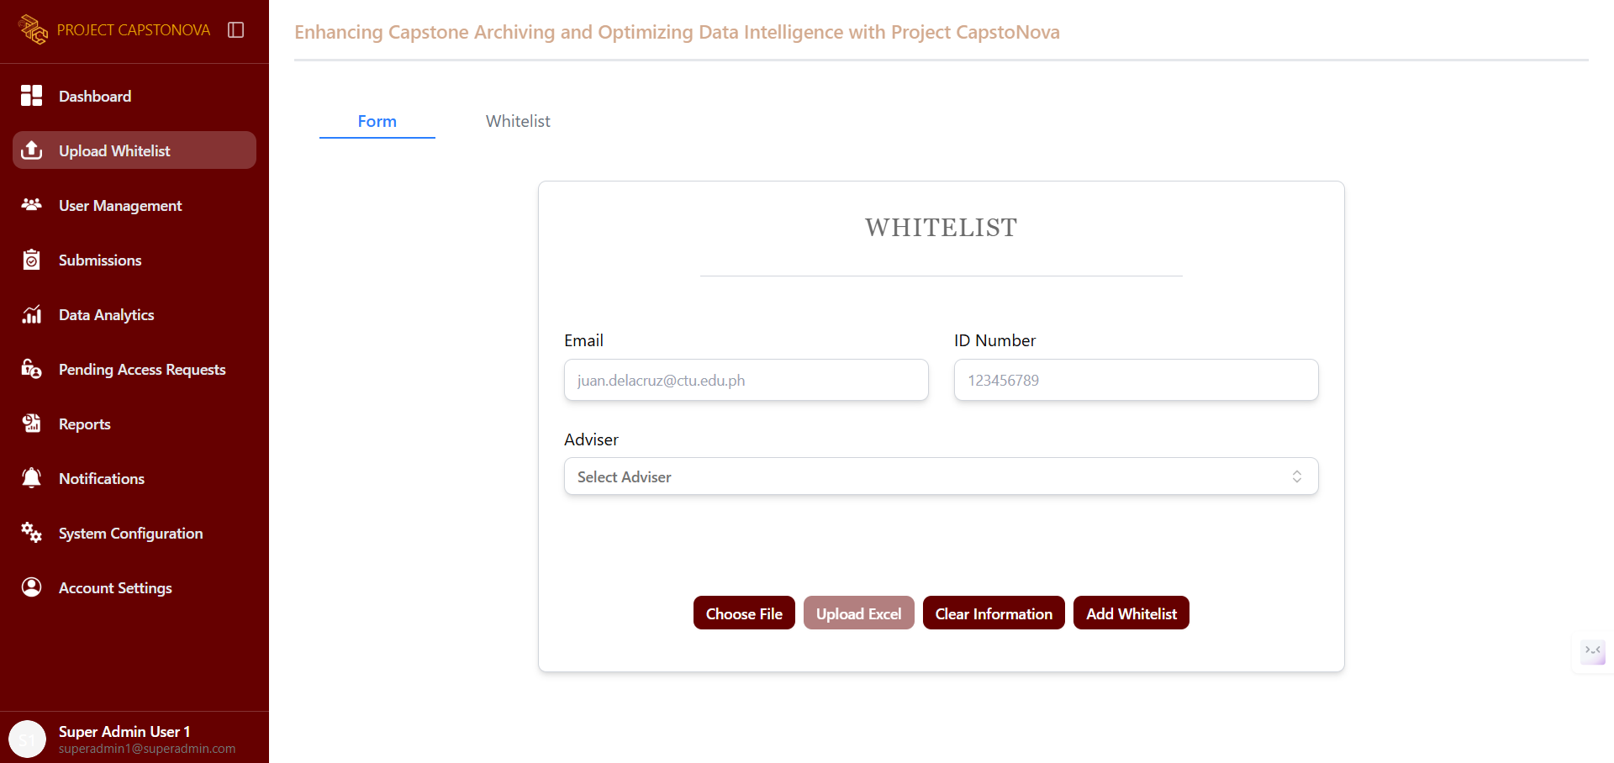

Figure 78. Super Admin- Whitelist Form UI

This page is dedicated to the whitelist form, where the Super Admin can add entries to the whitelist by providing the proponent’s email, ID number, and adviser.

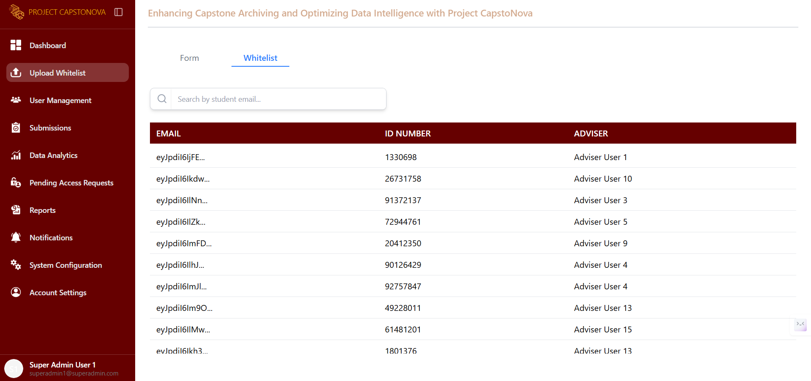

Figure 79. Super Admin- Whitelist UI

This page appears after the Super Admin clicks the whitelist tab, displaying the list of added whitelist entries.

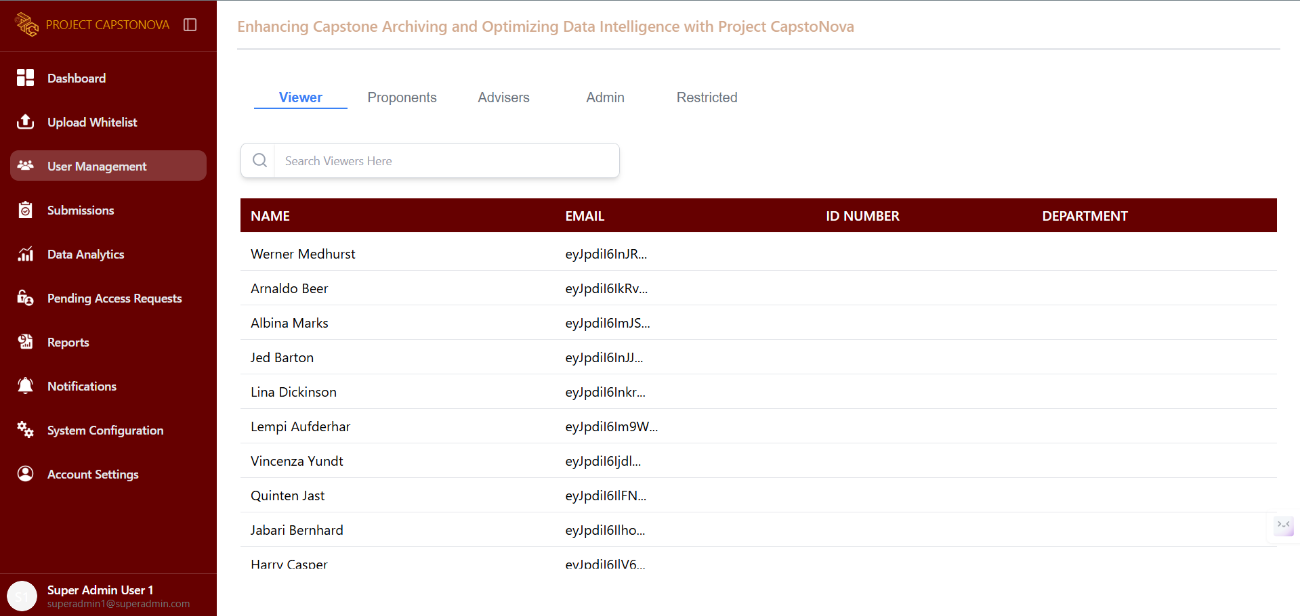

Figure 80. Super Admin- List of Viewers UI

This tab in the User Management page displays a list of all viewers who have requested full document access, including their name, email, ID number, and department.

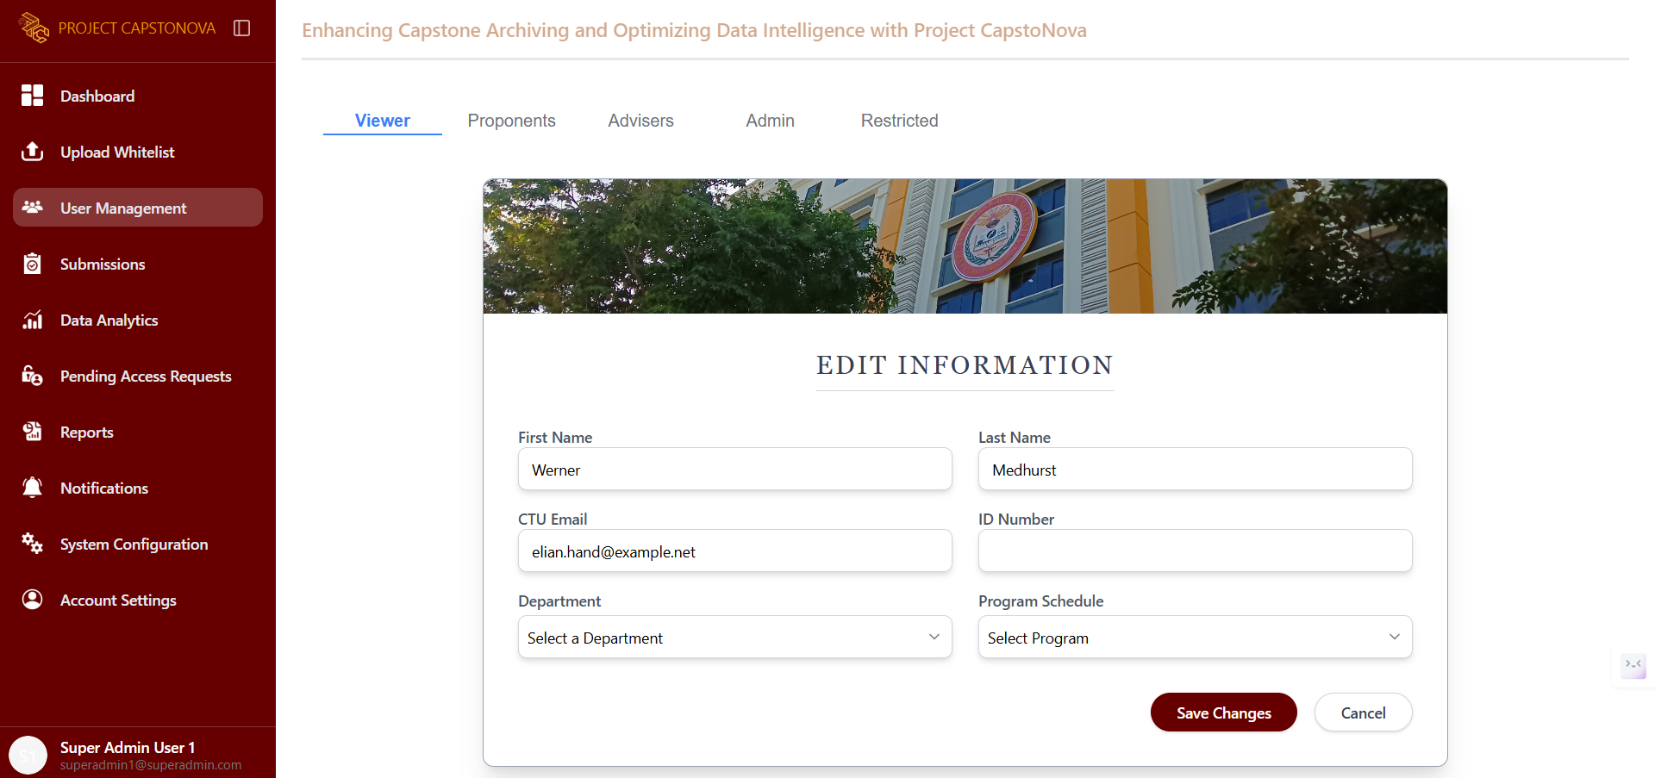

Figure 81. Super Admin- Viewer’s Profile UI

This page is displayed after selecting a specific viewer from the list. It provides options for editing and restricting the account. When the Edit button is clicked, this page allows the Super Admin to edit the account’s profile.

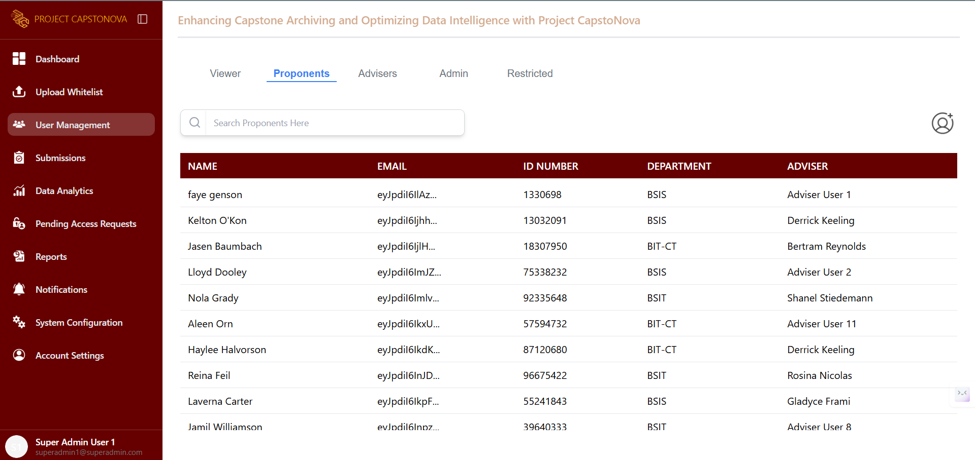

Figure 82.Super Admin- List of Proponents UI

This tab in the User Management page displays a list of all proponents, showing their name, email, ID number, department, and adviser.

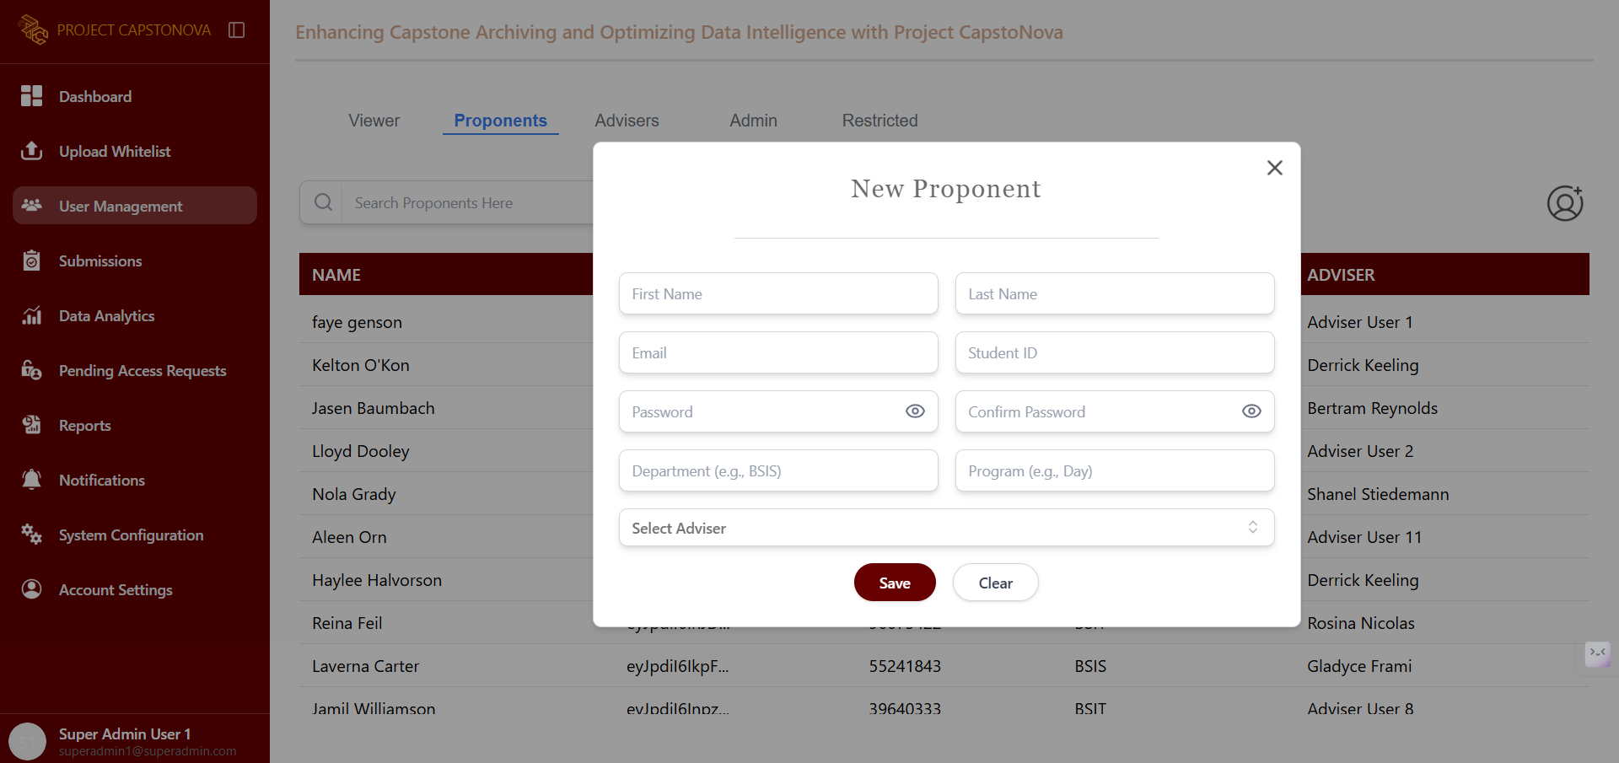

Figure 83. Super Admin- Add Proponent UI

This pops up when the Add button is clicked, displaying a form to add a new proponent.

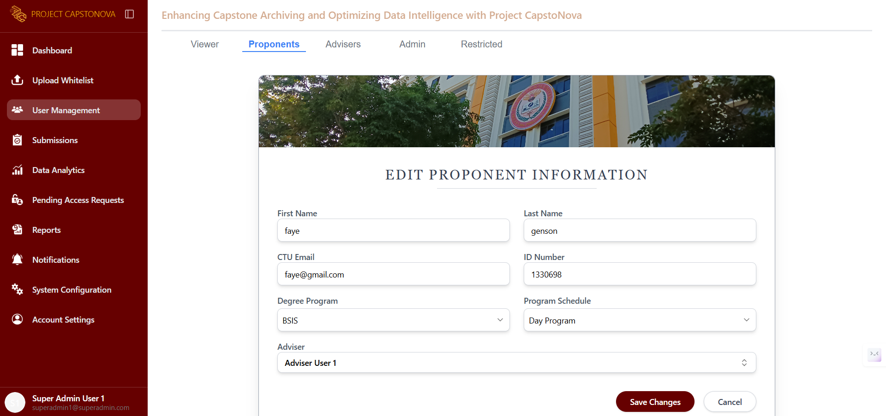

Figure 84. Super Admin - Proponent’s Profile UI

This page is displayed after selecting a specific proponent from the list. It provides options to edit or restrict the account. When the Edit button is clicked, this page allows the Super Admin to modify the account’s profile.

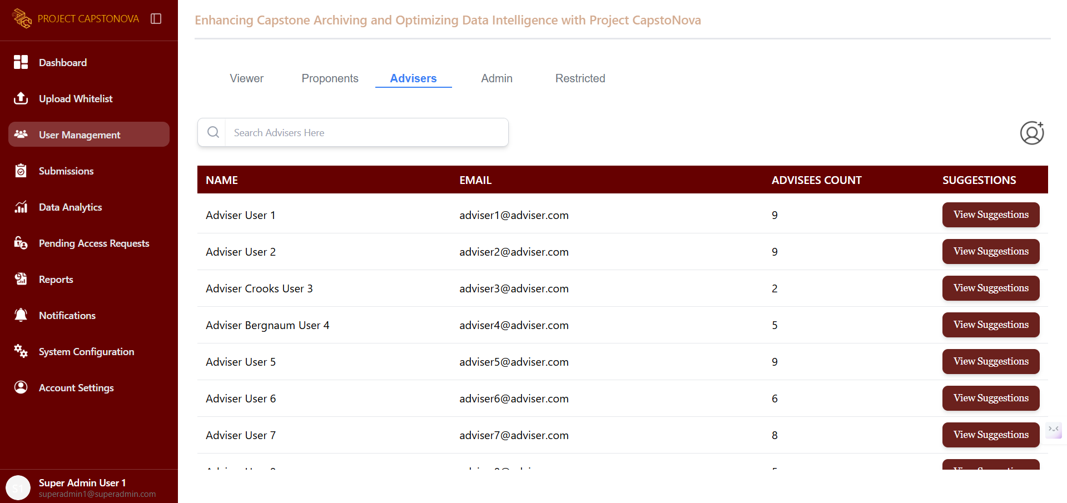

Figure 85. Super Admin - List of Advisers UI

This page displays a list of all advisers, showing their name, email, number of advisees, and a button to view their Capstone Idea suggestions.

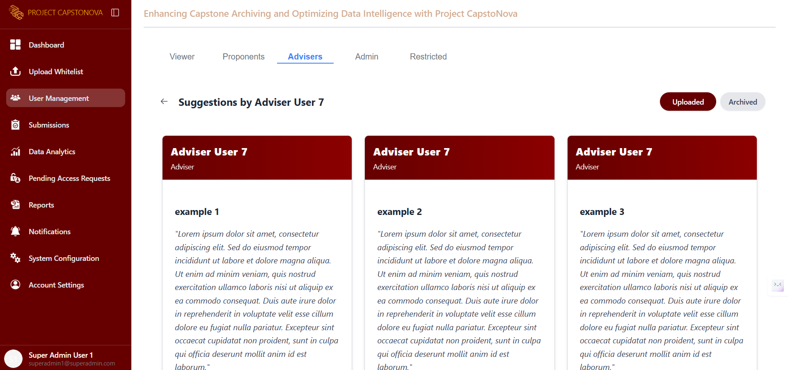

Figure 86. Super Admin - Adviser’s Suggestions UI

This page appears after the Super Admin clicks the button to view an adviser’s suggestions. They can view only the uploaded and archived suggestions.

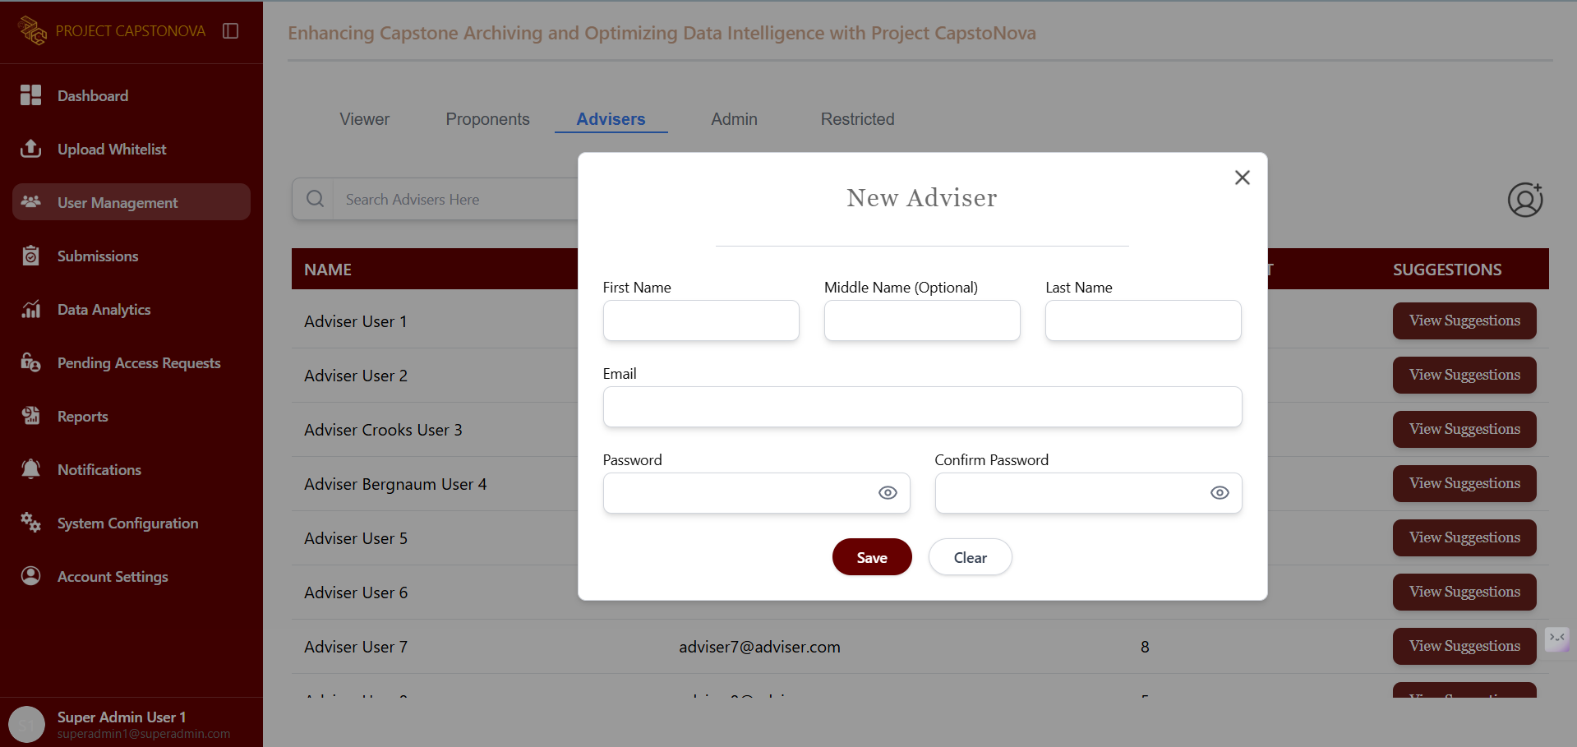

Figure 87. Super Admin- Add Adviser UI

This pops up when the Add button is clicked, displaying a form to add a new adviser.

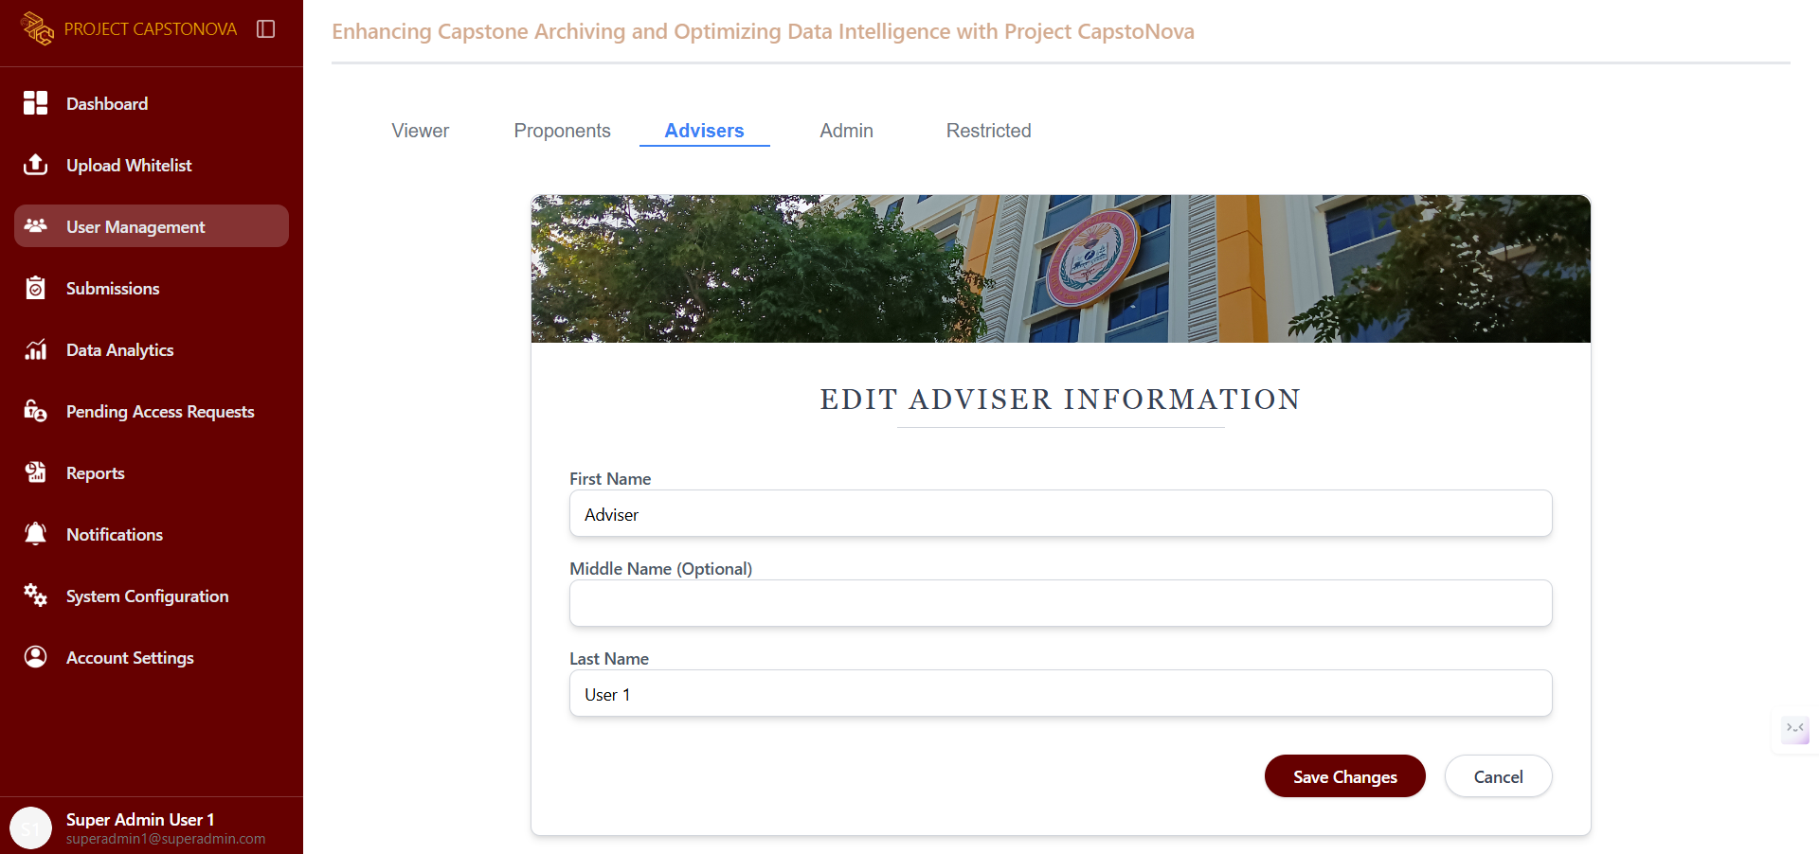

Figure 88. Super Admin - Adviser’s Profile

This page is displayed after selecting a specific adviser from the list. It provides options to edit or restrict the account. When the Edit button is clicked, this page allows the Super Admin to modify the account’s profile.

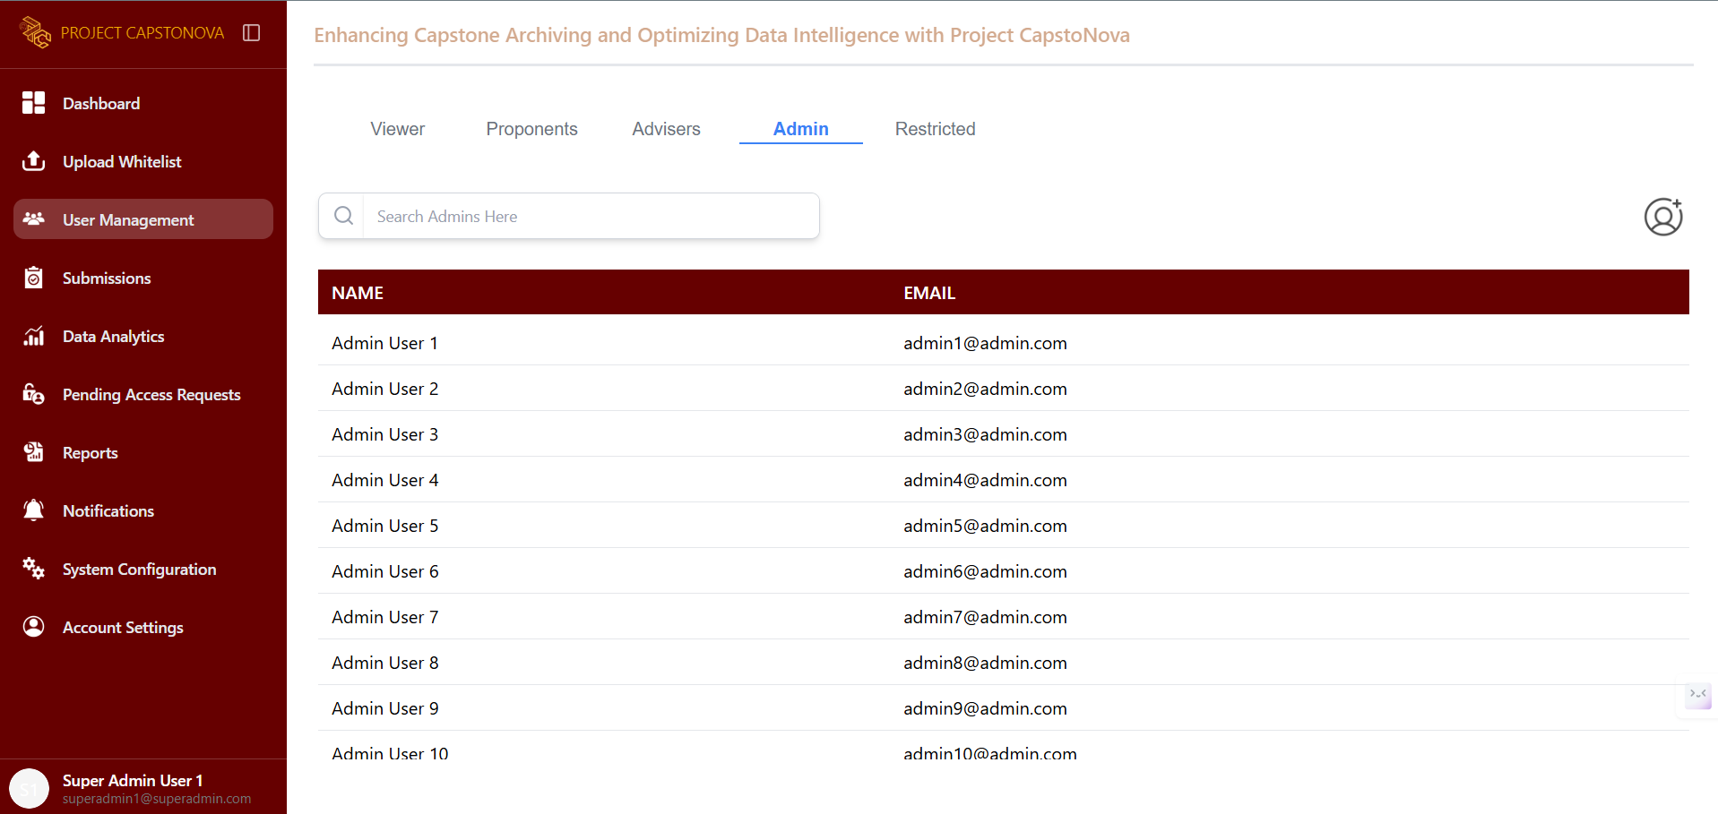

Figure 89. Super Admin - List of Admins

This page displays a list of all Admin showing their name and email

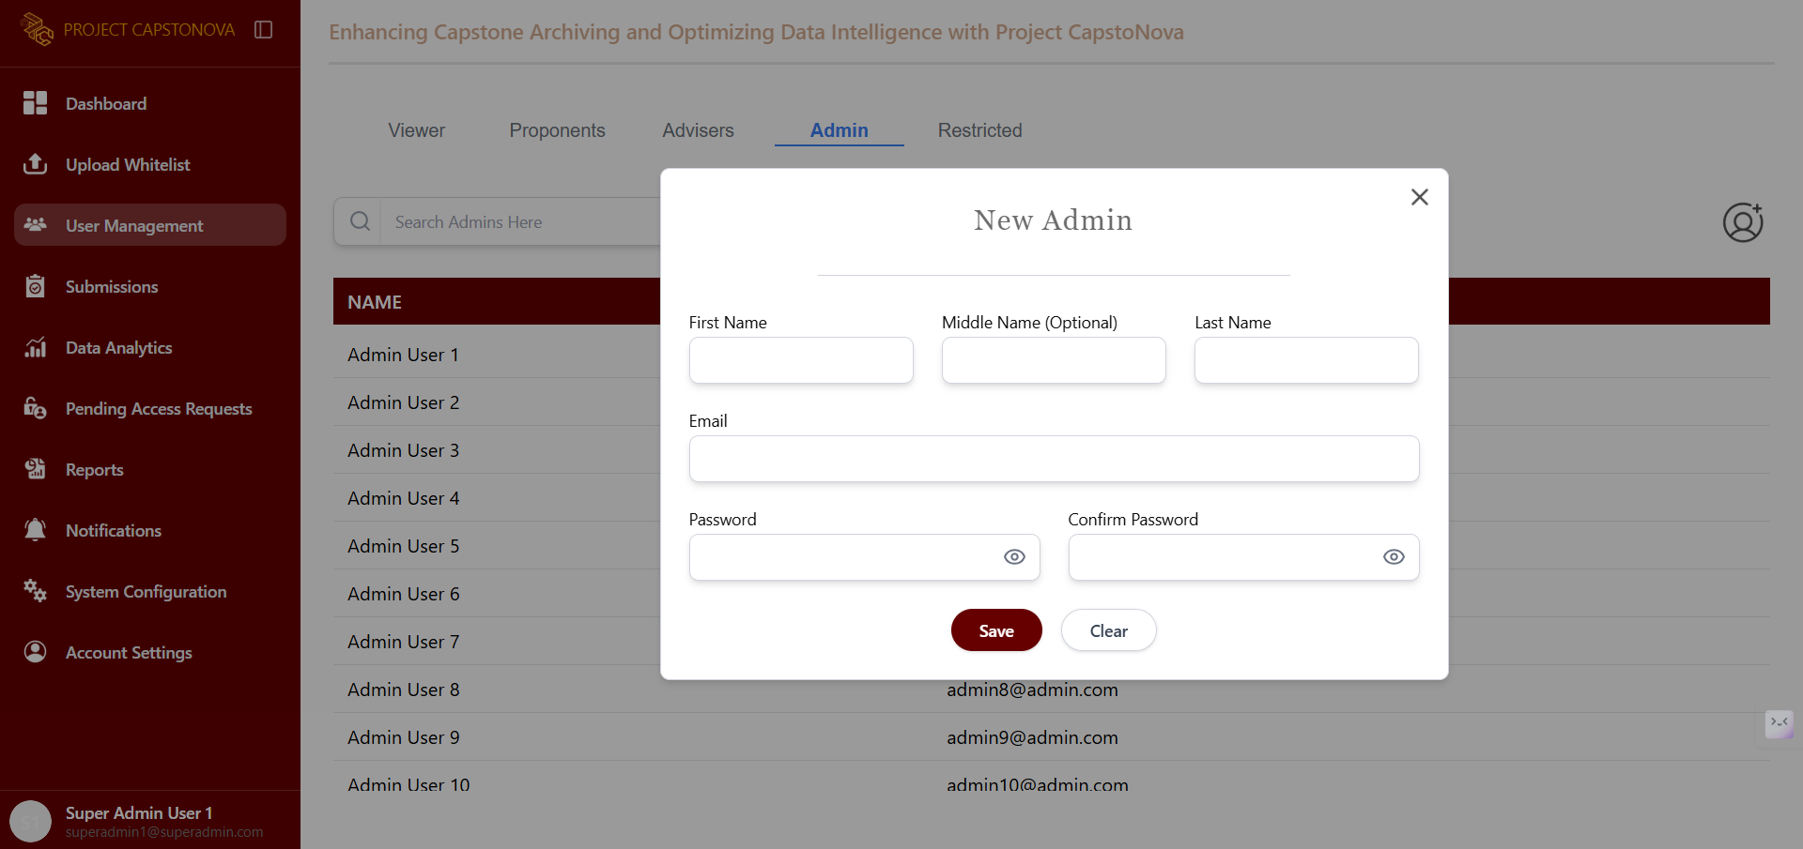

Figure 90. Super Admin - Add Admin UI

This pops up when the Add button is clicked, displaying a form to add a new admin.

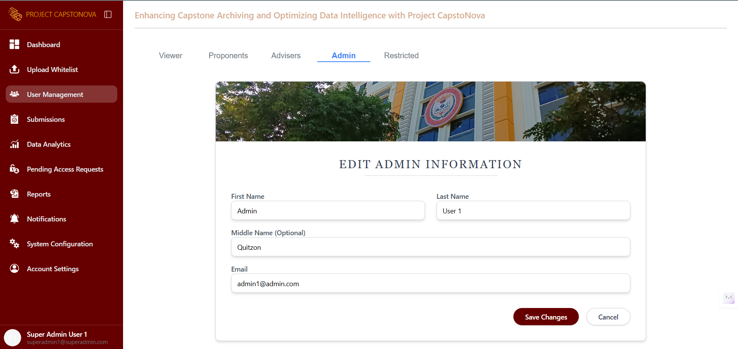

Figure 91. Super Admin - Admin’s Profile

This page is displayed after selecting a specific admin from the list. It provides options to edit or restrict the account. When the Edit button is clicked, this page allows the Super Admin to modify the account’s profile.

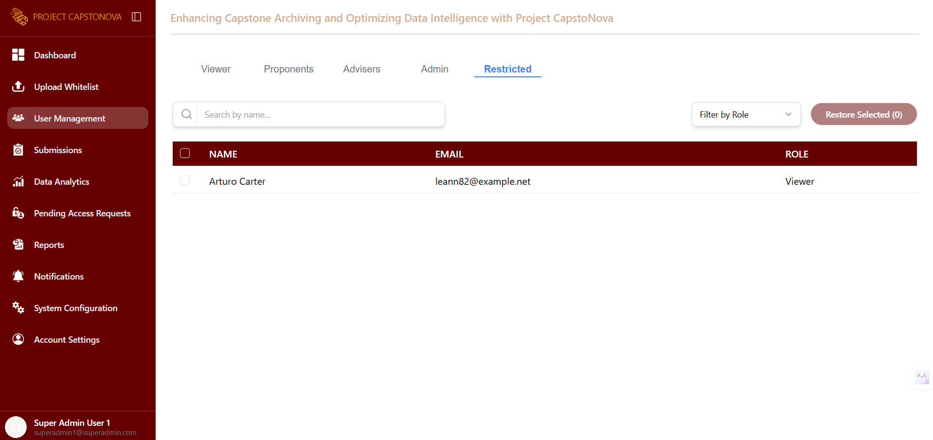

Figure 92. Super Admin - Restricted Accounts

This page displays a list of all restricted accounts, which can be restored by selecting and filtering them by role.

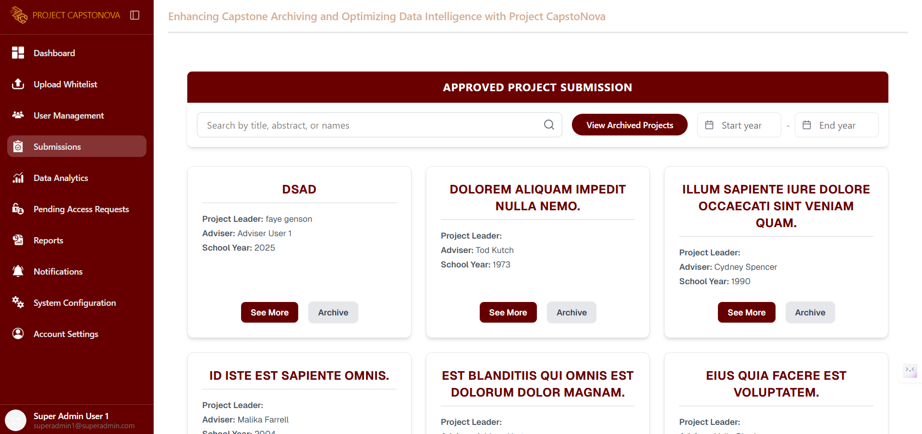

Figure 93. Super Admin - Submissions UI

This page displays all project submissions.

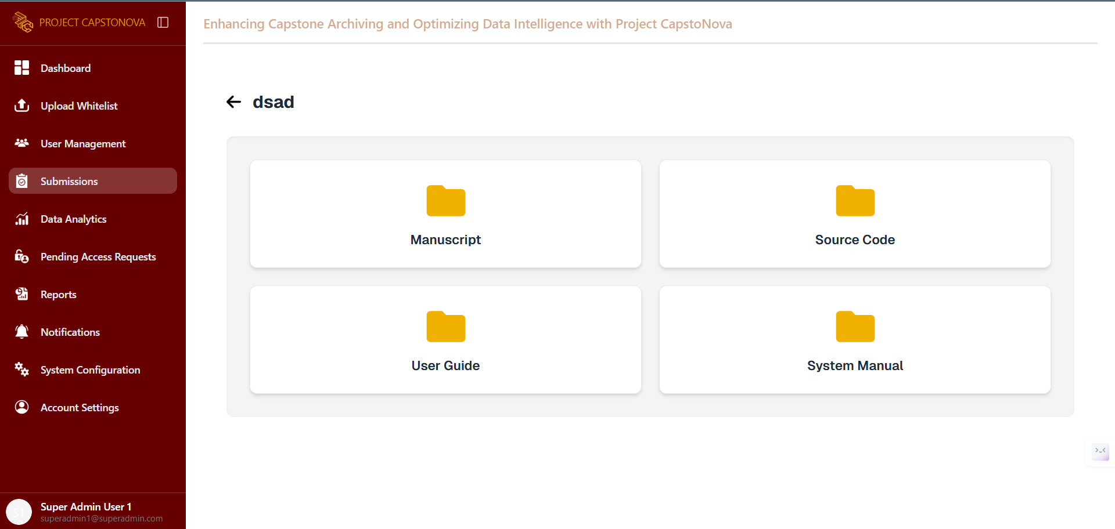

Figure 94. Super Admin - Capstone Project Files UI

This page appears after the Super Admin selects a project and clicks the See More button to view the manuscript, download the source code, and access the user guide and system manual.

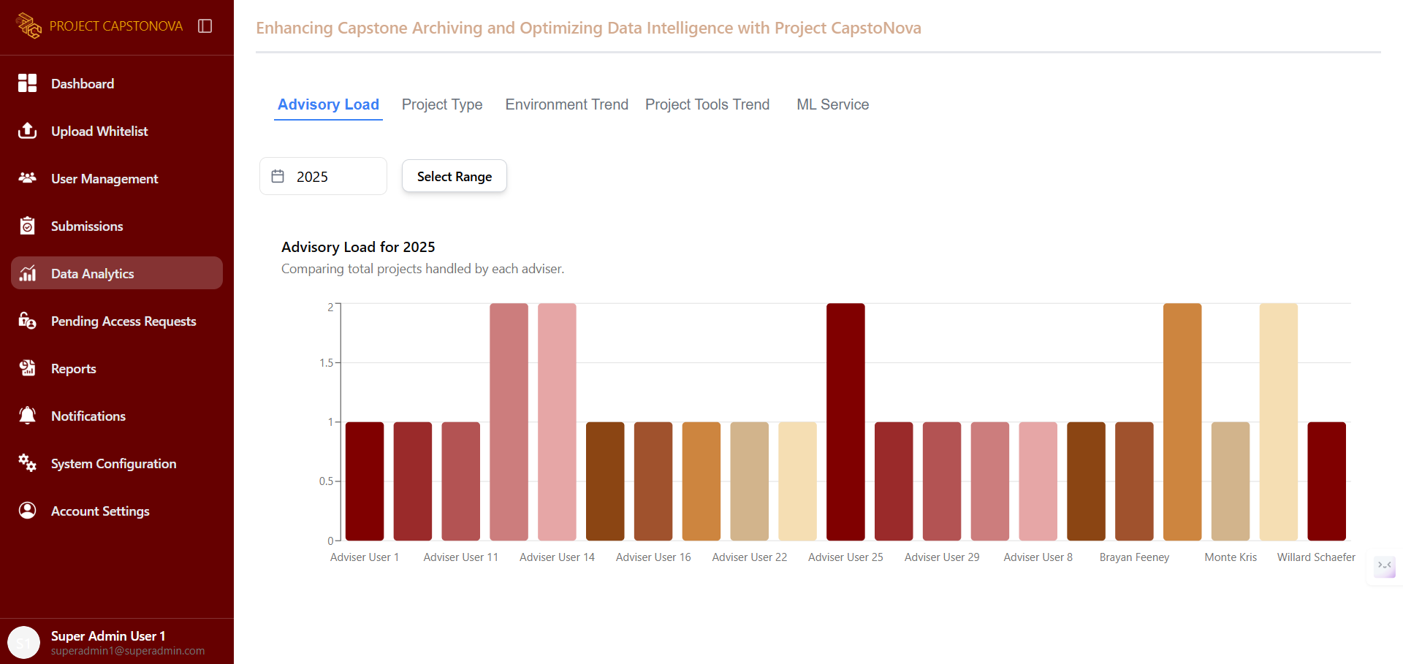

Figure 95. Super Admin - DA Advisory Load UI

This tab in the Data Analytics page displays the Advisory Load, showing and comparing the total number of projects handled by each adviser.

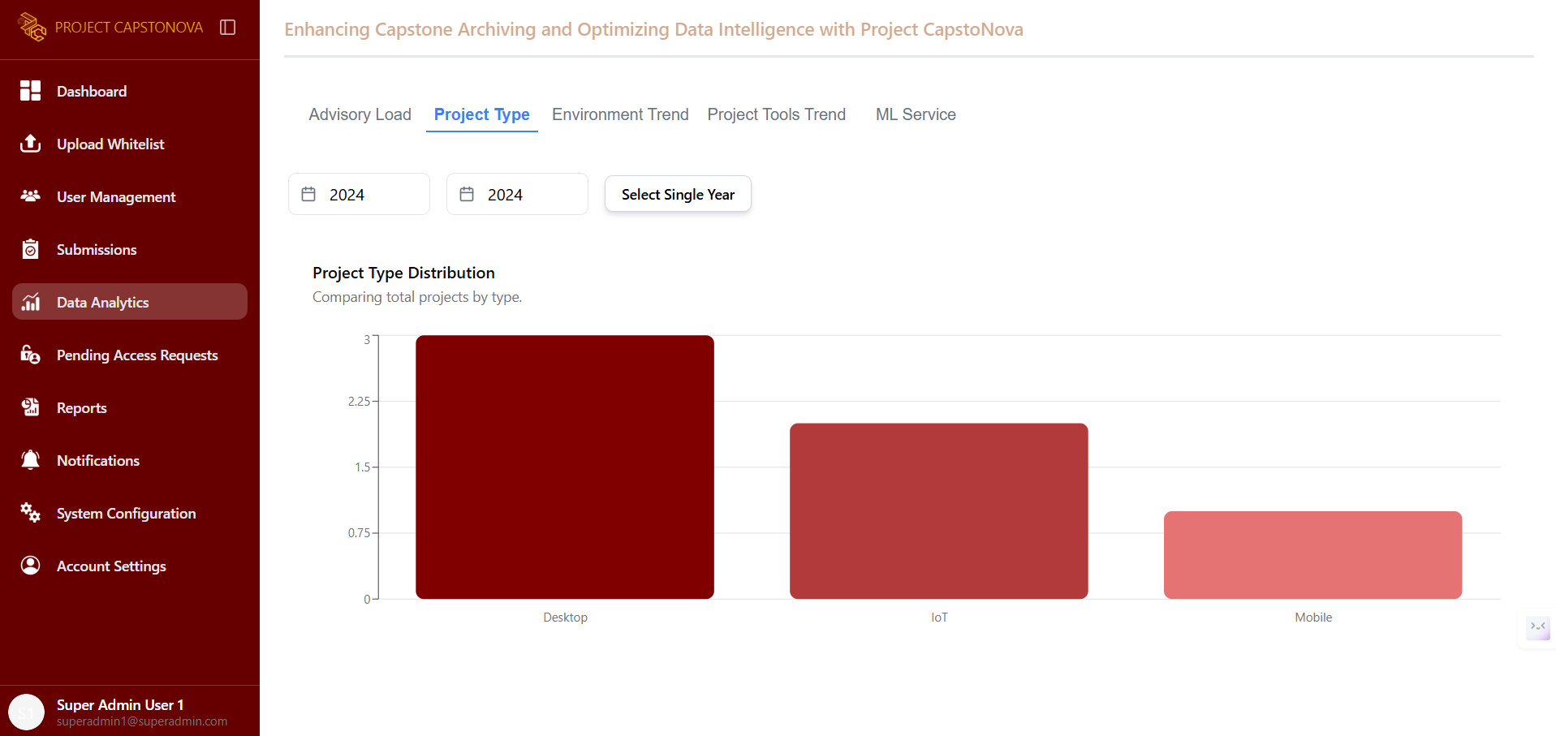

Figure 96. Super Admin - DA Project Type UI

This tab in the Data Analytics page displays the Project Type, showing and comparing the total projects by type.

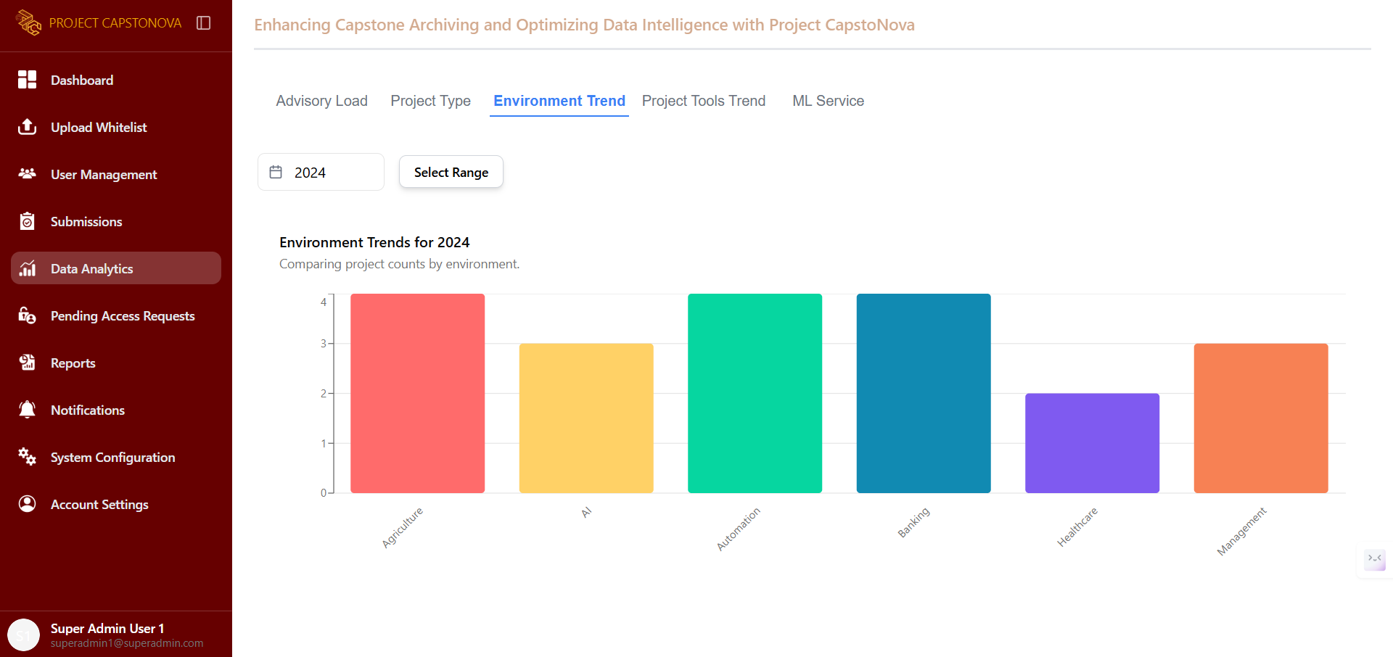

Figure 97. Super Admin - DA Environment Trend UI

This tab in the Data Analytics page displays the Environment Trend, showing and comparing project counts by environment.

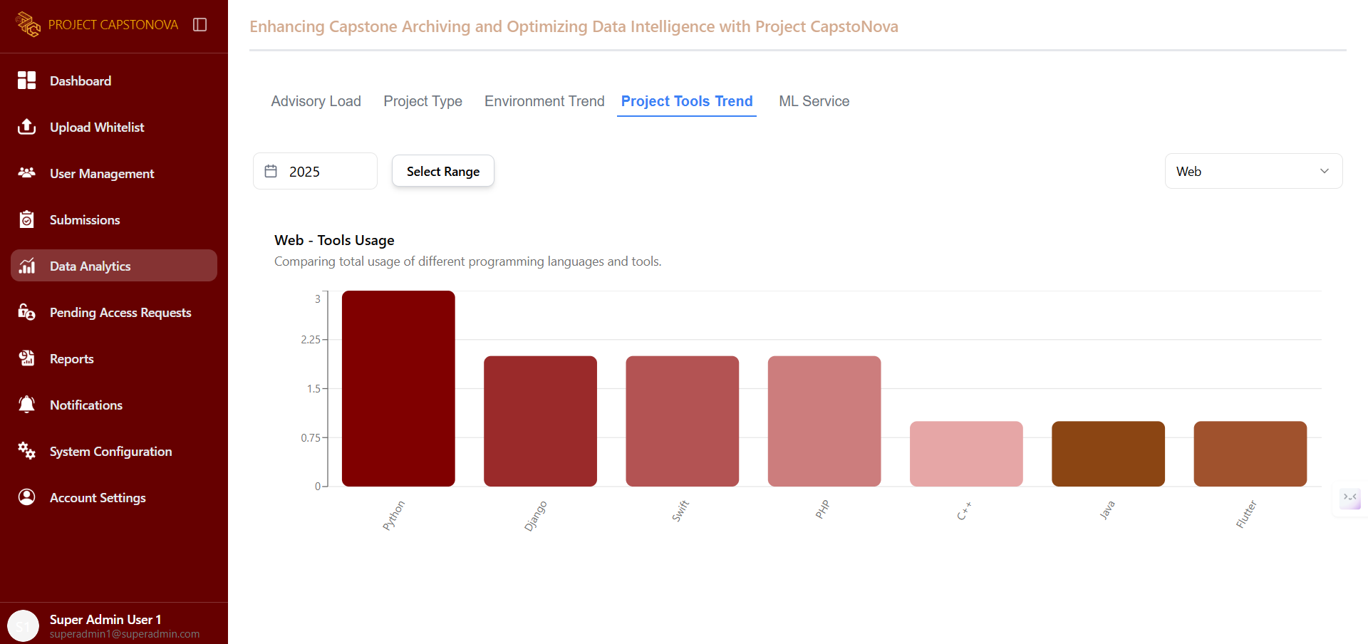

Figure 98. Admin - DA Project Tools Trend UI

This tab in the Data Analytics page displays the Project Tools Trend, showing and comparing the total usage of different programming languages and tools.

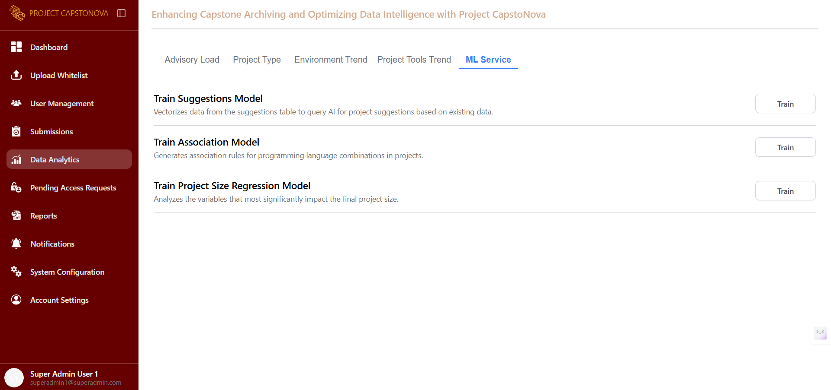

Figure 99. Super Admin - DA ML Service UI

This section provides the Super Admin with tools to train machine learning models that support data-driven decision-making. It includes models for generating project suggestions, identifying programming language patterns, and analyzing factors that influence project size. Each model can be trained with existing project data to enhance system intelligence and provide more accurate insights.

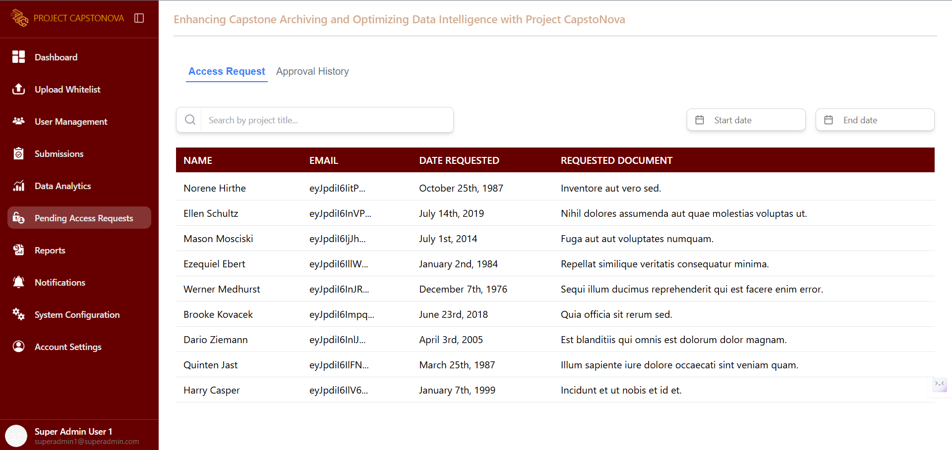

Figure 100. Super Admin - Pending Access Requests UI

This page allows the Super Admin to view all pending access requests from viewers and either approve or decline them.

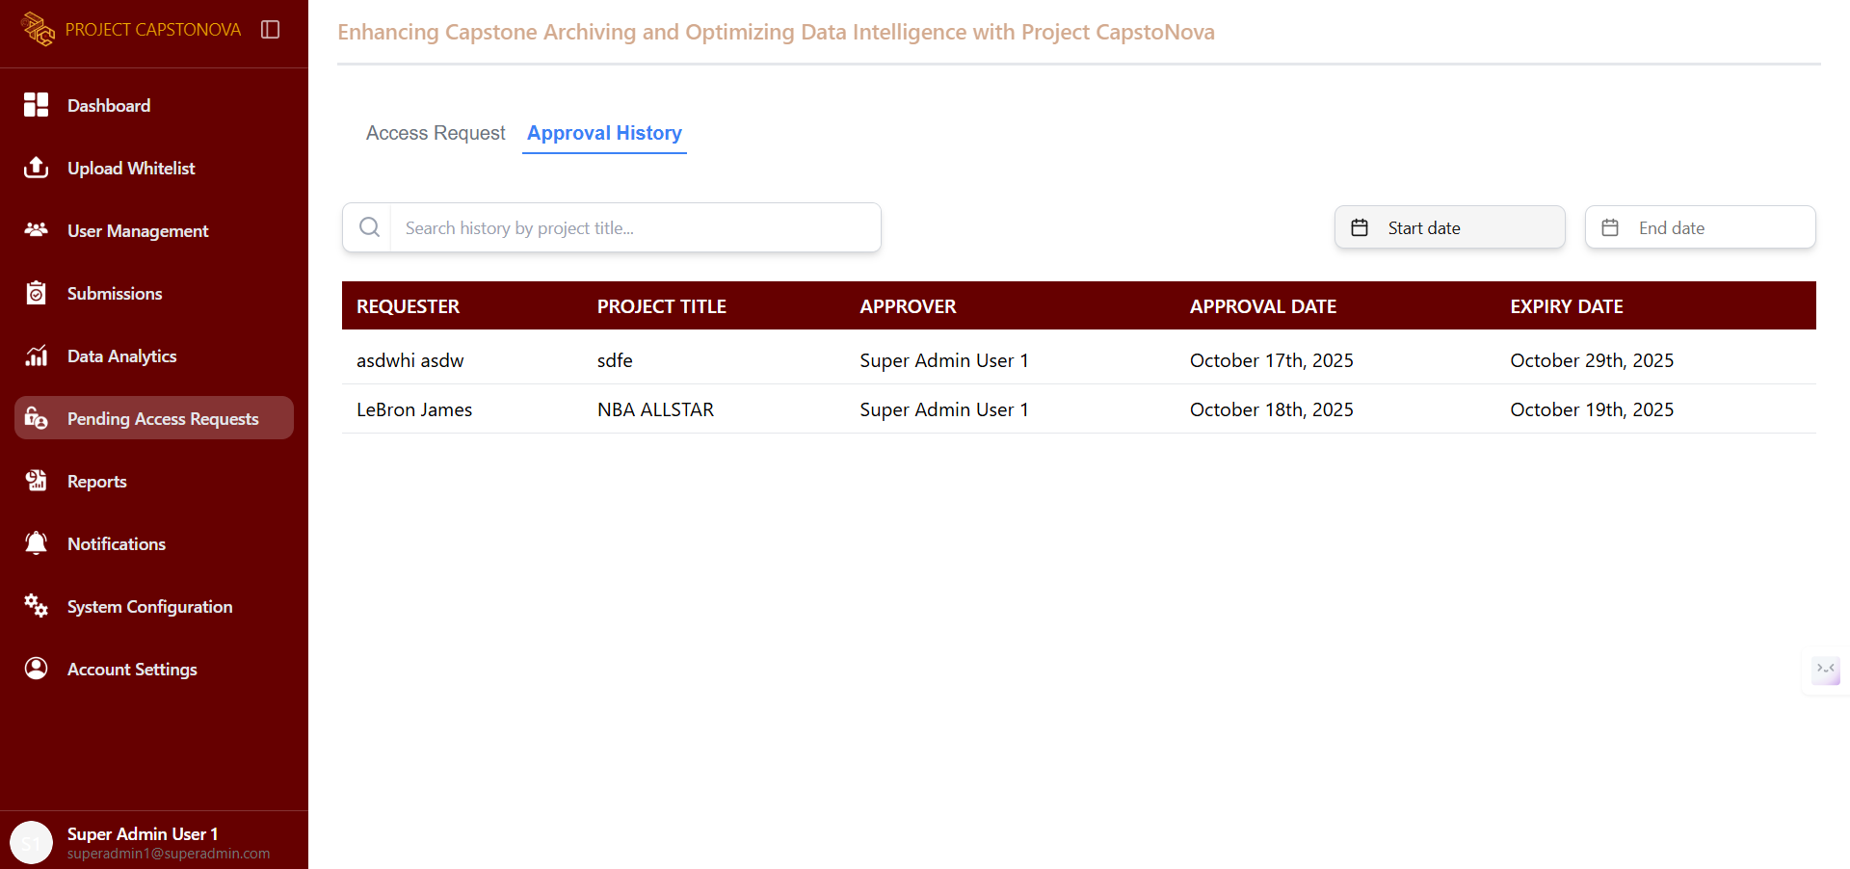

Figure 101. Super Admin - Approval History UI

This page allows the Super Admin to view all approved access requests, displaying the viewers’ approval details.

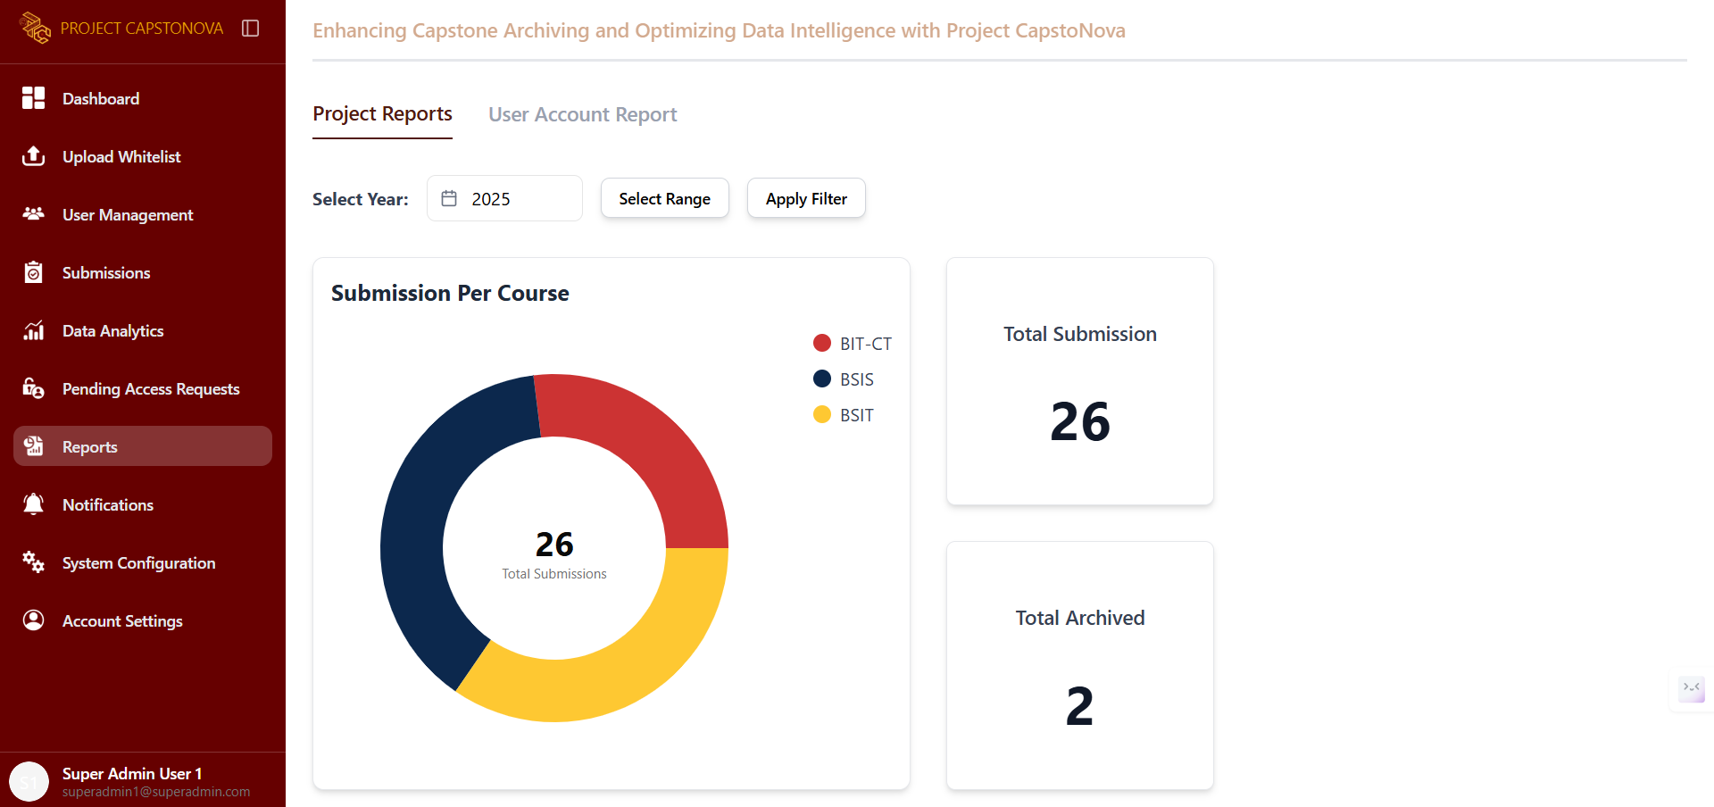

Figure 102. Super Admin - Project Reports UI

This tab in the Reports page, the Project Reports tab, shows the total number of submissions per course.

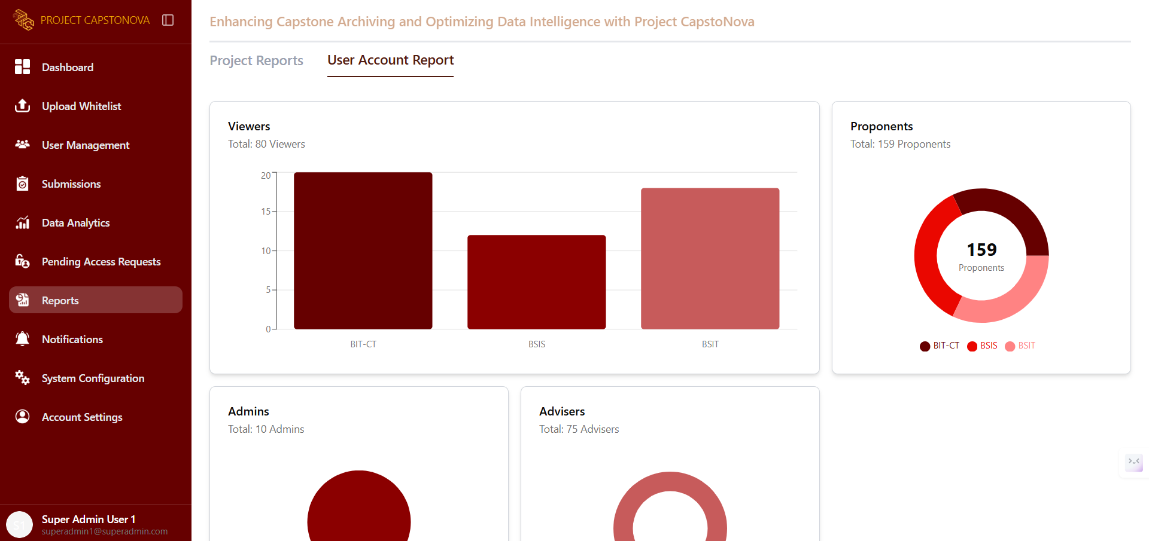

Figure 103. Super Admin - User Account Report UI

This tab in the Reports page, the User Account Report tab, displays a summary of all users and shows the total number of accounts.

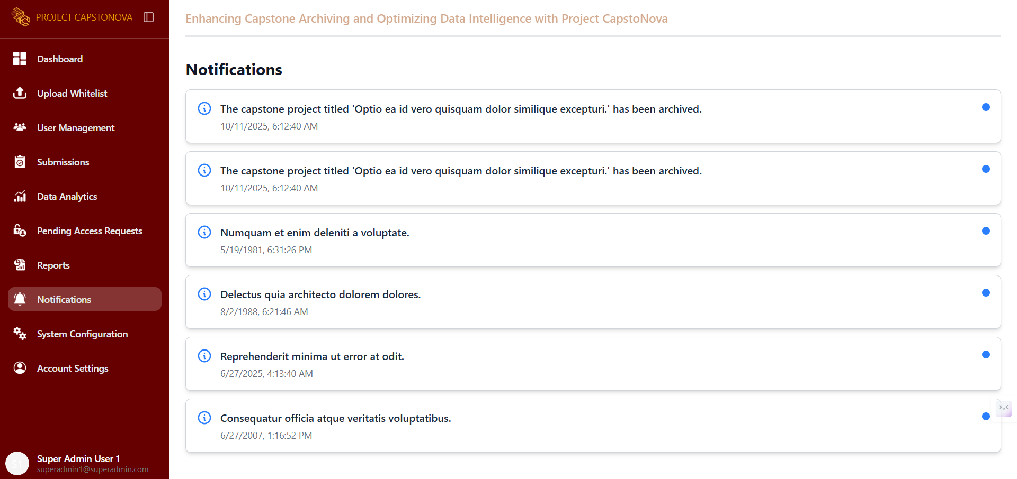

Figure 104. Super Admin - Notification UI

This page displays all system notifications.

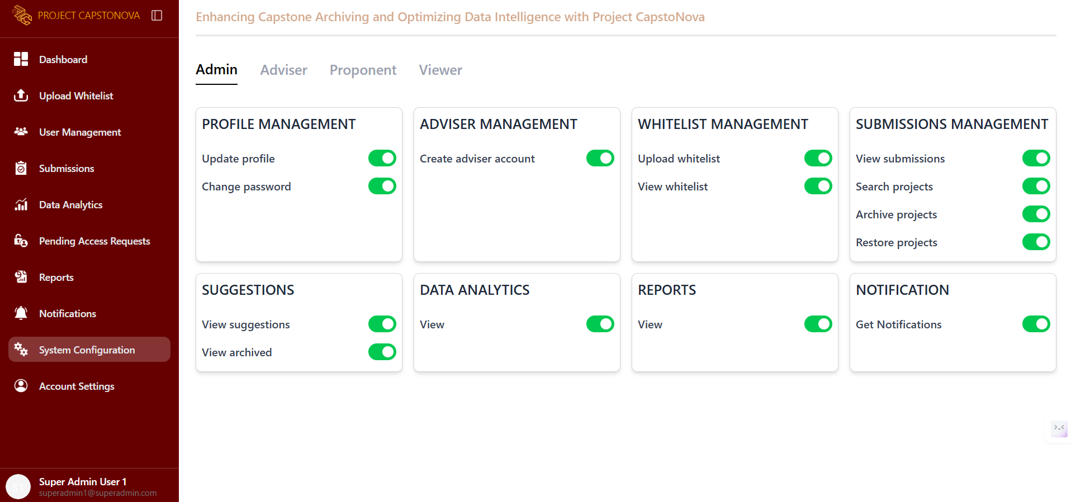

Figure 105. Super Admin - SysConfig Admin UI

This page is for system configuration, displaying all settings and configurations available for the admin user.

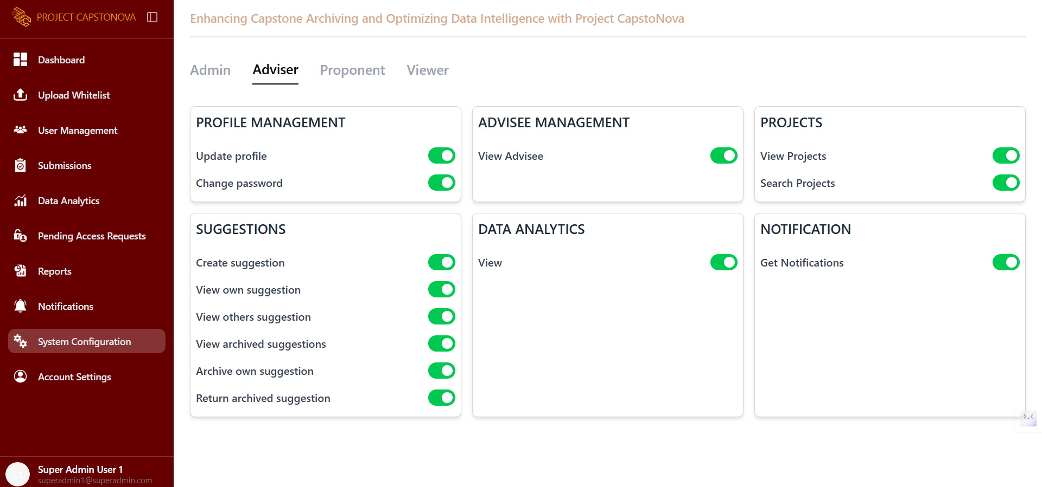

Figure 106. Super Admin - SysConfig Adviser UI

This page is for system configuration, displaying all settings and configurations available for the adviser user.

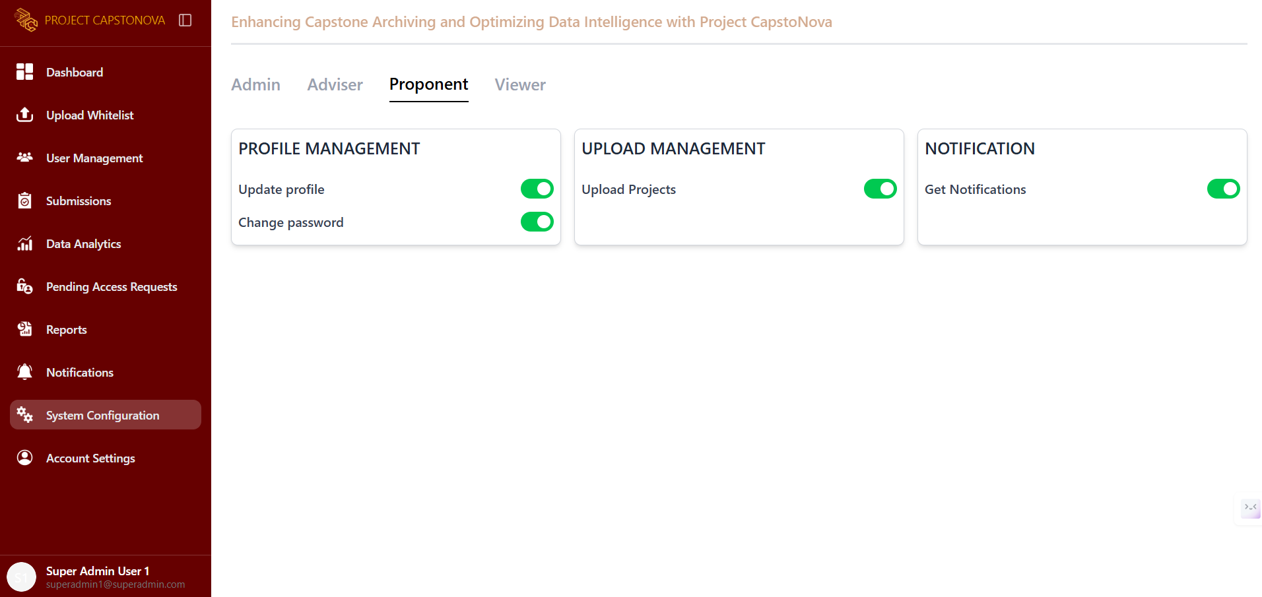

Figure 107. Super Admin - SysConfig Proponent UI

This page is for system configuration, displaying all settings and configurations available for the proponent user.

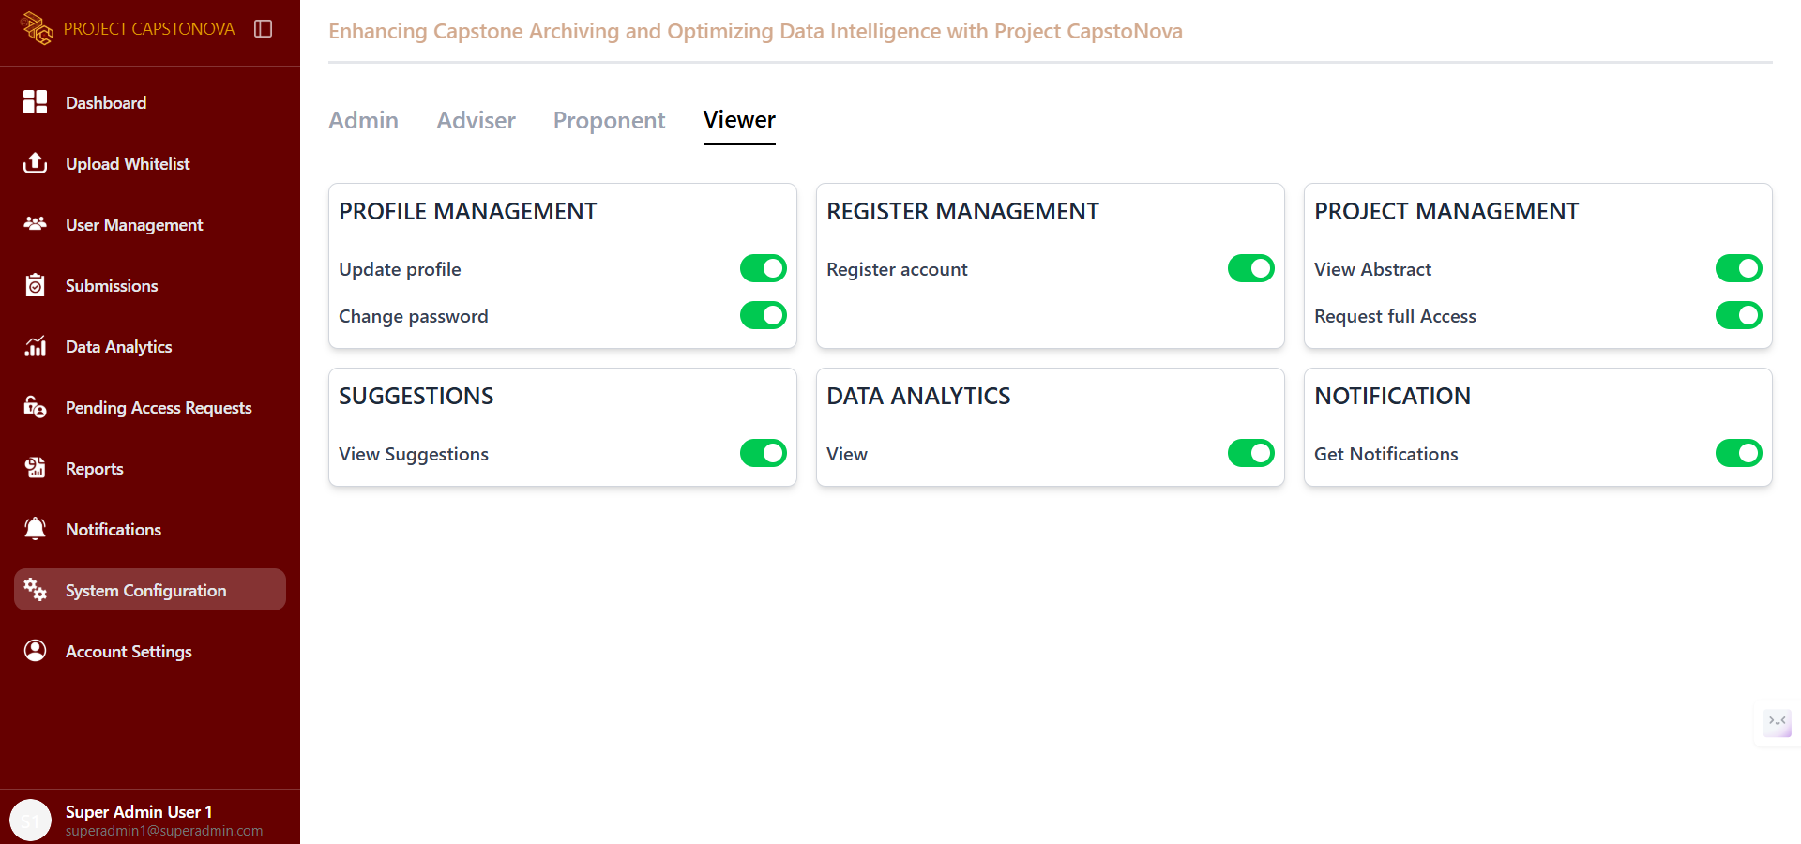

Figure 108. Super Admin - SysConfig Viewers UI

This page is for system configuration, displaying all settings and configurations available for the viewer user.

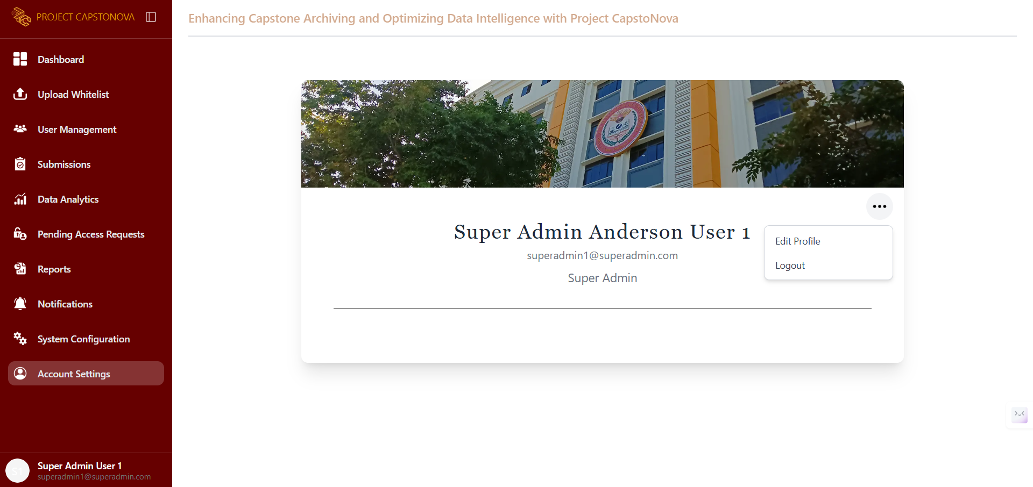

Figure 109. Super Admin - Account Settings UI

This page displays the Super Admin’s account settings, including their full name, email, and user role. It also provides options to edit the profile or log out.

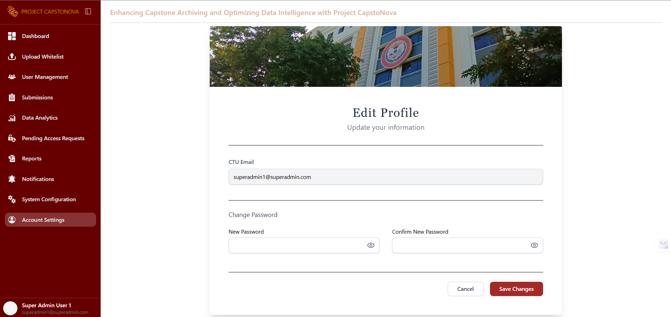

Figure 110. Super Admin - Update Profile UI

This page allows the Super Admin to update their profile.

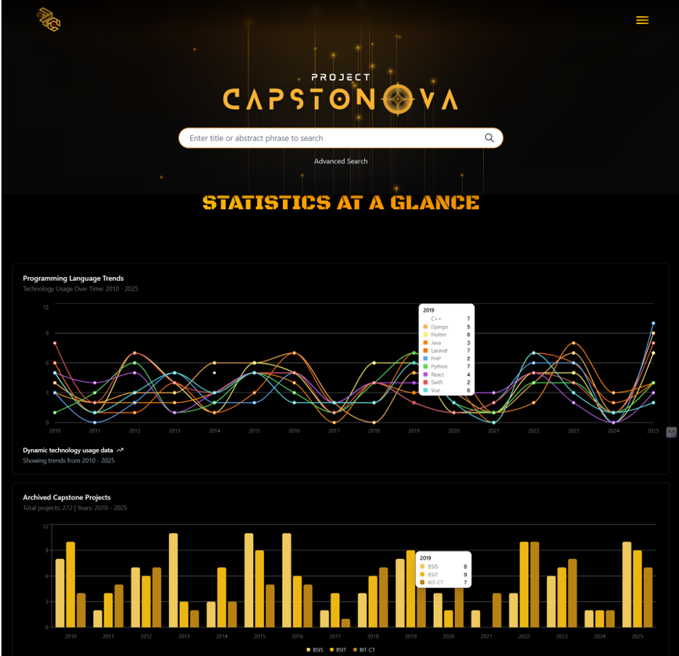

Figure 111. Viewers- Welcome Page One UI

This is the welcome page for viewer users, featuring a search bar with advanced search options. It also displays a summary of the analytics on programming language trends and archived capstone projects.

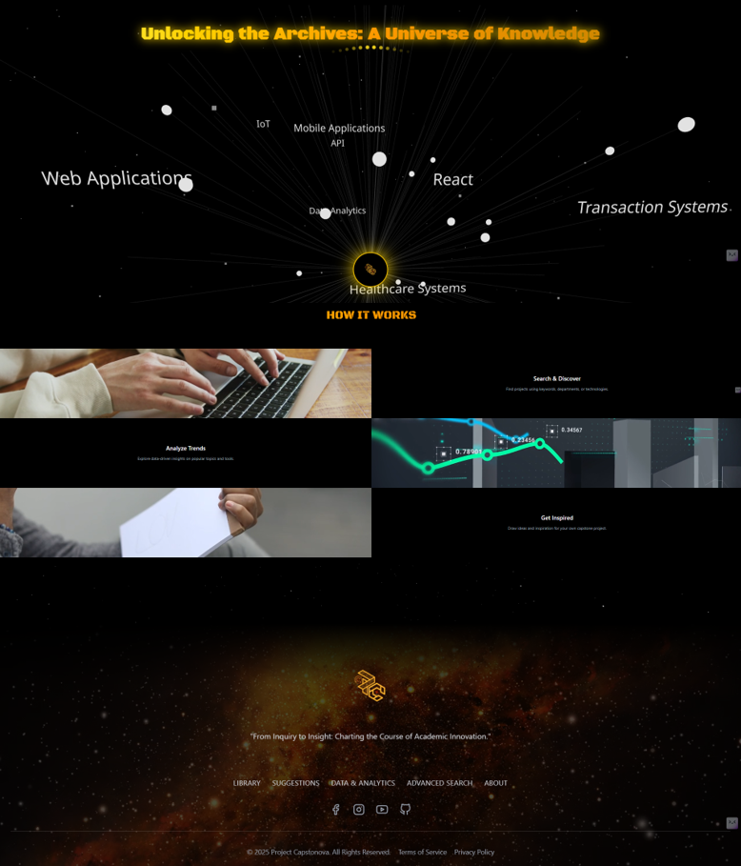

Figure 112. Viewers- Welcome Page Two UI

When the welcome page is scrolled down, it reveals an interactive section featuring a dynamic visualization of project categories and technologies. It also provides quick access to key features such as analyzing trends, searching projects, and getting inspiration. A footer with navigation links and social media icons appears at the bottom.

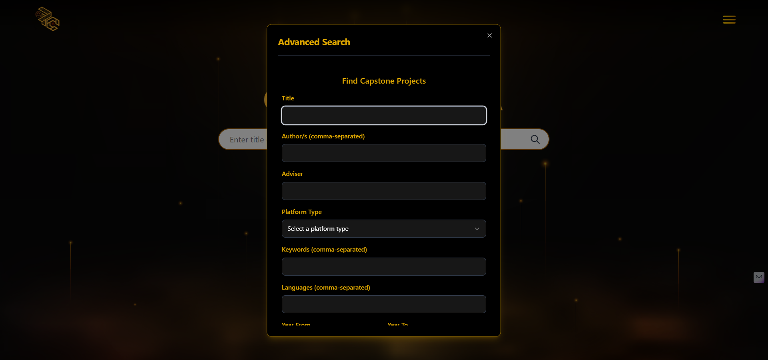

Figure 113. Viewer- Advanced Search UI

This is part of the welcome page for Viewer users, featuring an advanced search to help users easily find desired projects or results. Viewers can input the adviser’s name, authors, area of study, and date range.

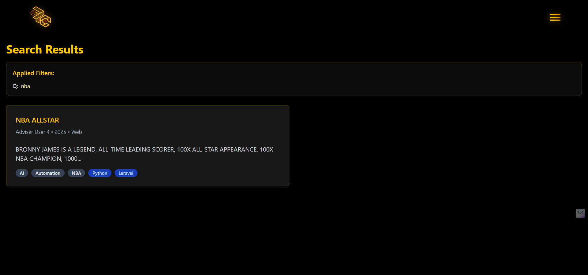

Figure 114. Viewer- Search Project UI

The results of all the entered project titles and their related matches will be displayed here.

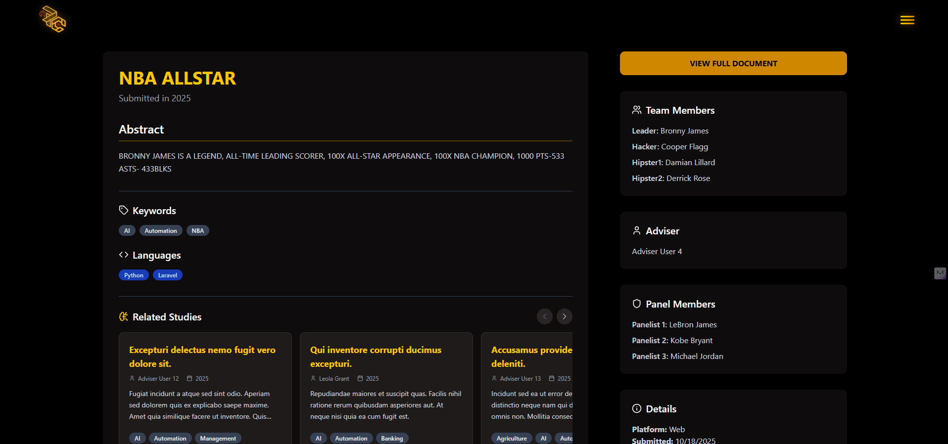

Figure 115. Viewer- View Abstract UI

This page displays only the abstract of the selected project from the search results.



Figure 116. Viewer - Sign Up Page UI

This page appears when a viewer doesn’t have an account and wants to request the full document of a capstone project. It displays a sign-up form for the viewer to fill out.

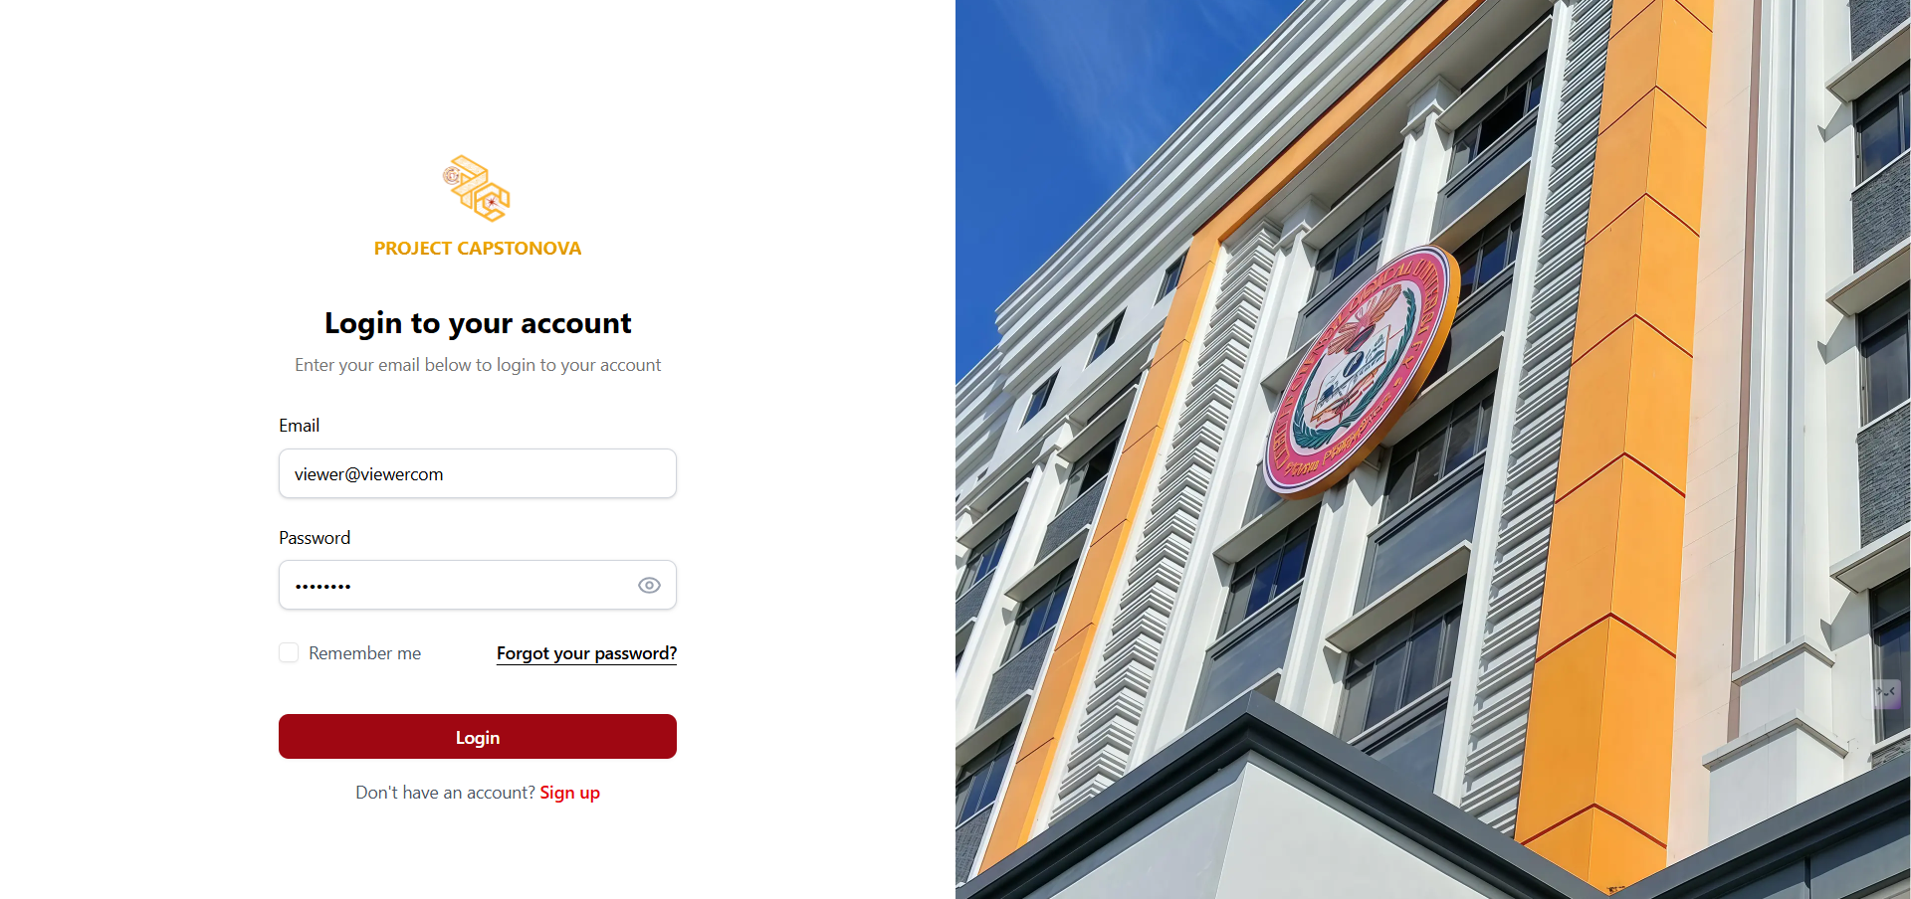

Figure 117. Viewer - Login Page UI

This page display once the viewer finishes filling out the sign-up form, they can log in through the login page.

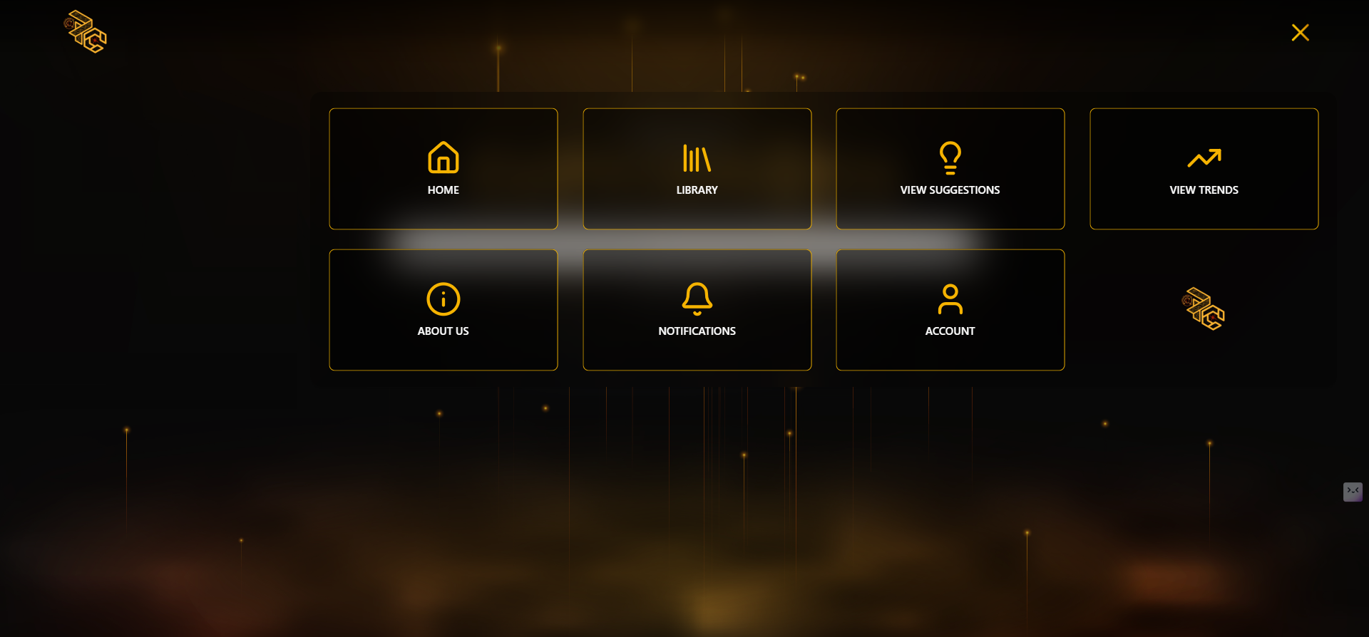

Figure 118. Viewer- Menu UI

This is part of the welcome page, displaying a menu with options such as Home, Library, View Suggestions, View Trends, About Us, Notifications, and Account.

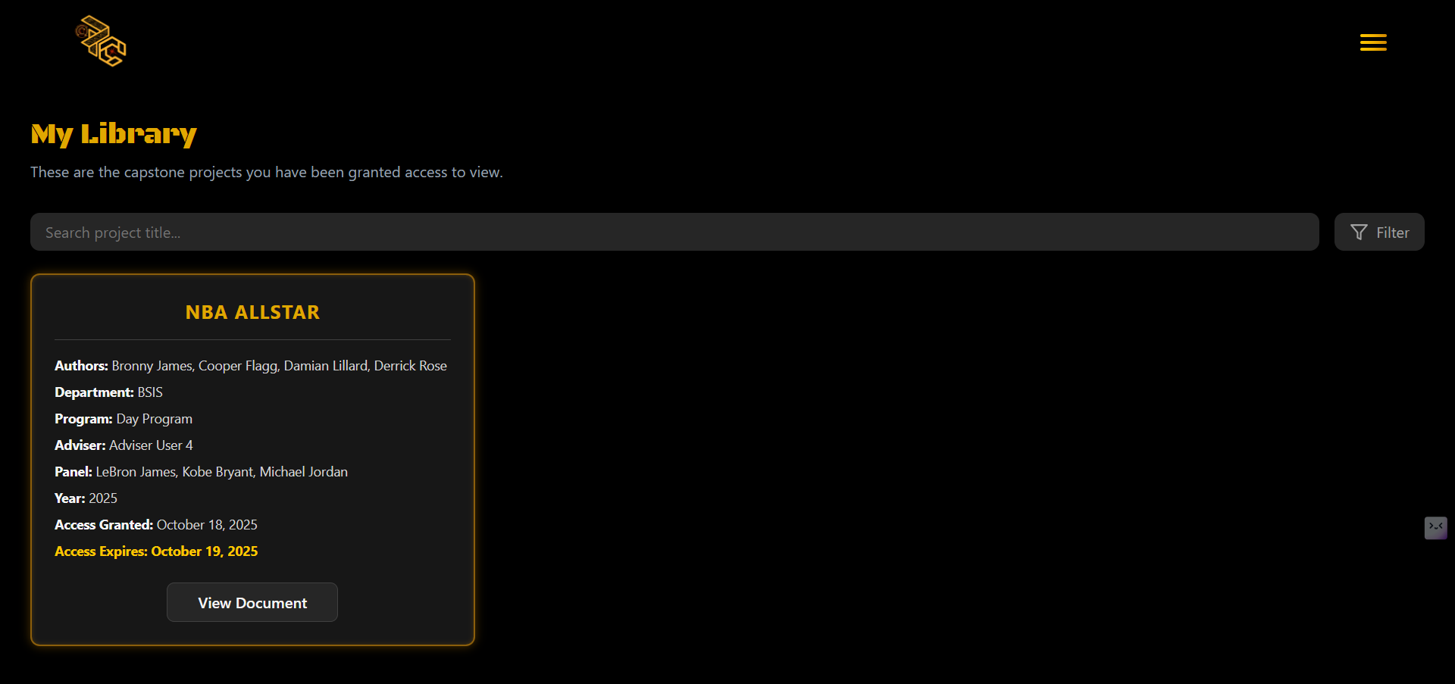

Figure 119. Viewer - Library UI

This is part of the welcome page sidebar for Viewer users, displaying the personal library for those who already have an account. Projects with approved full document access are stored here, showing the title and date of each. Clicking on a title reveals the full details of the project.

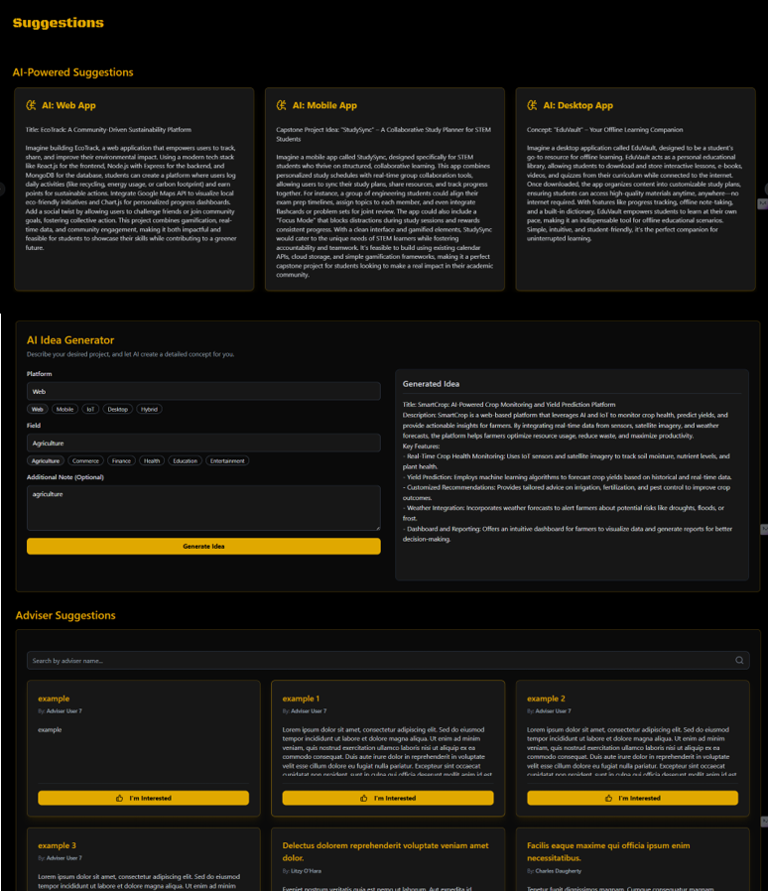

Figure 120. Viewer - View Suggestions UI

This is the suggestion page, where AI-powered suggestions and adviser recommendations are displayed. It includes buttons and indicators showing whether the viewer is interested in a suggestion or if it has already been marked as interested by other viewers.

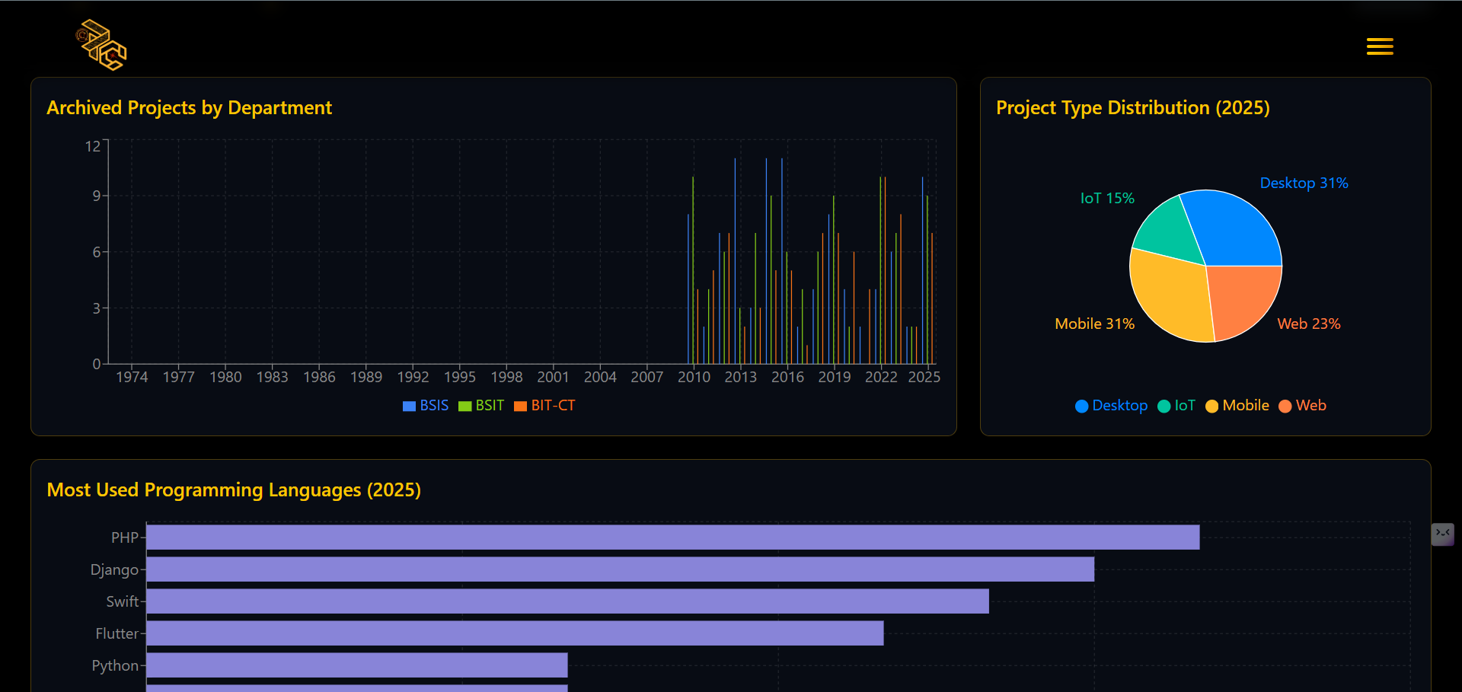

Figure 121. Viewer - View Trends UI

This is the View Trends page for Viewer users, displaying analytics and insights on project trends based on all projects uploaded to the system.

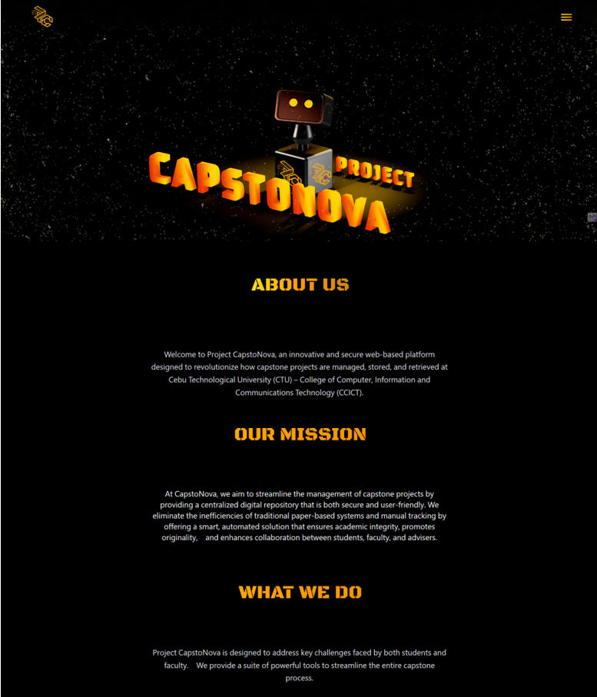

Figure 122. Viewer - About Us One UI

This is the About Us page, which shows a brief description of the system, its mission, and what we do.

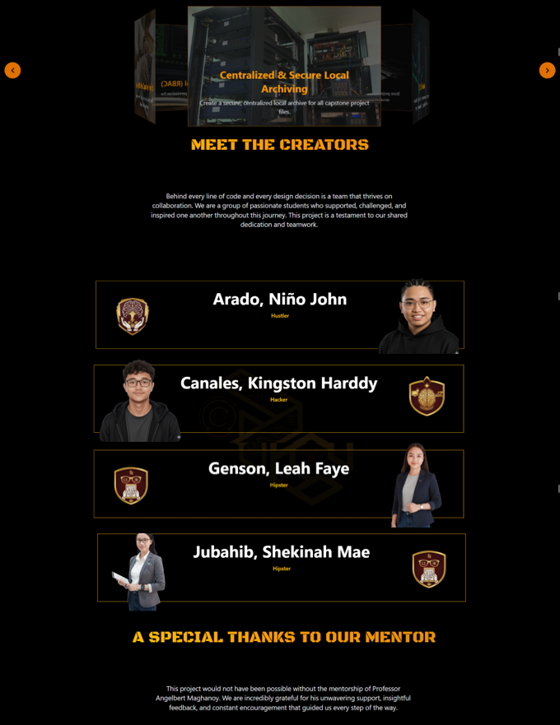

Figure 123. Viewer - About Us Two UI

This is the section of the About Us page that appears when scrolled down, showing some featured key challenges and tools, as well as the team who built the system.

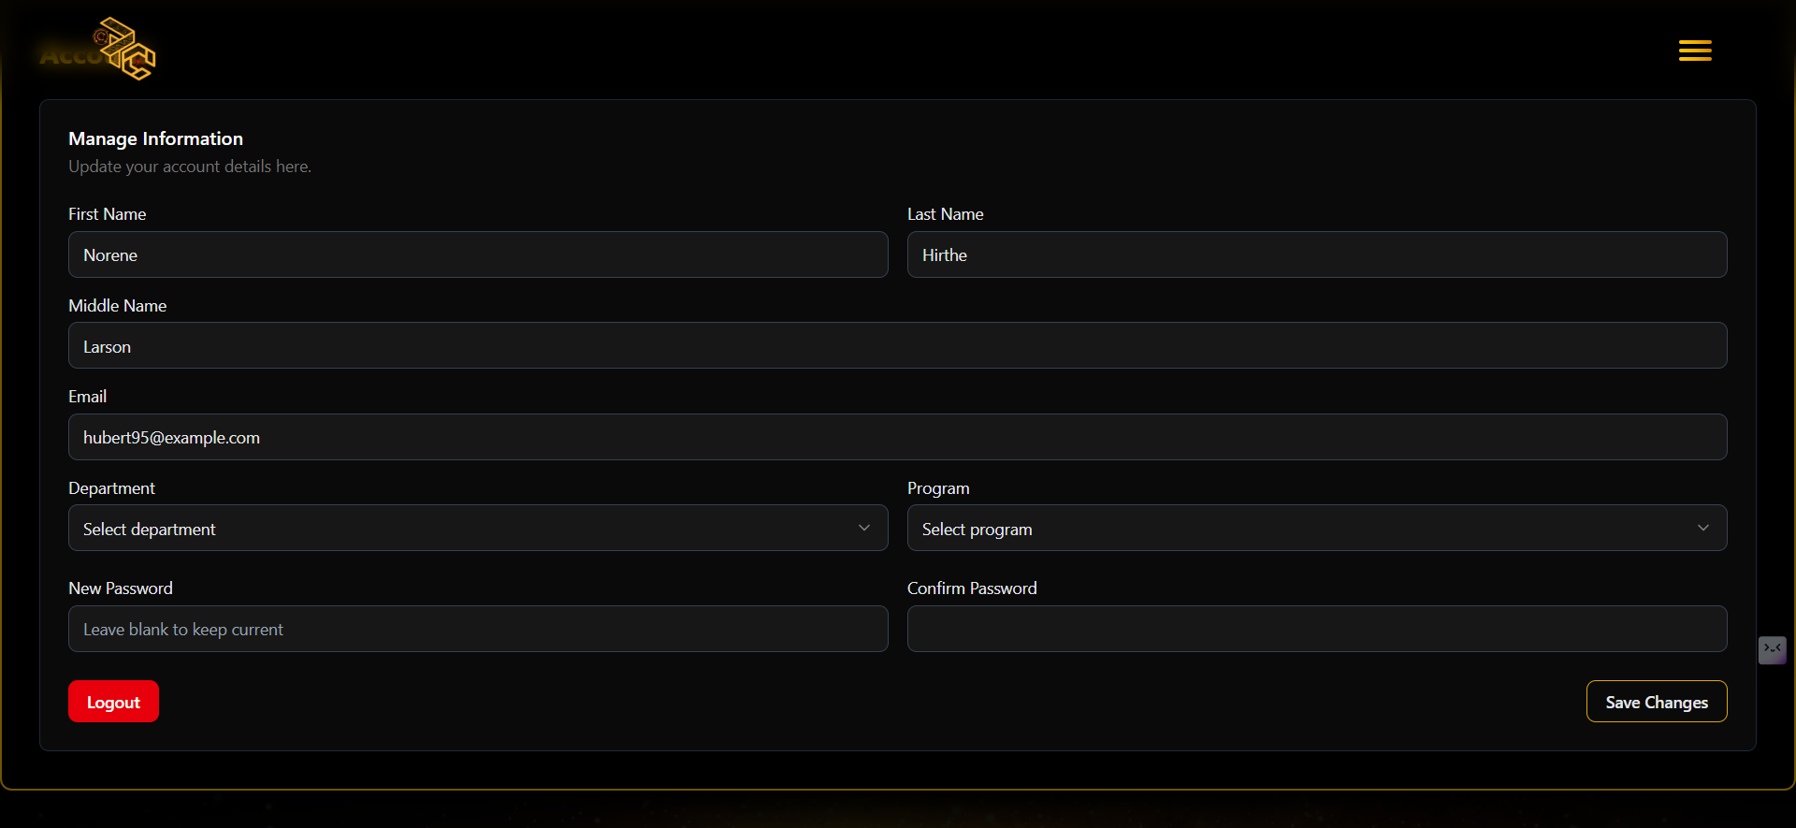

Figure 124. Viewers- Account Page UI

This is the account page, featuring a form for users who wish to view or update their account information. They can enter their full name, CTU email, department, course, program, and password.

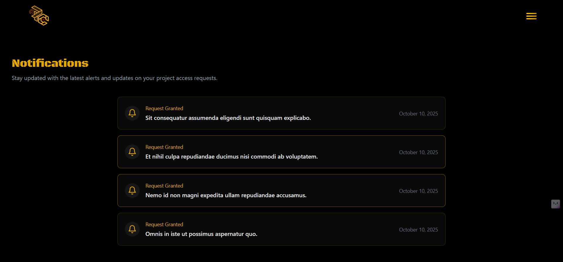

Figure 125. Viewer - Notification UI

This is part of the welcome page sidebar for Viewer users, displaying notifications especially those related to requests for full document access to projects.

#### **Database Design**

##### **Entity Relationship Diagram**

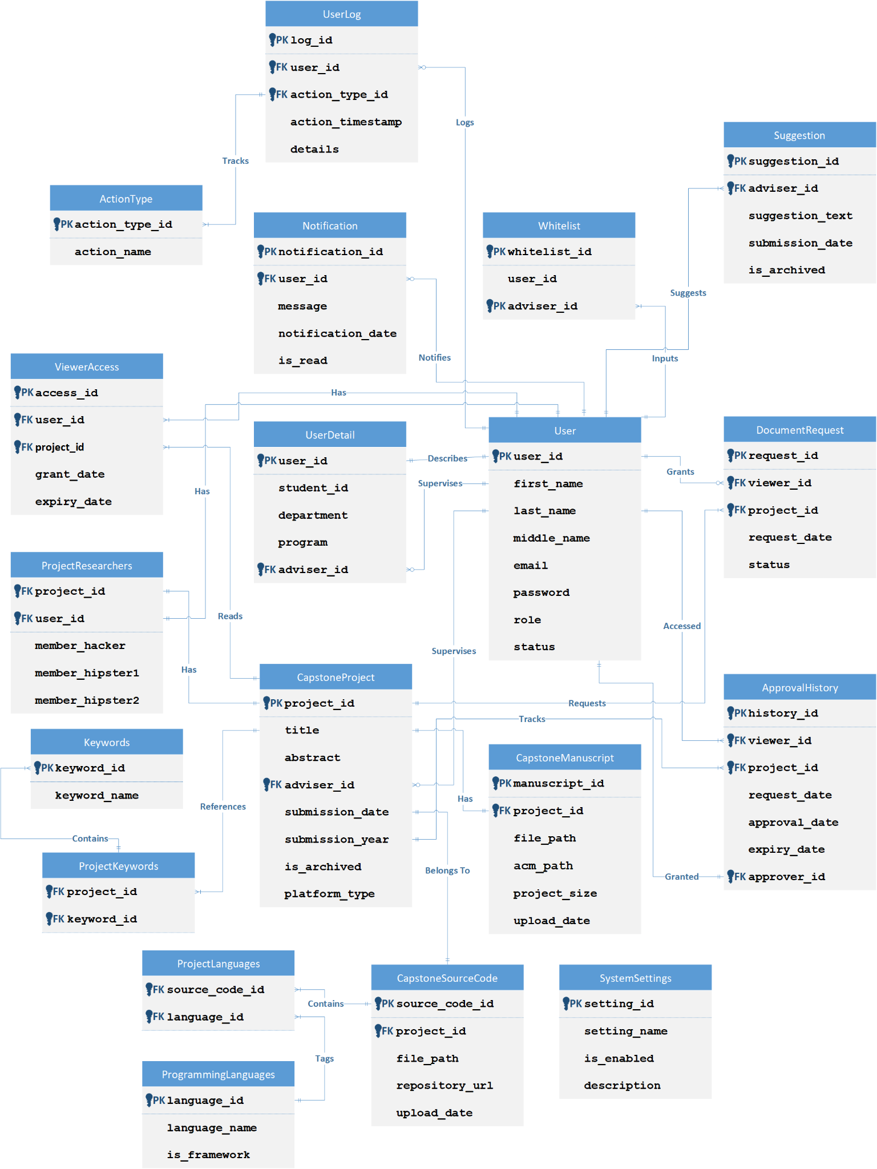

Figure 126. Entity Relationship Diagram

An Entity Relationship Diagram (ERD) is a simple visual tool that shows how parts of a system, like people or things, are connected. It helps plan and organize a database, making it easier to understand how data is linked and stored. ERDs also help avoid design errors and are useful for both technical and non-technical users.

##### **Data Dictionary**

**Table 2. User**

|  |  |  |  |  |  |  |  |
| --- | --- | --- | --- | --- | --- | --- | --- |
| **Attribute Name** | **Contents** | **Type** | **Format** | **Range** | **Required** | **PK/FK** | **FK Reference_ID Table** |
| user_id | Unique identifier for user | INTEGER | Integer |  | Y | PK |  |
| first_name | User’s first name | VARCHAR(100) | Alphanumeric | 1-100 | Y |  |  |
| last_name | User’s last name | VARCHAR(100) | Alphanumeric | 1-100 | Y |  |  |
| middle_name | User’s middle name | VARCHAR(100) | Alphanumeric | 0-100 | N |  |  |
| email | Email address | VARCHAR(255) | Alphanumeric (Unique) | 1-255 | Y |  |  |
| password | User’s password | VARCHAR(255) | Alphanumeric | 1-255 | Y |  |  |
| role | User’s role | ENUM('Super Admin', 'Admin', 'Adviser', 'Proponent', 'Viewer') | 'Super Admin'/'Admin'/'Adviser'/'Proponent'/'Viewer' |  | Y |  |  |
| status | Account status | ENUM('active', 'inactive', 'restricted') | 'active'/'inactive'/'restricted' (Default: 'active') |  | Y |  |  |

**Table 3. User Details**

|  |  |  |  |  |  |  |  |
| --- | --- | --- | --- | --- | --- | --- | --- |
| **Attribute Name** | **Contents** | **Type** | **Format** | **Range** | **Required** | **PK/FK** | **FK Reference_ID Table** |
| user_id | Links to User | INTEGER | Integer |  | Y | PK/FK | User(user_id) |
| student_id | Student’s school ID | VARCHAR(50) | Alphanumeric | 1-50 | Y |  |  |
| department | Department | VARCHAR(50) | Alphanumeric | 1-50 | Y |  |  |
| program | Program | VARCHAR(50) | Alphanumeric | 1-50 | Y |  |  |
| adviser_id | Assigned adviser (References User table) | INTEGER | Integer |  | Y | FK | User(user_id) |

**Table 4. Capstone Project**

|  |  |  |  |  |  |  |  |
| --- | --- | --- | --- | --- | --- | --- | --- |
| **Attribute Name** | **Contents** | **Type** | **Format** | **Range** | **Required** | **PK/FK** | **FK Reference_ID Table** |
| project_id | Unique identifier | INTEGER | Integer |  | Y | PK |  |
| title | Project title | VARCHAR(255) | Alphanumeric | 1-255 | Y |  |  |
| abstract | Abstract, publicly accessible | TEXT | Text |  | Y |  |  |
| adviser_id | Assigned adviser | INTEGER | Integer |  | Y | FK | User(user_id) |
| submission_date | Project submission date | DATE | YYYY-MM-DD |  | Y |  |  |
| submission_year | Year of project submission | INTEGER | Integer |  | Y |  |  |
| is_archived | Flag archived projects | BOOLEAN | True/False (Default: False) |  | Y |  |  |
| platform_type | Project Type (e.g., Web, Mobile, IoT) | VARCHAR(50) | Alphanumeric | 1-50 | Y |  |  |

**Table 5. Capstone Manuscript**

|  |  |  |  |  |  |  |  |
| --- | --- | --- | --- | --- | --- | --- | --- |
| **Attribute Name** | **Contents** | **Type** | **Format** | **Range** | **Required** | **PK/FK** | **FK Reference_ID Table** |
| manuscript_id | Unique identifier | INTEGER | Integer |  | Y | PK |  |
| project_id | Unique Identifier | INTEGER | Integer |  | Y | FK | CapstoneProject(project_id) |
| file_path | Path to the stored manuscript file | VARCHAR(255) | Alphanumeric | 1-255 | Y |  |  |
| acm_path | Path to the ACM document | VARCHAR(255) | Alphanumeric | 1-255 | Y |  |  |
| project_size | Manuscript file size in MB | FLOAT | Float |  | Y |  |  |
| upload_date | Upload timestamp | DATETIME | YYYY-MM-DD HH:MM |  | Y |  |  |

**Table 6. Capstone Source Code**

|  |  |  |  |  |  |  |  |
| --- | --- | --- | --- | --- | --- | --- | --- |
| **Attribute Name** | **Contents** | **Type** | **Format** | **Range** | **Required** | **PK/FK** | **FK Reference_ID Table** |
| source_code_id | Unique identifier | INTEGER | Integer |  | Y | PK |  |
| project_id | Unique Identifier | INTEGER | Integer |  | Y | FK | CapstoneProject(project_id) |
| file_path | Path to the stored source code file | VARCHAR(255) | Alphanumeric | 0-255 | N |  |  |
| repository_url | External repository link | VARCHAR(255) | Alphanumeric | 0-255 | N |  |  |
| upload_date | Upload timestamp for file or link | DATETIME | YYYY-MM-DD HH:MM |  | Y |  |  |

**Table 7. Project Researchers**

|  |  |  |  |  |  |  |  |
| --- | --- | --- | --- | --- | --- | --- | --- |
| **Attribute Name** | **Contents** | **Type** | **Format** | **Range** | **Required** | **PK/FK** | **FK Reference_ID Table** |
| project_id | Unique identifier | INTEGER | Integer |  | Y | PK/FK | CapstoneProject(project_id) |
| user_id | Proponent (leader) | INTEGER | Integer |  | Y | PK/FK | User(user_id) |
| member_hacker | Hacker member’s name | VARCHAR(255) | Alphanumeric | 1-255 | Y |  |  |
| member_hipster1 | First Hipster member’s name | VARCHAR(255) | Alphanumeric | 1-255 | Y |  |  |
| member_hipster2 | Second Hipster member’s name | VARCHAR(255) | Alphanumeric | 0-255 | N |  |  |

**Table 8. Programming Languages**

|  |  |  |  |  |  |  |  |
| --- | --- | --- | --- | --- | --- | --- | --- |
| **Attribute Name** | **Contents** | **Type** | **Format** | **Range** | **Required** | **PK/FK** | **FK Reference_ID Table** |
| language_id | Unique identifier | INTEGER | Integer |  | Y | PK |  |
| language_name | Programming Language | VARCHAR(50) | Alphanumeric (Unique) | 1-50 | Y |  |  |
| is_framework | Is it a framework? | BOOLEAN | True/False |  | Y |  |  |

**Table 9. Project Languages**

|  |  |  |  |  |  |  |  |
| --- | --- | --- | --- | --- | --- | --- | --- |
| **Attribute Name** | **Contents** | **Type** | **Format** | **Range** | **Required** | **PK/FK** | **FK Reference_ID Table** |
| source_code_id | Source Code Link | INTEGER | Integer |  | Y | PK/FK | CapstoneSourceCode(source_code_id) |
| language_id | Language Link | INTEGER | Integer |  | Y | PK/FK | ProgrammingLanguages(language_id) |

**Table 10. Keywords**

|  |  |  |  |  |  |  |  |
| --- | --- | --- | --- | --- | --- | --- | --- |
| **Attribute Name** | **Contents** | **Type** | **Format** | **Range** | **Required** | **PK/FK** | **FK Reference_ID Table** |
| keyword_id | Unique identifier | INTEGER | Integer |  | Y | PK |  |
| keyword_name | Keyword | VARCHAR(50) | Alphanumeric (Unique) | 1-50 | Y |  |  |

**Table 11. Project Keywords**

|  |  |  |  |  |  |  |  |
| --- | --- | --- | --- | --- | --- | --- | --- |
| **Attribute Name** | **Contents** | **Type** | **Format** | **Range** | **Required** | **PK/FK** | **FK Reference_ID Table** |
| project_id | Project Link | INTEGER | Integer |  | Y | PK/FK | CapstoneProject(project_id) |
| keyword_id | Keyword Link | INTEGER | Integer |  | Y | PK/FK | Keywords(keyword_id) |

**Table 12. Document Request**

|  |  |  |  |  |  |  |  |
| --- | --- | --- | --- | --- | --- | --- | --- |
| **Attribute Name** | **Contents** | **Type** | **Format** | **Range** | **Required** | **PK/FK** | **FK Reference_ID Table** |
| request_id | Unique identifier | INTEGER | Integer |  | Y | PK |  |
| Viewer_id | Requesting Viewer | INTEGER | Integer |  | Y | FK | User(user_id) |
| project_id | Target Project | INTEGER | Integer |  | Y | FK | CapstoneProject(project_id) |
| request_date | Submission Date | DATETIME | YYYY-MM-DD HH:MM |  | Y |  |  |
| status | Request Status | ENUM('pending', 'approved', 'rejected') | 'pending'/'approved'/'rejected' (Default: 'pending') |  | Y |  |  |

**Table 13. Viewer Access**

|  |  |  |  |  |  |  |  |
| --- | --- | --- | --- | --- | --- | --- | --- |
| **Attribute Name** | **Contents** | **Type** | **Format** | **Range** | **Required** | **PK/FK** | **FK Reference_ID Table** |
| access_id | Unique identifier | INTEGER | Integer |  | Y | PK |  |
| user_id | Viewer with access | INTEGER | Integer |  | Y | FK | User(user_id) |
| project_id | Target Project | INTEGER | Integer |  | Y | FK | CapstoneProject(project_id) |
| grant_date | Date access granted | DATETIME | YYYY-MM-DD HH:MM |  | Y |  |  |
| expiry_date | Optional expiration date | DATETIME | YYYY-MM-DD HH:MM |  | N |  |  |

**Table 14. Notification**

|  |  |  |  |  |  |  |  |
| --- | --- | --- | --- | --- | --- | --- | --- |
| **Attribute Name** | **Contents** | **Type** | **Format** | **Range** | **Required** | **PK/FK** | **FK Reference_ID Table** |
| notification_id | Unique identifier | INTEGER | Integer |  | Y | PK |  |
| user_id | Recipient | INTEGER | Integer |  | Y | FK | User(user_id) |
| message | Notification content | TEXT | Text |  | Y |  |  |
| notification_date | Date sent | DATETIME | YYYY-MM-DD HH:MM |  | Y |  |  |
| is_read | Read status | BOOLEAN | True/False (Default: False) |  | Y |  |  |

**Table 15. Whitelist**

|  |  |  |  |  |  |  |  |
| --- | --- | --- | --- | --- | --- | --- | --- |
| **Attribute Name** | **Contents** | **Type** | **Format** | **Range** | **Required** | **PK/FK** | **FK Reference_ID Table** |
| whitelist_id | Unique identifier | INTEGER | Integer |  | Y | PK |  |
| user_id | Whitelisted User | INTEGER | Integer |  | Y | FK | User(user_id) |
| adviser_id | Assigned adviser | INTEGER | Integer |  | Y | FK | User(user_id) |

**Table 16. Suggestion**

|  |  |  |  |  |  |  |  |
| --- | --- | --- | --- | --- | --- | --- | --- |
| **Attribute Name** | **Contents** | **Type** | **Format** | **Range** | **Required** | **PK/FK** | **FK Reference_ID Table** |
| suggestion_id | Unique identifier | INTEGER | Integer |  | Y | PK |  |
| adviser_id | Suggesting Adviser | INTEGER | Integer |  | Y | FK | User(user_id) |
| suggestion_text | Idea description | TEXT | Text |  | Y |  |  |
| submission_date | Submission date | DATE | YYYY-MM-DD |  | Y |  |  |
| is_archived | Is the suggestion archived? | BOOLEAN | True/False (Default: False) |  | Y |  |  |

**Table 17. System Settings**

|  |  |  |  |  |  |  |  |
| --- | --- | --- | --- | --- | --- | --- | --- |
| **Attribute Name** | **Contents** | **Type** | **Format** | **Range** | **Required** | **PK/FK** | **FK Reference_ID Table** |
| setting_id | Unique identifier | INTEGER | Integer |  | Y | PK |  |
| setting_name | e.g., 'REPORTS', 'NOTIFICATIONS' | VARCHAR(100) | Alphanumeric (Unique) | 1-100 | Y |  |  |
| is_enabled | Is the setting enabled? | BOOLEAN | True/False (Default: False) |  | Y |  |  |
| description | Setting description | TEXT | Text |  | N |  |  |

**Table 18. Approval History**

|  |  |  |  |  |  |  |  |
| --- | --- | --- | --- | --- | --- | --- | --- |
| **Attribute Name** | **Contents** | **Type** | **Format** | **Range** | **Required** | **PK/FK** | **FK Reference_ID Table** |
| history_id | Unique identifier | INTEGER | Integer |  | Y | PK |  |
| Viewer_id | Viewer ID | INTEGER | Integer |  | Y | FK | User(user_id) |
| project_id | Target Project | INTEGER | Integer |  | Y | FK | CapstoneProject(project_id) |
| request_date | Date request was made | DATETIME | YYYY-MM-DD HH:MM |  | Y |  |  |
| approval_date | Date request was approved | DATETIME | YYYY-MM-DD HH:MM |  | Y |  |  |
| expiry_date | Date access expires | DATETIME | YYYY-MM-DD HH:MM |  | N |  |  |
| approver_id | Approving Admin/Super Admin | INTEGER | Integer |  | Y | FK | User(user_id) |

**Table 19.. Action Type**

|  |  |  |  |  |  |  |  |
| --- | --- | --- | --- | --- | --- | --- | --- |
| **Attribute Name** | **Contents** | **Type** | **Format** | **Range** | **Required** | **PK/FK** | **FK Reference_ID Table** |
| action_type_id | Unique identifier | INTEGER | Integer |  | Y | PK |  |
| action_name | e.g., 'login', 'upload_project' | VARCHAR(50) | Alphanumeric (Unique) | 1-50 | Y |  |  |

**Table 20. User Log**

|  |  |  |  |  |  |  |  |
| --- | --- | --- | --- | --- | --- | --- | --- |
| **Attribute Name** | **Contents** | **Type** | **Format** | **Range** | **Required** | **PK/FK** | **FK Reference_ID Table** |
| log_id | Unique identifier | INTEGER | Integer |  | Y | PK |  |
| user_id | User performing action | INTEGER | Integer |  | Y | FK | User(user_id) |
| action_type_id | Type of action performed | INTEGER | Integer |  | Y | FK | ActionType(action_type_id) |
| action_timestamp | Timestamp of action | DATETIME | YYYY-MM-DD HH:MM |  | Y |  |  |
| details | Additional log details | TEXT | Text |  | N |  |  |

#### **Network Design**

Project CapstoNova shall be a centralized server-based centralized system, acting as a safe electronic repository of CTU-CCICT capstone projects. The system shall be accessed by users such as students, advisers, administrators, and visitors through a secure web-based interface with limited control over access. The system will have document encryption, compression, and auto-classification support to facilitate efficient and secure data management. There will be a middle server for storing metadata, user identification, and capstone papers, as well as title verification, classification, and inspection. Access will be provided through the intranet or internet of the university, integrating faculty office space, laboratories, student machines, and personal devices, with controlled access for Viewers. The architecture will include intellectual property protection features like firewalls, SSL encryption, role-based access control, and unauthorized screen capture prevention. Backups will be performed on a semester-by-semester basis and stored securely off-site or encrypted in cloud storage. The architecture provides instant access, simplicity of maintenance, and improved security of all capstone projects archived.

##### **Network Model**

Project CapstoNova uses a Client-Server Network Model with added security through two firewalls. Clients access the system using a web browser. Their requests pass through a firewall on the client side before reaching the internet. On the other end, another firewall protects the main server, which handles tasks like processing data, encrypting files, organizing and checking titles, managing searches, and controlling user access.

This model demonstrates several key strengths. Its efficiency stems from centralized processing, which enables fast search responses and structured data classification. In terms of security, the system is well-protected through the use of dual firewalls, access control mechanisms, and strict data integrity protocols. It also offers scalability, as the design can accommodate future users, additional features, or even multi-campus expansion. Lastly, its reliability is ensured by a dedicated server environment, which supports optimal and consistent system performance.

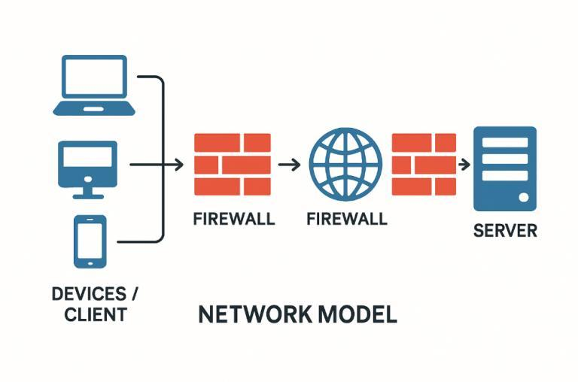

Figure 127. Dual-Firewall Client-Server Network Model

By using this model, Project CapstoNova delivers a secure, scalable, and cost-effective digital archiving solution, aligning with CTU-CCICT’s digitization initiatives and future multi-campus goals.

##### **Network Topology**

Project CapstoNova will use a Star Topology, where all user machines connect to a central server responsible for data storage, validation, classification, and retrieval of capstone projects. This topology is optimal due to its centralized management, reliability, scalability, security, and ease of maintenance. The central server ensures controlled data processing, and individual connections mean a single device failure won’t disrupt the entire network and resolved easily.

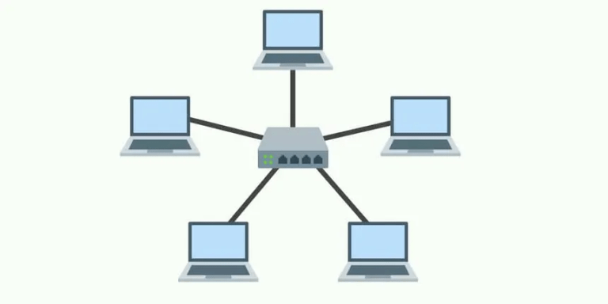

Figure 128. Star Network Topology

Star Topology is also scalable, and adding devices and users does not interfere with existing processes. Security is also increased through centralized data transport, where access control is implemented, encryption, and the firewall is enabled. System infrastructure comprises a central server for hosting the CapstoNova platform, client machines such as student PCs, instructor laptops, and administrative workstations, and network devices such as routers and switches to achieve optimum connectivity for extended networks.

### **Development Phase**

Proponents collaborate with stakeholders during the development stage to construct, build, and integrate system features from the project template. This includes conceptualization into an operational system, rigorous testing, and constant fine-tuning in an attempt to optimize performance. Fine-tuning is carried out to a point where the end product is of acceptable quality and user specifications.

#### **Technology Stack Diagram**

A technology stack diagram visually describes various software pieces and technologies involved in a project or system. It provides a systematic overview of various technological levels and how they interact to produce error-free system operation.

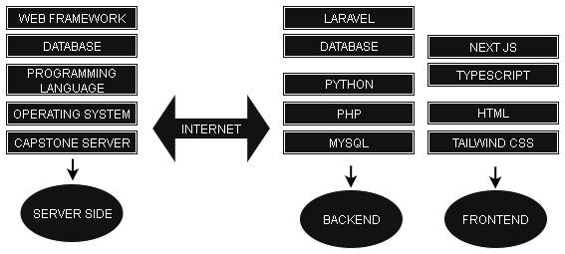

Figure 129. Technology Stack Diagram

PROJECT CapstoNova uses technologies that are familiar and easy to manage for the developers. For the front end, we used HTML, CSS, Bootstrap, and Tailwind, while in the back end, we used PHP with Laravel and MySQL for handling the database*.*

##### **Software Specification**

A software specification document outlines the needs, features, and constraints of a software project and acts as a reference point for developers, stakeholders, and users throughout the development process.

**Table 21. Software Specification**

|  |
| --- |
| **Website** |
| * Operating system: Windows 10 * Web browser: Google Chrome (Desktop / Mobile) * Program Language: PHP (Laravel Framework) * Markup & Styling Languages**:** : HTML, CSS (Tailwind) * Database Management: MySQL * Development Tools : Visual Studio, GitHub, Figma * Compression Tools: PHP ZipArchive / MySQL Compression Functions |

##### **Hardware Specification**

A hardware specification sets the hardware components and their specifications necessary for the smooth operation of the system.

1. Workstations: Desktop or laptop computers for users (admins, advisers, students) must have:

* Intel(R) Core (TM) i7-6600U CPU @ 2.60GHz 2.80 GHz
* 16.0 GB
* 1080p high-resolution monitor
* Google Chrome, Firefox, or Edge

1. Server: A dedicated or cloud-based server is required to host the CapstoNova system with the following minimum specs:

* 8-core CPU
* 16GB RAM
* 500GB SSD storage
* PHP 7.4+ and MySQL/MariaDB support

1. Internet Connectivity: Stable high-speed internet is necessary for both the server and users:

* Server: Minimum 50 Mbps upload/download speed
* User access: Minimum 10 Mbps recommended

1. Network Infrastructure: A reliable Local Area Network (LAN) with firewall protection and secure port configurations should be available for internal users and remote access.
2. Backup Devices: Cloud-based storage or external drives must be configured to store automated backups of capstone data every semester to prevent data loss.
3. Power Supply (UPS): Uninterruptible Power Supply (UPS) units must be available for the server and admin stations to protect against power outages and ensure continuous operations.
4. Mobile Devices: Smartphones or tablets with Android 10+ or iOS browsers are recommended for on-the-go access.

#### **Program Specification**

##### **List of Modules**

Legend:

P - Proponent S - Super Admin A - Admin O - Adviser V- Viewer

**Table 22. List of Modules**

|  |  |  |  |  |  |  |
| --- | --- | --- | --- | --- | --- | --- |
| **Programmer** | **Modules** | **P** | **S** | **A** | **O** | **V** |
|  | **MANAGE ACCOUNT MODULE** | | | | | |
|  | 1. Create Account |  | * | * |  | * |
|  | 1. View Accounts |  | * |  |  |  |
|  | 1. View Profile | * | * | * | * | * |
|  | 1. Edit/Update Profile |  | * | * | * | * |
|  | 1. Reset Password | * | * | * | * | * |
|  | 1. Forgot Password | * | * | * | * | * |
|  | 1. Remove Account |  | * |  |  |  |
|  | 1. Archive Account |  | * |  |  |  |
| *Number of points (1 point per user)* | | 1 | 1 | 1 | 1 | 1 |
|  | **MANAGE CAPSTONE PROJECT** | | | | | |
|  | 1. Upload Manuscript | * |  |  |  |  |
|  | 1. Upload Source Code | * |  |  |  |  |
|  | 1. View Submitted Project | * | * | * | * |  |
|  | 1. Archive/Retrieve Projects |  |  | * |  |  |
|  | 1. View Archived Projects |  |  | * |  |  |
|  | 1. Submission Confirmation Report | * |  |  |  |  |
| *Number of points (1 point per user)* | | 1 | 1 | 1 | 1 | 1 |
|  | **Manage Title Verification** | | | | | |
|  | 1. Search Capstone Titles |  | * | * | * | * |
|  | 1. View Abstract |  | * | * | * | * |
|  | 1. View Full Manuscript |  | * | * | * |  |
| *Number of points (1 point per user)* | |  | 1 | 1 | 1 | 1 |
|  | **Manage Capstone Idea Suggestion** | | | | | |
|  | 1. Submit Suggestion |  |  |  | * |  |
|  | 1. View Suggestion |  | * | * | * | * |
|  | 1. Archive Suggestion |  |  |  | * |  |
|  | 1. Retrieved Archived Suggestion |  |  |  | * |  |
|  | 1. View Archived Suggestions |  |  | * | * |  |
| *Number of points (1 point per user)* | |  | 1 | 1 | 1 | 1 |
|  | **Manage Whitelist** | | | | | |
|  | 1. Upload Whitelist |  | * | * |  |  |
|  | 1. View Whitelisted IDs |  | * | * |  |  |
|  | 1. View Whitelist Advisory |  | * | * | * |  |
|  | 1. View Archived Whitelist |  | * | * |  |  |
|  | 1. Archive/Retrieved Whitelist |  | * | * |  |  |
| *Number of points (1 point per user)* | |  | 1 | 1 | 1 |  |
|  | **Manage Access Request** | | | | | |
|  | 1. Register Account for Access Request |  |  |  |  | * |
|  | 1. Submit Access Request |  |  |  |  | * |
|  | 1. Approve/Reject Request |  | * |  |  |  |
|  | 1. View Approval History |  | * |  |  |  |
|  | 1. Access Notifications |  | * |  |  | * |
| *Number of points (1 point per user)* | |  | 1 |  |  | 1 |
|  | **View Data Analytics and Reports** | | | | | |
|  | 1. Project Type Trend |  | * | * | * | * |
|  | 1. Environment Type Trend |  | * | * | * | * |
|  | 1. Project Tools Trend |  | * | * | * | * |
|  | 1. Adviser’s Handled Projects |  | * | * |  |  |
|  | 1. Project Report |  | * | * |  |  |
|  | 1. Users Account Report |  | * |  |  |  |
| *Number of points (1 point per user)* | |  | 1 | 1 | 1 | 1 |
|  | **View Notification** | | | | | |
|  | 1. New Project Submission Heads-up |  | * | * |  |  |
|  | 1. New Registered Proponent Update |  |  |  | * |  |
|  | 1. New Whitelist Uploaded Notification |  | * | * |  |  |
|  | 1. Adviser’sProfile Update Notification |  |  | * |  |  |
|  | 1. Approval Reminder |  | * |  |  |  |
|  | 1. Access Request Confirmation |  |  |  |  | * |
|  | 1. Pending Request Notification |  |  |  |  | * |
|  | 1. Submission Confirmation Heads-Up | * | * |  |  |  |
|  | 1. Security Warnings |  | * |  |  |  |
|  | 1. User’s Profile Update Notification |  | * | * |  |  |
| *Number of points (1 point per user)* | | 1 | 1 | 1 | 1 | 1 |

#### **Testing Phase**

The Testing Phase ensures that the system is fully functional, stable, and ready for deployment. It involves several levels of testing to identify and fix issues early, improve performance, and verify that all modules work together seamlessly. Unit Testing focuses on checking individual components to ensure they perform their intended tasks correctly. Integration Testing verifies that different modules interact smoothly without errors. Alpha Testing involves initial evaluation to detect potential issues before wider release, while Acceptance Testing confirms that the system meets user requirements and is ready for final implementation.

##### **Unit Testing**

The “Enhancing Capstone Archiving and Optimizing Data Intelligence with Project Capstonova” system, prepared by KingSLeN on October 18, 2025, is designed to ensure that every component of the platform functions accurately and reliably through a structured Unit Testing process. This testing phase focuses on verifying that each module performs its specific tasks correctly in isolation, prior to integration with other parts of the system. The primary objectives include confirming that every function works as intended, detecting and correcting functional errors early, and validating both normal and edge-case input handling to maintain system stability and efficiency.

**Table 23. Unit Testing**

|  |  |  |  |  |  |
| --- | --- | --- | --- | --- | --- |
| Module | Test Case | Input | Expected Output | Actual Output | Result |
| **A. Manage Account Module** | | | | | |
| Login Account | Verify login with valid credentials | sample@sample.com | Redirect to dashboard | Redirected successfully | Passed |
| Login Account | Verify login with invalid credentials | wrongsample@wrongsample.com | Show “The provided credentials are incorrect” | Error displayed | Passed |
| Register Account | Test new user registration | Valid info | Account successfully created | Account visible in DB | Passed |
| Edit Profile | Test profile updates | Change name to “Juan Dela Cruz” | Profile updated | Changes saved | Passed |
| Forgot Password | Verify password reset | Registered email | Password reset email sent | Reset link received | Passed |
| **B. Manage Capstone Project Module** | | | | | |
| Upload Manuscript | Upload valid project file | example.pdf | Submitted | File displayed in list | Passed |
| Upload Source Code | Upload valid source code | example.tar | Submitted | File displayed | Passed |
| Upload User Guide | Upload valid User Guide | example.pdf | Submitted | File displayed in list | Passed |
| System Manual | Upload valid System Manual | example.pdf | Submitted | File displayed in list | Passed |
| View Submitted Project | View uploaded projects | N/A | List of projects displayed | Uploaded Manuscript shown correctly | Passed |
| Archive Project | Move project to archive | Click “Archive” | Project moved | Archived successfully | Passed |
| **C. Manage Project Documents Module** | | | | | |
| Search Capstone Titles | Search existing titles | Keyword: “Example” | Project Appear | Title displayed correctly | Passed |
| Advance Search | Click keyword | Keyword: “Example” | Related project appears | Titles displayed correctly | Passed |
| View Abstract | View project abstract | Click “View Abstract” | Abstract details shown | Displayed properly | Passed |
| View Full Manuscript | View uploaded file | Click “Full Manuscript” | PDF opens or saved on the library | Opens successfully | Passed |
| **D. Manage Capstone Idea Suggestion Module** | | | | | |
| Submit Suggestion | Submit a new capstone idea | Idea title and description | Suggestion saved | Suggestion recorded | Passed |
| View Suggestion | View list of submitted ideas | N/A | Display list of ideas | Ideas displayed correctly | Passed |
| Archive Suggestion | Move suggestion to archive | Click “Archive” | Suggestion archived | Archived successfully | Passed |
| View AI Capstone Ideas | View system-generated ideas | Click “AI Suggestions” | AI ideas displayed | Displayed successfully | Passed |
| **E. Manage Whitelist Module** | | | | | |
| Upload Whitelist | Upload valid whitelist file | whitelist.xlsx | File uploaded | Records added | Passed |
| View Whitelisted IDs | Display whitelist data | N/A | List of IDs shown | IDs displayed correctly | Passed |
| View Whitelist Advisory | Open whitelist advisory | Click advisory | Advisory displayed | Advisory list shown | Passed |
| Archive Whitelist | Move record to archive | Select → “Archive” | Record moved | Successfully archived | Passed |
| Retrieve Whitelist | Restore archived record | Select → “Retrieve” | Record restored | Successfully retrieved | Passed |
| **F. Manage Access Request Module** | | | | | |
| Submit Access Request | Submit request | Filled form | Confirmation shown | Request submitted | Passed |
| Approve Request | Super Admin approves request | Click “Approve” | Status changes to Approved | Approved successfully | Passed |
| Reject Request | Super Admin rejects request | Click “Reject” | Status changes to Rejected | Rejected successfully | Passed |
| View Approval History | View request history | N/A | Displays list of approved requests | Displayed correctly | Passed |
| **G. View Data Analytics and Reports Module** | | | | | |
| Project Type Trend | View project type analytics | N/A | Chart displayed | Chart visible | Passed |
| Project Tools Trend | View tools usage analytics | N/A | Chart displayed | Chart visible | Passed |
| Adviser’s Handled Projects | View adviser statistics | Adviser name | List of projects shown | Displayed correctly | Passed |
| Users Account Report | Generate user report | Click “Generate Report” | Report displayed/  downloaded | Report shown | Passed |
| **H. View Notification Module** | | | | | |
| New Project Submission Heads-up | Notify admin of new upload | Upload new project | Notification triggered | Notification received | Passed |
| New Registered Proponent Update | Notify admin of new registration | Register new user | Notification triggered | Notification received | Passed |
| Access Request Confirmation | Notify user of request submission | Submit access request | Confirmation shown | Notification received | Passed |
| Security Warnings | Notify about failed login | Invalid credentials | Warning notification | Warning displayed | Passed |

##### **Integration Testing**

The Integration Testing Documentation for the “Enhancing Capstone Archiving and Optimizing Data Intelligence with Project Capstonova” system, prepared by KingSLeN on October 18, 2025, aims to verify that all system modules function correctly when combined. Unlike Unit Testing, which focuses on testing components individually, Integration Testing ensures that data flows smoothly between interconnected modules and that their interactions produce accurate and expected results. The main goal of this phase is to confirm that modules exchanging data work seamlessly, actions in one module correctly trigger or update corresponding functions in another, and no data mismatch or functional errors occur during cross-module operations. This step is essential to guarantee system reliability and smooth user experience.

**Table 24. Integration Testing**

|  |  |  |  |  |  |
| --- | --- | --- | --- | --- | --- |
| Modules | Test Case | Input | Expected | Actual | Result |
| Manage Account → Manage Capstone Project | Verify that a logged-in user’s uploaded project is linked to their account. | Login → Upload project file | Project appears in user’s list | Project displayed properly | Passed |
| Manage Account → View Notification | Check if new user registration triggers admin and super admin notification. | Register new user | Notification displayed to admin and Super Admin | Notification received | Passed |
| Manage Capstone Project → View Data Analytics | Verify analytics update after new projects are uploaded. | Upload multiple projects | Analytics graphs updated | Data displayed correctly | Passed |
| Manage Project Documents → Manage Capstone Project | Check if manuscript retrieval links correctly. | View uploaded project → Open full manuscript | Correct file opens | File displayed properly | Passed |
| Manage Access Request → View Notification | Check if access request submission triggers notifications. | Submit access request | User and admin notifications appear | Notifications shown correctly | Passed |
| Manage Whitelist → Manage Account | Ensure that only whitelisted users can register. | Try to register non-whitelisted email | Error shown “Not whitelisted” | Restriction applied correctly | Passed |
| Manage Access Request → Manage Whitelist | Ensure approved requests are added to whitelist. | Approve access request | User added to whitelist | Added successfully | Passed |
| Manage Capstone Project → View Notification | Check notification after new project upload. | Upload capstone project | Notification displayed | Shown successfully | Passed |

##### **Alpha Testing**

The **Alpha Testing** phase focuses on ensuring that the system operates smoothly as a fully integrated product. It involves the development team and selected internal users who simulate real-world scenarios to uncover usability, performance, or logical issues before moving on to Beta or Acceptance Testing. The main objectives of this phase are to evaluate the system’s performance and usability in a near-real environment, confirm that all workflows function seamlessly from start to finish, and identify any remaining bugs or inconsistencies that need to be resolved prior to deployment.

**Table 25. Alpha Testing**

|  |  |  |  |  |  |
| --- | --- | --- | --- | --- | --- |
| User Role | Test Case | Module | Expected | Actual | Result |
| Proponent → Admin → Adviser | Proponent registers, uploads a capstone manuscript, and adviser views it. | Manage Account, Manage Capstone Project, Manage Project Documents | Admin and adviser can view uploaded file; project visible in the system. | Uploaded file successfully displayed on admin and adviser dashboards. | Passed |
| Viewer → Super Admin | Viewer submits access request, super admin approves | Manage Access Request, Manage Project Document | Super Admin approves and viewer can view the full document successfully | Access request approved and viewer can view the full manuscript | Passed |
| Adviser | Adviser submit suggestion idea | Manage Capstone Idea suggestion | Adviser can view his own suggestion | Adviser successfully displayed his latest suggestion in the system | Passed |
| Admin → Adviser | Admin added new adviser | Manage Account | Admin successfully added new adviser and adviser can login the system | Admin added new adviser and adviser login the system successfully | Passed |
| Super Admin → Proponent | Super Admin uploads whitelist file; Proponent attempts login. | Manage Whitelist, Manage Account | Only whitelisted proponents can log in | Whitelist verified and access restricted to approved users. | Passed |

##### **Acceptance Testing**

The Acceptance Testing phase ensures that the system meets all client requirements and performs effectively in a real-world environment. This testing is conducted by the target users or clients to determine whether the system is ready for official deployment. The main objectives are to verify that both functional and non-functional requirements are satisfied, ensure that all major features operate correctly from the client’s perspective, and confirm that the system is fully prepared for deployment and actual use.

**Table 26. Alpha Testing Clients**

|  |  |  |  |
| --- | --- | --- | --- |
| Name | Role | Department | Remarks |
| Angel Maghanoy | Super Admin | CCICT | Primary Tester |
| Angel Maghanoy | Admin | CCICT | Secondary Tester |
| BSIS 4B | Viewer | CCICT | Support tester |
| BSIS 4B | Proponent | CCICT | Support tester |
| Angel Maghanoy | Adviser | CCICT | Support tester |

**Table 27. Alpha Testing Test Cases**

|  |  |  |  |  |  |
| --- | --- | --- | --- | --- | --- |
| Test Case | Modules | Expected | Actual | Client Feedback | Result |
| User logs in successfully | Manage Account | Redirects to dashboard | Redirect successful | Easy to use | Passed |
| Upload and view project | Manage Capstone Project | File uploaded and viewable | File displayed correctly | Works fine | Passed |
| Search and view manuscript | Manage Project Documents | Search results accurate | Correct file shown | Satisfied | Passed |
| Submit access request and approve | Manage Access Request | Request approved | Function performed correctly | No issues | Passed |
| Receive system notifications | View Notification | Notifications triggered properly | Notifications received | Works as expected | Passed |
| Generate analytics and reports | View Data Analytics and Reports | Graphs and reports load properly | Reports displayed correctly | Useful and clear | Passed |
| Submit capstone idea suggestion | Manage Capstone Idea Suggestion | Suggestion saved | Displayed correctly | Works perfectly | Passed |

### **Implementation/Deployment Phase**

#### **User-Guide**

**Table 28. User Guide Super Admin**

|  |  |
| --- | --- |
| Login your credentials |  |
| Landing page after logging in |  |
| In the dashboard, you can search project |  |
| Click the title to view the abstract and click the button to view the full document |  |
| After the dashboard, there is an upload whitelist. You can enter a new email, id number and adviser of the new proponent or you can upload a file. |  |
| These are the new added whitelist; their emails are encrypted for security purposes. |  |
| You can edit the whitelist and save it. |  |
| For user management, you can view all registered users in the system |  |
| You can also add new users except viewers. |  |
| You can click a user and delete or restrict the user in accessing the system. |  |
| All restricted users will be placed here. |  |
| But you can also restore the user. |  |
| Submissions: you can search projects and view archived projects. |  |
| After clicking see more, you will see these folders |  |
| You still have to download the source code, user guide, and system manual to view them. |  |
| For data analytics you can view different data trends store in the system. |  |
| You can also view the viewers who are waiting for you to approve to view the full document |  |
| View reports |  |
| View notification |  |
| Modify user’s system configuration |  |
| You can edit your information in account settings and save it or click logout to exit. |  |

**Table 29. User Guide Admin**

|  |  |
| --- | --- |
| Login your credentials |  |
| Landing page after logging in, you can also search projects here. |  |
| After the dashboard, there is an upload whitelist. You can enter a new email, id number and adviser of the new proponent or you can upload a file. |  |
| These are the new added whitelist; their emails are encrypted for security purposes. |  |
| You can edit their information |  |
| You can view the viewers, proponents, advisers, and restricted accounts. |  |
| You can add new adviser |  |
| You can restrict and restore accounts. |  |
| For submission you can search and view projects. You can also see more archived projects. |  |
| When you click the see more button you can view the manuscript, source code, user guide, and system manual. |  |
| For suggestions, you can search the adviser’s name and view their suggestion. |  |
| Viewing adviser’s suggestion. You can also view their archived suggestion. |  |
| You can view different data analytics in the system. |  |
| You can view reports. |  |
| You can view notifications. |  |
| Under account setting you can edit your profile and save it or you can logout. |  |

**Table 30. User Guide Adviser**

|  |  |
| --- | --- |
| Login to your account |  |
| This is your landing page after logging in. You can also search projects, view suggestions, project advisory, and overview data. |  |
| You can view all the proponents under your advisory. You can search their name too. |  |
| You can view all the project under your advisory |  |
| You can search and view advisers’ suggestions. |  |
| You can also filter by choosing which suggestion to view |  |
| If you click the add suggestion button, you will see this. After giving new ideas, you can click the button to save your suggestion. |  |
| If you click manage button, you can update or archive your suggestion. |  |
| You can view data analytics of the system. |  |
| You can view the notification. |  |
| You can also edit your account profile or logout. |  |

**Table 31. User Guide Proponent**

|  |  |
| --- | --- |
| This is the login page that appears once the proponent has finished signing up successfully. |  |
| This is the landing page that displays the personal account of a proponent after logging into the system. |  |
| This page displays where the proponent can upload their capstone project files and details. |  |
| This page allows the proponent to upload their capstone manuscript, including the title, abstract, keywords, members, manuscript, and other files. |  |
| The proponent can also upload the source code file. |  |
| The proponent can also upload the user manual. |  |
| The proponent can also upload the usage guide. |  |
| The figure shows a successful project submission, allowing the proponent to view the uploaded document. |  |
| This page shows the Proponent’s Notification Page, where all notifications are displayed. |  |

**Table 32. User Guide Viewer**

|  |  |
| --- | --- |
| Landing page of the public view of the system |  |
| This is part of the welcome page for Viewer users, featuring an advanced search to help users easily find desired projects or results. Viewers can input the adviser’s name, authors, area of study, and date range. |  |
| This page appears when a viewer doesn’t have an account and wants to request the full document of a capstone project. It displays a sign-up form for the viewer to fill out. |  |
| This page displays once the viewer finishes filling out the sign-up form, they can log in through the login page. |  |
| This is part of the welcome page, displaying a menu with options such as Home, Library, View Suggestions, View Trends, About Us, Notifications, and Account. |  |
| This is part of the welcome page sidebar for Viewer users, displaying the personal library for those who already have an account. Projects with approved full document access are stored here, showing the title and date of each. Clicking on a title reveals the full details of the project. |  |
| This is the suggestion page, where AI-powered suggestions and adviser recommendations are displayed. It includes buttons and indicators showing whether the viewer is interested in a suggestion or if it has already been marked as interested by other viewers. |  |
| This is the account page, featuring a form for users who wish to view or update their account information. They can enter their full name, CTU email, department, course, program, and password. |  |

#### **Installation Guide**

This document outlines the setup and configuration procedures for deploying and running Project CapstoNova. The system is built with three main integrated components: Backend using Laravel (PHP) for API services, Frontend using Next.js (Node.js) for the client interface, and a Microservice powered by FastAPI (Python) for machine learning and AI operations. It also integrates Brevo for email communication, MySQL for database management, and cohere for natural language processing to ensure a secure, intelligent, and efficient system environment.

System Requirements

**Table 33. Installation Guide - Core Software**

|  |  |  |
| --- | --- | --- |
| **Component** | **Version** | **Purpose** |
| PHP | 7.4 or higher | Laravel backend |
| Composer | Latest | PHP dependency manager |
| MySQL | Latest stable | Database |
| Node.js | 20.16.0 | Frontend runtime |
| NVM | Latest | Node version management |
| Python | 3.13.7 | FastAPI microservice |
| Git | Latest | Version control |

Optional:

* Microsoft C++ Build Tools (required if matplotlib fails to install)
* Visual Studio Code or preferred IDE

**Project Acquisition and Installation**

**Repository Cloning**

|  |
| --- |
| git clone [repository_url] PROJECT-CAPSTONOVA  cd PROJECT-CAPSTONOVA |

**Dependency Installation**

**Backend (Laravel):**

|  |
| --- |
| cd backend  composer install |

**Frontend (**[**Next.js**](http://next.js)**):**

|  |
| --- |
| cd ../frontend  npm install |

**Microservice (FastAPI):**

|  |
| --- |
| cd .../microservice  python -m venv venv  venv\Scripts\activate (Windows)  source venv/bin/activate (Linux/Mac)  pip install -r requirements.txt |

**PHP Configuration**

**Enabling Required Extensions**

Open the php.ini configuration file (find its location with php --ini) and ensure the following extensions are enabled:

|  |
| --- |
| extension=curl  extension=mbstring  extension=pdo_mysql  extension=fileinfo  extension=openssl  extension=zip  extension=gd  extension=tokenizer  extension=exif |

**Installing the Zstandard (Zstd) Extension**

1. Download the Zstandard source or binaries from the official Facebook repository:  
   <https://github.com/facebook/zstd>
2. Obtain or compile a compatible php_zstd.dll (for Windows) or .so (for Linux/macOS) suitable for your PHP version.
3. Copy the compiled extension file into your PHP extensions directory (e.g., C:\xampp\php\ext).

|  |
| --- |
| extension=php_zstd.dll |

1. Add this line to php.ini:
2. Verify the extension directory path:

|  |
| --- |
| extension_dir="C:\xampp\php\ext" |

1. Restart Apache or PHP.

|  |
| --- |
| php -m | findstr /i "zstd pdo_mysql mbstring curl" |

1. Confirm that Zstd and other required extensions are active:

**Laravel Backend Configuration**

**Environment File**

Duplicate the environment template:

|  |
| --- |
| cp .env.example .env |

Open .env and fill in your environment-specific values. Sensitive credentials should be replaced with secure placeholders as shown below:

|  |
| --- |
| APP_NAME=PROJECT-CAPSTONOVA  APP_ENV=local  APP_KEY=base64:YOUR_APP_KEY_HERE  APP_DEBUG=true  APP_URL=localhost  APP_LOCALE=en  APP_FALLBACK_LOCALE=en  APP_FAKER_LOCALE=en_US  LOG_CHANNEL=stack  LOG_STACK=single  LOG_LEVEL=debug  DB_CONNECTION=mysql  DB_HOST=127.0.0.1  DB_PORT=3306  DB_DATABASE=capstonova  DB_USERNAME=your_database_user  DB_PASSWORD=your_database_password  SESSION_DRIVER=cookie  SESSION_LIFETIME=120  SESSION_ENCRYPT=false  SESSION_PATH=/  SESSION_DOMAIN=localhost  SANCTUM_STATEFUL_DOMAINS=localhost:3000  FRONTEND_URL=http://localhost:3000  BROADCAST_CONNECTION=log  FILESYSTEM_DISK=local  QUEUE_CONNECTION=database  CACHE_STORE=database  REDIS_CLIENT=phpredis  REDIS_HOST=127.0.0.1  REDIS_PASSWORD=null  REDIS_PORT=6379  MAIL_MAILER=smtp  MAIL_HOST=smtp-relay.brevo.com  MAIL_PORT=587  MAIL_USERNAME=your_brevo_username  MAIL_PASSWORD=your_brevo_api_key  MAIL_ENCRYPTION=tls  MAIL_FROM_ADDRESS="your_email@example.com"  MAIL_FROM_NAME="${APP_NAME}"  TWO_FACTOR_ENABLED=false  ML_SERVICE_URL=http://127.0.0.1:8001  EXTERNAL_SSD_ROOT="G:/capstonova"  AWS_ACCESS_KEY_ID=  AWS_SECRET_ACCESS_KEY=  AWS_DEFAULT_REGION=us-east-1  AWS_BUCKET=  AWS_USE_PATH_STYLE_ENDPOINT=false  VITE_APP_NAME="${APP_NAME}" |

**Database and Application Initialization**

Run the following commands to generate the application key, migrate the database, and seed the default data:

|  |
| --- |
| php artisan key:generate  php artisan migrate  php artisan db:seed |

**File Storage Configuration**

By default, PROJECT-CAPSTONOVA uses **local storage** for file uploads and generated files:

|  |
| --- |
| FILESYSTEM_DISK=local |

If using an external SSD, configure .env as follows:

|  |
| --- |
| FILESYSTEM_DISK=ssd  EXTERNAL_SSD_ROOT="G:/capstonova" |

After configuring the storage disk, create a symbolic link for public access:

|  |
| --- |
| php artisan storage:link |

**Email Configuration (Brevo)**

Ensure your Brevo SMTP credentials are correctly set in .env:

|  |
| --- |
| MAIL_MAILER=smtp  MAIL_HOST=smtp-relay.brevo.com  MAIL_PORT=587  MAIL_USERNAME=your_brevo_username  MAIL_PASSWORD=your_brevo_api_key  MAIL_ENCRYPTION=tls  MAIL_FROM_ADDRESS=your_email@example.com  MAIL_FROM_NAME="${APP_NAME}" |

**Python FastAPI Microservice Configuration**

**Python Environment**

Use Python 3.13.7. If matplotlib fails to install, install Microsoft C++ Build Tools from:  
<https://visualstudio.microsoft.com/visual-cpp-build-tools/>  
Select *Desktop Development with C++* during setup, then reinstall the package:

|  |
| --- |
| pip install matplotlib |

**Virtual Environment**

|  |
| --- |
| python -m venv venv  venv\Scripts\activate (Windows)  source venv/bin/activate (Linux/Mac)  pip install -r requirements.txt |

**Cohere API Configuration**

Create a .env file inside the microservice/ directory:

|  |
| --- |
| COHERE_API_KEY=your_cohere_api_key_here |

Obtain your API key from: <https://dashboard.cohere.com/>

**Running the Microservice**

Start the FastAPI microservice with:

|  |
| --- |
| python run.py |

**Running All System Components**

**Table 34. Installation Guide - System Components**

|  |  |  |
| --- | --- | --- |
| **Component** | **Command** | **Directory** |
| Laravel Backend (API) | php artisan serve | backend |
| Laravel Queue Worker | php artisan queue:work | backend |
| FastAPI Microservice | python run.py | microservice |
| Next.js Frontend | nvm use 20.16.0 && npm run dev | frontend |

Each service can be launched in separate terminal windows or managed via a process manager such as PM2.

**Post-Deployment Procedures**

Once all services are operational:

1. Log in as Super Admin via the web interface.
2. Access Manage Whitelist and upload the list of students/proponents and advisers.
3. Navigate to Data Analytics and train the following models:
   * Suggestions Model
   * Association Model
   * Project Size Regression Model
4. Verify that:
   * The Dual-Firewall is active.
   * File Encryption is enabled.
   * External SSD storage (if configured) is accessible

**Development Workflow**

Follow this Git-based development procedure:

|  |
| --- |
| git pull origin main  git checkout -b feature/your_branch_name  git add .  git commit -m "Describe your change"  git push -u origin feature/your_branch_name |

**Summary**

**Table 35. Installation Guide - Summary of all Components**

|  |  |  |
| --- | --- | --- |
| **Component** | **Technology** | **Key Configuration** |
| Backend | Laravel (PHP 7.4+) | PHP extensions, env, database, Brevo, storage |
| Frontend | Next.js (Node.js 20.16.0) | Installation and runtime environment |
| Microservice | FastAPI (Python 3.13.7) | Virtual environment, dependencies, Cohere API |
| Database | MySQL | Schema creation and seeding |
| Email | Brevo SMTP | Transactional email service |
| Storage | Local or SSD | Controlled via FILESYSTEM_DISK and EXTERNAL_SSD_ROOT |
| AI & ML | Cohere, sklearn, matplotlib | Model training and analytics |

#### **Roadmap**

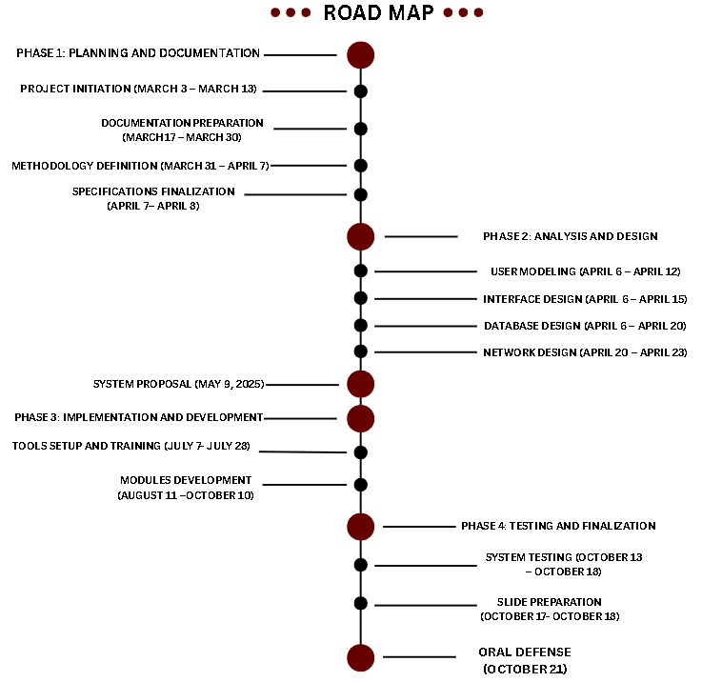

Figure 130. Roadmap

# **CONCLUSION**

The development of Project CapstoNova marks a significant step in modernizing the way capstone projects are stored, managed, and accessed at Cebu Technological University – College of Computer, Information, and Communications Technology. By transforming the traditional manual archiving process into a secure and intelligent digital repository, the system addresses issues of accessibility, efficiency, and preservation. Through its role-based access, advanced search, automated processes, and analytics features, CapstoNova ensures that valuable research outputs are safeguarded while remaining easily available for students, advisers, and other stakeholders.

This project demonstrates the power of integrating technology with academic needs—streamlining workflows, enhancing collaboration, and supporting future innovation. With continuous improvements and proper implementation, CapstoNova can serve as a reliable foundation for academic growth, research development, and institutional knowledge preservation for years to come.

# 

# **RECOMMENDATIONS**

To further enhance the functionality and effectiveness of Project CapstoNova, the following recommendations are proposed:

* Expand System Coverage – Extend the system to accommodate projects from other colleges or partner institutions to promote research collaboration and knowledge sharing.
* Integrate Plagiarism Detection – Add advanced plagiarism detection features to ensure the originality and integrity of capstone projects.
* Enhance Advisory Features – Include tools that allow advisers to directly track the progress of students from proposal to final defense.
* Improve Viewer Access – Offer flexible and controlled access options for viewers to encourage wider use of research outputs while maintaining security.
* Strengthen User Training and Support – Provide comprehensive user training and help resources to ensure that all user roles can effectively navigate and maximize the system.
* Continuous System Upgrades – Implement regular updates to keep up with technological advancements and ensure system security and scalability.

# **REFERENCES**

1. Sarawan, K., Khalwipat, R., Daengkasai, W., & Khumla, P. (2025). Implementing lean principles for digital archiving of student projects: A case study in higher education. *Sustainable Engineering and Innovation, 7*(1), 51–64.<https://www.sei.ardascience.com/index.php/journal/article/view/396>
2. Perante, W. J. A., Barnaba Jr., E. O., Cañete, J. R., & Niegas, M. E. (2024). Design and develop a thesis and capstone project manuscript archiving management system for Eastern Visayas State University Ormoc Campus. *International Journal of Recent Advances in Multidisciplinary Research*, *11*(11), 10417-10422.<https://www.researchgate.net/publication/387225348_DESIGN_AND_DEVELOP_A_THESIS_AND_CAPSTONE_PROJECT_MANUSCRIPT_ARCHIVING_MANAGEMENT_SYSTEM_FOR_EASTERN_VISAYAS_STATE_UNIVERSITY_ORMOC_CAMPUS>
3. Hoelscher, C. (2024). Digital primary source literacy: Developing skills for online archival research. *New Directions for Teaching and Learning*, *2024*(180), 39-47 <https://onlinelibrary.wiley.com/doi/abs/10.1002/tl.20607>
4. Omondi, F., & Wanjiru, M. (2024). *Enhancing Digital Access to Kenya's Archival Materials through AR/VR Technologies*. Emerald Publishing.<https://www.emerald.com/insight/content/doi/10.1108/dts-08-2024-0148/full/html>
5. Nagrama, N. D. C., Lingating, M. L. D., Calleno, J. T., Rato, R. K. A., Catungal, M. L. P., & Encarnacion, P. C. (2024). Web-based Document Management System. *International Journal*, *13*(3).

<https://www.ijstm.inarah.co.id/index.php/ijstm/article/view/976>

1. Sultan, M., & Pasha, A. (2024). *Web-Based Digital Archival Processing and Collection Management System*. ResearchGate.<https://www.researchgate.net/publication/385342403_Web_Based_Digital_Archival_Processing_and_Collection_Management_System>
2. Panoply. (2024). *The 34 Best Data Management Tools, Systems and Solutions*.<https://blog.panoply.io/28-data-management-tools-5-ways-of-thinking-about-data-management>
3. HERITRACE Project Team. (2024). *HERITRACE: Tracing Evolution and Bridging Data for Streamlined Curatorial Work in the GLAM Domain*. arXiv.<https://arxiv.org/abs/2402.00477>
4. Network Encyclopedia. (2024, January 15). *Star topology*.<https://www.networkencyclopedia.com/star-topology/>
5. Pngtree. (2024, February). Agile development process infographic. <https://pngtree.com/freepng/agile-development-process-infographic_8277884.html>
6. Ronquillo, R. A. U. (2023). *WEB-BASED REPOSITORY OF RESEARCH OUTPUTS FOR CITY COLLEGE OF TAGAYTAY* (Doctoral dissertation, City College).

<https://www.academia.edu/download/110881648/Web_based_Repository_Of_Research_Outputs_For_City_College_Of_Tagaytay.pdf>

1. MES Ltd. (2023). *The Impact of Document Archiving on Data Security: A Comprehensive Analysis*.<https://blog.mesltd.ca/the-impact-of-document-archiving-on-data-security-a-comprehensive-analysis>
2. Jatheon. (2023). *Data Archiving: Definition, Benefits, Best Practices*.<https://jatheon.com/blog/data-archiving-benefits/>
3. Springer. (2023). *Knowledge Management and Data Analysis Techniques for Data-Driven Decision Making*.<https://link.springer.com/article/10.1007/s13132-023-01607-z>
4. Tindoc, F., Torres, R., Corpuz, K. A., Salem, J., & Paliuanan, L. (2023). Design and Development of the ASSET: A Web-Based Research Archiving System. *Journal of Pure and Applied Sciences*, *1*(2), 8-8.

<https://csu.org.ph/jpas/article/view/32>

1. National Library of Medicine. (2023). *Improving Health Literacy Using the Power of Digital Communications*.<https://pmc.ncbi.nlm.nih.gov/articles/PMC10693297/>
2. Montalban, L. J. T., & Antiquera, C. V. (2023). ISAT U Miagao Campus students thesis archiving and profiling system. *International Journal of Computer Science and Information Technology Research*, *11*(2), 50-54.

<https://scispace.com/papers/isat-u-miagao-campus-students-thesis-archiving-and-profiling-3lhyij0m>

1. Barlow, T. (2023). *Institutional Data Repository Development, a Moving Target*. Code4Lib Journal.<https://journal.code4lib.org/articles/15821>
2. MES Ltd. (2023). *The Impact of Document Archiving on Data Security: A Comprehensive Analysis*.<https://blog.mesltd.ca/the-impact-of-document-archiving-on-data-security-a-comprehensive-analysis>
3. Tindoc, F., Torres, R., Corpuz, K. A., Salem, J., & Paliuanan, L. (2023). Design and Development of the ASSET: A Web-Based Research Archiving System. *Journal of Pure and Applied Sciences*, *1*(2), 8-8.

<https://csu.org.ph/jpas/article/view/32>

1. American Journal of Multidisciplinary Research and Development. (2022). *Digital preservation practices for Institutional Repositories (IRs)*.<https://www.ajmrd.com/wp-content/uploads/2022/12/A4120108.pdf>
2. Dohinog, D. A. (2022). Centralized documents repository. *Globus-An International Journal of Management and IT*, *13*(2), 12-14.

<https://www.indianjournals.com/ijor.aspx?target=ijor:gijmt&volume=13&issue=2&article=003>

1. Al-Khanjari, Z., et al. (2022). *Repository system - an overview*. ScienceDirect.<https://www.sciencedirect.com/topics/computer-science/repository-system>
2. Patel, D., Wilson, J., & Green, A. (2022). *ARCHANGEL: Trusted Archives of Digital Public Documents*. arXiv.<https://arxiv.org/abs/1804.08342>
3. Singh, R., & Kumari, P. (2022). *Electronic Records and Archives in the Cloud*. International Journal of Engineering Trends and Technology, 72(10), 126.<https://ijettjournal.org/Volume-72/Issue-10/IJETT-V72I10P126.pdf>
4. Ithaka S+R. (2022). *The Effectiveness and Durability of Digital Preservation and Curation Systems*.<https://sr.ithaka.org/publications/the-effectiveness-and-durability-of-digital-preservation-and-curation-systems/>
5. Author Unknown. (2022, May 5). *A brief history of database processing since the 1960s* [Image]. Brewminate.<https://brewminate.com/a-brief-history-of-database-processing-since-the-1960s/>
6. Buchanan, S. A., Gracy, K. F., Kitchens, J., & Marciano, R. (2022, December). Computational Thinking Integration into Archival Educators’ Networked Instruction. In *2022 IEEE International Conference on Big Data (Big Data)* (pp. 2500-2506). IEEE.

<https://ieeexplore.ieee.org/abstract/document/10021019>

1. Syukhri, S., & Gusmayeni, P. (2021). Design of Web-Based Archive Management Information System. *J. Teknol. Inf. dan Pendidik*, *14*(2), 92-98.

<https://scispace.com/papers/research-and-capstone-project-electronic-repository-57vcgblsun>

1. Colavizza, G., Blanke, T., Jeurgens, C., & Noordegraaf, J. (2021). Archives and AI: An overview of current debates and future perspectives. *Journal on Computing and Cultural Heritage*, *15*(1), 1–15.<https://doi.org/10.1145/3479010>
2. Frasincar, F., & Telea, A. (2021). *Content Management Systems Performance and Compliance in Libraries, Archives, and Museums*. MDPI.<https://www.mdpi.com/2078-2489/12/7/259>
3. Consultative Committee for Space Data Systems (CCSDS). (2020). *Audit and Certification of Trustworthy Digital Repositories*.<https://public.ccsds.org/Pubs/652x0m2.pdf>
4. Gan, B. K. S., & Ouh, E. L. (2020, October). Experience report on the use of technology to manage capstone course projects. In *2020 IEEE Frontiers in Education Conference (FIE)* (pp. 1-8). IEEE.

<https://ieeexplore.ieee.org/abstract/document/9274111/>

1. Labou, S., Yoo, H.J., Minor, D., & Altintas, I. (2019). Sharing and Archiving Data Science Course Projects to Support Pedagogy for Future Cohorts. *2019 15th International Conference on eScience (eScience)*, 644-645.

<https://www.semanticscholar.org/paper/Sharing-and-Archiving-Data-Science-Course-Projects-Labou-Yoo/32a740a2ab15b0849dd37d324040a73b64012460>

1. Lalisan, S. J. W., & Sobejana, N. P. (2019). Research and capstone project electronic repository. *Current Journal of Applied Science and Technology*, *38*(4), 1-12.

<https://www.academia.edu/download/113186536/57003.pdf>

1. Malik, S., Al-youbi, S. A., Al-youbi, S. B., Hussein, R., Dweik, G., & Arif, S. (2018). Web-based Archive Management and Student Guidance for Final Year Projects. *The Journal of Organizational Management Studies*.

<https://ibimapublishing.com/wp-content/uploads/articles/JELHE/2018/871144/871144.pdf>

1. Wikipedia contributors. (2017, May 24). *Samvera*. Wikipedia.<https://en.wikipedia.org/wiki/Samvera>
2. Jansen, D., & Akers, K. (2016). *Digital repositories and the future of preservation and use of scientific knowledge*. ResearchGate.<https://www.researchgate.net/publication/289806868_Digital_repositories_and_the_future_of_preservation_and_use_of_scientific_knowledge>
3. [Ahmed, A.](https://www.emerald.com/insight/search?q=Aquil%20Ahmed), [Alreyaee, S.](https://www.emerald.com/insight/search?q=Sulaiman%20Alreyaee) and [Rahman, A.](https://www.emerald.com/insight/search?q=Azizur%20Rahman) (2014), "Theses and dissertations in institutional repositories: an Asian perspective", [*New Library World*](https://www.emerald.com/insight/publication/issn/0307-4803), Vol. 115 No. 9/10, pp. 438-451.

<https://doi.org/10.1108/NLW-04-2014-0035>

1. Barandiaran, D., Rozum, B., & Thoms, B. (2014). Focusing on student research in the institutional repository: DigitalCommons@ USU. *College & Research Libraries News*, *75*(10), 546-549.

<http://crln.acrl.org/index.php/crlnews/article/view/9209/10206>

1. Kumar, G., & Bhatia, P. K. (2012). Impact of agile methodology on software development process. *International Journal of Computer Technology and Electronics Engineering (IJCTEE)*, *2*(4), 46-50.

<https://www.researchgate.net/profile/Gaurav-Kumar-175/publication/255707851_Impact_of_Agile_Methodology_on_Software_Development_Process/links/00b49520489442e12d000000/Impact-of-Agile-Methodology-on-Software-Development-Process.pdf>

1. Kumar, G., & Bhatia, P. K. (2012). Impact of agile methodology on software development process. *International Journal of Computer Technology and Electronics Engineering (IJCTEE)*, *2*(4), 46-50.

<https://www.researchgate.net/profile/Gaurav-Kumar-175/publication/255707851_Impact_of_Agile_Methodology_on_Software_Development_Process/links/00b49520489442e12d000000/Impact-of-Agile-Methodology-on-Software-Development-Process.pdf>

1. Wikipedia contributors. (2012, August 10). *Islandora*. Wikipedia.<https://en.wikipedia.org/wiki/Islandora>
2. Chan, F. K., & Thong, J. Y. (2009). Acceptance of agile methodologies: A critical review and conceptual framework. *Decision support systems*, *46*(4), 803-814.

<https://www.sciencedirect.com/science/article/pii/S0167923608002133>

1. Bradley, K., Lei, J., & Blackall, C. (2007). Towards an open source archival repository and preservation system.

<https://citeseerx.ist.psu.edu/document?repid=rep1&type=pdf&doi=ff5ce1f74832453e34247dc79c8ca09ff75519a6>

1. Corcoran, B. J., Swamy, N., & Hicks, M. (2007, November). Combining provenance and security policies in a web-based document management system. In *On-line Proceedings of the Workshop on Principles of Provenance (PrOPr)* (p. 40).

<https://citeseerx.ist.psu.edu/document?repid=rep1&type=pdf&doi=8a2b883a4f96cd9bbd0d95a213a75962506f2e57>

1. Nolan, C. W., & Costanza, J. (2006). Promoting and archiving student work through an institutional repository: Trinity University, LASR, and the Digital Commons. *Serials Review*, *32*(2), 92-98.

<https://www.sciencedirect.com/science/article/pii/S009879130600044X>

1. Wikipedia contributors. (2005, March 7). *Open Archival Information System*. Wikipedia.<https://en.wikipedia.org/wiki/Open_Archival_Information_System>
2. Wikipedia contributors. (2005, November 25). *Enterprise content management*. Wikipedia.<https://en.wikipedia.org/wiki/Enterprise_content_management>

OCLC. (2002). *Trusted Digital Repositories: Attributes and Responsibilities*.<https://www.oclc.org/content/dam/research/activities/trustedrep/repositories.pdf>

# **CURRICULUM VITAE**

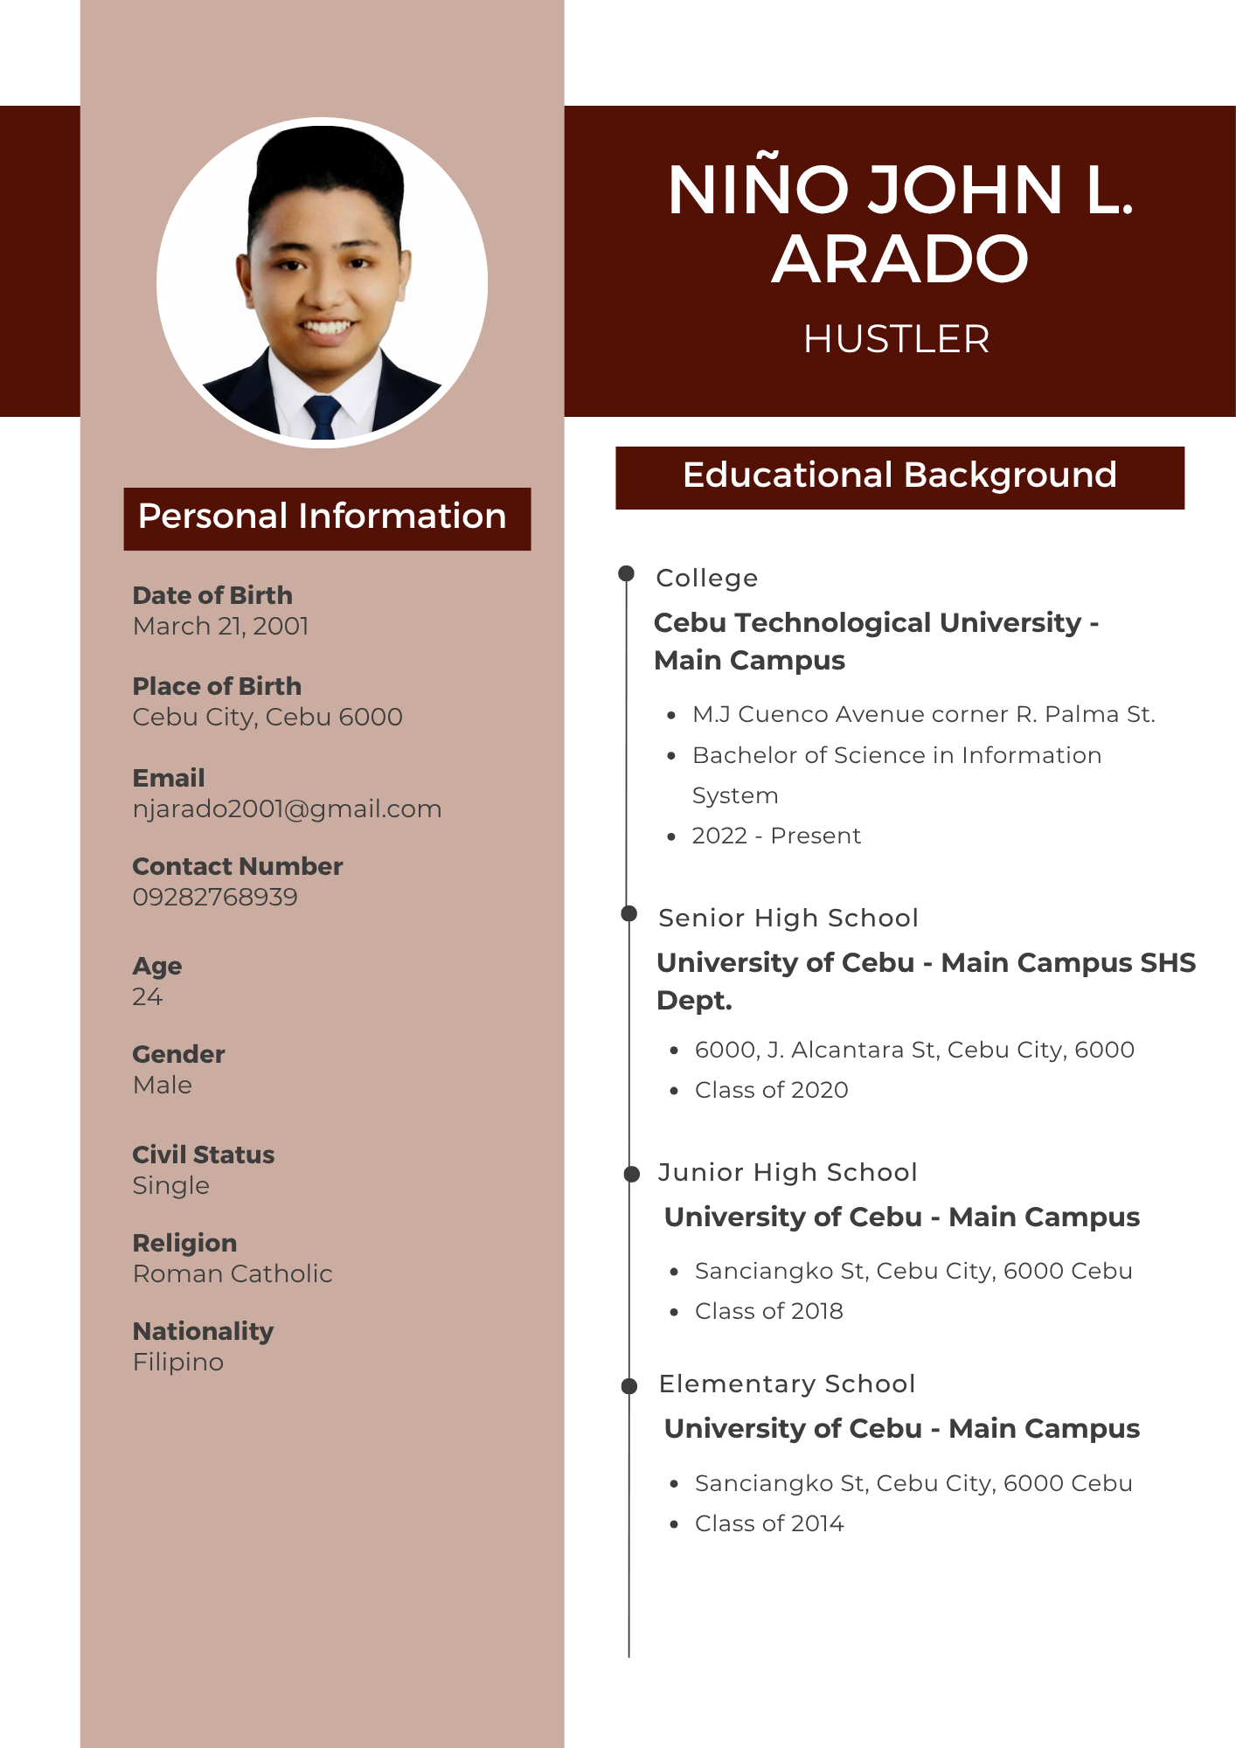

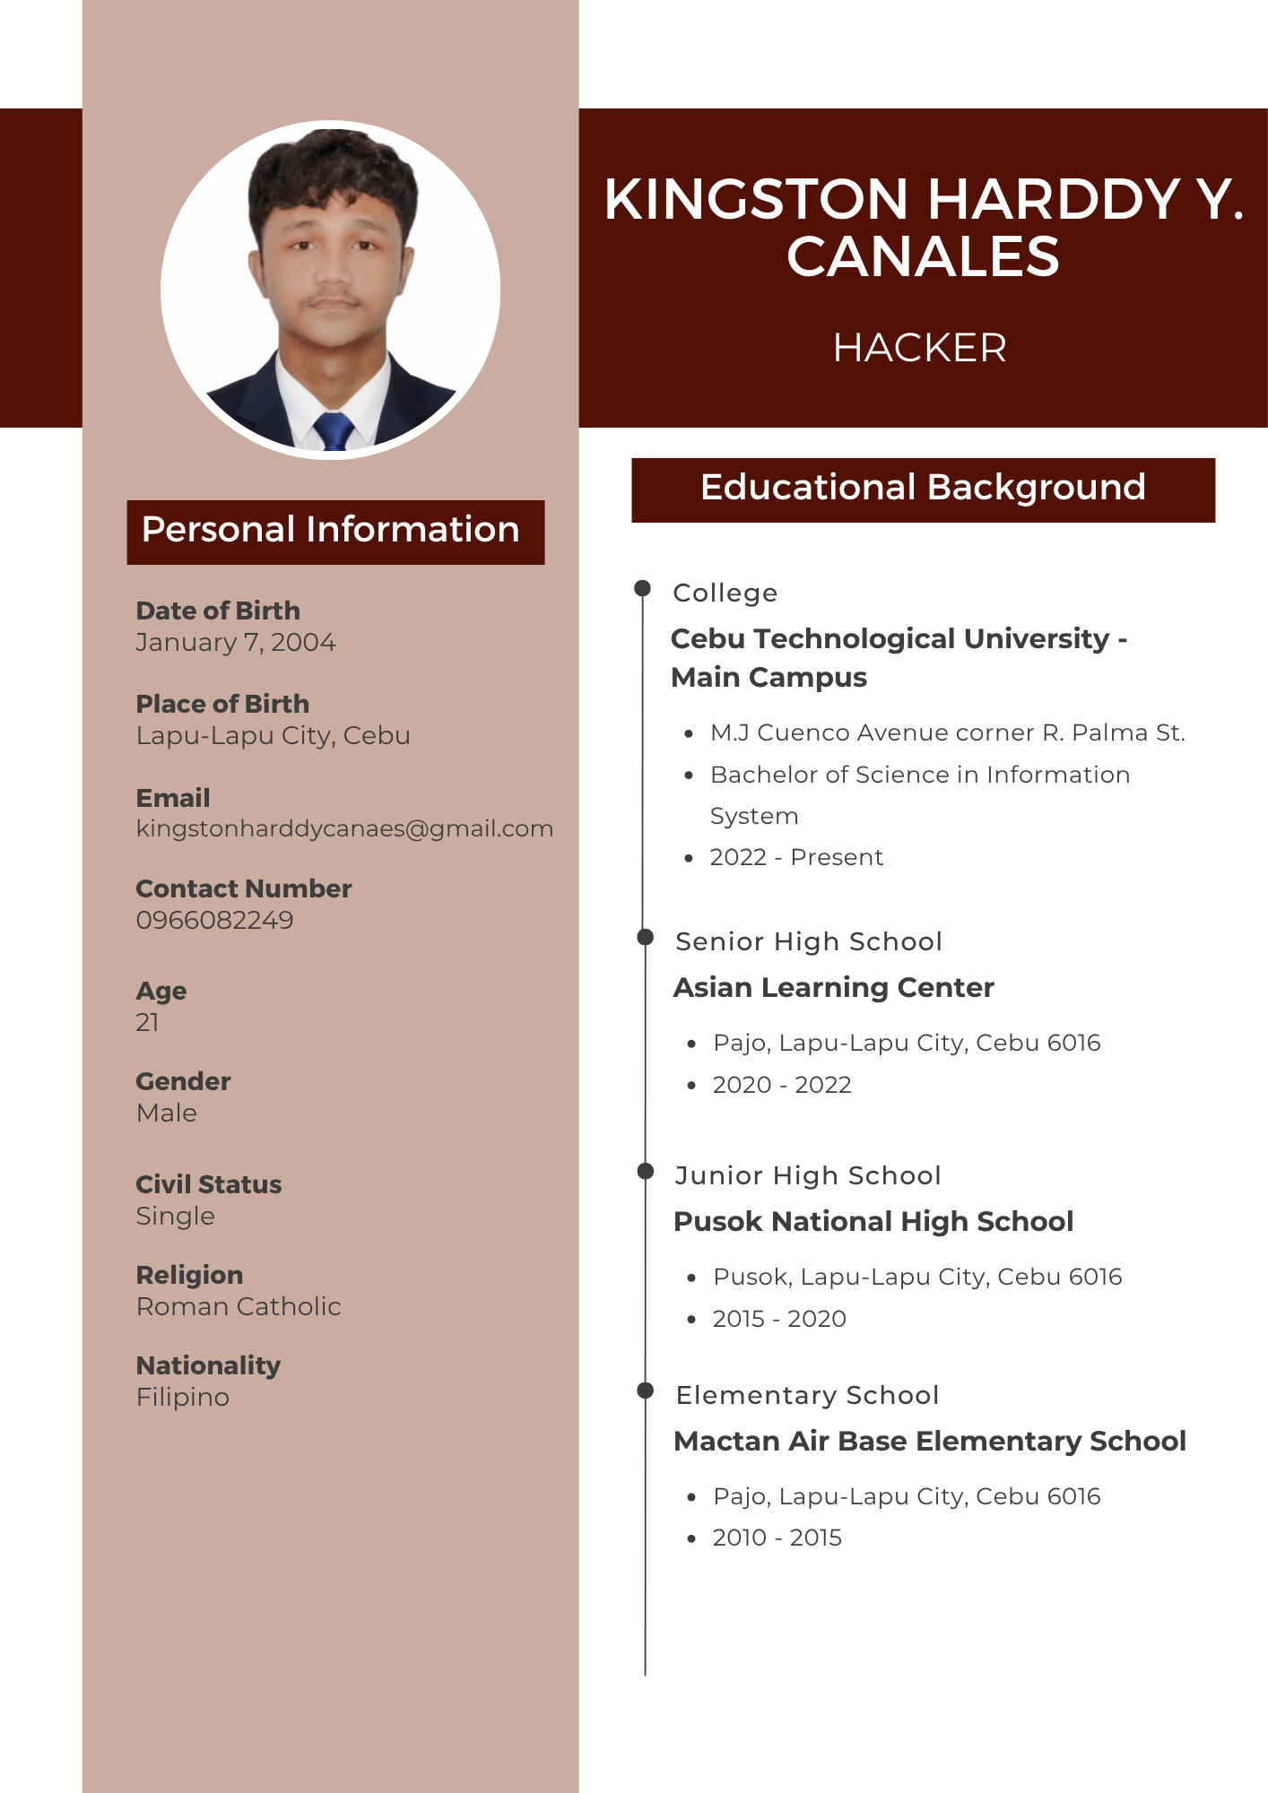

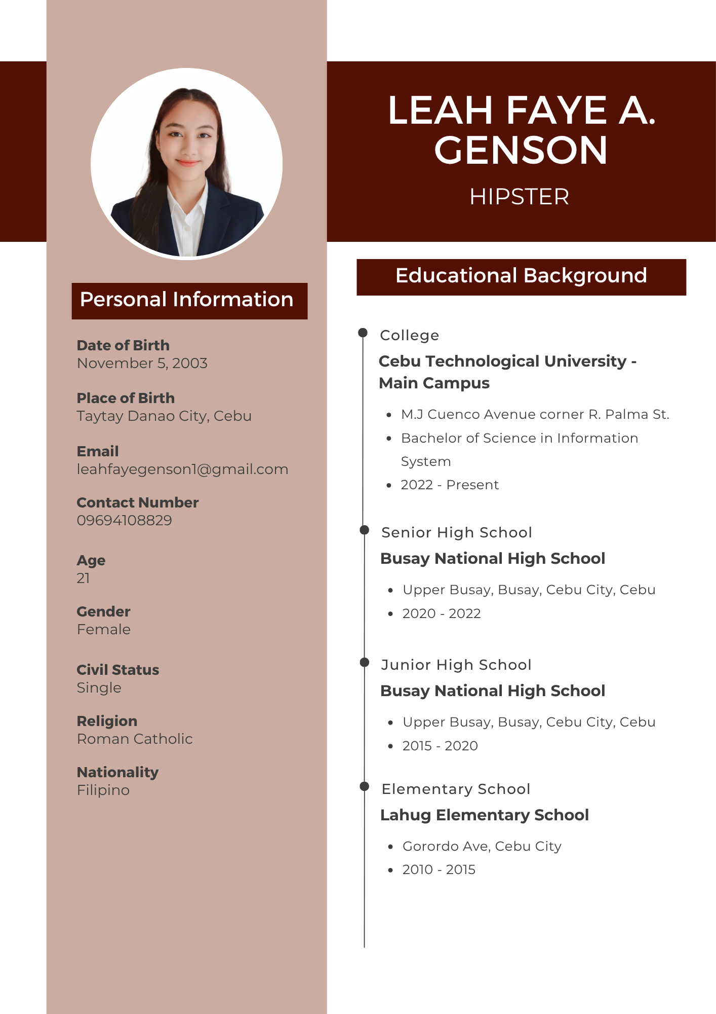

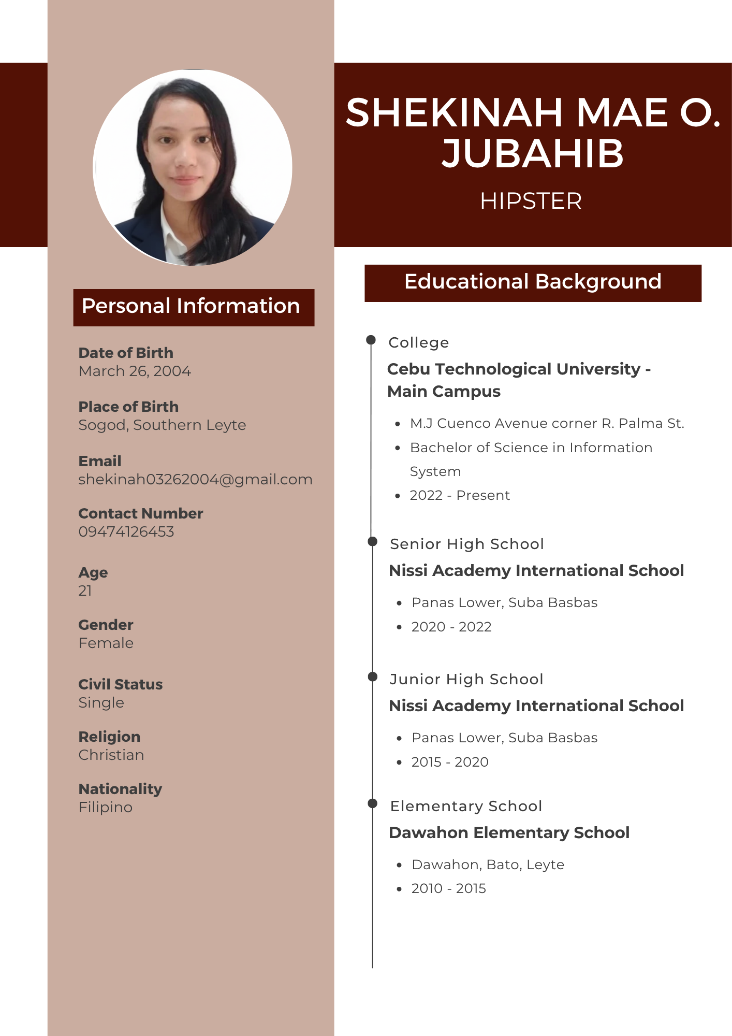

# **APPENDICES**

**Appendix O**

**Capstone 2 Oath of Confirmation**

Date: 08/20/2025

**OATH OF CONFIRMATION**

This is to confirm that I, **Niño John L. Arado**, a BSIS-4 student, currently enrolled in the course of Capstone Project 2, have aptly received a copy; religiously read and understood its contents; and openly submit to the terms, rules, conditions and regulations stated in the Capstone Project Manual document implemented by the Subject Teacher.

This is also to affirm that said guidelines were judiciously discussed and explicitly elaborated in a forum conducted by the Subject Teacher.

CONFORME: 

NIÑO JOHN L. ARADO

________________________________________

(Signature of Student over Printed name)/ Date

Date: 08/20/2025

**OATH OF CONFIRMATION**

This is to confirm that I, **Kingston Harddy Y. Canales**, a BSIS-4 student, currently enrolled in the course of Capstone Project 2, have aptly received a copy; religiously read and understood its contents; and openly submit to the terms, rules, conditions and regulations stated in the Capstone Project Manual document implemented by the Subject Teacher.

This is also to affirm that said guidelines were judiciously discussed and explicitly elaborated in a forum conducted by the Subject Teacher.

CONFORME: 

KINGSTON HARDDY Y. CANALES

________________________________________

(Signature of Student over Printed name)/ Date

Date: 08/20/2025

**OATH OF CONFIRMATION**

This is to confirm that I, **Leah Faye A. Genson**, a BSIS-4 student, currently enrolled in the course of Capstone Project 2, have aptly received a copy; religiously read and understood its contents; and openly submit to the terms, rules, conditions and regulations stated in the Capstone Project Manual document implemented by the Subject Teacher.

This is also to affirm that said guidelines were judiciously discussed and explicitly elaborated in a forum conducted by the Subject Teacher.

CONFORME: 

LEAH FAYE A. GENSON

________________________________________

(Signature of Student over Printed name)/ Date

Date: 08/20/2025

**OATH OF CONFIRMATION**

This is to confirm that I, **Shekinah Mae O. Jubahib**, a BSIS-4 student, currently enrolled in the course of Capstone Project 2, have aptly received a copy; religiously read and understood its contents; and openly submit to the terms, rules, conditions and regulations stated in the Capstone Project Manual document implemented by the Subject Teacher.

This is also to affirm that said guidelines were judiciously discussed and explicitly elaborated in a forum conducted by the Subject Teacher.

CONFORME: 

SHEKINAH MAE O. JUBAHIB

________________________________________

(Signature of Student over Printed name)/ Date

**Capstone Project Team Composition Form**

|  |  |  |  |  |
| --- | --- | --- | --- | --- |
| **Name** | **Signature** | **Role**  **Assignment** | **Email** | **Contact #** |
| **1. Niño John L. Arado** |  | **Hustler** | **njarado2001@gmail.com** | **09282768939** |
| **2. Kingston Harddy Y. Canales** |  | **Hacker** | **kingstonharddycanales@gmail.com** | **09660862249** |
| **3. Leah Faye Genson** |  | **Hipster** | **leahfayegenson1@gmail.com** | **09694108829** |
| **4. Shekinah Mae O. Jubahib** |  | **Hipster** | **shekinah03262004@gmail.com** | **09474126453** |

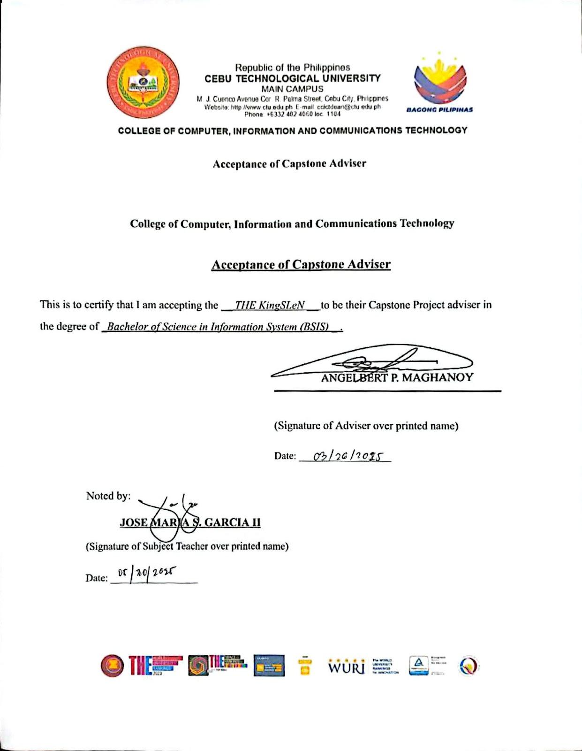

|  |  |
| --- | --- |
| Name of the Proponents | Roles |
| 1. **Niño John L. Arado** | **Hustler** |
| 1. **Kingston Harddy Y. Canales** | **Hacker** |
| 1. **Leah Faye A. Genson** | **Hipster** |
| 1. **Shekinah Mae O. Jubahib** | **Hipster** |
| Proposed Research Title: | |
| **ENHANCING CAPSTONE ARCHIVING AND OPTIMIZING DATA INTELLIGENCE WITH PROJECT CAPSTONOVA** | |
| Date: March 13, 2025 | Date: March 26, 2025 |
| Submitted by: | Noted and approved by: |
| NIÑO JOHN L. ARADO | JOSE MARIA S. GARCIA II |
| (Signature of Project Leader over  Printed Name) | (Signature of subject Teacher) |

**Research Working Title Form**

**Appendix P**

**Capstone Project 2 Consultation Logs Form**

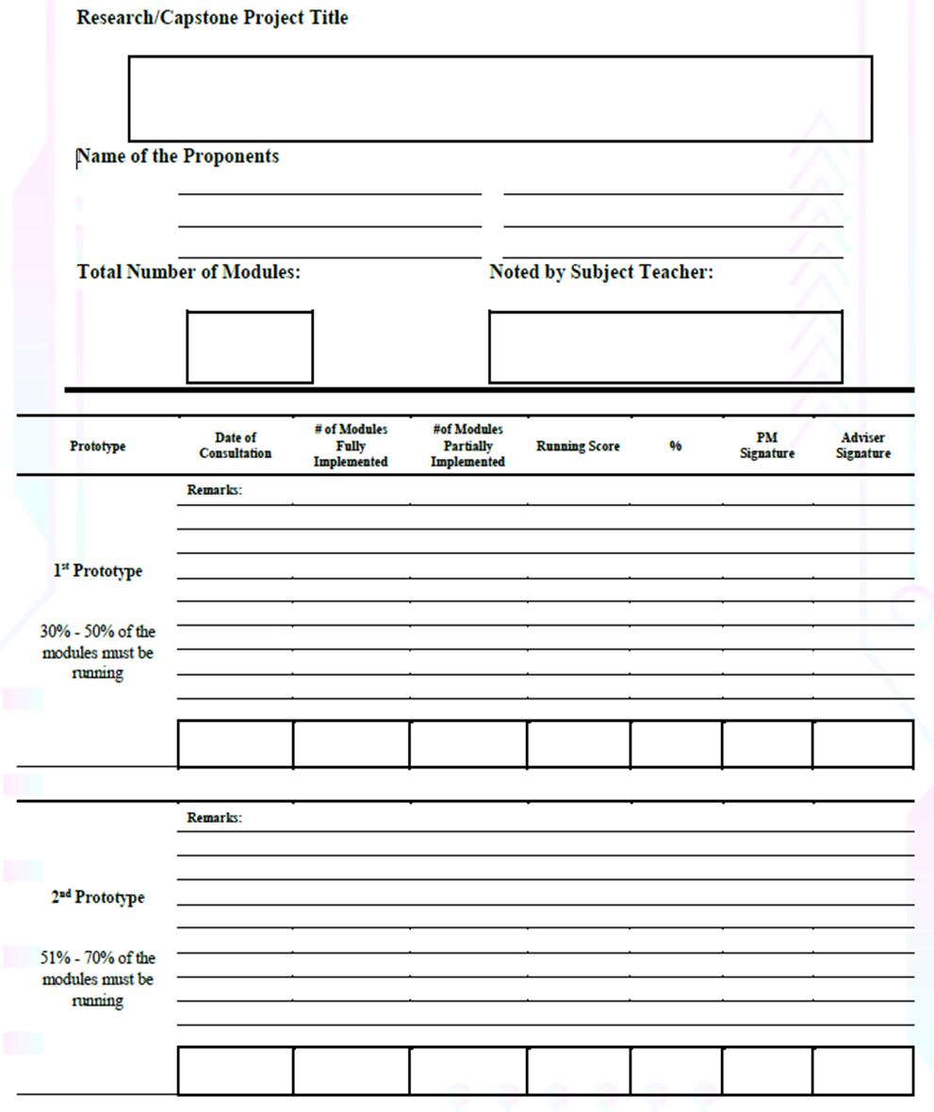

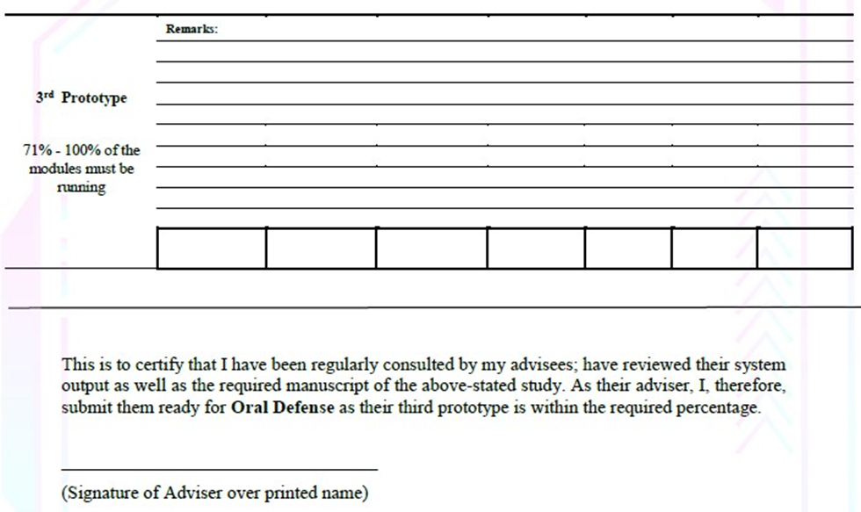

**Appendix Z: System Proposal Sheet**

|  |  |
| --- | --- |
| **SYSTEM PROPOSAL SHEET** | |
| Title of the Project:  **Enhancing Capstone Archiving and Optimizing Data Intelligence with Project CapstoNova** | Name of Proponents:  **Niño John L. Arado**  **Kingston Harddy Y. Canales**  **Leah Faye A. Genson**  **Shekinah Mae O. Jubahib** |
| Semester: 1st Semester | Academic Year: 2025-2026 |
| **Brief Description of the System:**  The Project CapstoNova is a centralized, secure, and web-based Capstone Archiving Information System designed for Cebu Technological University – College of Computer, Information, and Communications Technology (CTU-CCICT). It replaces the traditional method of storing printed capstone projects with a digital platform that allows for easy submission, storage, search, and retrieval of research work. The system automatically classifies projects by platform, programming language, and topic, helping prevent duplicate topics and supporting student research and innovation. With features like access control, advanced search, adviser monitoring, and data mining tools, CapstoNova improves academic collaboration, protects intellectual property, and ensures long-term preservation and accessibility of capstone projects.  **Statement of the Problem:**  Currently, the Cebu Technological University – College of Computer, Information, and Communications Technology (CTU-CCICT) stores capstone projects in printed, bookbound copies kept in physical rooms. This method causes several problems, such as:   1. Difficulty in accessing past capstone projects for both students and teachers. 2. High risk of damage or loss of important academic documents. 3. Time-consuming manual processes in checking for duplicate project titles and verifying originality. 4. Missed opportunities for collaboration, innovation, and reusing valuable research.   Due to the lack of a centralized and secure digital system, students and faculty face inefficiencies in submitting, retrieving, and referencing research outputs.  **The study aims to address the following central problem:** How can CTU-CCICT improve the storage, management, security, and accessibility of capstone projects using a centralized and intelligent digital system?  **Objectives of the System:**  This project seeks to create Project CapstoNova, a web-based system designed to develop capstone project archiving, storage, secure access management, and smart data analysis at the College of Computer, Information, and Communications Technology (CCICT) at Cebu Technological University – Main Campus.  To achieve this goal, the following specific objectives are defined:   1. To design and develop a centralized archiving system for securely managing capstone manuscripts and source codes using the school's local storage repository. 2. To implement role-based user access for proponents, advisers, admins, super admins, and viewers—each with defined permissions and responsibilities. 3. To provide title verification and suggestion features to prevent duplicate titles and allow advisers to share new capstone project ideas. 4. To automate the capstone submission, approval, and classification processes, including document uploads, workflow approvals, and category tagging. 5. To organize archived projects based on course, project type, field of study, tools used, adviser, and academic year to enable easier retrieval and browsing. 6. To integrate analytics and reporting tools that display project trends and statistics useful for research and institutional planning. 7. To develop a secure access request system where registered users (viewers) must create an account before requesting permission to view full ACM-formatted manuscripts. 8. To provide real-time notifications to users about project statuses, account updates, access requests, and system activities. 9. To generate system reports (e.g., total submissions, archive status, active users, adviser participation) for administrative use. 10. To ensure file backup and protection through local storage strategies, user authentication, and file integrity verification. 11. To prepare complete documentation, including technical manuals, user guides, and the final capstone paper to support system training, usage, and maintenance.   **Scope and Limitation of the System:**  The study focuses on the design and development of Project CapstoNova, a web-based capstone project archiving system exclusively for Cebu Technological University – College of Computer, Information, and Communications Technology (CTU-CCICT). The system is intended to improve the submission, approval, classification, storage, retrieval, and access of capstone projects using digital tools and analytics.  The system includes the following functionalities:   * Role-based user access for Proponents, Advisers, Admins, Super Admins, and Viewers. * Capstone submission, categorization, title verification, and source code upload. * Search and retrieval based on project type, course, adviser, study field, tools used, and academic year. * Adviser project idea suggestion and project monitoring tools. * Access control, user authentication, and manuscript request approval. * Real-time notifications and system analytics. * Report generation and data trend analysis. * Backup protocols and file integrity checking. * Full documentation including user manuals and technical support.   **However, the system is not capable of the following:**   1. It only supports a web-based platform – there is no mobile application or mobile-optimized version currently available for use on smartphones or tablets. 2. It does not accept projects from outside institutions – only CTU-CCICT students and faculty can access or upload capstone projects. 3. It does not include full plagiarism detection – aside from title verification and basic similarity checks, the system does not perform comprehensive plagiarism scanning. 4. It lacks a full advisory workflow system – although advisers can suggest topics and monitor submissions, they cannot track detailed student progress or provide ongoing mentoring within the system. 5. Viewer access is restricted – viewers must register and request access before viewing full project documents, subject to admin or super admin approval. 6. The system may require extensive training – due to the complexity of its multiple user roles and functionalities, users might struggle to use the system effectively without proper training, manuals, or ongoing support. | |
|  |
| **PANEL OF EXAMINERS**  **NOREEN B. FUENTES, Ph.D, DIT**  Chairman  **JANETH S. UGANG, Ph.D.   EMELIE C. VILLACERAN, Ph.D**         Member             Member    Noted by:                                                                Approved by:  **JOSE MARIA S. GARCIA II, Ph.D.**                  **ANGELBERT P. MAGHANOY, Ph.D.**       Instructor                                                         Program Chair - IS Department | |  |

